
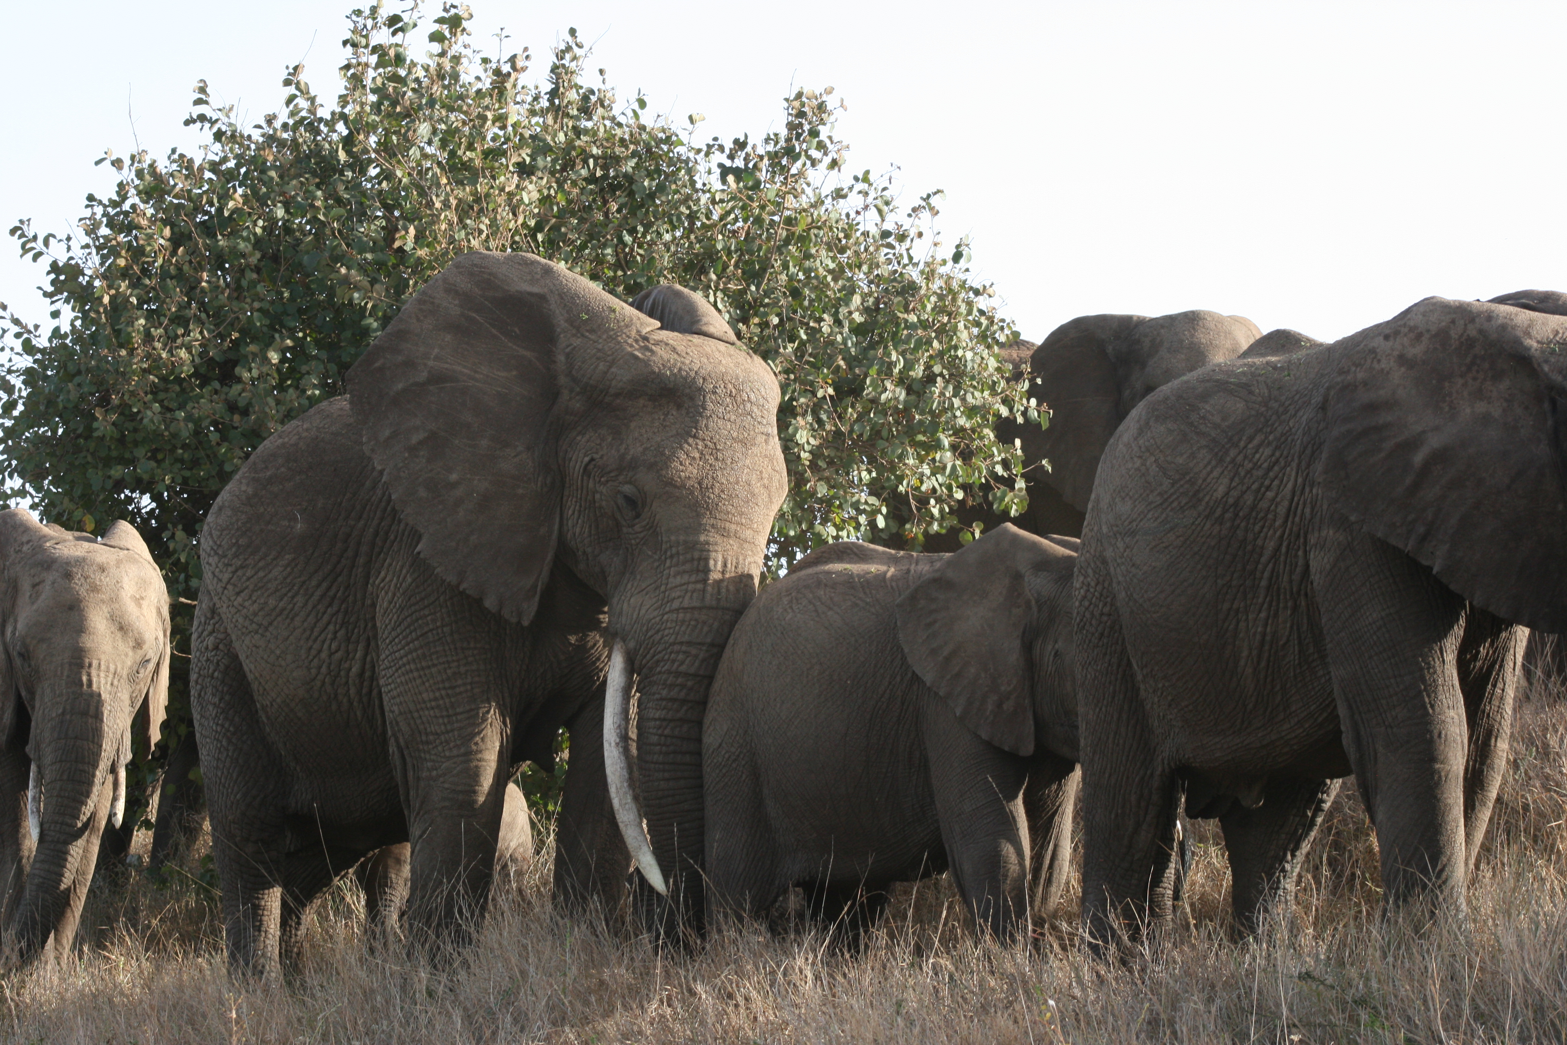
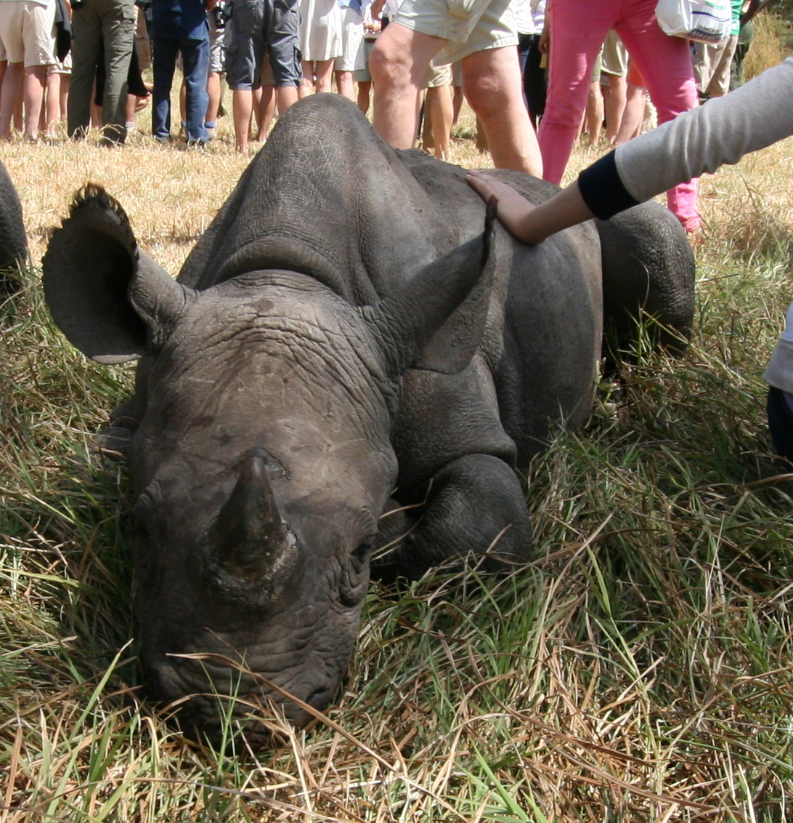
Tusk is a small, dynamic organization with 24 years of experience initiating and funding conservation, community development and environmental education programs across Africa. Tusk currently works in 17 African countries to protect wildlife, while helping to alleviate poverty through sustainable development and education programs. Tusk’s aim is to forge an inextricable link between the preservation of Africa’s wildlife and its natural heritage and the future of its land, culture and people. Tusk has been at the forefront of promoting and funding community driven conservation programs. Tusk ‘s holistic approach recognizes that the long-term future for wildlife is dependent on education and sustainable development.
HRH the Duke of Cambridge became the charity’s Royal Patron in 2005 and has been a proactive supporter of Tusk’s work ever since.

Protecting Wildlife, Supporting Communities, Promoting Education
212-602-1588
www.tusk.org
WHERE YOUR MONEY GOES?
- $50 will purchase four school desks
- $100 will purchase a pair of boots for a rhino security guard
- $500 will stage three wildlife and ecology awareness plays for primary school children
- $500 will sponsor three classes to take part in an environmental education program
- $1,500 will cover the monthly costs of hand rearing an orphaned baby rhino
- $2,000 will equip two rangers with radios and portable solar panels on anti-poaching patrols
- $5,000 will cover the annual operating costs of a 2 man rhino surveillance team

