Expanded Polystyrene (EPS) Recycling Rate Report – Copy Page 1

Many are not aware expanded polystyrene (EPS) packaging is recyclable – and is being recycled successfully by businesses and consumers throughout the United States. The 2012 Expanded Polystyrene Recycling Rate Study (the “Rate Study”) was conducted by the EPS Industry Alliance (EPS-IA). To better track EPS recycling trends EPS-IA gathers data to reflect both post-commercial and post-residential collection streams. Based on data received from forty-one EPS manufacturers and independent recyclers in the U.S., the 2013 results reflect a modest decrease in the amount of post-industrial pounds recycled and a substantial increase in the number of post-consumer pounds recycled.

As reflected in Table 1, more than 125 million pounds of EPS was recycled during calendar year 2013. This figure includes 72.8 million pounds of post-commercial and post-consumer packaging and 54.5 million pounds of post-industrial recovery. Post-consumer and post-commercial recycling are defined as any material that is recycled after its intended end-use – while post-industrial recovery includes EPS facility scrap that is recycled but never served its intended purpose as a packaging material or other end-use application.

Since 1991, EPS recycling has demonstrated stable, incremental growth and steady end-use market developments. This growth can be attributed to innovative and sustainable programs specifically geared to EPS recycling. Businesses and consumers play a key role in reducing the amount of packaging material that enters the waste stream by contributing to a shared-responsibility approach to recycling.

As compared to the 2012 Rate Study, 2013 showed a notable growth for post-consumer and post-commercial recycling. This is supported by a strong reliance on high volume sources and proves the success of industry recycling efforts in the United States. Advances in EPS recycling technologies, collaborative collection programs and new end-use markets have continued to broaden EPS recycling opportunities. In addition, the EPS industry fosters ongoing development of new and innovative recycling initiatives that will promote further EPS recycling growth. These include recycled content resin and unique volume reduction technologies that are showing great potential.

Figure 1: Domestic Post-Consumer EPS Recycling (1990-2013)
Figure 1
Domestic Post-Consumer & Post-Commercial EPS Recycling: 1990—2006¹

Table 1: 2013 Domestic EPS Recycling
Figure 1
Domestic Post-Consumer & Post-Commercial EPS Recycling: 1990—2006¹
(millions of pounds)

Post-Consumer 72.8
Post-Industrial 54.5
Total EPS Recycling 127.3

EPS RECYCLING: Stronger Than Ever
Expanded Polystyrene (EPS) Recycling Rate Report – Copy Page 2

As shown in Figure 2, the EPS packaging recycling rate percentage continues to grow steadily, showing a dependable track record to deliver consistent results. In fact, when comparing rigid, durable PS and other grade materials, EPS post-consumer and post-commercial recycling represent 47% of all post-use polystyrene recycled in the U.S. and is one of the highest within the plastics family.

Figure 2: Post-Consumer EPS Recycling Rate History (1990-2013)

Report Methodology

The methodology for this annual report focuses on the development of a numerator and denominator figure. Recycled pounds, used as the numerator in the recycling rate equation, are based on an annual survey of post-consumer and post-commercial plastic recyclers (including EPS industry manufacturing facilities ) and reflect the quantity of EPS recycled each year. Recycled pounds were counted at the stage where materials enter a reclamation facility (as opposed to net material recycled into resin or products) or were shipped for recycling outside the U.S.
Due to supply distribution chains and multiple end-use applications for EPS, a fixed number for EPS packaging generated each year is not available. Other manufacturing streams include building and construction applications, sporting goods and other durable products. As a proxy, resin sales data as reported for custom moded applications are used as the denominator in the recycling rate equations, which were provided by the American Chemistry Council (ACC) Plastics Industry Producers’ Statistics Group. ACC reports are compiled from primary data reported by resin producers to the professional services firm of Veris Consulting, LCC. This does not account for non-U.S. resin sales which may offset the quantities reported by U.S. resin suppliers sold into custom molding facilities for non-packaging applications.

Recycling Criteria

Not all materials are well suited for recycling. Post-consumer EPS packaging must be clean and free of tape, film and cardboard. Expanded polystyrene made with a fire retardant additive, typically used in the manufacture of EPS building insulation, requires special reprocessing conditions. To enhance collection efforts and maximize the investment in recycling equipment, EPS-IA recycling locations concentrate on large volume, commercial sources of post-consumer EPS. Some locations also offer consumer drop-off access.

To find out if EPS recycling is available in your area, visit www.epsinsutry.org. For consumers that do not have access to a local drop-off center, the Alliance of Foam Packaging Recyclers sponsors a National Take-Back Program intended for smaller quantities of EPS which can be mailed via U.S. Postal Service or UPS to more than 30 locations nationwide. Full instructions and a list of Take-Back locations are available on the EPS-IA website

EPS Collection & Reuse
Expanded Polystyrene (EPS) Recycling Rate Report – Copy Page 3

Expanded polystyrene (EPS) foam packaging is an excellent material for recycling and reuse with a 15 year history of environmental stewardship. Members of the EPS Industry Alliance sponsor these efforts with ongoing financial support and active involvement in the collection and reprocessing of EPS. Recycling gives everybody a sense of well being. Working together with communities, local businesses and citizens, this unified approach is achieving increased awareness with bigger and better results – for a material often thought to be non-recyclable! Individually, none of these groups could have realized this exponential growth trend.

NOVA Chemicals in Monaca, Pennsylvania introduced a program for its employees to recycle their EPS foam. The initiative was so successful it spurred NOVA to take their recycling efforts further by partnering with the Pennsylvania Resources Council (PRC) to collect EPS for recycling free of charge at PRC events that enabled hundreds of individuals to drop off over 1,300 cubic yards of unwanted EPS foam for recycling.

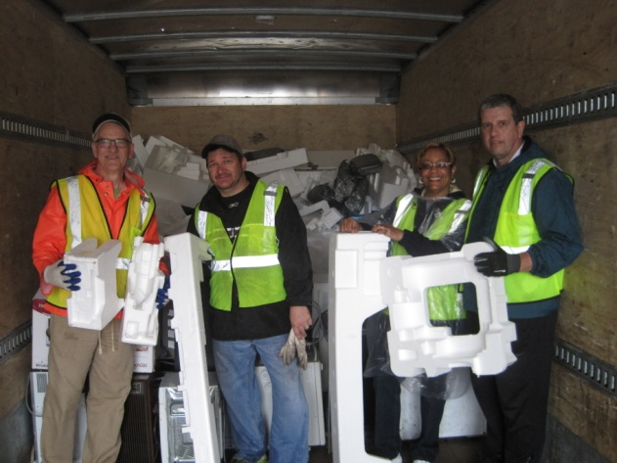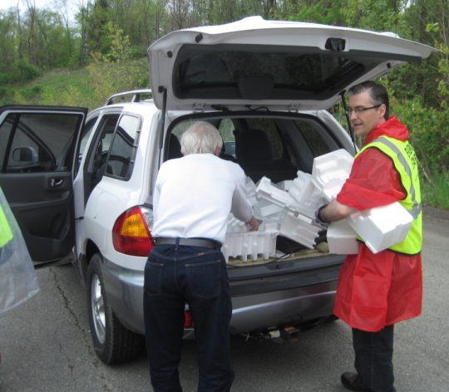

While EPS is usually recycled into products such as coat hangers, insulation, decorative moldings and picture frames, new market developments continue to evolve. Nine Lives Products launched a new recycled glue product, Glu6, which is made from a blend of recycled polystyrene waste collected in the San Francisco Bay area and plant-based ingredients. This type of new and inventive market development is a key aspect of sustainable EPS recycling initiatives.

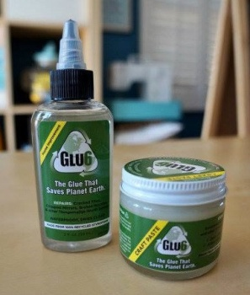

For a fun and unique solution to EPS recycling, Waste-To-Waves collects material to make new surfboard blanks. With 18 collection sites in California, special events and corporate partnerships with Patagonia, Rip Curl and others, this initiative delivers a closed loop recycling solution and is spreading the word on surfing sustainability.

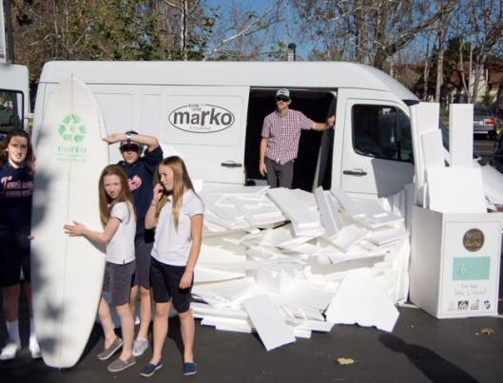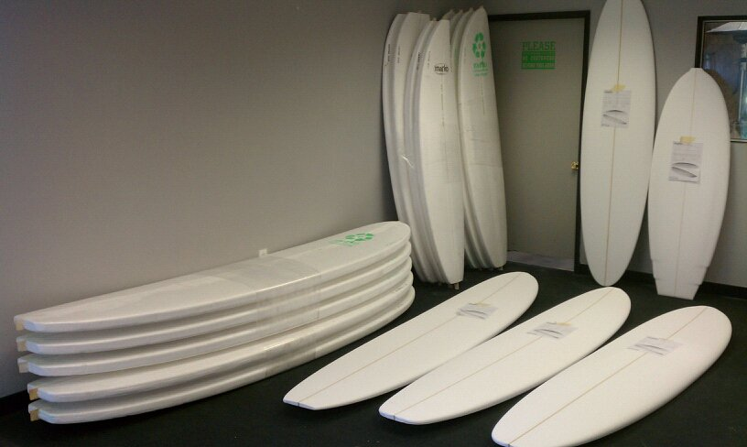

Other EPS Recycling Successes:

Nutrisystem
This information should be highlighted in a sidebar or some other fashion,
Omaha Steaks
Walmart
City of Baltimore
Whirlpool Corporation
City of Houston

This information should be highlighted in some fashion,
facebook.com/EPSRecycling

Expanded Polystyrene (EPS) Recycling Rate Report – Copy Page 4

The Plastic Loose Fill Reuse Program

The Plastic Loose Fill Reuse Program features a Google map that automatically directs consumers to local packaging businesses, primarily pack and ship stores conveniently located in neighborhood shopping centers, which reuse the loose fill packaging in new outbound shipments.

Established in 1991, the program has thousands of locations throughout the country and is listed in community recycling directories, on websites for national retailers and has been featured in publications ranging from The New York Times to Modern Bride and Recycling Today. More details can be found at epspackging.org.

EPS-IA Members

ACH Foam Technologies
ADLAM Films LLC
AFM Corporation
Airlite Plastics Co./Fox Blocks
APTCO, LLC
Aqua-Pak Styro Containers Ltd.
Argus DeWitt
Armstrong Brands, Inc.
Atlas EPS, A Division of Atlas Roofing
Avangard Innovative
BASF Corporation
Beaver Plastics Ltd
Cellofoam North America, Inc.
Comfort Research LLC
Concrete Block Insulating Systems, Inc.
DiversiFoam Products
Drew Foam Companies, Inc.
EFP Corporation
Flint Hills Resources, LP
FMI-EPS, LLC
Foam Equipment & Consulting Co.
Foam Fabricators, Inc.
Fransyl LTD
Gala Industries, Inc.
Groupe Isolofoam
HIRSCH Americas, LTD
Houston Foam Plastics
Huntington Foam LLC
InSoFast, LLC
Insulation Corporation of America
Insulation Technology, Inc.
Insulfoam LLC
KBM ApS
Kurtz ERSA
Lanxess Corporation
Le Groupe LegerLite, Inc.
Lifoam Industries
Logix ICF Ltd.
Mansonville Plastics(BC)Ltd./First Choice Manufacturing
MODIX Corporation
Nantong Chaoda Science & Technology Co. LTD
Nexkemia Petrochemicals Inc.
Northwest Foam Products
NOVA Chemicals, Inc.
Nuova IdroPress SpA
OPCO, Inc.
Plasti-Fab Ltd.
Plymouth Foam Inc.
Polar Industries, Inc.

Polyfoam Corporation
Polyform Inc.
Polymos Inc.
Progressive Foam Technologies, Inc.
ProWall Building Products
Quad-Lock Building Systems Ltd.
RAPAC, LP
Riemschneider Recycling & Plastics, Inc.
Sebright Products, Inc.
Shell Chemical LP
Shelter Enterprises, Inc.
Solid Green Systems
Sonoco Protective Solutions
Steves & Sons
Styrotek Inc.
Takashima U.S.A., Inc.
TEC Associates
ThermaFoam, LP
Thermal Foams, Inc.
Truefoam Limited
Versa-Tech, Inc.
Zimmermann Management Solutions, LLC

©Copyright 2014 EPS Industry Alliance
The information contained herein is provided without any express or implied warranty as to its truthfulness or accuracy. The EPS Industry Alliance does not endorse the products or processes of any individual manufacturer or recycler.

Additional photos/logos for brochure design:

