Greetings from
Kerry

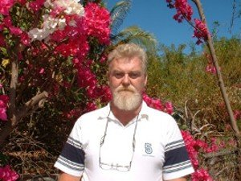E-mail: vk2fomz@wia.org.au
Kerry Hogan
QTH: Lightning Ridge NSW AUSTRALIA
Rig Yaesu FT847. Ant: Yaesu/Yagi 6 Element Gamma Confirming our Meter CW QSO,
on - at UTC. Your RST:

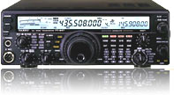

Note to user: You can change the WA3DPL WordArt call sign to your own call sign:
In Word, turn on the WordArt toolbar, by clicking "View", "Toolbars", "WordArt".
Then go to the header/footer layer by clicking "View", "Header & Footer".
Then in the WordArt toolbar, click on "Edit Text", to change the call sign text.

Before you use your completed form as a template:
In Word, turn on the Forms toolbar, by clicking "View", "Toolbars", "Forms.
Lock the form by clicking on the lock-shaped icon in the Forms toolbar.
Save it in your template folder, as a template.

