



Reviving Speech and Improving Lives

Clinician Manual

1.0 Welcome
Congratulations on taking the first step toward increasing your patient’s speech clarity! SpeechVive incorporates a patient-centered design with proven results. SpeechVive detects when the patient is speaking with an accelerometer built into the non-occlusive earpiece. During speech, the device plays a gentle background sound into the patient’s ear. The background sound, which resembles a room full of people talking, is a natural cue that elicits improved speech clarity through the subconscious reflex known as the Lombard Effect. When a patient is not speaking, the SpeechVive device turns off the background sound, which enhances the patient’s ability to hear and communicate effectively.
SpeechVive comes with a rechargeable battery and charger. At the end of the day, the patient can easily charge the device in the included charging station. The charging station is designed with a plug-in interface to provide a straightforward charging solution that does not require replacing batteries or manipulating small parts.
SpeechVive is provided with a Clinician Application Software which allows the speech-language pathologist to easily program SpeechVive device settings to individualize patient needs. The intuitive design enables speech-language pathologists to quickly monitor patient usage and therapeutic progress. The software makes the record keeping process more efficient by saving patient information, device settings, and supporting data to allow the speech-language pathologist to make periodic adjustments to the SpeechVive device during patient follow-up visits.
The SpeechVive software also automatically populates initial evaluation and follow up reports with a simple command. The editable reports include all of the necessary information for record keeping allowing the speech-language pathologist to spend more time treating patients.

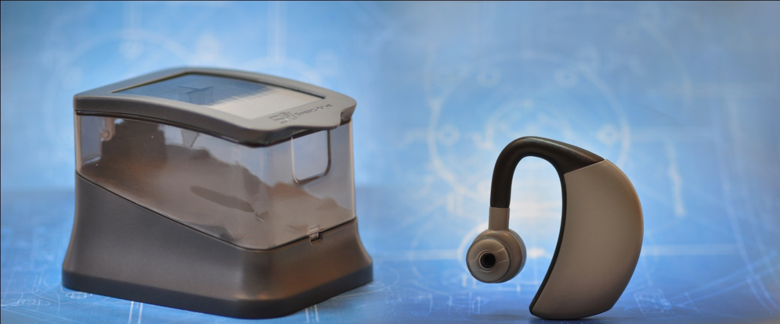
“SpeechVive Device and Charger demonstrate a patient-centered design.”
Table of Contents
1.0 Welcome 1
2.0 Indications for Use 4
3.0 Intended Use 4
4.0 Important Safety Information 4
5.0 Hazards & Warnings 4
6.0 SpeechVive System Overview 6
6.1 Patient System 6
6.2 Clinician System 6
7.0 SpeechVive Software 7
7.1 Computer and Software Requirements 7
7.2 Install SpeechVive Software 7
7.3 Become Familiar with the SpeechVive Software 8
7.3.1 General Information 8
7.3.2 SpeechVive Programming 8
7.3.3 Initial Assessment Results 9
7.3.4 Follow Up Results 10
7.3.5 SpeechVive Use Data 10
7.3.6 Generate Reports 11
7.3.7 Clinician & Practice Information 11
7.3.8 Help Information 11
8.0 Prior to Your Patient’s Fitting Appointment 12
8.1 Unpack the SpeechVive System and the Clinician System 12
8.2 Become Familiar with SpeechVive 12
8.3 Charge SpeechVive 24 Hours Prior to Patient’s Appointment 12
9.0 Fitting a Patient with SpeechVive 14
9.1 Quick Start Guide 14
9.2 Detailed Fitting Process 14
9.2.1 Get the patient situated 14
9.2.2 Select the appropriate sized silicone tip to place on SpeechVive 14
9.2.3 Have the patient put on SpeechVive 14
9.2.4 Open the SpeechVive Software Program 16
10.0 Changing and Cleaning Silicone Tips 19
10.1 To remove the silicone tip 19
10.2 To place a new silicone tip on the earpiece 19
10.3 To remove ear wax from the silicone tip 19
11.0 Frequently Asked Questions 20
12.0 Tips for Better Communication 21
13.0 Troubleshooting 22
14.0 Technical Information 23
15.0 Symbols Used in Labeling 24
Appendix 25

2.0 Indications for Use
SpeechVive electronically generates noise when activated or when it senses a user’s speech and is intended to reduce the user’s ability to hear the sound of his or her own voice. The device is used to increase speech clarity.
3.0 Intended Use
SpeechVive is intended to increase speech clarity by:
- Increasing sound pressure level
- Improving articulation
- Normalizing speech rate
4.0 Important Safety Information
Please read the following information prior to using, fitting, or programming SpeechVive.
Infrequent use of SpeechVive does not permit a user to attain full benefit from the product. This device is only part of speech rehabilitation and may need to be supplemented by other speech training. A patient should only use a SpeechVive that has been programmed specifically for them by a speech-language pathologist. Changes or modifications to the product that are not explicitly approved by their speech-language pathologist or SpeechVive Inc. are not permitted and may invalidate product warranty. A patient should discontinue use of the device and consult their speech-language pathologist, audiologist or physician if they feel pain in or behind their ear, experience inflammation, irritation or accelerated accumulation of ear wax. In very rare cases, the soft silicone tip of the earpiece may remain in their ear canal when removing the device. In the unlikely event that the tip remains in their ear canal, patients should consult their physician for safe removal. While using SpeechVive, your patient may have difficulty hearing noises in the environment around them. Please be aware that warning signals or noises coming from behind the user may be partially suppressed. SpeechVive contains small parts that may be swallowed by children or pets. Please remind your patient to keep SpeechVive in its charging station when not in use and on a table out of reach of small children and pets.
5.0 Hazards & Warnings
Failure to comply with these warnings may invalidate the product warranty and or result in serious injury.
- Never immerse SpeechVive in water. Protect it from excessive moisture. The patient should always remove the device before showering, bathing, or swimming.
- Protect SpeechVive from high temperatures. Do not attempt to dry with or expose SpeechVive to an appliance that emits heat.
- Store SpeechVive in the charging station when not in use; if it is not available, store it in a safe, dry, clean location.
- X-ray radiation (e.g. CT scans) may adversely affect the correct functioning of the SpeechVive. The patient should remove the device and leave it outside the room when undergoing X-ray procedures.
- Do not use SpeechVive in areas where electronic equipment is prohibited.
- The patient should avoid wearing SpeechVive in locations that may be a source of potential electromagnetic interference.
- Device should not be used in an oxygen rich environment (greater than 25% oxygen).
- The USB cover should only be removed by a speech-language pathologist when programming the device. After programming, insert the USB cover back into the USB slot. Be careful not to misplace the cover when it is not attached to SpeechVive.
- Heat generated by SpeechVive should not exceed 41°C or 105.8°F.
- SpeechVive is not a hearing aid and cannot be used as such.
- Do not stick anything into the earpiece besides a silicone tip.
- The loop cleaning tool should only be used to clean the silicone tip.
- Do not stick the cleaning tool into your ear or your patient’s ear.
- Do not swallow silicone ear tips. The removal of the tips from the device may pose a choking hazard to children and pets.
- Do not touch the gold contact pins on the charging station.
- Only connect items that have been specified as part of the SpeechVive System to the charger and device. These items include the silicone tips for the device, the supplied USB cord and the supplied power cord for the charger.
- Never use size small Plantronics Voyager Pro Ear Tips (Part #: 81292-01) with SpeechVive.
- An additional multiple socket-output or extension cord cannot be connected to the charging station. Connecting the charging station to a multiple socket outlet may result in possible overload of the socket by other equipment. This may render the outlet unusable, resulting in the charging station being electrically non-operational and not able to recharge the battery in the earpiece.
- The sound level output from SpeechVive is approximately 85 dBA, which is within the accepted guidelines per IEC 60601-1 12.4.2. This level may be adjusted by a speech-language pathologist at their professional discretion, however the output volume setting shall not exceed 120 dBA.
- If SpeechVive is accidently programmed incorrectly, the device may output sound levels higher than therapeutically necessary; however the output level is limited to 120 dBA. Consult with your patient whether the sound output of SpeechVive is at a comfortable level for them.
- If SpeechVive is accidently programmed incorrectly, the device may output sound levels lower than therapeutically effective. Your patient should consult with a speech-language pathologist if they feel they are not receiving full benefit from the device.
- SpeechVive is not effective in environments with high levels of ambient background noise.
6.0 SpeechVive System Overview
6.1 Patient System
The SpeechVive Patient System will be shipped directly to you once your patient orders the system from SpeechVive Inc. This system is composed of the SpeechVive Earpiece and the SpeechVive Charging Station. Accessories included with the patient system are silicone ear tips (one each of the medium and large size), a power cord for the charger, and a loop cleaning tool. The SpeechVive Earpiece is designed to be worn over the patient’s ear for up to 8 hours a day in continuous operation. SpeechVive detects when the patient is speaking and plays a gentle background sound in their ear to elicit the Lombard Effect. The background audio subconsciously increases their speech clarity thereby requiring little to no cognitive demand. The SpeechVive Charging Station recharges the internal SpeechVive battery, eliminating the need to replace batteries during the lifetime of the device. The charging station also serves as a safe place to store the SpeechVive Earpiece when SpeechVive is not being worn.
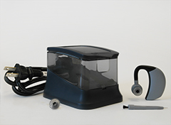
6.2 Clinician System
The SpeechVive Clinician System is necessary for fitting a patient with SpeechVive. The system can be used on each patient you believe will benefit from SpeechVive. The system includes:
- Calibrator: Used to ensure that the sound pressure level readings from the computer are accurate. Galaxy Audio (CM-C200 Calibrator). (pictured below).
- Preamplifier: Used to amplify the signal from the microphone. MXL (USB Mic Mate Classic) microphone preamp.
- A head-worn microphone: Used to convert the patient’s voice into an electrical signal so the program can calculate the patient’s fundamental frequency and sound pressure level. Shure (Beta 53) Omni-Directional Headworn Microphone.
- SpeechVive Software: Used to program the device, serves as a patient database, and generates documentation reports.
- Preamplifier: Connects to the microphone on one end and to the Mic Mate on the other. It is black.
- Microphone clip: Used to connect the USB cord from the device to the patient’s shirt to avoid tugging on the device.
- USB cord: Used to connect the mic mate to a computer.
- Calibrator adapter: Used to connect the head-worn microphone to the calibrator. It is a hard white piece of plastic.
- USB-A/USB-B cord.: USB 2.0 type A to micro B cord. Connects the SpeechVive device to the computer.

Calibrator ($249.99)
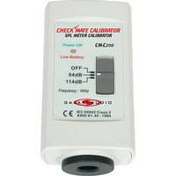
The Galaxy-Audio CM-C200 Calibrator for SPL Meter is used to correct base measurements lost over time on your meter. It meets IEC 60942 2003 Class 2, ANSI S1.40-1984 standards and is designed to handle 1/2" and 1" microphone capsules at 94 dB and 114 dB.
This accurate and easy to use calibrator comes in a handy carrying case and ready to go with batteries included. It works with any CheckMate SPL Meters and many other brands.
Maintains Industry Standards
Whether you monitor sound for car audio or a theater you can be sure your work is accurate. The CM-C200 conforms to ANSI S1.40-1984 and IEC 60942 2003 Class 2.
Lightweight
This calibrator is a lightweight addition to your equipment case, weighing in at less than half a pound.
Multiple Microphones
The CM-C200 fits a variety of microphones as it can calibrate microphones with a diameter of 1/2" or 1".

Pre Amp Mic Mate Classic ($49.95)
The USB Mic Mate Classic from MXL is a pocket-sized microphone preamp that features a 16-bit analog-to-digital converter (44.1 and 48.0kHz) while also providing 48V phantom power to condenser microphones directly from a computer's USB port.
The preamp/USB interface is no-hassle solution for mobile recording, podcasting and garage bands.
USB microphone preamp
Supplies 48V phantom power for use with condenser microphones
Plug and record with any software - no special drivers required
Fully balanced, low-noise analog front end
Three-stage analog gain control
Heavy-duty diecast metal construction

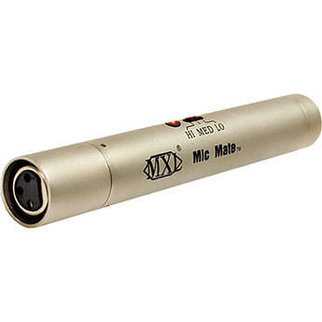

Preamplifier
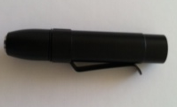
RPM626 Preamplifier
Connects to the microphone on one end and to the pre amp Mic Mate on the other.

Note: The SpeechVive Clinician System is available through SpeechVive Inc. Please contact SpeechVive Inc. at 800-392-3309 or info@speechvive.com.
7.0 SpeechVive Software
7.1 Computer and Software Requirements
- Microsoft Word (only needed for report generation in Word)
- OS: Windows 7 or later
- Software: Office 97 or later
- Minimum hardware requirements for Windows 7 are sufficient.
- You MUST have local admin rights. You MUST run the software as admin. This affects write permissions on folders.

7.2 Install SpeechVive Software
For Windows 8 and 8.1 only. Windows 7 users skip to page 15 and follow installation instructions.

Disable Driver Verification in Windows 8 and 8.1
Windows 8 requires drivers to be digitally signed before it will allow them to install. Many drivers, including the one for the SpeechVive device, are unsigned. To get around this, you will need to use the following procedure.
To disable driver signature verification in Windows 8 and 8.1:
NOTE: There are slight differences between Windows 8 and 8.1 in Steps 3, 4, and 5.
- Press Windows key + C to open the Charms Bar.

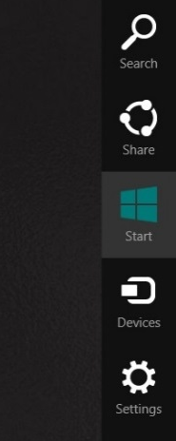
Figure 1: Charms Bar

- Click Settings to open the Settings Bar.

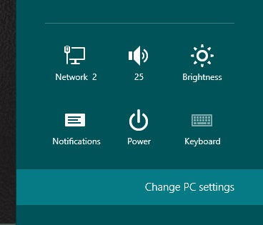
Figure 2: Settings Screen
- Click Change PC settings to open the Windows 8 Control Panel. Figure 6 shows the Control Panel for Windows 8 and Figure 7 shows the Control Panel for Windows 8.1.
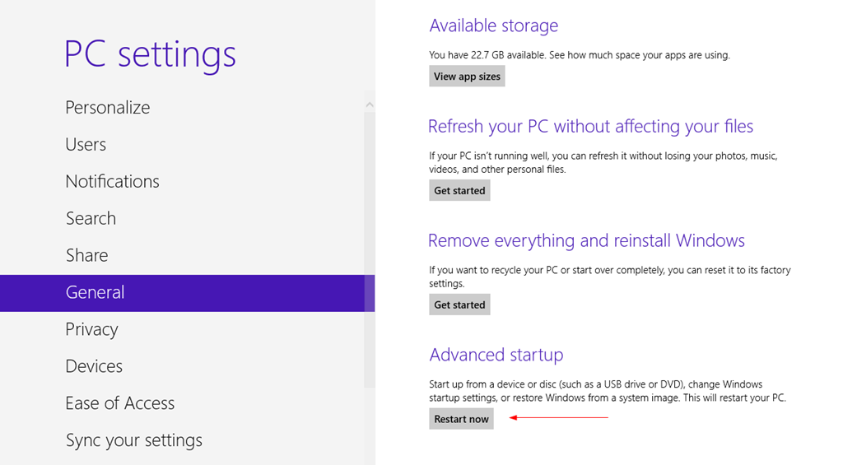
- Figure 3: Windows 8 Control Panel

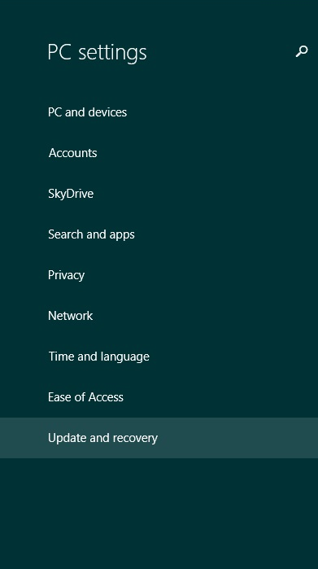
Figure 7: Windows 8.1 Control Panel

For Windows 8.1, choose Update and Recovery to open Update and Recovery ().
  - For Windows 8, choose General to show general settings, then click Restart Now.
- In Windows 8.1, click Recovery in the Update and recovery screen, then click the Restart Now button to restart your computer (Figure 9).
  - For Windows 8, after your computer reboots, choose the Troubleshoot option.
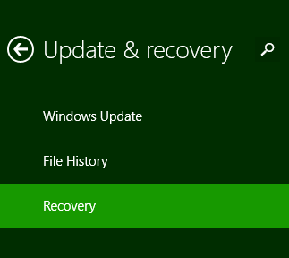
Figure 4: Update and Recovery (Windows 8.1)

Figure 5: General Settings (Windows 8)


Figure 6: Troubleshoot Option

- Click on Advanced Options.
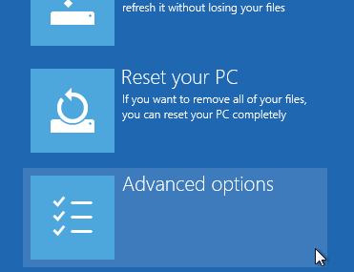
Figure 7: Advanced Options

- Click Startup Settings.

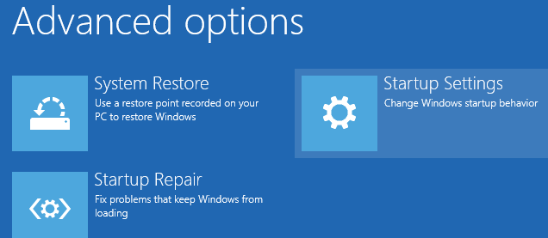
Figure 8: Startup Settings
- You will be asked to restart the computer one more time because we are changing boot options.
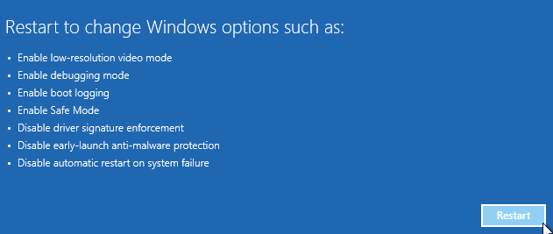
Figure 9: Restart to Change Boot Options

- Once the computer reboots, you will see a list of startup settings to change. Choose ‘Disable driver signature enforcement’ by pressing the F7 key on your keyboard.
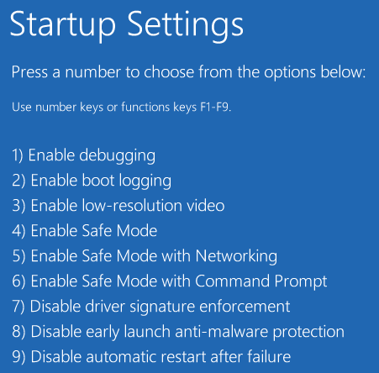
Figure 10: Startup Settings
- Your computer will reboot one last time.
This procedure enables you to install unsigned drivers to Windows 8 and 8.1 without an error message. If you attempted to install the SpeechVive driver before disabling driver verification, you will need to go back and 1) Disable the driver verification 2) check to see if you are running Windows 64-bit or 32-bit 3) Run DPInst if you have 32-bit or run DPInst64 if you have 64 bit. This will install the SpeechVive driver

Installation: Windows 7

Installing the SpeechVive Software
To install the software on your computer, navigate to the Volume folder on the provided USB drive. Double-click Setup (Figure 11), click ‘Yes’ to allow changes (User Account Control, Windows 7 or later), and follow the on-screen instructions. You may encounter several pop-ups during installation depending on the type of operating system you are using. Accept each pop-up and continue installation.
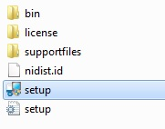
Figure 11: Setup

To find the application after install, navigate to C:\Program Files\SpeechVive. See Figure 12.
NOTE: If you’re on a 64-bit computer, navigate to C:\Program Files (x86)\SpeechVive. 32-bit versions of Windows do not have a Program Files (x86) folder.

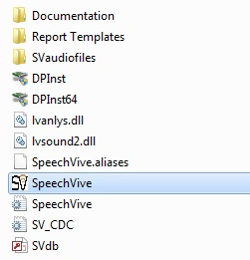
Figure 12: Application Location
To create a shortcut on the desktop, right-click on the SpeechVive application and select Create Shortcut from the menu (Figure 13). From here, you can also pin the application to the Taskbar and the Start Menu.

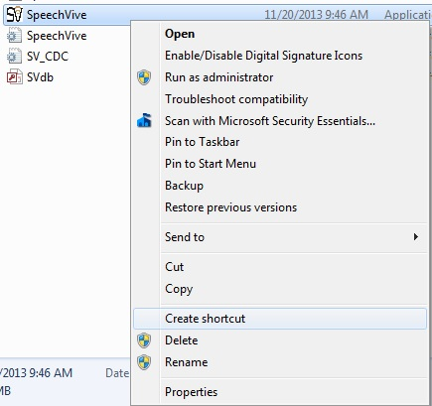
Figure 13: Create Shortcut

8.0 Prior to Your Patient’s Fitting Appointment
8.1 Unpack the SpeechVive System and the Clinician System
The SpeechVive Patient/User System includes the following:
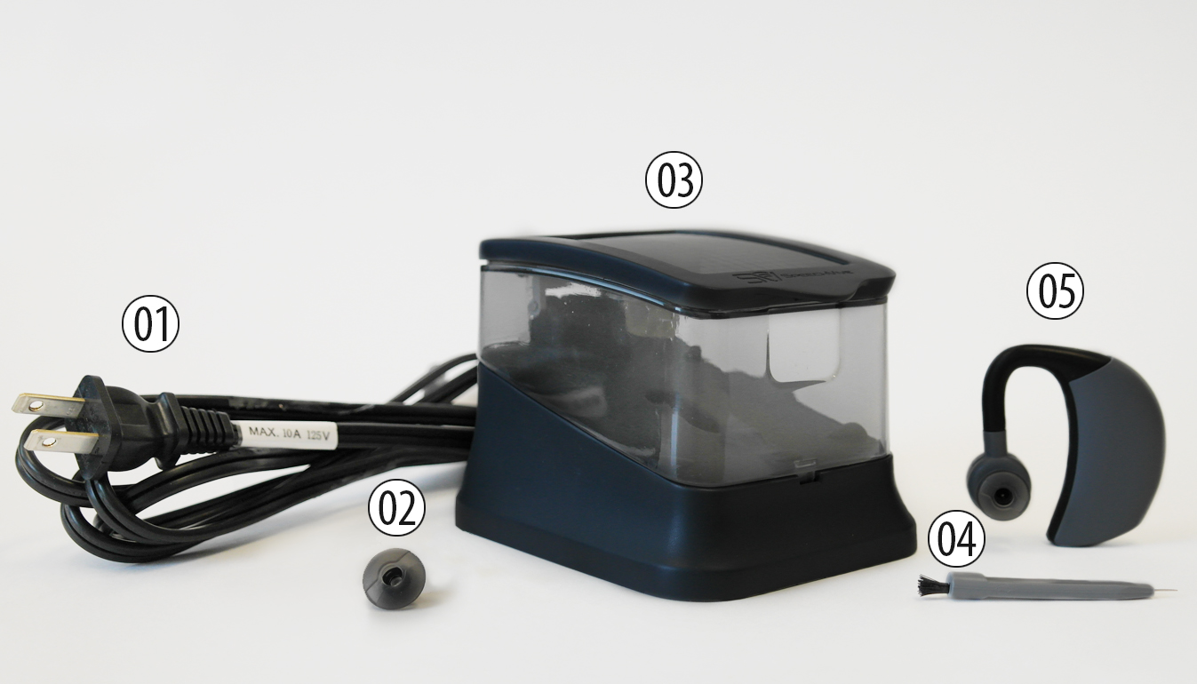
1- Power cord, 2 - Silicone Tips, 3 - SpeechVive Charging, Station, 4 - Cleaning Tool, and 5- SpeechVive.
The SpeechVive Clinician System includes a complete Patient/User System plus: following: Preamplifier (Mic Mate), head-worn microphone, SpeechVive Software, Preamplifier (black), Microphone clip, USB cord, Calibrator adapter, USB-A/USB-B cord. (See pages 7-9)

8.2 Become Familiar with SpeechVive
Take SpeechVive in your hands and become familiar with its shape, size, and components. This will make the fitting, programming, and putting the device on and off easier for you.
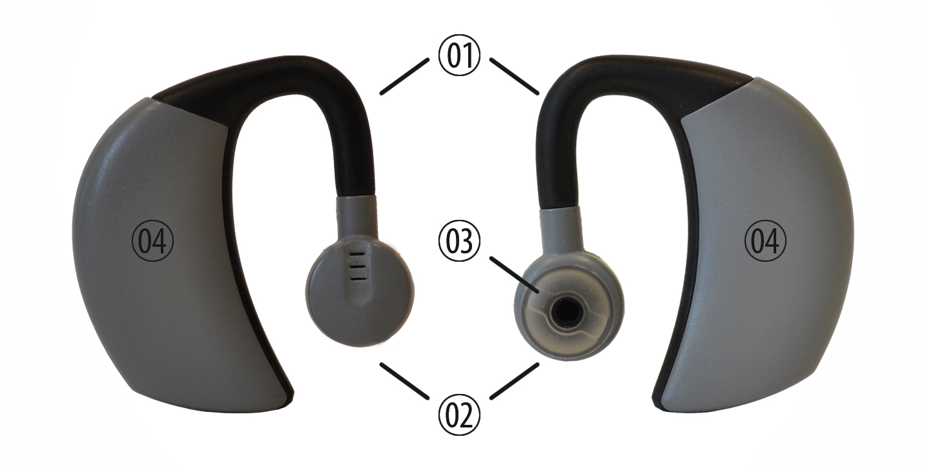

1- Bridge, 2 - Silicone Tips, 3 – Silicone Tips, Station, 4 - Body.

8.3 Charge SpeechVive 24 Hours Prior to Patient’s Appointment
When SpeechVive is delivered to your office, there will be little to no charge left in the battery.
- Place the charging station in an easily accessible location so you can plug and unplug the charging station with ease.
- Plug the end of the power cord that does not have prongs into the backside of the charging station.
- Plug the end of the power cord that has two prongs into the wall.

- Warning: Only use the power cord supplied with SpeechVive, if lost contact SpeechVive, Inc. for a replacement.

- The LED on the front of the charging station should turn blue.
- Place SpeechVive in the charging unit to recharge the battery:
  - Place the device in the cradle of the charging station. The body of the device should be toward the back of the charging station and the earpiece should be toward the front of the charging station.
  - When the device is placed in the charging station correctly, the LED will turn amber or green.
Note: If the LED does not turn amber or green, reposition the device in the cradle until it does. If the LED still does not turn amber or green please the Troubleshooting Guide on page 25.

  - Close the charging station lid gently and slowly and be careful not to pinch your fingers in the process.
  - When the LED on the charging station turns green the device is fully charged and can be removed from the charging station. However, if the battery is completely drained prior to charging, the LED may turn green for 5 minutes when the device is placed in the charger prior to turning amber. If this occurs, do not remove the device from the charger for 5 hrs.
Note: If the LED is amber, the device may still be used. However, the device is not fully charge and may not give the designed benefit to the patient for the intended time of use.

7.3 Become Familiar with the SpeechVive Software
The SpeechVive program has 11 features on the Main Menu page:
1. New Patient
2. Initial Evaluation
3. Follow-Up Session
4. Update Patient Information
5. Microphone Calibration
6. Log in
7. Log out
8. User Account Information
9. Update Practice information
10. Help
11. Exit

9.0 Fitting a Patient with SpeechVive
9.1 Quick Start Guide
Calibrate the microphone daily prior to seeing patients
- Remove the screen from the microphone
- Place the screen in a safe place as you will need to replace it on the microphone after calibration
- Place the end of the microphone into the calibrator and place them on a table. Do not hold the microphone or calibrator during calibration.
- Connect the head-worn microphone and preamplifer to an available USB port on your computer
- Open up the SpeechVive software, go to microphone calibration and follow the detailed instructions in the lower right portion of the screen.
- Remove the microphone from the calibrator and replace the screen
- The microphone is now calibrated

9.2 Detailed Fitting Process
9.2.1 Get the patient situated
- Have the patient in a chair comfortably close to the computer you will use to program the patient’s SpeechVive
- Ensure that the patient cannot see the computer screen as watching the programming may bias the fitting results
- Remove SpeechVive from the charging station
- Show the patient the components from the SpeechVive Patient System
9.2.2 Select the appropriate sized silicone tip to place on SpeechVive
- Three sizes of silicone tips are provided: Small (Plantronics Part #: 81292-02), Medium (Plantronics Part #: 81292-02) and Large (Plantronics Part #: 81292-03)
- Visually inspect the patient’s ear canal size
- Take the silicone tip that you feel will fit the best in the patient’s ear canal.
- Place the silicone tip on SpeechVive
  - In one hand hold the silicone tip between your index finger and thumb
  - In your other hand hold SpeechVive with the earpiece side facing up.
  - Line up the guides on the back of the silicone tip with the slots on the earpiece
  - Gently push the silicone tip into the earpiece and turn the tip 90° to lock into place
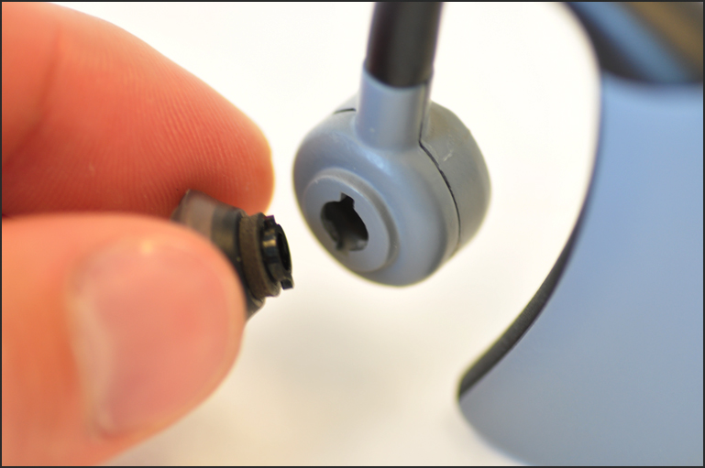
9.2.3 Have the patient put on SpeechVive
- The SpeechVive provided in the clinician kit will be for the patient’s right ear. When ordering a device for your patient you must specify if you want a device for the right or left ear.

  - Right ear: Have the patient hold the body of SpeechVive between their index finger and thumb or their right hand. If needed, have the patient use their middle finger along with their index finger on the top of the body to stabilize the device. With their left hand pull the earpiece slightly forward.
  - Left ear: Have the patient hold the body of SpeechVive between their index finger and thumb or their left hand. If needed, have the patient use their middle finger along with their index finger on the top of the body to stabilize the device. With their right hand pull the earpiece slightly forward.

- Have the patient place the body of SpeechVive behind their ear and place the bridge of the device over top of their ear. Make sure the bridge is between their ear and their head.

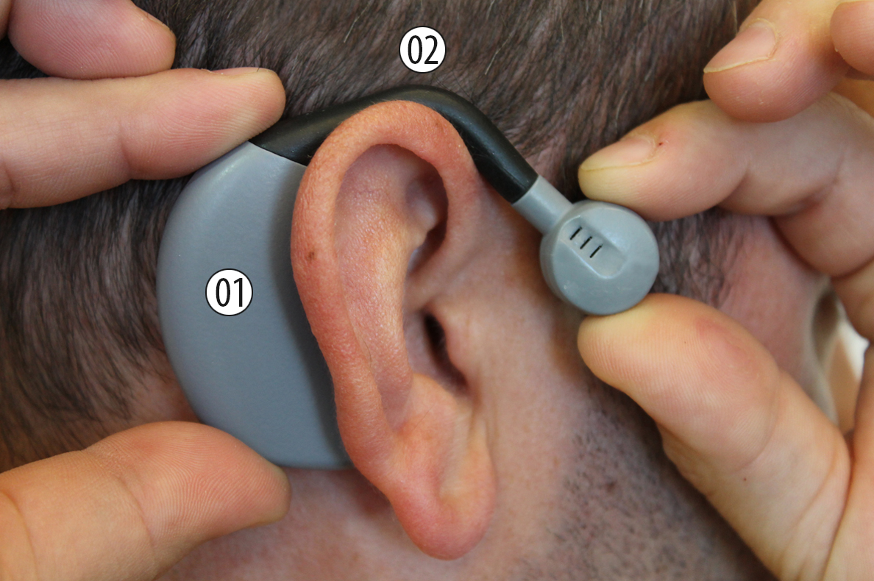
  - Have the patient place the silicone tip so it rests in the conch of their ear comfortably.

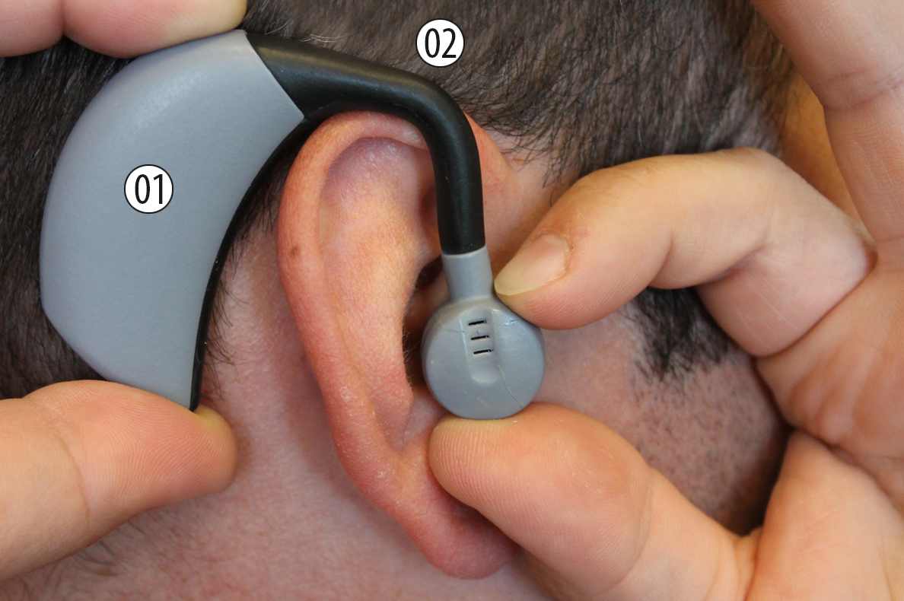

  - Have the patient adjust the bridge and silicone tip until it is secure.
  - Check to make sure SpeechVive does not feel loose with head movement or too snug.
  - If the fit is too loose or too snug, have the patient remove SpeechVive from their ear by grasping the body of SpeechVive and lifting it above the upper part of their ear with one hand while using their other hand to grasp the silicone tip and gently remove it from their ear.

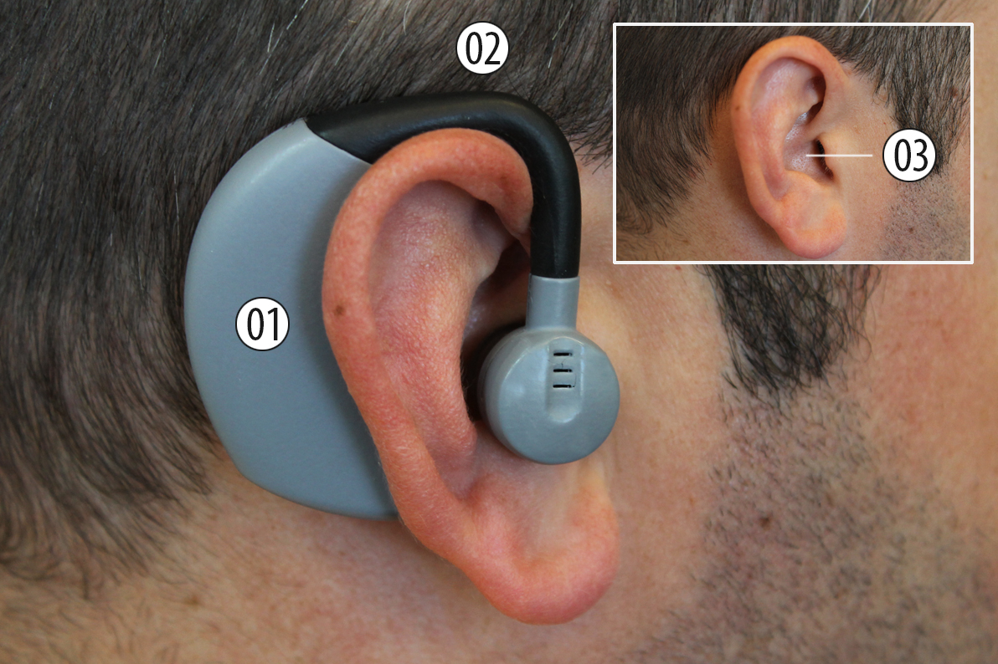

  - If the silicone tip seems too large or too small or you are having difficulty getting a secure fit, put the other silicone tip size on the device and have the patient place SpeechVive on in order to evaluate the fit once again
  - Once you determine the correct silicone tip size, turn to page 29 in the patient manual and check the appropriate box for the correct silicone tip size. This is what the patient will refer to in the future to order replacement silicone tips
  - The patient has successfully placed SpeechVive on their ear
  - Note: You or the patient does not need to turn on SpeechVive. It will automatically turn on when your patient begins speaking

- Have the patient remove SpeechVive from their ear at this time
  - Have the patient grasp the body of SpeechVive and lift it above the upper part of their ear with one hand while using their other hand to grasp the silicone tip and gently remove the earpiece from their ear
  - Place SpeechVive aside until further direction to put the device back onto the patient is given

9.2.4 Open the SpeechVive Software Program
- Determine the appropriate option: New Patient or Returning Patient.

  - New Patient: First create a new patient by going to the Main Menu and selecting the New Patient button. This information will be used later in your reports and to search for patient records.
  - Returning Patient: Login and enter the patient’s name or ID. Select the correct patient. Proceed to the SpeechVive Programming or Follow Up Tabs.

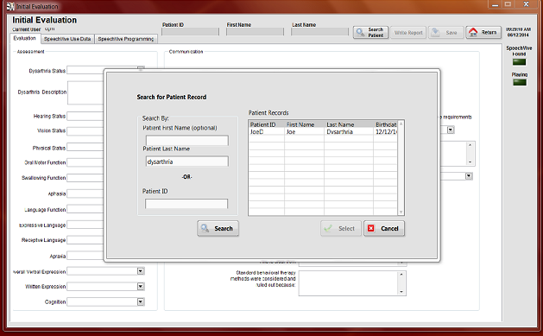
- Programming SpeechVive
  - Connect the head-worn microphone and preamplifer to an available USB port on your computer.
  - Login to the SpeechVive software.
  - Select the SpeechVive Programming Tab
  - Calculate the patient’s fundamental frequency (F0)
    - Place the head-worn microphone on the patient with the microphone 6 cm from the patient’s mouth.
    - Request that the patient makes an “Ah” sound for 5-10 seconds.
    - Once the patient holds the sustained vowel, press the “Set Patient F0” button.
      - This sets the patient’s fundamental frequency to the value shown on the program
      - If you feel this is not accurate, have the patient try again or you can manually override the automatic calculation by inputting the patient’s fundamental frequency
  - Calculate the patient’s sound pressure level (SPL) without SpeechVive
    - Ask the patient to discuss a topic for about 30 seconds
    - Toggle the “averaging button” from fast to slow to assess the patient’s SPL.
    - When ready press the “set patient SPL” to calculate the patient’s average SPL. You may press this button multiple times if you wish to recalculate the SPL.
    - The patient’s average SPL will be shown on the bar graph and also in the numeric indicator and is adjustable.
    - Press the up arrow next to the Avg SPL to Comfort label to record the average SPL value as the patient’s comfortable SPL (the level without the SpeechVive)
    - You will notice that a green line appears on the bar graph indicating the patient’s comfortable SPL
  - Set the patient’s target SPL
    - Click on “Set SPL” this will automatically set the SPL to 3 dB above the patient’s comfort level. You may also manually set the target SPL by typing a number into the “target” area (bottom right of the SPL bar graph) or using the up/down arrows to set the number. It is not recommended that the target SPL be set more than 5dB above the comfort SPL.
    - You will notice that a red line appears on the bar graph indicating the desired target SPL value for the patient.
  - Connect SpeechVive to your computer for programming
    - With your dominate hand carefully remove the USB cover, opening the rubber flap from the bottom of the SpeechVive body
    - Place the USB cover in a safe place as you will need to reinsert the USB cover after successfully programming SpeechVive
    - Plug the USB cord into an available USB port on your computer and the mini USB connector into the USB port on SpeechVive
  - Place SpeechVive on the patient (refer to pages 25-26 for proper handling and placing instructions)
  - Clip the USB cord to the patient’s shirt with the microphone clip provided in the Clinician System. This will lessen the weight of the cord on SpeechVive and the patient’s ear.
  - Set the sensitivity threshold
    - Set the “speaker output” level of SpeechVive to 40-45 dB or loud enough to hear the babble and check speaker sensitivity.
    - Have the patient talk about a topic of their choice with you at a comfortable level
    - Watch the green LED light and adjust the sensitivity up and down until the green light only comes on when the patient is speaking
  - Increase the “speaker output” level so the patient is increasing their average SPL to the targeted level on the SPL Meter bar graph

10.0 Changing and Cleaning Silicone Tips
10.1 To remove the silicone tip
- Gently push the silicone tip into the earpiece
- Turn the tip 90°
- Gently pull the silicone tip free of earpiece
  - To place a new silicone tip on the earpiece
- Line up the guides on the back of the silicone tip with the slots on the earpiece
- Gently push the silicone tip into the earpiece
- Turn the tip 90° to lock into place
- Dispose of the previously used silicone tip, immediately. By themselves, silicone tips may pose a choking hazard to you, others, and pets.

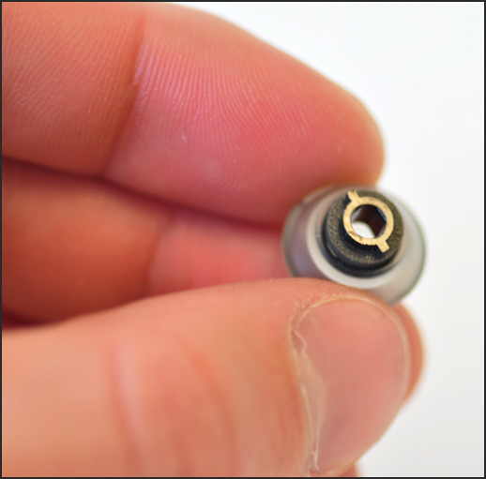

10.3 To remove ear wax from the silicone tip
- Remove the silicone tip from the earpiece as shown on page 31.
- Note: you need to press the silicone tip gently while turning it in order to remove the tip
- Use the loop cleaning tool to gently scrape ear wax from the inside of the silicone tip
- Use a soft dry cloth to clean the outside of the silicone tip and to clear excess debris from the device
- Place the silicone tip back onto the earpiece for use
- Warning: Silicone tips pose a choking hazard, use caution when removing and placing silicone tips back onto the device.

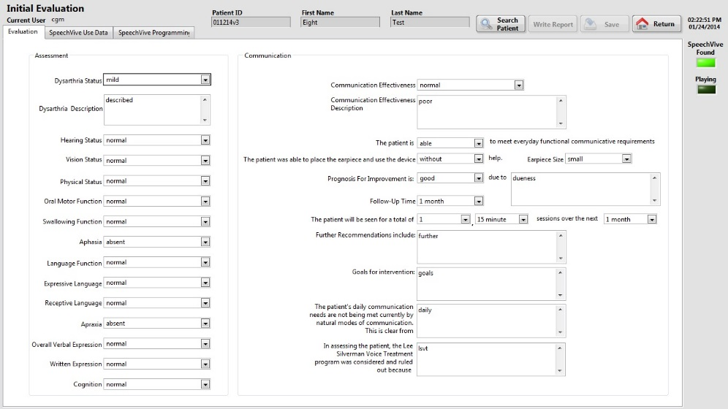

7.3.5 SpeechVive Use Data
This tab contains two graphs that display the usage data from the memory log of SpeechVive.
- SpeechVive Intensity vs. Date
This graph provides the clinician with information on when during the day the user is speaking the most.

- Total Use vs. Date
This graph allows the clinician to tell how many minutes per day the device played.
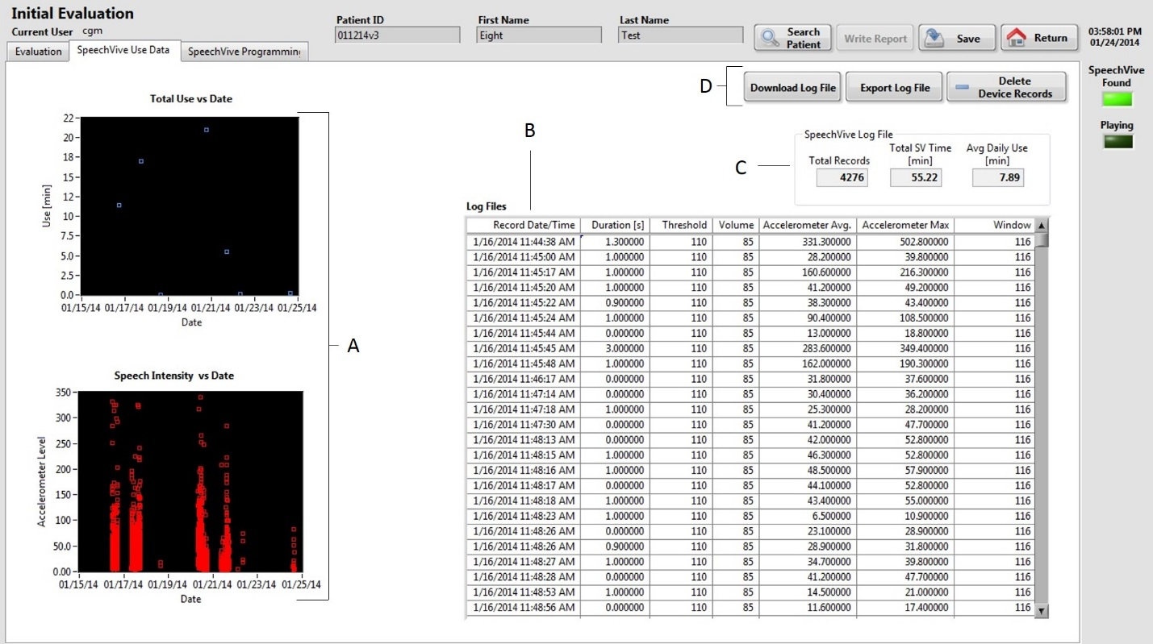

7.3.6 Write Reports
This button is used to generate reports for the patient’s file. The reports can be generated as an evaluation report or a follow-up report but you MUST use this feature during the session. After you have saved and closed the Evaluation or Follow-up session you cannot go back and generate a report. The Write Report button can be found in the margin on the top left, between the Search and Save buttons.

7.3.7 Clinician & Practice Information
This page contains the clinician and practice information including name, address, degree, ASHA certification number, and state license number. This information can be saved and reloaded so it doesn’t need to be filled in each time the program is opened. This information is used to auto populate the reports for the patient file. To access this page go to the Main Menu and click on the Clinician Information button.
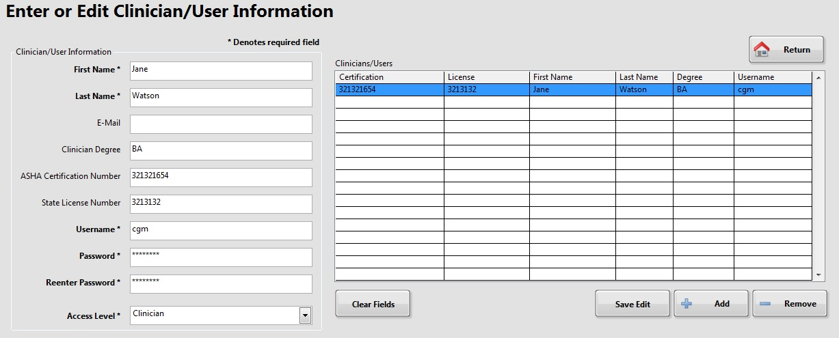
7.3.8 Help Information
This button contains references for troubleshooting and other informative documents. To access the help folders go to the Main Menu and click on the Help button at the bottom of the page.

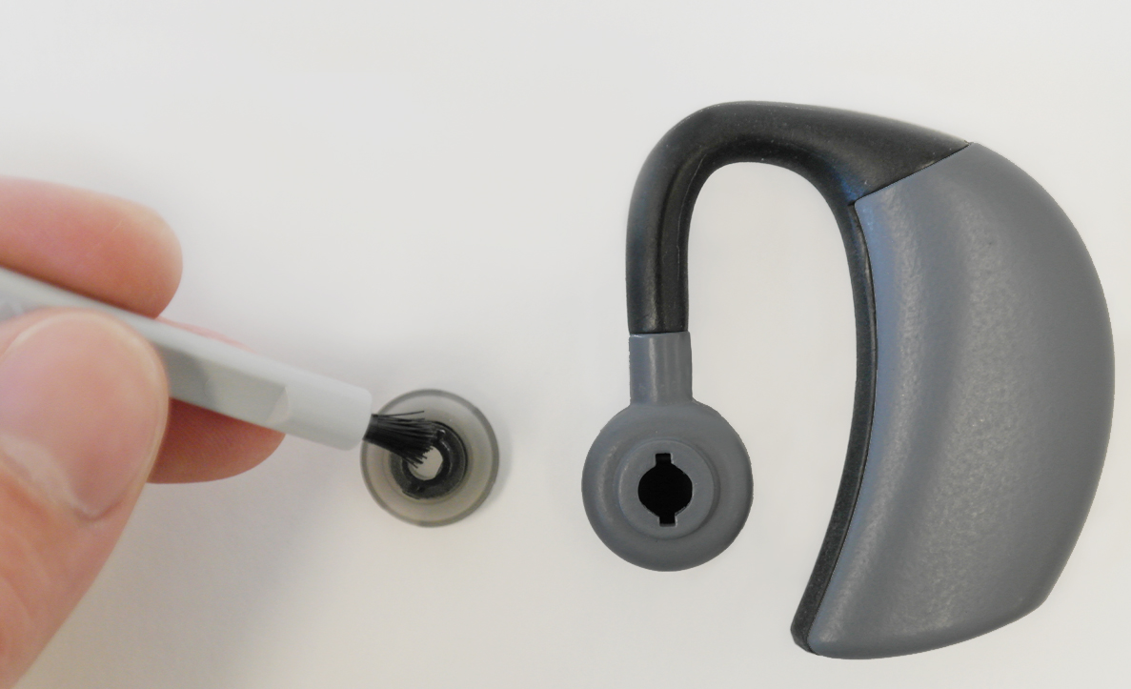

11.0 Frequently Asked Questions
How much gain is too much? We recommend increasing target SPL by 3-5dBL per session. Any more and you can over tax the voice.

Who is a good candidate for SpeechVive? A good SpeechVive candidate will have a diagnosis of Parkinson Disease and will have experienced changes in their voice that may include; decreased volume, increased rate, or poor articulation. Others may perceive your speech as too soft, too rushed or mumbled.

Does SpeechVive work for patients with DBS? Yes. SpeechVive has been proven to increase clarity and volume for patients who have had DBS.

Does SpeechVive work for patients who have already had other types of voice therapy? Yes. Patients who have already completed a speech therapy program can still benefit from SpeechVive.

Can SpeechVive work on patients with cognitive decline? Yes. SpeechVive does not require the wearer to think about their speech so it works well with wearers who may experience cognitive decline.

Can people who are aphonic use SpeechVive? No. People who are unable to achieve voicing are not candidates for SpeechVive.

13.0 Troubleshooting
Device Not Recognized.
Give the program a minute to find the device, recognition may not be instantaneous. If the software doesn’t find the device after 1-2 minutes unplug the device, quit the SV program, and restart the process.

Device Not Working.
Start the SpeechVive software and plug the device into the computer. This may reset the device.

Device Not Charging.
Check to make sure all charger’s cord is plugged into an outlet and securely plugged into the back of the charger. If the LED does not turn amber or green, reposition the device in the cradle until it does. If the LED still does not turn amber or green please call SpeechVive for additional assistance.

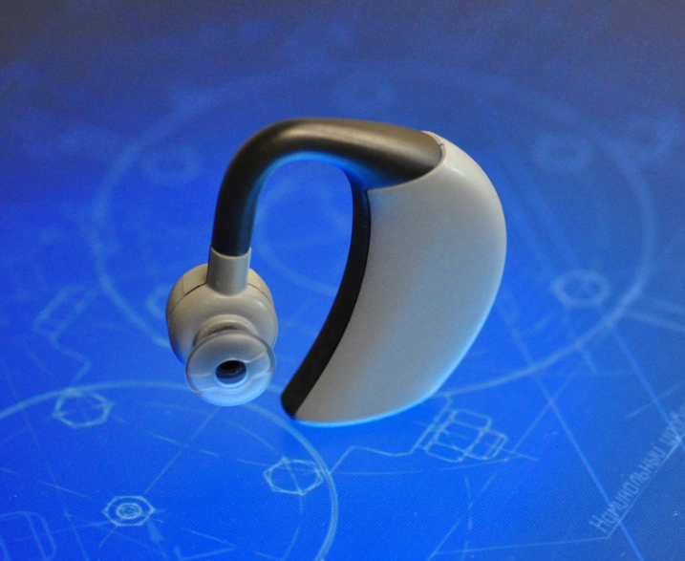
14.0 Technical Information
SpeechVive is worn over the ear and contains an accelerometer that detects when a patient speaks. Upon exceeding a threshold value, indicating that a patient is speaking, SpeechVive plays background audio that subconsciously improves the patient’s speech clarity. SpeechVive does not play the background audio when the patient is not speaking. The SpeechVive accelerometer sensitivity settings are programmed by that patient’s speech-language pathologist. The SpeechVive Charging Station and Earpiece is classified for Continuous Operation.
- The SpeechVive Charging Station is classified as Class II ME equipment and is externally powered from a 100-240 Vac, 50/60 Hz, 150 mA max AC Mains power source.
- The SpeechVive Charging Station output is rated at 5.1 Vdc and 250 mA Max.
- SpeechVive is classified as internally powered ME equipment as it is powered by an internal 3.7 Vdc Lithium Rechargeable Battery.
- SpeechVive is a Type B applied part.
- SpeechVive enclosures are classified as IPX0 for dust and water protection.
- In order to isolate the SpeechVive Charging Station from the supply mains, disconnect the power cord.
- SpeechVive should be stored or transported in a safe, dry, environment not exceeding 41 °C. When SpeechVive is not in use SpeechVive should be kept in the charging station provided for safe keeping when possible.
- The sound output from SpeechVive may range from 0-120 dB This output level is programmed by the patient’s SLP.
- For disposal follow local code requirements for proper equipment disposal and/or for recycling of the SpeechVive Charging Station and Earpiece containing an internal Lithium Battery.

15.0 Symbols Used in Labeling
The following symbols may be found on the SpeechVive and Charging Station labels. These symbols tell you about the proper and safe use of the SpeechVive System. Some of these symbols may not have meaning in your regions and are listed for informational purposes only. Refer to the table below for the meaning of each symbol.
Symbol | Meaning
 | Serial Number
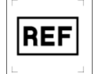 | Part Number, Catalog Number
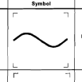 | Alternating Current
 | Marking certifies that the device meets the European Council Directive
 | Direct Current
 | General Warning Sign
 | Class II Equipment
 | Type B Applied Part
 | Refer to Instruction manual

Appendix



FILL IN WITH PATIENT MANUAL ONCE FINALIZED

