Coupons for Dominos

Web Application Processes

Table of Contents
Main Screen 1
Flow 1
Process 1
Store Process 3
Flow 3
Process 3
Coupon Screen 5
Flow 5
Process 5
Submit Coupon 6
Flow 6
Process 6

Main Screen

Flow
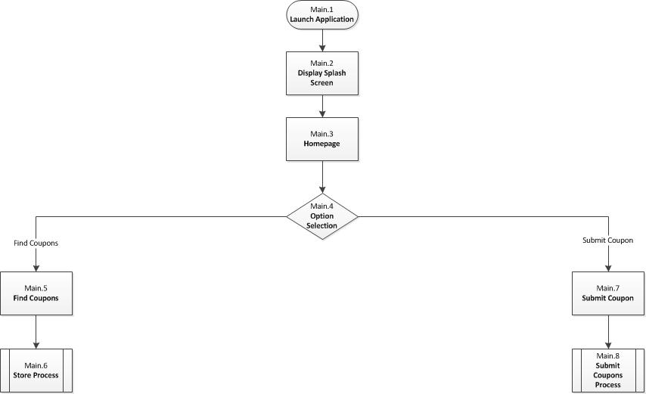

Process

Step | Completed By | Description | Next Step
 | User | User launches the application from their phone. | Main.2
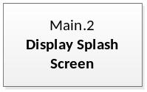 | Application | Application displays the splash screen. | Main.3
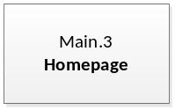 | Application | Application displays the Main screen. | Main.4
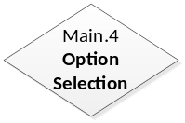 | User | User needs to selects the function required. | Find Coupons: Main.5  Store Process: Main.7  Find Coupons: Main.9
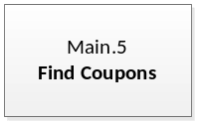 | User | User selects Find Coupons function. | Main.6
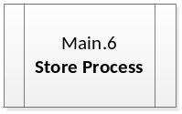 | Process Flow | Process Flow moves to Store Selection process. | Store.1
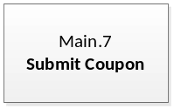 | User | User selects Submit Coupon function. | Main.8
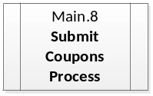 | Process Flow | Process Flow moves to Submit Coupon process. | Coupon.1

Store Process

Flow
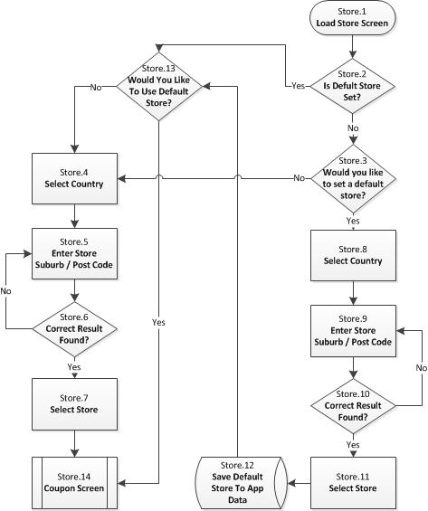

Process
Step | Completed By | Description | Next Step
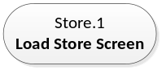 | Application | Load the Store screen. | Store.2
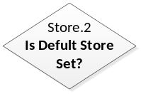 | Application | Has the user previously selected their default store? | Yes: Store.13  No: Store.3
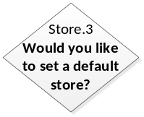 | User | User to select if they would like to select a default store. | Yes: Store.8  No: Store.4
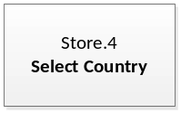 | User | User must select the country that the store they would like to use is located in. | Store.5
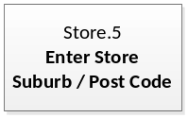 | User | User must select enter the suburb or post code of the store they would like to use. | Store.6
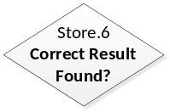 | User | If the correct store is not found the user will need to delete the current information they have put in and start again. | Yes: Store.7  No: Store.5
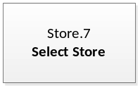 | User | User to select the store that they would like to use. | Store.14
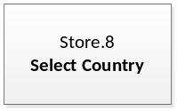 | User | User must select the country that the store they would like to use as a default store is located in. | Store.9
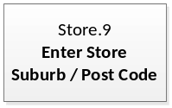 | User | User must select enter the suburb or post code of the store they would like to use as a default store. | Store.10
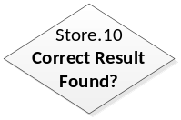 | User | If the correct store is not found the user will need to delete the current information they have put in and start again. | Yes: Store.11  No: Store.9
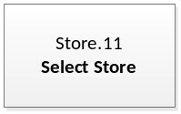 | User | User to select the store that they would like to use as a default store. | Store.12
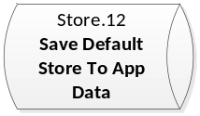 | Application | Application saves the users selection directly on the phone in the applications files. | Store.13
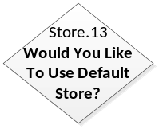 | User | User to select if they would like to use their default store. | Store.14
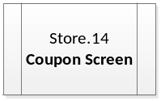 | Process | Process flow moves to Coupon screen. | Coupon.1

Coupon Screen

Flow
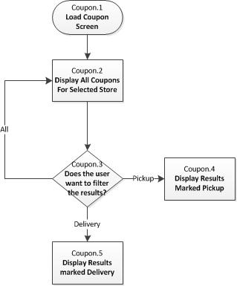

Process

Step | Completed By | Description | Next Step
 | Application | Load Coupon screen. | Coupon.2
 | Application | Display all coupons for the selected store. | Coupon.3
 | User | User to select a filter if they want it. | Pickup: Coupon.4  Delivery: Coupon.5  None: No Movement
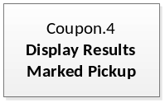 | Application | Display pickup coupons only. | No Movement
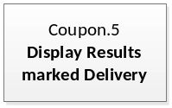 | Application | Display Delivery coupons only. | No Movement

Submit Coupon

Flow

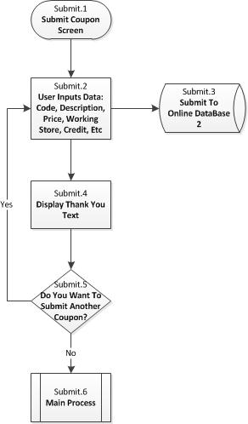

Process
Step | Completed By | Description | Next Step
 | Application | Load Submit Coupon screen. | Submit.2
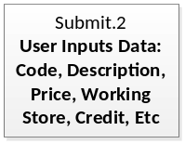 | User | User to fill in all fields in form. | Submit.3
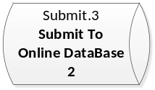 | Application | Submit form to Database 2. | Submit.4
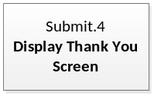 | Application | Display thank you text. | Submit.5
 | User | User to select if they want to submit another coupon. | Yes: Submit.1  No:Submit.6
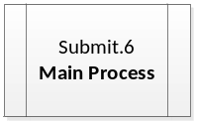 | Application | Return to Main screen | Main.1

