Colors
#B3B366 TEAL
#008080 BROWN GOLD
#222e53 DARK BLUE

Fonts
1. Something like “Gothic Ultra” for “Trinity House Café.” The font you choose should be a little thinner and taller than Gothic Ultra, if possible.

2. Choose another font you think goes well #1 for the tagline, “a little bit of heaven”

Description of Logo Owner Wants
Teal oval shape with name and tagline inside. The “H” in house should look like a very simple house (see example below).

A subtle cloud shape with sun rays coming out from behind.

A few four-point stars that are light and thin.

Design Guide
This is just a guide to show you where she wants items placed—obviously, your design will be a million times better!

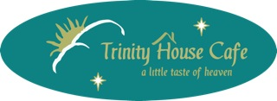

Inspiration for Stars and Suns
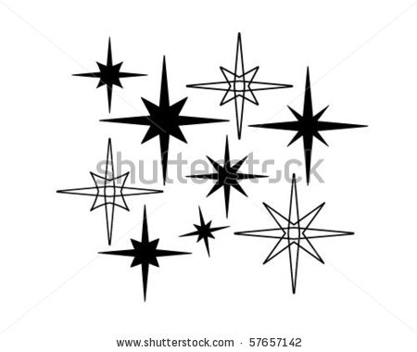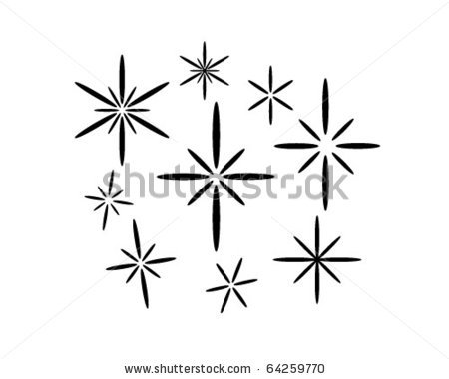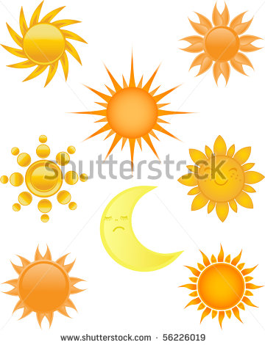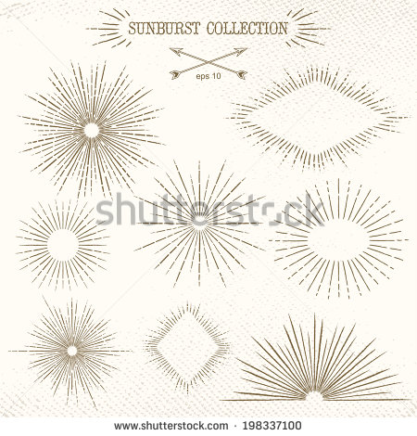
Bottom right sun

