Identity Project background briefing

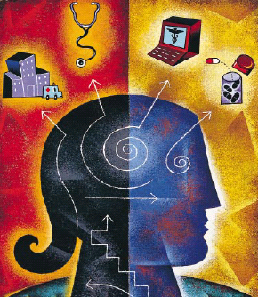

For a patient, the Person Centered Medical Home practice operates as the central hub for their health care information, providing both primary care and care coordination across different health care settings

Corporate identity project 3
Purpose of document: 3
The heart of our vision 3
Putting a compelling idea at the heart of Caresentral 4
Great brands put the consumer at the heart of the experience 4
Traditional ways of expressing care 5
Design Projects 6
Priorities 6
Company Details 7
Living longer… living better 8
The ageing of Malaysia is an opportunity for us 10
Our focus - Care on the home front 11
Caresentral connecting care providers 12
Caresentral - new paradigm for community care delivery 13
Principals - we adopt to deliver services 15
Person-centerd 15
Comprehensive 15
A Team aligned with your needs 15
Accessible 15
Coordinated 15
Committed to quality and safety through systems approach 15
Our mission statement 16
What we’re trying to do: 16
Our core values 16
Our Strategy 16
Our strategy incorporates 17
We understand our users will 17
How we describe ourselves commercially 18
Social Media 19
How we will deliver services 20
The services we deliver 21
What our competitors look like 24
Nurse Station 26
Branding Touch-points 29
Caresentral branding reflects : 29
Images, color, expression: 30
Shopfront Visibility 35
Interesting facts about ageing 36

Corporate identity project

Purpose of document:

Through this document we hope to provide a background to our business, examples of the market we seek to enter, how we seek to carry on our business and examples of how we like to explain what we do and what’s important to us. We are looking for innovative ways to express this.

This project – Priority 1 is to achieve

- Logo for Caresentral
- Branding / Logo for Nurse Station

The heart of our vision

At the heart of our vision is a desire “to be recognised as the world leader at innovatively connecting and delivering healthcare”. As such, our mission is “to improve healthcare by delivering a next generation of care to the benefit of citizens and healthcare professionals”.

Ultimately this mission is both very broad and rational and we need to go further. This is particularly important as the stakes are high in the healthcare industry – trust and integrity are critical components in this industry.

We believe that this requires the need to go beyond the functional expertise that describes what we do and articulate a clearly defined perspective on how healthcare should be.

This will enable us to transform from being just a name into something with meaning and value for all stakeholders - a brand with a resonant, category-leading perspective, based on an idea that can truly energize the business.

Our services and solutions provide a unique patient experience. Indeed, it puts the patient at the center of the journey by managing and orchestrating the information around them. It manages and protects the patient’s unique identity through this journey. This is particularly relevant in today’s institution-centric healthcare environment in which individuals are dependent on ‘strangers’ for some of the most crucial and intimate moments of their lives.

Despite technological advancements, the experience of the patient today is a disjointed and often exasperating one. The patient is left to wade through a sea of systems and bureaucracy at a time when their emotions are elsewhere. As institutions work through their own processes and procedures, the patient is reduced to a series of numbers on a page, a set of lab results, a pair of x-rays, or a ranking on a board. What’s left is a hazy and fragmented picture of the individual.

Caresentral is in a unique position to help move modern healthcare towards a more individual-centric model, a model which is future-looking, but also returns emphasis to the patient – empowering the most important person in the healthcare journey.

Caresentral’s technology puts the patient at the center again. Like a gyroscope the systems built up around the patient will continue with varying levels of complexity and movement, but at the center, where the patient is and where the practice of medicine take places, there will be still and calm, thanks to the technology we use.

Putting a compelling idea at the heart of Caresentral

At the core of the Caresentral brand is a commitment to human-centric care delivery: care and technology that puts the patient at the heart of the experience. What the software does in its simplest terms is to allow each and every carer to see the patient with crystal-clear clarity, placing an individual before them along with their own unique identity.

And whilst Caresentral cannot necessarily provide (claim to) a superior healthcare experience, it can provide a superior patient experience because we are driven by the idea that the patient should sit at the heart of their experience of healthcare rather than be alienated or atomised by the systems and processes we have built up around modern healthcare treatment.

This idea projects the notion that Caresenral provides a more patient-centric experience, but it will have broader relevance and resonance. The various institutions and personnel who work with hospitals and GPs are ultimately concerned with providing a more human experience of healthcare. Whilst our competitors may only speak about services, products or functionality, ‘Humanising Healthcare’ appeals to the higher and shared sentiment of making healthcare better. Whether you are a physician, nurse, IT specialist or healthcare advisor, ‘Humanising Healthcare’ recognises a global ambition that the industry has of making the experience of healthcare more personal and more tailored to the individual. In so doing it becomes the rallying cry for a philosophy of more personal healthcare that is pertinent to the entire industry.

Above all, it creates a brand that connects with people, which is the trait of all great brands……..

Great brands put the consumer at the heart of the experience

Great brands are built around people. So much so that the strongest and most iconic ones tend to behave like people. They have a distinct language, use unique imagery, and encourage the creation of communities of consumers, some of whom become loyal devotees. Think about the Mercedes owner who has only ever driven a Mercedes – and there are a lot of them. What these brands stand for not only helps create lasting emotional connections with consumers but also helps them appear to behave in a way that feels more intimate.

Of course, any brand idea has to co-exist and indeed direct and inspire the core expertise within the business and the functionality it delivers, but at the end of the day it is the idea that lies at the heart of the brand that provides the foundation stone.

Traditional ways of expressing care

Ultimately, whilst we are not necessarily presenting ‘Humanising Healthcare’ as a corporate strapline, we do think we need to question the traditional ways of expressing care through images of devices, needles, and sick people.

We are not locked into any specific look and feel or colors to express what we do. We are however conscious of the culture, values and attitudes to colors, numbers and images of the Asian markets we will initially focus on.

In developing our longer-term strategy, we appreciate:

- Our identity, branding, channels to market and priorities are evolving

- We have a need to reflect a corporate, business image to our investors, corporate partners and the established medical community. Whilst reflecting to our clients an image of :

- Compassion* | Focusing on our Clients
- Integrity | Delivering Quality
- Collaboration | Caring within Communities
- Responsibility | Ensuring Best Practice
- Innovation | Enabling Accessibility

It may be considered to have images (business cards) that carry a corporate image and ones for nursing (care) staff that carry a separate image, branding.

- Our initial clients are the elderly, however decisions to select our service may be made by or in conjunction with their children who will more than likely be well educated, high income earners, social media savvy and TIME POOR. We need to reach out to both

- In the longer term our market will be the current educated, high income earners, social media savvy people

- We need to be agile and adopt an execution strategy that gets us into the market as soon as possible

- We are conscious the market is highly segmented ranging from the worried well through to the chronically ill, through to seniors and those who are in the last days of their life

- We have limited funds and need to prove our capability in the market before further funds can / will be sourced

Design Projects

Priorities

Priority 1

- Corporate logo Carestation
- Brand Logo / Colour Nurse Station

Priority 2
- Business Card
- Letter Head
- Face book cover page
- Brochure / Flyer Template
  - This will be used as an interim product brochure / flyer. There will be a number of products which will need flyers / brochures. The concept is to have common template, where the overall color might change for each product and we drop in text to represent the product being described. There could be one or two sections that have callouts that we drop text into . A common contact us / address area. Two sides A4.

Ideally the same designer would then go onto develop the remaining priorities.

Priority 3

- 1. Style guide
- 2. Graphics Design
- 3. Web Design

Priority 4

- Web / Print design
- Brochures web and print
- Quick call to action material

Priority 5

- Portal selection and prioritized implementation of WEB presence

Company Details

Company Name: Caresentral (Malaysia) Sdn Bhd

Domain: caresentral.com

Headquarters: Kuala Lumpur

Living longer… living better

The majority of the healthcare delivery systems in the developed world are a product of the 1950’s when the prime focus was on doctors, acute disease and hospital care.
Owing mainly to explosive advances in diagnostic and interventional medical services over the last several decades, most patient care, research, and educational; efforts have been directed toward in-hospital medicine.
The healthcare system as we know it, is set up to focus on treating people once they have a problem – “sick care“ instead of health care.
The treatment of the patient in the protective, highly sophisticated hospital environment is usually but a small fragment of the continuous process of patient care. It is the more vulnerable, out-of-hospital, ambulatory setting to which major medical efforts must be directed to enable the patient to follow a normal life routine.
Only recently have the realization of this imbalance and the prohibitive rise in medical expenditure caused a change in this trend, and efforts at out-of hospital ambulatory patient care are gaining increasing momentum.
As cost and quality issues increasingly drive the delivery of care away from institutions (hospitals) and towards community care settings the importance of a health information and communications infrastructure to support the health professionals and the newly empowered citizen will become an increasingly important component of care delivery.
This capability will be developed through empowering patients through access to healthcare information, advice and guidance, enhancing the linkage and trust between the patient and their health professional and facilitating the delivery of care to a patient located in the community whilst supporting the health professional who has to deliver and monitor care.
Caresentral will provide value added services to engage the citizen & clinician as lifelong partners to improve the quality and efficiency of care delivery in the community. Healthcare any where, at any time from multiple sources.

The care spectrum we will cover
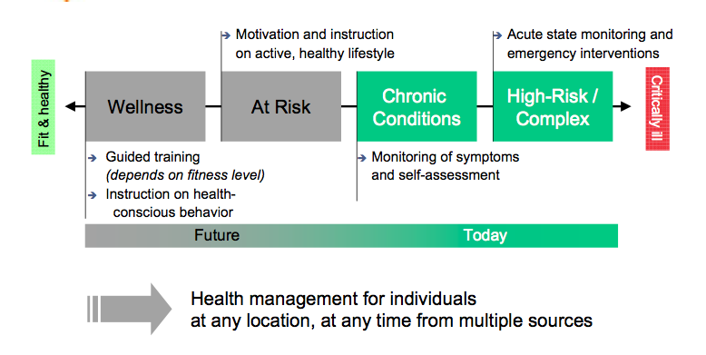

The ageing of Malaysia is an opportunity for us

Aged care is fundamentally about ageing well, supporting people to remain independent and socially engaged.

The ageing of Malaysia’s population is a profound social shift, which requires an equally profound shift in society’s mind set about ageing.
At present, the number of Malaysians aged 60 years and above is estimated to be 1.4 million and is projected to increase to 3.3 million in the year 2020. The percentage of the population that is 60 and over has also increased over the years – 5.2% in 1970, 5.7% in 1990 a dn6.3% in the year 2000. In the year 2020 this percentage is expected to be 9.8% of the population. Between 1990 and 2020, the population of Malaysia is expected to increase from 18.4 million to 33.3 million – an increase of 80%. The aged population however os expected to increase from 1.05 million in 1990 to 3.62 million over the same period, an increase of 210%
Malaysian’s can now expect to have an extended period of healthy, active retirement that was unimaginable in the past. Our challenge is to make sure that as Malaysians live longer, they continue to lead happy, healthy, productive and connected lives. Older Malaysians have the energy, experience and wisdom to contribute to business, to education and to the community, and we need to be more creative in the way we encourage and support these contributions.
Growing older does not dampen dreams and aspirations, we (not just Government) must all strive to build systems and services that cater for the changing needs of the older population.
The elderlies are less healthy then the young’s, hence an increase in the proportion of the aged groups is associated with an increase in the prevalence of ill health. The physical and social changes associated with ageing are combined with the debilitating effects of multiple acute and chronic diseases. Frailty is often compounded by problems such as urinary incontinence, instability, falls and acute confusion states. Consequently, multiple pathologies resulting from multiple systems are a common phenomenon in the elderly.
Today, too few people are able to access care and support in their own home where they want it, not enough nursing homes are being built, employers are having trouble recruiting and keeping aged care workers.

Our focus - Care on the home front
Care by friends and family is becoming a well-recognised source of support for our ageing or vulnerable population with a growing emphasis on home-based care.
On the home front, a major cause for concern for many families is caregiving. Coming from an Asian society that values filial piety, it is usually taken as a given that children will look after aged parents. However, with families becoming smaller and the gradual erosion of the joint family, this may become more difficult than anticipated.
The financial and physical burden of taking care of an elderly (and in some cases, two or more) parents could well prove to be beyond the children’s means (from a capacity to allocate the time and or financial). After all, we have cases of the elderly being abandoned at old folks’ homes or hospitals.
The health of older Malaysian’s is one of the most important medical and economic challenges facing Malaysia. Healthy, older Malaysians are less likely to leave the workforce for health reasons, and are more likely to enjoy retirement, with fewer health-care needs and less chronic disease and disability, hence placing less pressure on the national health economy.
Effective and sustainable home care reform requires a whole-of-system approach that involves the following key stakeholders operating as ‘partners in care’:
Care recipients
- carers
- Professional care workers
- Healthcare professionals
- Government.

Caresentral’s intention, linked to government programs (policy) and collaboration with ‘partnering’ organisations, is to implement a proactive model whereby seniors under home care conditions have their needs ‘managed’ and future complaints anticipated and prevented (where possible) by a disciplined, quality based care approach, which assures those who need care and those who struggle with the burden of caring for their loved ones an environment of reliable, pro-active, personal care is available
Often referred to as “Active ageing” or “ageing in place” this approach allows people to realize their potential for physical, social, and mental well-being throughout the life course and to participate in society, while providing them with adequate protection, security and care when they need.
Active ageing is the process of optimizing opportunities for health, participation and security in order to enhance quality of life as people age. It applies to both individuals and population groups. “Active” refers to continuing participation in social, economic, cultural, spiritual and civic affairs, not just the ability to be physically active or to participate in the labour force. Older people who retire from work, ill or live with disabilities can remain active contributors to their families, peers, communities and nations. Active ageing aims to extend healthy life expectancy and quality of life for all people as they age.

Maintaining autonomy and independence for the older people is a key goal

Caresentral connecting care providers

Malaysians with disabilities, temporary or long term impairment or simply ageing clearly want to remain in their own homes for as long as possible as their care needs increase.
Our plan is to create a flexible and seamless care system that provides Malaysians with more choice, more control and easier access to a full range of services, where they want it and when they need it.
Malaysia’s community and aged care is an ecosystem with many different players and voices. Many types of service providers make up the complex Malaysian health, community and aged care system including a range of medical practitioners, allied health professionals, hospitals, clinics, and other government and non-government agencies, not to mention non-clinical services such as cleaning or other home maintenance tasks.

While there are many programs that provide a range of support services in the home, these programs are often fragmented and inconsistent, leaving vulnerable and older people and their families confused and not always being treated fairly as their needs change.
Our plan is to create a flexible and seamless system that provides Malaysians with more choice, more control and easier access to a full range of services, where they want it and when they need it.
Most individuals are closely connected to the health system via their primary care practice and their primary care provider is viewed as an entryway to the complicated world of health and healthcare for patients, families and consumers alike.

Ground in the longer term healing relationship between primary care provider and patient, Caresentral vision is one where the door of a primary care provider opens in both directions: one focused on compassionately treating illness and injury when it occurs, and the other focused on prevention and wellness, and even the social and physical environments in which we live and work.

In planning the services we will offer, we have taken account of the needs of Malaysian’s, the business imperatives of care providers and the Government’s commitment to ensure the best possible systems and support for the future.

Caresentral - new paradigm for community care delivery

Caresentral plans to establish a new paradigm by reframing the delivery of care in the community for the increasing number of Malaysians:

- facing chronic diseases
- those who have a heavy reliance on carers or family for organisation/management of their social and medical care and;
- senior citizens who increasingly choose independence and living in their own home

Caresentral provides an individual and his/her family with a single contact for healthcare and community service needs.

We’ll link you to doctors, and you’ll be guided by your very own support team that works together to create your individualized plan of care.

We make it easy to get better healthcare by coordinating your treatment across all of your providers – whether at home, an outpatient office or in the hospital.

Caresentral’s health services “navigators” will link you to your Care Coordinator, to doctors, physiotherapist, and serve as a support team whenever you have questions, need guidance or assistance in managing your care. We make it easy to get better healthcare by coordinating treatment across all providers – whether at home, an outpatient office or in the hospital

Find the care you need
Care Central is the place you can turn if you:
- are not feeling well
- need a doctor
- need support at home
- need medical care at home
- have health questions
- need mental health services
- need help with medications
- need referrals to specialty services (e.g., dental care, diabetes management, nutritional support)
- have social service needs (e.g., transportation, housing, food);

Health Navigators are there when you need them to help with healthcare, housing and other services that keep them healthy and well. Our Care Navigators even visit you at home or in the hospital if necessary.
New care delivery model, from the old to the new

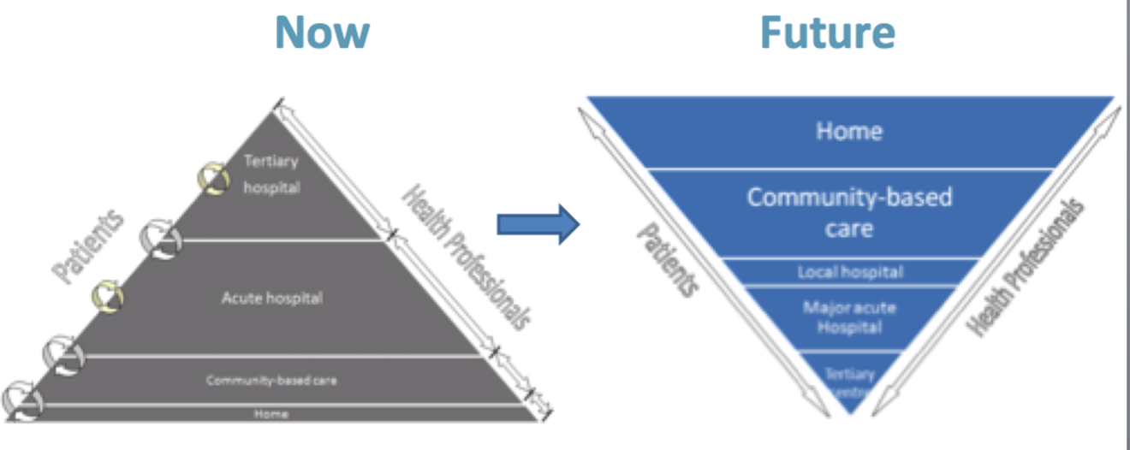

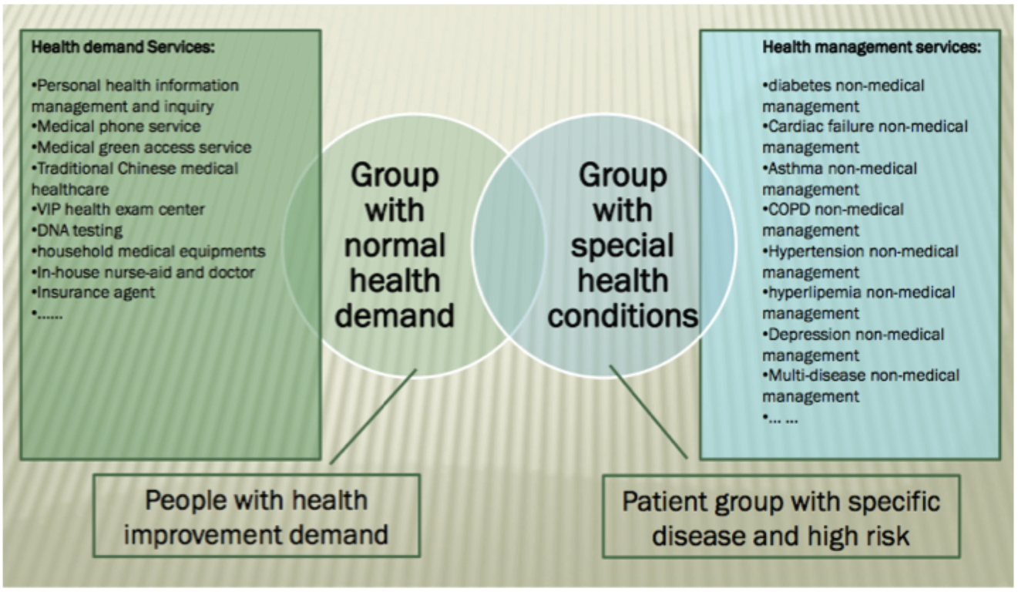

Principals - we adopt to deliver services

Person-centerd

The partnership we developed with you, your family your medical practitioners ensures that your decisions made respect your wants, and preferences and that you have the education and support needed to make decisions to participate in your own care.

Comprehensive

A team of care providers is wholly accountable for your physical and behavioral health are needs, including prevention and wellness, mental and behavioral health, acute care, and chronic care.

A Team aligned with your needs
A multidisciplinary clinical and support staff who deliver all primary care and coordinate the remainder of your needs including speciality care enhancing continuity of care staff are organised into “teamlets” that provide care, to an assigned panel of clients.

Accessible

You have access to services with shorter waiting times “after hours” care 24/7 electronic or telephone access, and are able to communicate with your care providers through email, patient portals or other trusted health IT tools.

Coordinated

Care is organized across all elements of the broader healthcare system, including speciality care, hospitals, home healthcare, community services and support.

Committed to quality and safety through systems approach

Health professionals and staff enhance quality improvement through the use of health IT and other tools to ensure that you and your family make informed decisions about your health.

Our mission statement

What we’re trying to do:

Our goal is to empower people to take control of their health by providing the guidance, education and assistance needed to be an active player in managing their care.

Empower personal independence, dignity and choice as the leading provider of community-based health and lifestyle services to individuals, their carers and organisations committed to their well-being.

Enable unrestricted access to community-based health and lifestyle services with universally familiar, reliable and flexible support systems.

Our core values

Value | Practical Application -
- Compassion* | Focusing on our Clients
- Integrity | Delivering Quality
- Collaboration | Caring within Communities
- Responsibility | Ensuring Best Practice
- Innovation | Enabling Accessibility

Strong emphasis on positioning the organisation as expert, high quality, compassionate and caring

Our staff are our core asset. It’s important that they relate and link to the company. Its important that the client relates to the company and not just the staff member.

Bonding the staff member to the company will be important. Visual connection of the staff member through uniforms, name cards etc will also be important.

Our Strategy

- Ecosystem of two complimentary business units providing the respective client care and technology support
- Initial priority is to ensure that all required support is available for continued delivery of existing services
- Will endeavour not to distract or disturb incumbent care operations
- In the future, we’ll be looking to introduce innovative home care services supported by state-of-the-art technology

Our strategy incorporates
- mobile, device and sensor components,
- the middleware that transmits messages (two way messages)
- the backend decision support based medical operations center and

the surrounding messaging and contact center
- the strategy is closely aligned (integrated) with the productivity and administrations (case management, rostering & scheduling) and clinical solutions (CDR LDE)

We understand our users will
- Span a range of ages
- Have a range of capabilities to use technology
- Have requirements that vary through out a day/night and location
- Will have preferences ranging from no device through to specific brand and architecture
- Do not want to be tethered to the home or a specific room in the home
- Travel within the community, Malayisa and Overseas and want to take their monitoring technology with them

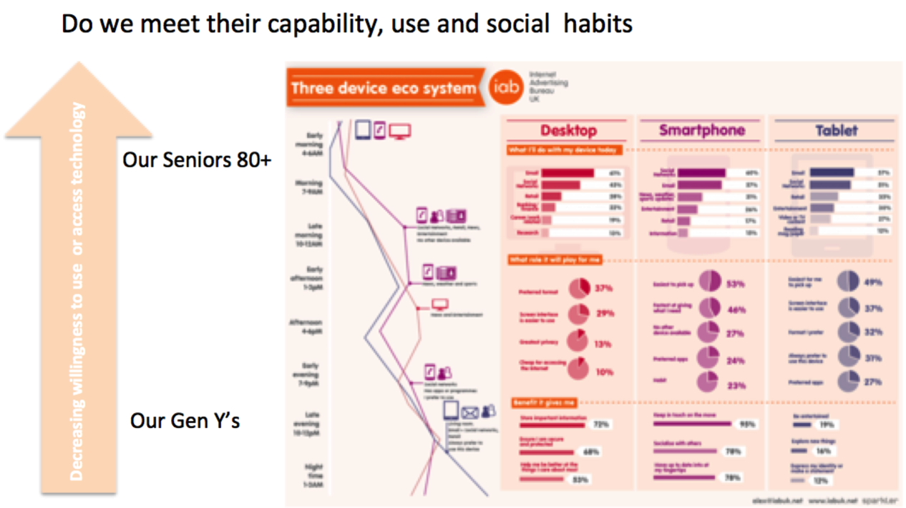

How we describe ourselves commercially

- To act as a holding company for the sponsorship, development and or acquisition or part acquisition and operational management of business involved in the planning, coordination, and delivery of domestic, medical and specialised care to individuals located in the community and their home

- To deliver a whole-of-system approach to the coordination and delivery of social, personal and medical care to individuals and their families located in community settings including the individuals home, providing an individual and his or her family members with a single contact for healthcare and community service needs, coordinating an individuals treatment across all of his/her providers – whether at home, an outpatient office or in the hospital, acting as a navigator linking individuals to care coordinators, doctors, physiotherapist, allied health professionals, Traditional Chinese Medicine providers and serve as a support team whenever an individual has questions, needs guidance or assistance in managing his or her care, making it easy to get better healthcare by coordinating treatment across all providers – whether at home, an outpatient office or in the hospital

- To carry on the business of training and education of participants involved in the delivery of attended care, this includes the development of skills in domestic, aged, mental, disability and palliative care and the necessary skills in the aforesaid community care and coordination activities including an individuals career and life development needs. Training and education involves the development of general and specialty course material and the delivery of formal and informal attended and remote (internet) education classes.

- To carry on the business of making available to care organizations such as hospitals, clinics, aged care providers, retirement facilities, or markets outside Malaysia that have needs for skilled care providers

- To carry on the business of sourcing and selling directly or using an internet based market place to individuals who have the need for over the counter medicines, appliances and medical apparatuses, inclusive of medical, anatomical, orthopedic and care appliances of every description and other aids for the relief of defects of body or sight or hearing.

- To acquire and hold investments in care and delivery organisations , including land , buildings, shares, stocks, debentures, bonds, securities and other assets issued or guaranteed by any company , private undertaking, syndicate or persons constituted to be carrying on a business in Malaysia or elsewhere, or any government, public body, authority supreme, municipal, local or otherwise, and to acquire any such shares, stocks, debentures, bonds securities by original subscription, tender purchase, charge or otherwise and exercise and generally, to enforce all rights and power conferred to the ownership thereof, and to sell, transfer, or otherwise dispose of the same; in any manner whatsoever, and to layout and preparing the same buildings for any other purpose whatsoever, and to enter into contracts or any arrangements or any arrangements whatsoever with builder, tenants and other.

Social Media

The fundamentals of social media are key to the way we access the market now and in the future.

A key driver for building and supporting the carer and their client is the harnessing of social media technology and methodologies that will result in the building of “communities” linked to carers, clients and the support network around clients to ensure the client, professional and caregiver engagement is a simple, collaborative care experience.

Clients and caregivers will be empowered through access to social media technology changing the dialogue with clients from a one-to many to a many-to many delivering customised population-level health interventions via social media campaigns.

Access to social media technology will enable carers to expand their role with clients.

How we will deliver services

Converged digital multi media strategy

Our core management systems and services will be delivered on a foundation of a converged digital muti media strategy

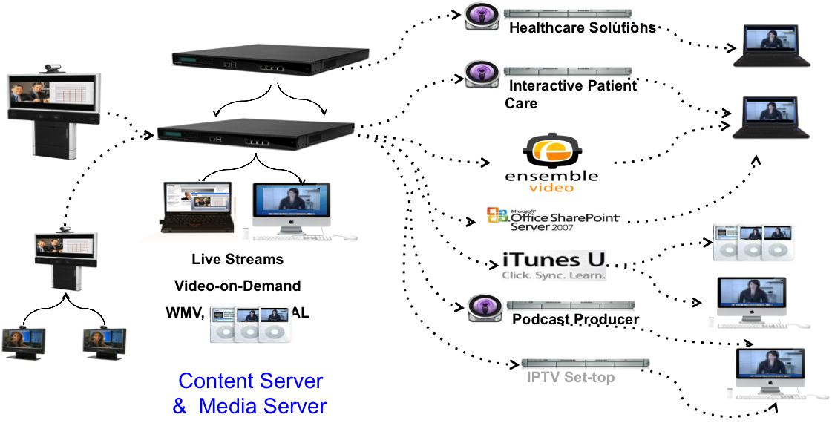

The services we deliver

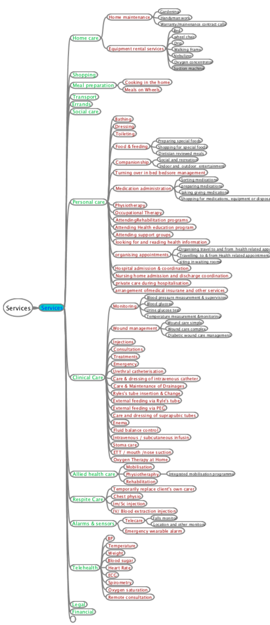

Services
- Services
  - Home care
    - Home maintenance
      - Gardening
      - Handyman work
      - Warranty/mainenance contract calls
    - Equipment rental services
      - Bed
      - wheel chair
      - Drip
      - Walking Frame
      - Nebulizer
      - Oxygen concentrator
      - Suction machine
  - Shopping
  - Meal preparation
    - Cooking in the home
    - Meals on Wheels
  - Transport
  - Errands
  - Social care
  - Personal care
    - Bathing
Dressing
Toileting
Food & feeding
      - Preparing special foods
      - Shopping for special foods
      - Dietician reviewed meals
Companionship
      - Social and recreation
      - Indoor and outdoor entertainment
Turning over in bed bedsore management
Medication administration
      - Sorting medications
      - preparing medications
      - taking giving medications
      - Shopping for medications, equipment or disposables orother necesary health items
Physiotherapy
Occupational Therapy
AttendingRehabilitation programs
Attending Health education program
Attending support groups
looking for and reading health information
organising appointments
      - Organising travel to and from health related appointments
      - Travelling to & from Health related appointments
      - siting in waiting rooms
Hospital admission & coordination
Nursing home admission and discharge coordination
private care during hospitalisation
arrangement ofmedical insurane and other services
  - Clinical Care
    - Monitoring
      - Blood pressure measurement & supervision
      - Blood glucose
      - Urine glucose test
      - Temperature measurement &monitoring
    - Wound management
      - Wound care simple
      - Wound care complex
      - Diabetic wound care management
    - Injections
    - Consultations
    - Treatments
    - Emergency
    - Urethral catheterisation
    - Care & dressing of intravenous catheter
    - Care & Maintenance of Drainages
    - Ryles's tube insertion & Change
    - External feeding via Ryle's tube
    - External feeding via PEG
    - Care and dressing of suprapubic tubes
    - Enema
    - Fluid balance control
    - Intravenous / subcutaneous infusin
    - Stoma care
    - ETT / mouth /nose suction
    - Oxygen Therapy at Home
  - Allied health care
    - Mobilisation
    - Physiotheraphy
      - Integrated mobilisation programme
    - Rehabilitation
  - Respite Care
    - Temporarily replace client's own carer
    - Chest physio
    - Im/Sc injection
    - IV/ Blood extraction injection
  - Alarms & sensors
    - Telecare
      - Falls monitor
      - Location and other monitors
    - Emergency wearable alarm
  - Telehealth
    - BP
    - Temperature
    - Weight
    - Blood sugar
    - Heart Rate
    - ECG
    - Spirometry
    - Oxygen saturation
    - Remote consultation
  - Legal
  - Financial

What our competitors look like

We think these sites are very bland, have too much confusing content, difficult to navigate, do not consider the age groups that may be trying to navigate them, lack any thought about color and color combinations, do not reflect in many cases the unique Malaysian culture.
http://www.myflexhealth.com/
https://www.facebook.com/MyFlexHealth
http://www.flexhealth.com.au/news-items/news-headline-2
http://www.loveonwheelshealthcare.com/
http://www.loveonwheelshealthcare.com/direction/kasih-project/
http://etp.pemandu.gov.my/16_November_2012-@-K@A@S@I@H@_Mobile_Healthcare_Services.aspx
http://homehealth.com.my/
http://www.melorita.com/splash/
https://www.facebook.com/MeloritaHomeHealth
http://www.groupon.my/deals/klang/melorita-home-health/716161100
http://www.hnp-mobilenursing.com/
http://www.icarehomehealth.com.my/
http://www.majalah.com/?business:private-nursing-penang-by-aspire-healthcare:C8YM9LLNS0S
http://nursesathome.com.my/
http://www.ramsaysimedarby.asia/eng/patient-services/home-care-nursing-services
http://www.ytsnursing.com/
http://www.qasehnursing.com/
https://www.facebook.com/pages/Qaseh-Nursing-CARE-QNC/100723716685387
http://thecarehub.com.my/
http://www.perdana.kpjhealth.com.my/promotion-detail.php?id=19
http://kpjkajang.com/Housing-Options-for-Seniors-article-680.html
http://kpjkajang.com/How-to-Choose-a-Nursing-Home-Brief-Version-article-1307.html
www.lifelinkhomecare.com
www.attianursingcare.com
www.2heartshomenursing.com
www.mnalfalah.com.my
www.penangangles.com
www.prestigehealthmanagement.com.my
www.shalom.com.my

Nurse Station

Nurse Station is Brand name.

It is used to describe the collection of services that Caresentral will deliver to the market. Shop front and window signage will clearly display “Nurse Station”

Services are collected into 5 core areas – We have called pillars

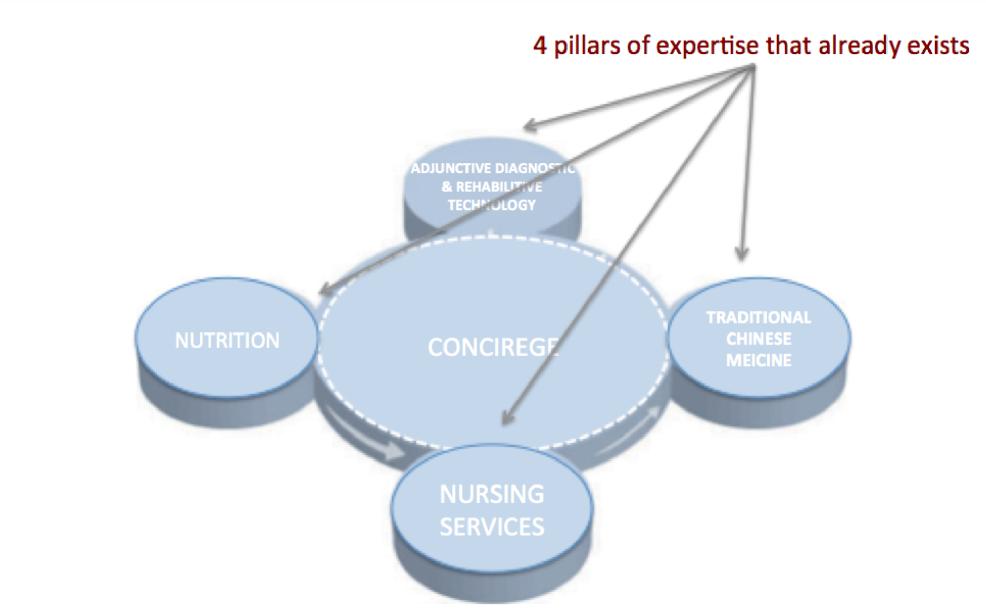

Functions / speclaities from the pillars are aggregated to produce specialist products/ services for the consumer

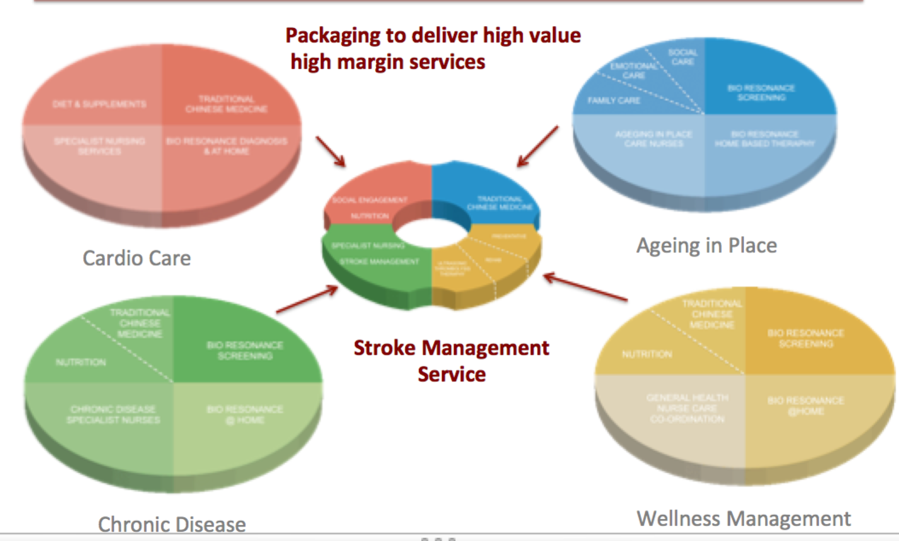

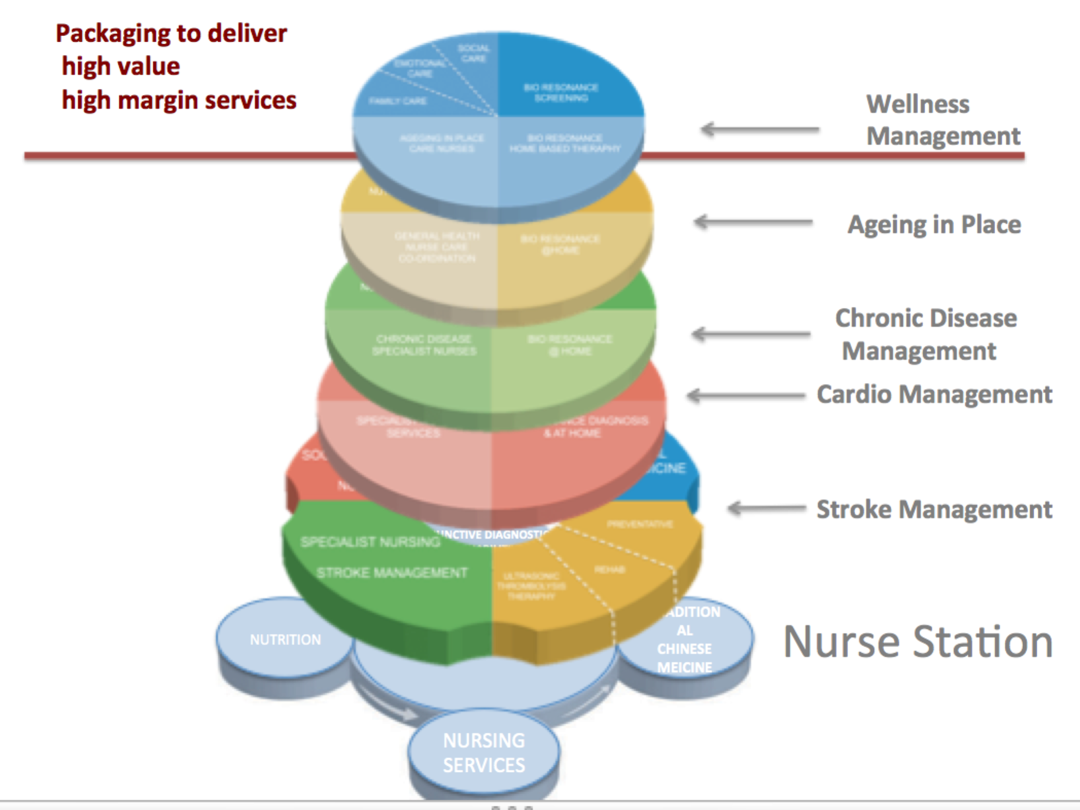

Branding Touch-points

Caresentral branding reflects :

- Core values with a strong emphasis on positioning the organisation as expert, high quality, compassionate and caring

- Empower personal independence, dignity and choice

- Decisions made respect your wants, and preferences and that you have the education and support needed to make decisions to participate in your own care
- Sa team “navigators” link you to your Care Coordinator, to doctors, physiotherapist, and serve as a support team whenever you have questions, need guidance or assistance in managing your care. We make it easy to get better healthcare by coordinating treatment across all providers – whether at home, an outpatient office or in the hospital

- Citizens are able to realise a true sense of ownership in managing their own health, and really feel like members of a community health team. They can readily plan and receive care when they need it, as close to home as possible. They can communicate with their health professionals by email, webcam or in person – whatever suits.

- Key stakeholders include clients, their families, their caregivers, organisations committed to their well-being, management staff, board members, commercial partners, community partners, regulators and investors

- Operating entity names, colour schemes, fonts, logos, marketing collateral, web sites, uniforms, retail space and signage will consistently reflect key brand messages

Images, color, expression:

We want design input into our overall look and feel, and the way we express ourselves visually. We don’t want to restrict your design input.
We recognize the culture and unique ways the Asian markets we will initially operate in apply to words, words combinations of words, numbers, colors, images, and how people express themselves.
All images MUST reflect Malaysia’s (Asia’s) multi cultural image.
Stock images reflecting western images will not be acceptable
Images must not reflect people in pain or distress
Some WEB sites we like in (terms of color) images

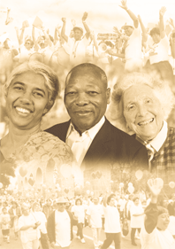



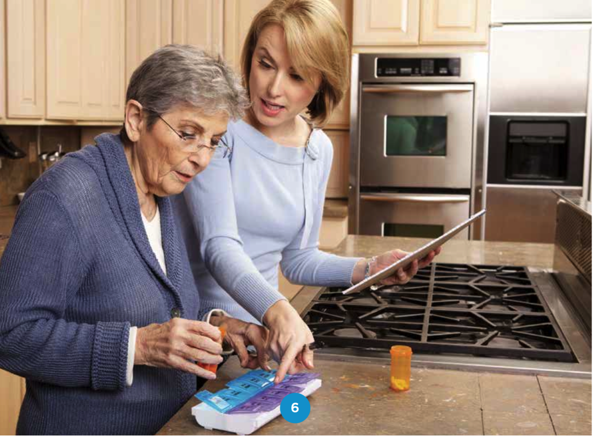

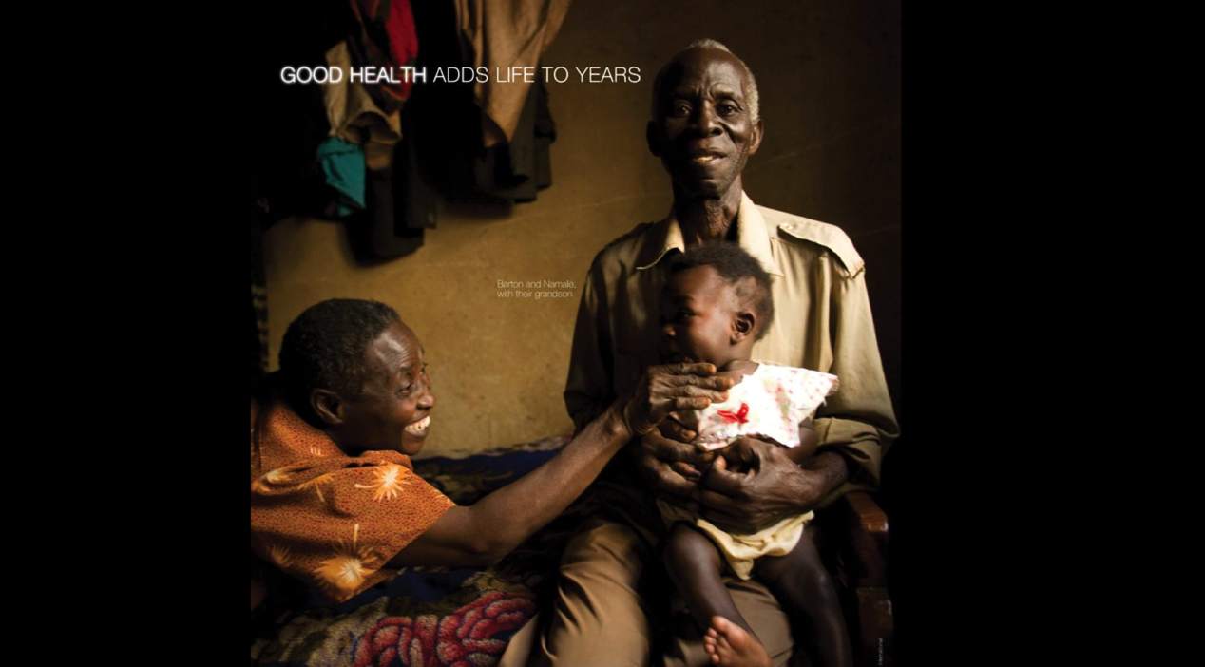

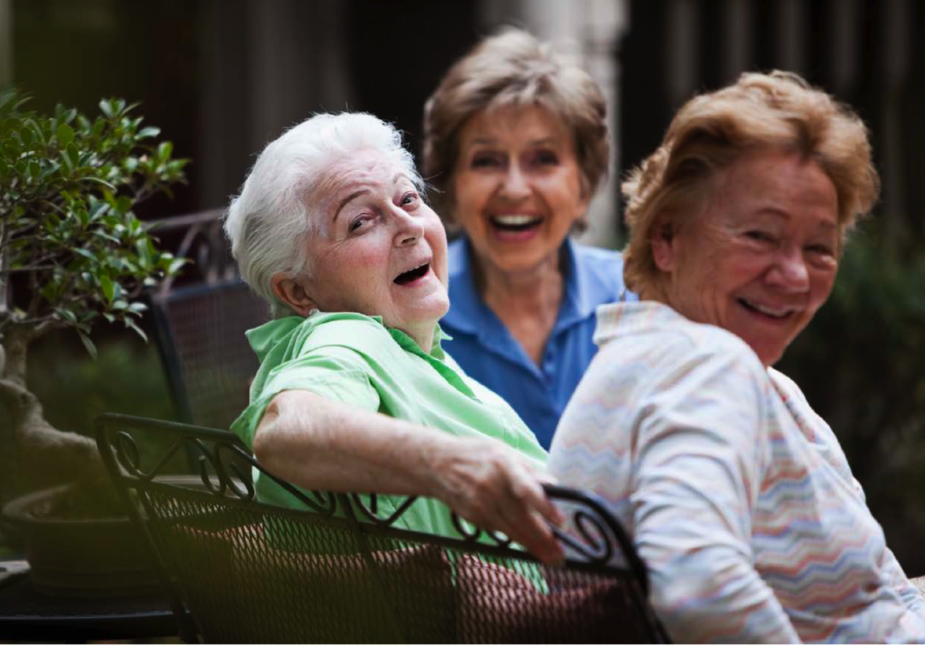

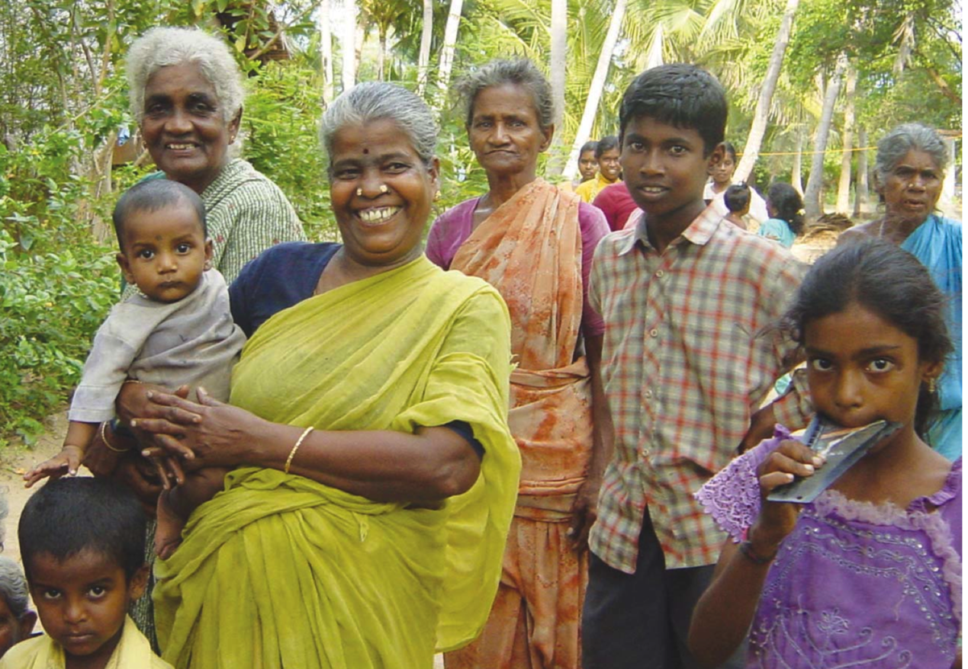

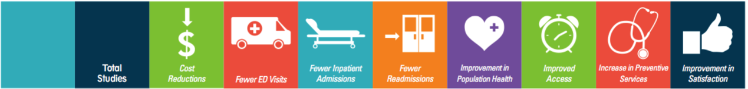

Shopfront Visibility

Key to developing a pipeline of clients will be being visible in the market place. The visibility will be of great benefit to the sales process. Consumers have longed complained about the complexity of gaining advice and access when requiring care.

Clients enquiring about services will be meet with a concierge who will help “navigate” them through the available options.

The shopfront will:
- Client care planning facilities
- house remote monitoring equipment (blood pressure, weight, ECG) along with voice and video technology to connect the shopfront with the Clinic doctors.
- A regional meeting place for carers
- Regional training facilities
- Meeting rooms for focused client groups
- Sale of equipment and retail and OTC items
- Wellness and or Day Care center
- Day Therapy Centers
- Blood collections points
- Diagnostic tests

Interesting facts about ageing

The world population is rapidly ageing
Between 2000 and 2050, the proportion of the world's population over 60 years will double from about 11% to 22%. The absolute number of people aged 60 years and over is expected to increase from 605 million to 2 billion over the same period.
Low- and middle-income countries will experience the most rapid and dramatic demographic change
It took more than 100 years for the share of France's population aged 65 or older to double from 7 to 14%. In contrast, it will take Malaysia less than 25 years to reach the same growth.
Malaysia will have more people who live to see their 80s or 90s than ever before
The number of people aged 80 years or older, for example, will have almost quadrupled. There is no historical precedent for a majority of middle-aged and older adults having living parents, as is already the case today. More children will know their grandparents and even their great-grandparents, especially their great- grandmothers. On average, women live six to eight years longer than men.
How well we age depends on many factors
The functional capacity of an individual's biological system increases during the first years of life, reaches its peak in early adulthood and naturally declines thereafter. The rate of decline is determined, at least in part, by our behaviours and exposures across the whole life course. These include what we eat, how physically active we are and our exposure to health risks such as those caused by smoking, harmful consumption of alcohol, or exposure to toxic substances.
Most older people die of NCDs
Even in poor countries, most older people die of noncommunicable diseases such as heart disease, cancer and diabetes, rather than from infectious and parasitic diseases. In addition, older people often have several health problems at the same time, such as diabetes and heart disease.

Globally, many older people are at risk of maltreatment
Around 4-6% of older people in developed countries have experienced some form of maltreatment at home. Abusive acts in institutions include physically restraining patients, depriving them of dignity (by for instance leaving them in soiled clothes) and intentionally providing insufficient care (such as allowing them to develop pressure sores). The maltreatment of older people can lead to serious physical injuries and long-term psychological consequences.
The need for long-term care is rising
The number of older people who are no longer able to look after themselves in is forecast to quadruple by 2050. Many of the very old lose their ability to live independently because of limited mobility, frailty or other physical or mental health problems. Many require some form of long-term care, which can include home nursing, community care and assisted living, residential care and long stays in hospitals.
There will be a dramatic increase in the number of people with dementias such as Alzheimer's disease, as people live longer
The risk of dementia rises sharply with age with an estimated 25-30% of people aged 85 or older having some degree of cognitive decline. Older people with dementia in low- and middle-income countries generally do not have access to the affordable long-term care their condition may warrant. Often their families do not often have publicly funded support to help with care at home.
In emergency situations, older people can be especially vulnerable
When communities are displaced by natural disasters or armed conflict, older people may be unable to flee or travel long distances and may be left behind. Yet, in many situations they can also be a valuable resource for their communities as well as for the humanitarian aid process when they are involved as community leaders.

