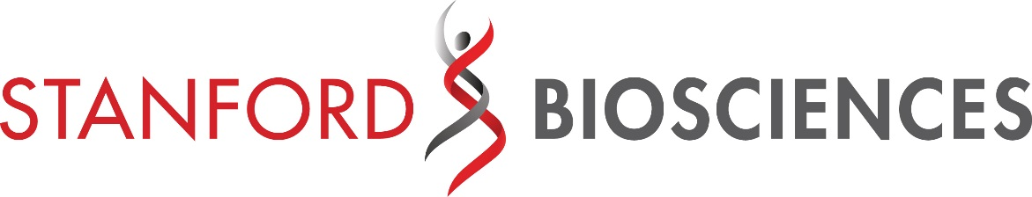
When you join Stanford Biosciences, you join a collaborative network tackling some of the world's toughest questions.
The Stanford Biosciences Home Programs comprise eight departments and five interdisciplinary programs, which span the School of Medicine and the School of Humanities and Sciences. These Home Programs are the foundation of our collaborative culture, offering students the opportunity to tailor their graduate education by working within an entire network of faculty, labs, and approaches to pursue their research.
Each student is admitted to a particular Home Program and initiates training with a core group of faculty, students, and postdoctoral fellows who share scientific interests. Many Home Programs host annual retreats—facilitating the exchange of ideas between Stanford colleagues and fostering team-building—as well as seminar series that invite outside speakers.
In addition to that intimate setting, all Biosciences students have access to faculty in every Home Program for laboratory rotations and potential thesis work. One of Stanford Biosciences' biggest strengths is the physical proximity of programs and labs, encouraging face-to-face collaboration and feeding an environment of interdisciplinary innovation. Indeed, the Biosciences PhD Programs combine the supportive atmosphere of a small program with the many opportunities afforded by a large umbrella program—the best of both worlds.

INTERDISCIPLINARY COLLABORATION

Stanford lies at the world's epicenter of discovery and innovation. Within just a few hundred yards of any spot on campus, the most brilliant minds in medicine, engineering, physics, statistics, psychology, business, law, humanities, ethics, public policy, computer science, and all the biosciences are working together to expand to new frontiers of human knowledge. And within just a few miles, that knowledge is put to work in and around Silicon Valley, creating new technologies to improve the human condition.

This co-location of genius, steeped in entrepreneurial spirit, makes Stanford truly unique. A cardiologist and a physicist can discuss a promising research idea over coffee at a moment's notice. An immunologist and an electrical engineer can work side-by-side on a prototype, deep into the night. A biochemist can consult with a neurologist and his patients daily during a clinical trial.

UNPARALLELED FACULTY

In the past six decades, there have been eight Stanford Nobel laureates in the biosciences alone. Stanford researchers have also garnered the largest number of NIH Pioneer Awards, New Innovator Awards, and Transformative Research Awards for a single institution—more than twice that of any other.

The Stanford Biosciences Ph.D. Programs include over 350 faculty members. Our extremely high faculty to student ratio means that students have an abundance of choices when selecting their rotations and thesis labs. Our current faculty includes six Nobel Prize winners:

Tomas Sudhof - Physiology or Medicine • 2013 Andrew Fire - Physiology or Medicine • 2006
Michael Levitt - Chemistry • 2013 Roger Kornberg - Chemistry • 2006
Brian Kobilka - Chemistry • 2012 Paul Berg - Chemistry • 1980

STUDENT LIFE

With easy access to San Francisco and a host of outdoor attractions, Stanford students enjoy a world of cultural options that round out their graduate experience. The diversity of things to see and do in the Bay Area fosters an innovative, entrepreneurial, and creative environment that encourages students to think big and pursue original ideas.

BIOSCIENCES HOME PROGRAMS

Biochemistry

The Biochemistry Program provides research training

that spawns leaders in academia, biotech, and beyond.

Our faculty seek to better understand the highly complex,

intra- and intercellular processes.

Biology
The Biology Program trains students for careers in
basic research, offering intensive instruction in laboratories, seminars, and teaching. Our program addresses the most important problems within the different fields of biology.

Biomedical Informatics
The Biomedical Informatics Program trains research leaders to design, implement, and evaluate novel quantitative and computational methods that solve challenging problems across biomedical science and clinical medicine.

Biophysics
The Biophysics Program trains students in quantitative
approaches to biological research involving two overlapping branches of biophysics: the application of physical and chemical principles and methods to solving biological problems, and the development of new methods.

Cancer Biology
The Cancer Biology Program provides our students with education and training that will enable them to make significant contributions to this remarkable field by translating basic scientific findings into modern cancer diagnostics and treatments.

Chemical and Systems Biology
The Chemical and Systems Biology Program explores the mechanisms that underlie cellular function and contribute to human disease. Our department emphasizes interdisciplinary research that spans the biological and physical science.

Developmental Biology
The Developmental Biology Program trains scientific leaders in using cutting-edge approaches to advance the understanding of the molecular mechanisms that generate diverse cell types in contexts ranging from the embryo to evolution.

Genetics
The Genetics Program trains students to pursue careers in academic or industrial settings, health care, health policy, and education. Our program offers opportunities in a broad array of areas overlying a consistent intellectual framework.

Immunology

The Immunology Program offers two tracks: Molecular, Cellular, and Translational Immunology (MCTI) and Computational and Systems Immunology (CSI). Our curriculum includes lab and foundation courses, immunology and computational biomedical sciences core courses.

Microbiology and Immunology
The Microbiology and Immunology Program has a holistic approach which considers the entirety of the system, from pathogenesis of autoimmune diseases to pathogen-produced virulence proteins that reprogram infected cells.

Molecular and Cellular Physiology
The Molecular and Cellular Physiology Program redefines the august field of Physiology, bringing cutting-edge approaches to the study of how life works. Our goal is to train students in how to think about science so that they can excel in a wide range of research-related careers.

Neurosciences
The Neurosciences Program trains students to become leaders in neuroscience research, education, and outreach. The program offers a flexible and rich research environment in which our researchers attempt to solve the major biological questions of our time.

Stem Cell Biology and Regenerative Medicine
The Stem Cell Biology & Regenerative Medicine Program offers training at the intersection of basic science and clinical application. Our program expands career opportunities by providing graduates with skills to encompass the continuum of basic, translational and clinical sciences.

Structural Biology
The Structural Biology Program emphasizes research training, with coursework covering quantitative approaches to biology. Department research tackles biological problems at the atomic level, using structural and biophysical methodologies to explain both function and disease

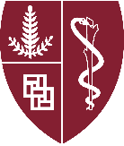
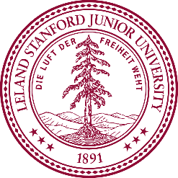
For more information about the application process and deadline, and other important admissions information, visit us online at http://biosciences.stanford.edu.

