BagSwap logo brief
Background | BagSwap.com.au is a start up website where women will be able to go to swap a handbag that they own but no longer use for another bag that they like and would use.  It provides a solution for women who are looking to be more recycle/freecycle friendly and aware and also means that they can be sure that their previously loved handbag is going to a new home  This is a win win for both swappers as they both end up benefiting from a new handbag.
Audience | The target market is women most likely in their 30’s or 40’s – they probably have a fair amount of disposable income which has meant being able to buy nice handbags in the past, but they are also more aware now of the need to recycle or freecycle some of their unwanted goods. They probably can’t be bothered with things like eBay but they also don’t want to donate items to Vinnies as the emotional attachment to the bag is too great and that feels like a waste.
Brands/Logos that I like | 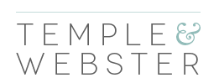  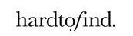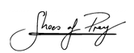  I don’t mind colour though so adding a shade of grey or teal (something subtle and appropriate for the audience) I would like to consider. I would also be interested in looking at a handbag icon as I could use a simple light icon across my website so would like this to be part of the consideration.
Brands/logos that I don’t like | 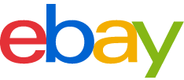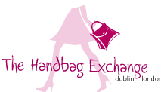  These logos are too colourful, too girly or too large and would be hard to place across all items like a website or a business card
Usage considerations | I am going to use this logo in the following places:  Website, blog, Twitter, Facebook, business cards, swing tags  And I would like the logo to not be too deep/high or long which makes it harder to place

