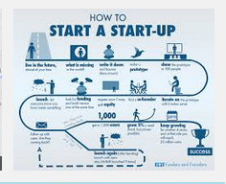
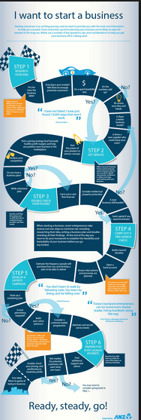

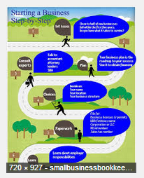

These are infographics I grabbed from the web. We do not want to copy one, but draw upon the good points.

What I like about all these is they have a beginning and an end.

#1 may be difficult to follow – and the coloring is bland.
#2 makes the point about having a beginning and an end, but it has too many words
#3 seems too scant
#4 is attractive – we would need to use different icons.

Words alone are not acceptable – the icons or art needs to support the text.

We need one main icon or drawing that is a metaphor for strategy. A reworking of the one below is possible (although I doubt we want so many colors.) This icon will be on our presenations.



