About INTRA

INTRA is a team of professionals, engaged in providing a high quality services to our valuable clients, in order to meet their business requirements, especially in financial & business sector. The Company works as an intermediary between the clients and their stakeholders with a most efficient and cost‐effective way of prioritizing the business needs. We have tremendously developed integrated network of searching, repossessing, collecting, recovering & surveying of assets & others in UAE with addition to our intercity self-relations with the Govt. authorities.

Our Vision

It is to set an efficiency benchmark in Debt Collection industry, by providing a flexible frame work, customized according to current financial market condition, to render our services in order to optimize best results out of it.

Business Perspective

INTRA is a group of professionals that identifies the relationship as the essence of business and is well versed with latest market trends in order to maintain the prestige of its clients.
We are aiming to provide a high quality service with a wide variety of tools, seasoned and sophisticated methods tailored to satisfy each of our client's specific needs.
Our service constitutes of negotiations, management, consolidation and settlement processes in an amicable way. In more delinquent issues where the amicable settlement fails to get results we can also process your cases legally by our experienced law expertise to take further criminal and civil actions to get your outstanding moneys back from your customers.

Areas of Operation

Company has its Head Office based in Qusais Dubai the address for same is
303 Al Mezan Bldg Qusais Beirut Street OPP, Galadari Driving School

Intra Group has sub offices in Sharjah and Abu Dhabi as well which help us to arrange field visit for our prestigious clients in different areas quite easily. The sub offices of intra group also can be used as a backup if required in case of any issue with the company head office.

Why INTRA

INTRA is one of the leading debt collection company in the market providing there service in this field since 2006. It has a dynamic approach and strong influences in Government and Private sector as its USP “Unique Selling Point” as well as the support of our Managing Director who is an Emirati.
Salient Features for INTRA can be weighed as under;
- INTRA has a capacity to adopt fastest methods of services under variable circumstances to be more time – efficient and productive.
- INTRA has the most experienced team of collectors whose strategic alliances to remove any obstinate issues of our clients.
- INTRA is committed to operate with the highest standards of integrity, while preserving absolute confidentiality.
- We are aiming to provide a constant and consistent, undivided attention to gain highest level of satisfaction for our valuable clients.

Collection Procedure

The Standard collection procedure of our company is as mentioned below.

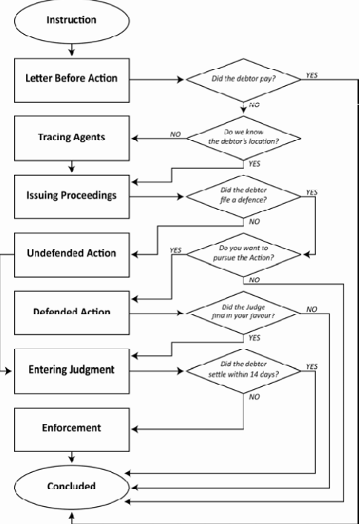

The process defined

Skip Tracing
INTRA offers a unique procedure for the skip tracing on personal and commercial levels. Our experience has shown that it is extremely difficult to disappear completely... by utilizing the most up‐to‐date information databases and technology available, coupled together with our team skills our service can find most 'Gone‐away's'.
Process Serving, Litigation and Judgment Execution One of the most frustrating experiences, is to be unable to locate a person or the assets that will enable a recovery to be affected for you. Through our skip tracing resources in all over the country, supported by our network of accredited agency offices, we are able to carry out this vital task.

Demand Notice
A demand notice or letter before action will be forwarded to the Debtors.

Follow Ups
Telephonic follow up will start in next to the demand notice delivered to the debtors and no response received. Our tele‐calling team is proficiently trained in negotiations and communication techniques to convince the debtors and to answer their queried as well.

Field Visits
A professional and aggressive Skip tracing team is covering the each estate and area of the country to track and crack the debtor and to recover the debts for our clients.

Legal Persuasion
Debt Recovery is not possible without legal backing in any area of the world. A team of lawyers / legal officers can also assist our clients with filling police case.

Recovery of Bad Debts
With all of the possible recovery methods the case finally reaches to edge of maturing by the collection of the bad debts.

Benefits
A highly skilled workforce with vast experience in banking and debt collection is engage in working on the debt portfolio. Highly personalized service with regular updates. Reduction in overhead cost of the business.

Quality Assurance
Intra Debt collections are ensuring the following steps to maintain the quality of the clients
- Hiring collectors with proven record in collections.
- Call monitoring system.
- Collector training on etiquettes of calling as per client defined procedures.
- Managing bank records with backup servers and saving data and work on timely basis

Our Valuable Clients


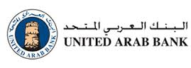
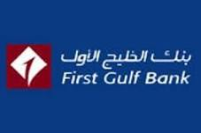


Contact Us

For any further inquiry please contact us on below given contact points and we would oblige as requested
Intra Group of Companies
Tel: 042206244, Fax: 042206877
Off: 303 Al Mezan Bldg Qusais Beirut Street OPP, Galadari Driving School
Email: Info@intradebtcollection.com Website: www.intra.ae

