Job Type
Logo Design
Task Outline
- Create a Logo Design
Task Description
www.dalowend.com is a music blog focused on urban, R&B and other harder bass heavy percussion oriented EDM dance music. .
The point of difference between the “lowend” and other music blogs is an almost maniacal focus on music that makes you move. The author of the music blog is a DJ, drummer and club promoter that has spent time in Miami, San Francisco, Singapore, Frankfurt, and other major cities actively involved in the music scene for over 20 years.

We all know the feeling when you are driving in your car, or you walk into a record store or a dance club and there is a song playing, perhaps louder than your comfort level which reaches deep into you, causes you to bob your head to the beat…elevates your heart rate. I find that most of these songs tend to be hip hop/r&B and certain deep house style tracks. Some of us feel this a bit deeper; the song never leaves our head until we find it.
This blog is focused on people searching for that perfect track to drop while DJ’ing or hosting a party, As we are talking about dalowend, the logo should let the user know what kind jams
Logo Text
LOW END, LOW, The low end, LE etc (note, the logo does not need to be text based.
Logo Styles of Interest
Wordmark Logo
Word or name based logo (text only)
 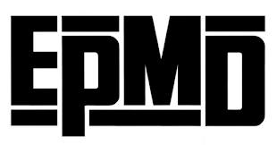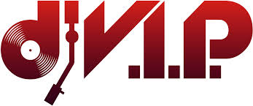

Abstract combined with text Logo
Acronym or letter based logo (text only)

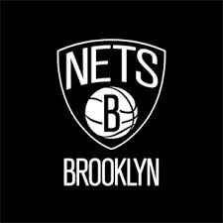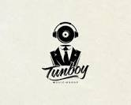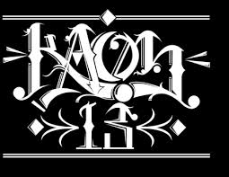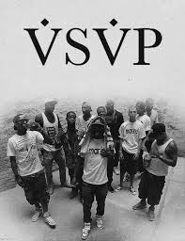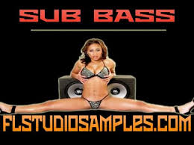
Abstract Logo
Conceptual / symbolic (optional text)

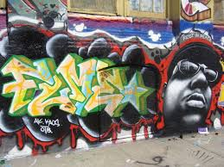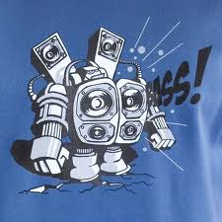

Deadline
Per upload project details
Target Market(s)
DJ’s, music enthusiasts, club goers, promoters, active night life people, fashionistas, .
Look and Feel
Each slider illustrates characteristics of the customer's brand and the style your design should communicate.
Elegant | *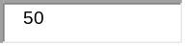 | Bold
Playful | *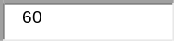 | Serious
Traditional | *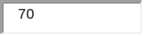 | Modern
Personable | * | Professional
Feminine | * | Masculine
Colorful | * | Conservative
Economical | *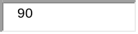 | Upmarket
Black (American) | * | White (American)
Dark | * | light
Daytime | * | nighttime
Clean | * | dirty
Pure |  | sinful

Requirements
Must Have:
- finely drawn, clean lines
Nice to Have:
- a tag line such as “boom”, “move”' for example - open to suggestions here . some sort of graffiti might work as would images of speakers, rappers, turntables, hot chicks dressed provocatively etc.
Should Not Have:
- anything that looks like clipart. (unless done VERY tastefully)

