Hello
Below is our existing Logo – we want a fresh new look. You will note that the primary use of the logo is printed on baby clothing. Therefore the logo need to be clean (not fussy) so it prints well on garments. We will also use it on website, online media and in print materials

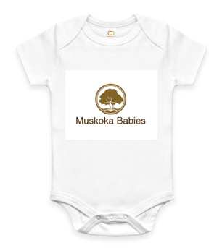

Name of Company: Muskoka Babies

Existing Logo
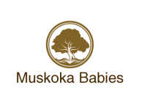
What I like about the existing logo:
This logo is clean and simple and will look beautiful on baby clothing. It is one colour only and so versatile. The brown colour is a neutral and so will look very Zen on white and cream clothing. Will also look nice on pale colour items. It will also translate well to the reverse white logo when printed on vibrant shade clothing
This is a baby clothing company – we need a logo that has the softens of a baby logo but no obvious baby references (baby bottles, rattles, trains, sheep and so on) No hard lines and sharp edges – soft for a baby.
What it needs: Need to have a Canadian element – a maple leaf incorporated somehow. The maple leaf itself should be subtle and incorporated into the design. The maple leaf should not be the design itself
Logo is one colour – meet s the brand need of:
- Simple
- Clean
- Unencumbered
- Relaxed cottage life
- On vacation
- Zen
- Peaceful
- High quality (not fussy)
- Luxurious (not trendy)
- Beautiful & Serene (not touristy!!!!) this is very important
- Canadian (pride)
- NOT BABYISH!!!!!!!! – no lambs, trains, rattles or sheep!!!!
- Likened to Roots Label (see next pages)
- Not modern or industrial looking
- Soft lines/ softness to the logo

- Printed on the front of all clothing
- Website
- Social Media – facebook so on
- Stationary
- Ads

Logos in general that I like

