Holiday Swim Classes

Holiday Program Dates
2014  2015 | Sep 23rd – 27th
2014  2015 | Sep 30th – Oct 4th
2014  2015 | Jan 6th – 10th
2014  2015 | Jan 13th – 17th
2014  2015 | Jan 20th – 24th
2014  2015 | Mar 30th – Apr 3rd
2014  2015 | Apr 6th – 10th
2014  2015 | Jun 29th – Jul 3rd

* $52 per child due to 4 day week
Salt Water Pool
Ages 3 and older
$75 per child per week
(5x½ hour classes per week)

No bookings are taken without a fully completed enrolment form and payment.
Places are limited so book early to avoid disappointment.

Pool Locations Contact Details & Office Hours

Heidelberg P.S. Pool
Location: 116 Cape Street, Heidelberg 3084 | Phone: 9455 1330
Office Hours: Mon-Fri 9:00am-5.30pm, Sat-Sun 9.15am-12.15pm

Ivanhoe Grammar Pool
Location: Gate 1, Russell Street, Ivanhoe 3079

All Correspondence
Post: P.O. Box 2219, East Ivanhoe 3079
Email: info@learntoswimvic.com.au
ABN: 74 005 480 973

Important

• All holiday swim clas ses are conduc ted at the Heidelberg primary school pool
• 30 minute classes run every ½
hour from 9.30am to 12 noon

• Limited places due to small class
sizes

• Beginners to advanced
swimmers welcome

• A ll children are grouped by age
and ability

• No refunds or makeups for
holiday programs

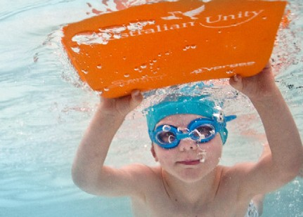



Our qualified staff makes learn to swim not only a rewarding but also a lot of fun. This is a great opportunity to kick-start your child’s aquatic education.

Learn to Swim Classes
2014/15 Term Dates & Prices

Our Streamlined Pathway to Success

Baby Awareness
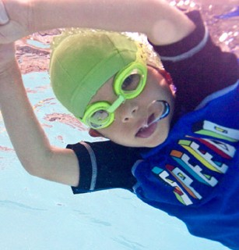

½ hour class per week

Baby Transition Classes
½ hour class per week

Learn to Swim Classes
½ hour class per week

Transitional Stroke Group
1 hour class per week

*2014: Term 4 – 10 week term
Oct 6th – Dec 14th
Bookings taken from 22nd Sep 2014

Babies | Transition | LTS | TSG
$155 | $165 | $170 | $210

*2015: Term 1 – 9 week term
Jan 27th – Mar 29th
Bookings taken from 15th Dec 2014
Babies | Transition | LTS | TSG
$139.50 | $148.5 | $153 | $189

Important
• No bookings are taken without a fully completed enrolment form and payment.

• Read LTSV Policies and Procedures for information on discounts, payment methods, refunds and makeups.

• Book early – place are limited due to small class sizes.

• Bookings can only be made in person at our Heidelberg Office or online.

• During holidays, all bookings must be done via the Heidelberg Office.

• Photographs and video footage is not allowed to be taken without the permission of all the parents/ guardians whose children are in the class.
*2015: Term 2 – 11 week term
Apr 13th – Jun 28th
Bookings taken from 30th Mar 2015

Babies | Transition | LTS | TSG
$170.5 | $176 | $181.5 | $231

2015: Term 3 – 10 week term
Jul 13th – Sep 20th
Bookings taken from 29th Jun 2015

Babies | Transition | LTS | TSG
$160 | $170 | $175 | $215

* Note that these terms have public holidays and prices will be adjusted accordingly.

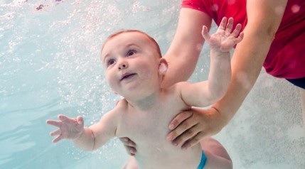

All swimmers, male and female, are required to wear a cap –
please name your cap and goggles with a biro to prevent it washing off.

