FASHION
SALE DAYS.
Logo 1st Draft

Context: Logo for a Fashion Blog web site

Style: girly but very elegant, minimalist, design/fashion, neat, clean and very symmetric.

To change and improve:
1) proportions and size: space between black and pink, space between the name and pink background).

2) Typing used for the logo, I am looking for something a bit more round as for Logo style 2

3) Space: I would like the name fashion will take almost as much space as sale days (as for Logo style 1)

Logo style 1
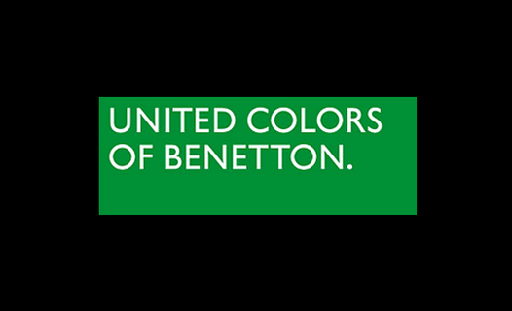

Logo style (Typing style) 2

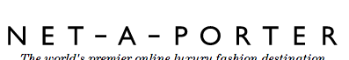

Logo style 3

