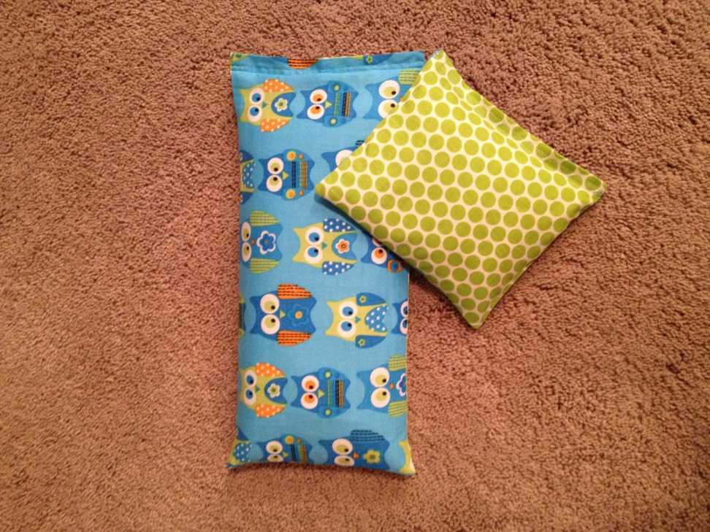
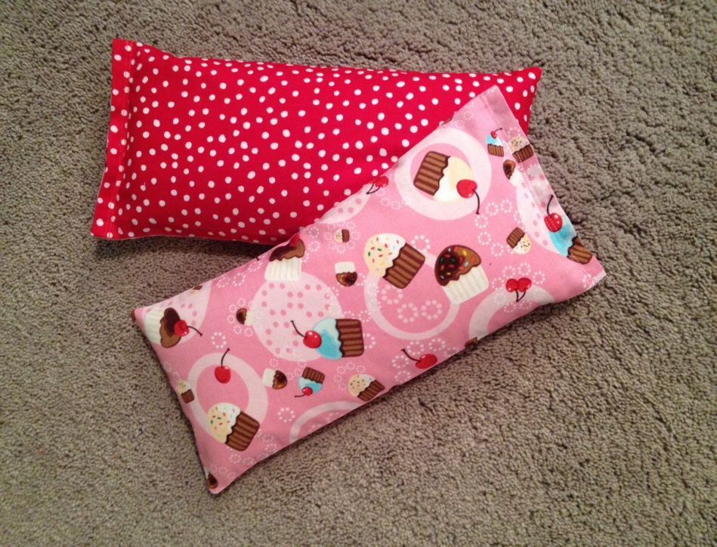

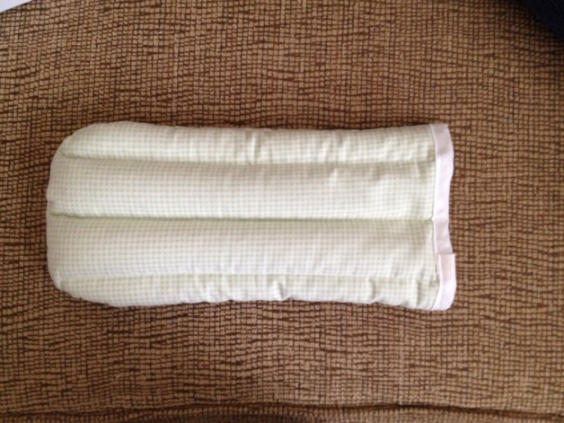
Full Size Bag 12” x 6” & Boo-Boo Bag 6”x6”
Full Size Bag 12” x 6”
Therapy Hand Mitt- arthritis, carpel tunnel, aching joints

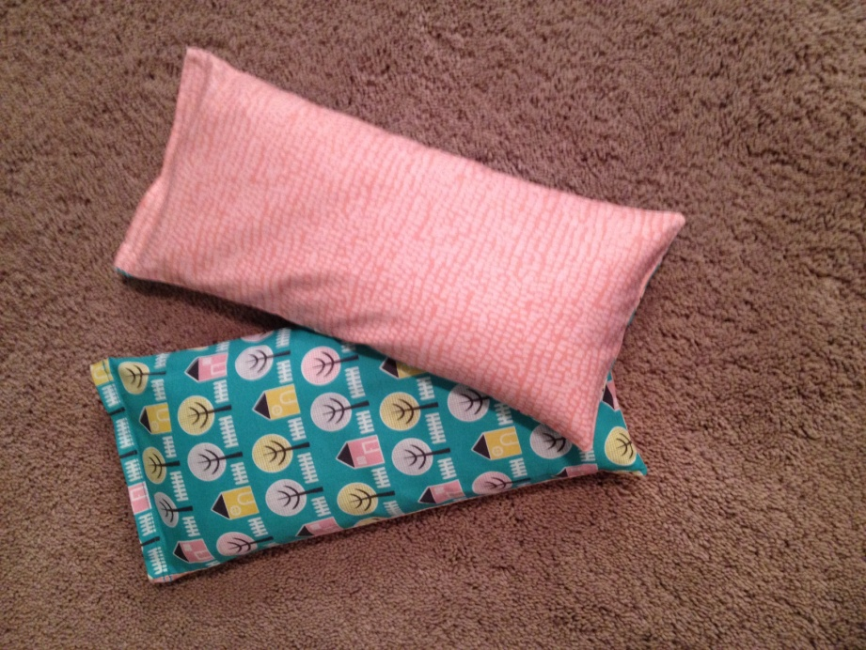
Nail Bag 12” x 6”
Eye Mask – flax seed ,fragrance can be added if desired
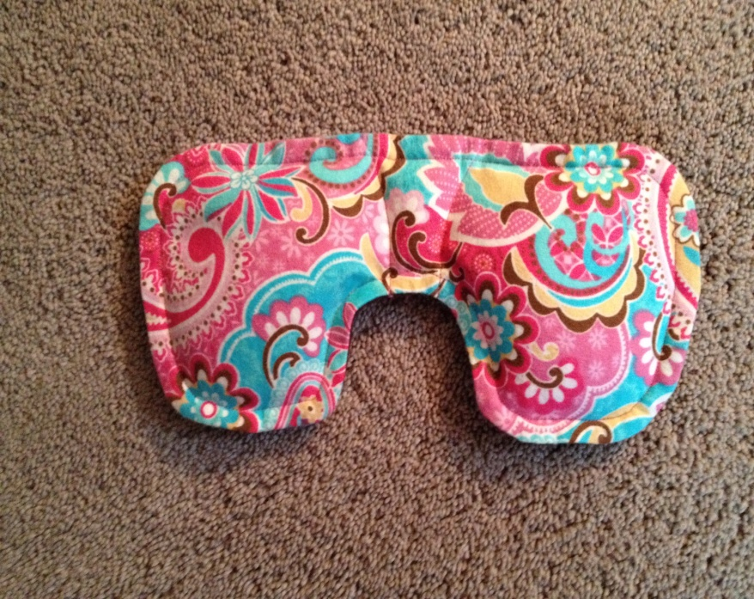
Nail Bag 6” x 3” or hand warmer 3”x3”
Eye Mask – can add fragrance if desired

