COVER PAGE & BACK PAGE INFO

[TAGLINE]
GET MORE FOR LESS – WITH OUR EFFECTIVE MARKETING PACKAGES FOR PROPERTY LAUNCHES

[LOGO]


[COMPANY INFO]
MBO NETWORK LLP
18 Sin Ming Lane #07-03, Midview City. Singapore 573960

Mobile: +(65) 97361631
Office: +(65) 62887716
Email: admin@todaynewlaunch.sg
Web: www.todaynewlaunch.sg

ABOUT TODAYNEWLAUNCH.SG

TodayNewLaunch.sg is a fast growing property search portal, which focuses on the new property developments in the market.

Working closely with real estate developers and agencies, we provide consumers with genuine, reliable, and up-to-date information on the current and new property launches. Together with an interface that is both smart and easy to navigate, TodayNewLaunch.sg will soon become the “Go-To” portal for consumers looking for new property launches.

HOW ARE WE DIFFERENT
When you advertise with TodayNewLaunch.sg, you are not just advertising with us. Instead of simply providing a platform and wait for consumers to take notice of your project, we initiate to reach out to them.

Together with our team of designated marketing specialists – which includes the very top expertise in Search Engine Optimization (SEO) & Social Media Marketing, experience and innovative marketing strategists, designers, editors & copywriters, we will work out an integrated marketing campaign package for your project, which will give your project the maximum exposure, at the most effective rates.

In 3 simple steps, you will see how our service will yield better response, greater results, and stronger awareness for your project, as well as for your company.

1. We Create A Full-Featured Webpage For Your Project

GOOD IMAGE
Instead of having your project appears merely like a listing, or by simply stuffing information inside, we create a full-featured webpage for your project within our portal, almost as like a website on it’s own – with information, content, and images nicely-arranged and organized.

See an example: http://www.todaynewlaunch.sg/waterfront-faber

By better presenting your project, we leave potential buyers with a good impression, and a better chance of them to make an enquiry or view the showflat.

WE DO IT ALL FOR YOU
If you have any worries on the hassles required to get this done… Well, you don’t have to. Simply send us all your available information and related files on your project, and let our professional editors & designers do the rest. You can also send us any updates along the way and we will refresh the webpage accordingly.

ONE SOURCE OF TRUSTED INFORMATION
With thousands of listings in property portals and hundreds of separate websites by salesperson, it is almost an impossible task to ensure the right information on your projects are disseminated to the public. This may mislead your potential buyers with outdated information or give them a wrong perception.

That is why it is important to have one source of trusted information that best represents your project. Working closely with you, we ensure updated, reliable, and accurate information of your project, presented in the way you prefer. Soon enough, consumers will recognize TodayNewLaunch.sg as a reliable source for information on new property launches, thus, less influenced by the many other sources.

From the project webpage, we will also link back to your company website or official project website for consumer’s reference, as well as to promote your company.
2. We Prepare Effective Marketing Campaigns To Give Your Project Great Exposure

Putting together an integrated marketing campaign requires lot of work, and it doesn’t come cheap as well. We can take all these tasks off your hands and, thanks to economies of scale, offer these services at a lower price. Our marketing team will put together an effective marketing campaign based on your requirements, to give your project great exposure on widely recognized online and offline medias

Here are the marketing packages we provide to maximize your exposure.

HIGH GOOGLE RANKING
With improve in technology and current social behavior, it is now very common for consumers to search property online. And being highly visible on Google – the most widely used search engine in the world – means you will be able to reach out to the tens of thousands of consumers monthly, who are actively looking for new property.

In order to achieve that, you can choose between:
1) Search Engine Marketing (SEM) – Pay-Per-Click (pay as you go) type of marketing campaign
2) Search Engine Optimization (SEO) – Having your page appears highly on Organic Search Results

Though we provide both services, we will usually recommend SEO. While it is more challenging to rank highly in organic searches, statistics shows that the click-through-rate is much higher (better response and higher conversion), more reputable, and in the long run more cost effective. The difficult part is getting the right expertise. Luckily for us, we have the very top SEO specialist, and you can be assured of a first page ranking in Google, and possibly in the top 3.

To prove our results, we did some sample optimization on some of the most competitive and frequently used searched terms related for our purposes. And in just a couple of month, we have already manage to outrank well-established property portals, with certainty that our ranking will only gets better in time, and to include a wider range of relevant search terms.

Google Search Results

General Search Terms Targeting Our Portal (www.todaynewlaunch.sg)
Search Terms | Avg Monthly Searches | TodayNewLaunch Ranking
New Launch Condo | 1,000 | #1 ~ #3
New Launch Property | 480 | #3 ~ #6
New Launch Singapore | 260 | #2 ~ #4

Specific Search Terms Targeting Individual Project Webpage (www.todaynewlaunch.sg/your-project)
Search Terms | Avg Monthly Searches | TodayNewLaunch Ranking
Commonwealth Towers | 2,900 | #2 ~ #5
Waterfront @ Faber | 1,300 | #3 ~ #7
The Santorini | 1,300 | #3 ~ #7
* Ranking fluctuates and may be slightly different from the time to time.

See It For Yourself -> www.google.com.sg
EFFECTIVE FACEBOOK MARKETING
Another very important platform when it comes to online marketing, is Facebook. Recognized as the most popular social media, with growing number of users and increase in average time spent per user, Facebook marketing is increasingly popular, and if done right, is way more effective compared to traditional marketing methods.

Considering distribution of 100,000 flyers, it will easily cost you more than $10,000 for design, printing and distribution.

However, with our Facebook marketing campaign, it will be much more effective in the following ways:
- Reach out to the same number of consumers at a much, much lower cost
- Targeted consumers, based on age/gender/interest etc.
- The advertisement will link directly to your project webpage for better reference
- Consumers are more likely to respond to the advertisement

Sample Facebook Ad Sample Summary Report
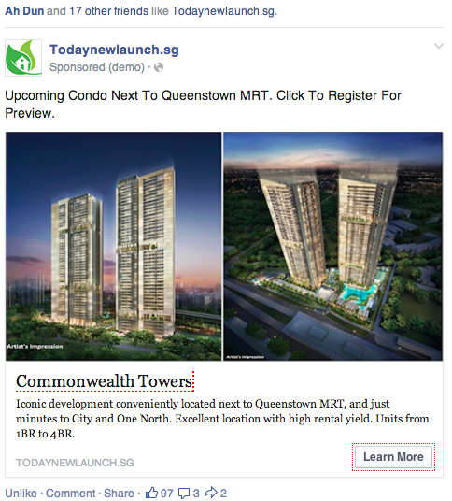
Active From: 01/04/2014 to 07/04/2014

89,088 people seen your ad
1,750 people engaged your ad

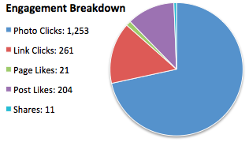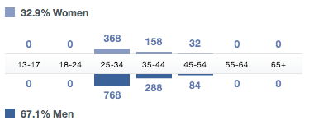
STRAITS TIME EXPOSURE
While online marketing is slowly taking over printed ads, looking for property from straits time is still a common practice by many consumers. The viewership is enormous, but how do you make your ad stands out and get your targeted buyers to pay more attention to your ad at a reasonable price?

As such, we will put together a periodical ad on Straits Times for you to feature your project. This ad will consolidates the new property launches in one full-color, prominent advertisement, so that buyers looking for new property will definitely take notice of this ad, and thus, your project featured with us will receive more attention as well, as compared to cluttering with the other advertisements in other sections.

Sample Straits Times Ad
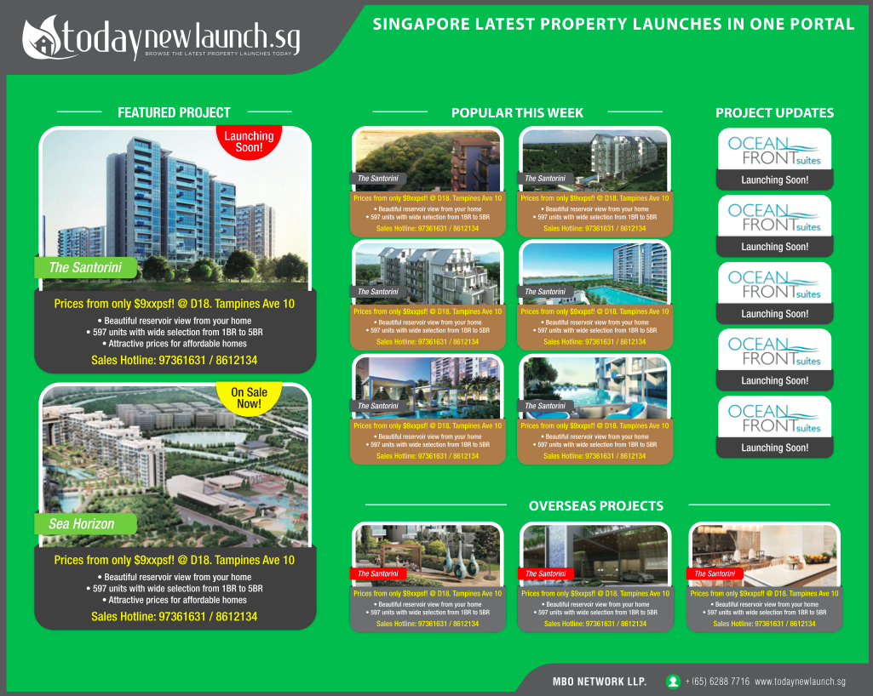
Compare these 2 ads. Which one gets better attention for a buyer looking for new launches property?

EMAIL BLASTING
Want immediate attention for a new launch project? A promotion? A Re-launch? Or project coming to completion? Consumers are always interested with such events. Let us help you to spread this to public by notifying our subscribers, as well as local agents, on such important updates through our emails blasting service.

How is it different from sending your own? Well, beside avoiding the hassle - a trusted name, recognized server, and a well-designed newsletter - will better catch the recipients attention, less likely to end in spam, and our targeted recipients are consumers with genuine interest and our subscribers numbers are growing fast.

How Our Marketing Campaigns Boost Your Project Awareness

Google
Your
Project
Straits Times
Facebook
60,000 to 100,000 targeted consumers per campaign
Tens of thousands of genuine property searchers monthly
Hundreds of thousands of eyeballs

Illustration 1: Active Marketing

3. Your Project Gains Huge Awareness From TodayNewLaunch.sg

Even when your project isn’t actively marketing, it will still receive great interest and awareness from quality consumers, and here is how.

CROSS TRAFFIC
The marketing campaigns on the many other projects will generates high number of visitors to our portal, and these visitors has a high chance to see your project as well.

How Your Project Gains Constant Awareness From TodayNewLaunch.sg

Google Facebook Straits Times

Marketing activities for many other projects in TodayNewLaunch

Project 1
Project 2
Project 5
Project 4
Project 6
Project 3

Your Project
Huge Traffics Flows To
TodayNewLaunch

Illustration 2: Passive Marketing

QUALITY VISITORS
As our portal is dedicated solely on the new launches property, visitors to TodayNewLaunch.sg are probably interested in new property and a good chance they will be interested in your project. And as showed by our extremely low bounce rate, they don’t simply come and go after landing on any of our page.

[Illustration to compare our 1% bounce rate to 10% average]

FAST GROWTH IN TODAYNEWLAUNCH.SG
All these marketing campaigns also means the public will take notice of our portal very fast, and with our neat interface, user friendly features, reliable and updated content, we are absolutely certain to have an exponential growth in viewership, in order to bring to you more quality visitors on your project very soon.

COMING SOON
TodayNewLaunch.sg is continually improving. We’re planning a major update to the portal soon, to make it even better with:
- Enhanced features
- Improved functionality
- An even more useful, user friendly interface
- More marketing packages
OUR PACKAGE PRICING

Advertise with us today and you will enjoy amazing discount and other benefits!

PACKAGE OVERVIEW | PROMOTIONAL PRICE | ALL-IN-ONE PACKAGE
PACKAGE OVERVIEW | (limited period) | (highly recommended)
Full-Featured Webpage | $1,000  (50% off) | WAIVED
• Nicely arranged & organized info & images | $1,000  (50% off) | WAIVED
• User-friendly and search-engine-friendly content
Advertising Space On TodayNewLaunch | $1,500 per quarter  (50% off) | $3,888 per quarter
• Huge awareness from cross traffic | $1,500 per quarter  (50% off) | $3,888 per quarter
• Regular maintenance and updates
SEO for Google Ranking | $1,500 per quarter  (50% off) | Included
• On-page and Off-page optimization | $1,500 per quarter  (50% off) | Included
• Page 1 Google ranking, and possibly top 5
Facebook Marketing | $800 per round  (50% off) | FREE 1 round every quarter
• Design & prepare ad campaign on facebook | $800 per round  (50% off) | FREE 1 round every quarter
• Reach out to 60,000 to 100,000 targeted consumers
 | $150 per round | FREE 1 round every quarter
Email Marketing | (50% off) | FREE 1 round every quarter
• Design & prepare newsletter
• Send to 10,000++ interested subscribers & agents
Straits Times Ad | $500/$2,000 per ad | FREE 1 mid size ad every quarter
• Design & prepare project ad | (20% off) | FREE 1 mid size ad every quarter
• Prominently placed in our consolidated, colored ad

** Prices are charged at a quarterly basis. Jan-Mar, Apr-Jun, Jul-Sep, Oct-Dec. Pro-rating applies for first quarter subscription based on number of remaining days on that particular quarter.
** Prices are subjected to change without advance notice. However, advertiser who takes full package now gets to enjoy the same pricing and benefit for four consecutive quarters.

CALL OUR SALES REPRESENTATIVE TODAY
97361631 / 94556779

