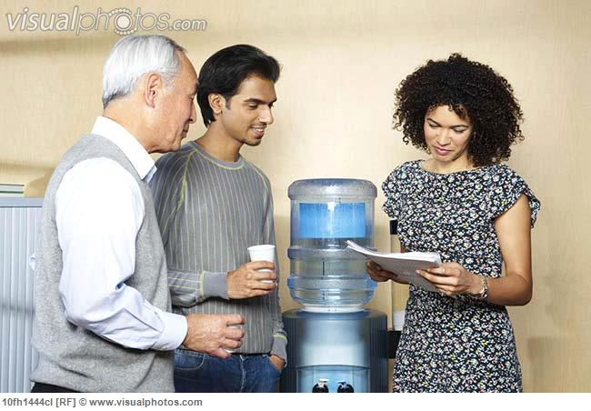

Please find picture when:
1. small business owner can relax because the accountant helps them
2. the accountant do his job

