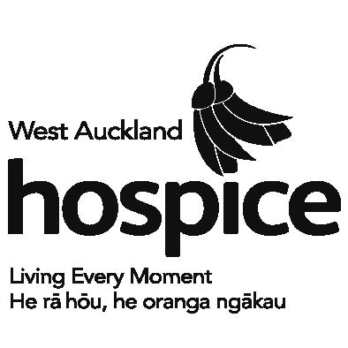
presents



A night of upcycled fashion, beauty, auctions and entertainment

*with celebrity MC Colin Mathura-Jeffree*
Thursday 21 August 2014, 7.30pm
Langtons on Lincoln
130 Lincoln Rd, Henderson
Auckland

Tickets* $49 or $60VIP
Tickets strictly limited - book online at iticket.co.nz or ph (09) 361 1000 

All tickets include complimentary canapés & a glass of bubbles
VIP tickets include a Goodie Bag and reserved seating (front two rows)
*+ booking fee

Showcasing fabulous upcycled fashion from Hospice Shops - all garments available for sale on the night at Op Shop prices!

ALL PROCEEDS TO HOSPICE WEST AUCKLAND’S NEW SPECIALIST PALLATIVE CARE UNIT

