CLEAN ENERGY ACCELERATION PROGRAM
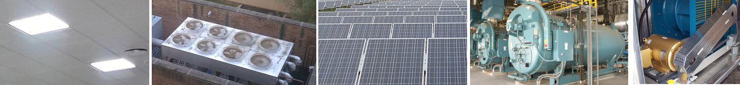

OVERVIEW
Enerdigm Capital is a specialty financing company focused on helping accelerate the implementation of clean energy projects such as lighting, HVAC retrofits, boilers, solar PV and cogeneration.

HOW
Enerdigm provides financing solutions moving an energy upgrade project from a “capital improvement” to an “operating expense”. Our structure is off-balance sheet and is similar to a basic utility payment. We even take-on the long-term maintenance costs. Our customers benefit from substantial electricity and maintenance savings for decades.

EXAMPLE
Hospital Case Study
Today | Enerdigm Acceleration | Savings
Makes an energy payment to its local electric utility for $5,000,000 per year.  Spends $100,000 per year on maintenance. | Makes an energy payment to its local electric utility for $3,500,000 per year.  Makes an energy payment to Enerdigm for $1,000,000 per year for 10 years.  Also saves maintenance | Hospital saves: $500,000 per year in energy and $100,000 per year in maintenance.

BENEFIT TO THE DEVELOPER
- Paid by Enerdigm Capital based on a pre-negotiated milestone delivery schedule.
- Captures full margins.
- Speeds up project implementation cycles.
- May have the option to conduct the facility long-term maintenance.

ABOUT OUR FUND
We are a $500 million energy project fund, initially established in 2013. Our leadership hails from over 20 years in energy services and renewable energy project development and deployment. In our work we have always found excellent projects, short paybacks and motivated clients. Consistently, the greatest challenge has been a lack of project financing. We seek to close this gap and accelerate all energy projects.

OUR MISSION
We seek to implement over 1 GW’s worth of energy efficiency and renewable energy solutions by 2017 and become the World’s largest clean energy asset portfolio.

OUR PORTFOLIO
Our current fund has allocations for different projects based on technology. Hence, this is a first-come-first-served situation.

PROJECT CHARACTERISTICS
We are seeking projects with simple paybacks as follows:
Energy Conservation Measure | Payback (Years)
Lighting Retrofit | 2-5 Years
Chiller Retrofit | 3-7 Years
Motor Retrofit | 2-4 Years
Variable Frequency Drives | 1-3 Years
Solar PV (In Key Markets) | 5-8 Years
Enerdigm Efficiency Portfolio Payback (L-T) | 4 Years

IF YOU HAVE A PROJECT PLEASE CONTACT US:
Enerdigm Capital Management, LLC  825 San Antonio Road Suite 209  Palo Alto, CA 94303  415-630-2306  www.enerdigm.com |  | Managing Members:
 |  | Darren Kimura | dkimura@enerdigm.com
 |  | Juan Pablo Albán, CFA | jpalban@enerdigm.com

