The Stanford Biosciences Grant Writing Academy presents..
The Science and Art of Grant Writing

This widely acclaimed seminar comprehensively addresses both practical and conceptual aspects that are important to the proposal-writing process. Participants will be taught to write with a linear progression of logic using strategies designed to merit a fundable priority score. National Institutes of Health’s mentored K Awards and NIH’s Ruth L. Kirschstein F National Research Service Award will be highlighted.

Presenter:
Stephen W. Russell, D.V.M., Ph.D.
Co-Founder and Managing Member
Grant Writers' Seminars and Workshops, LLC

July 23rd, 2014
8:30am-5pm
Hewlett Auditorium 200 (Engineering Quad)
Register Here: http://biosciences.stanford.edu/fellowships
ADD QR CODE
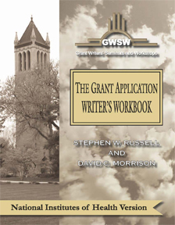

Free Book! ($75 Value)
Often referred to as the “grant writer’s bible”

