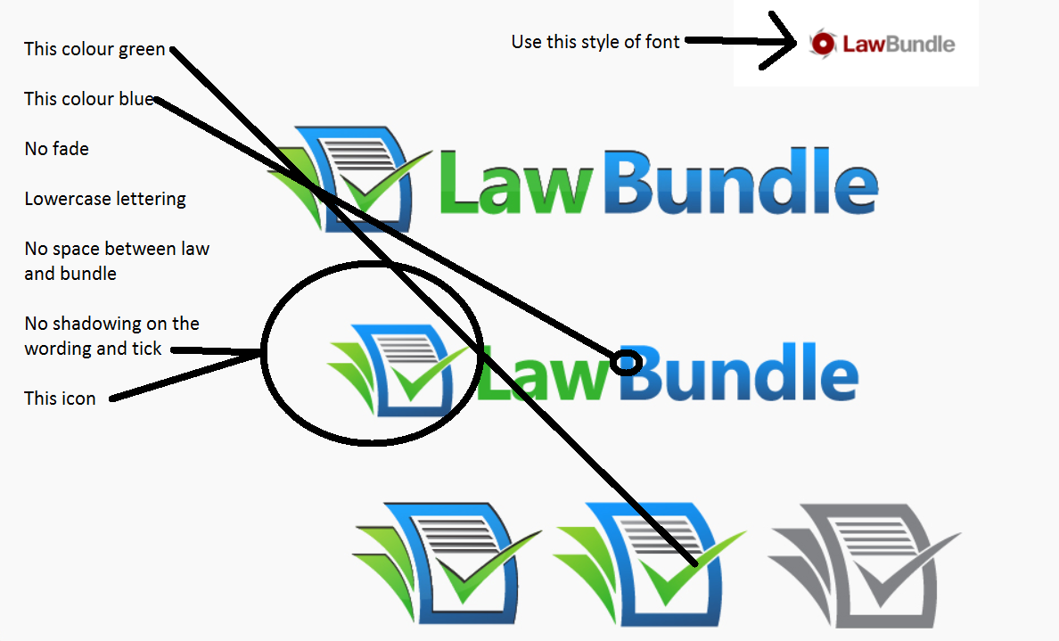
The logo style we like the most is this one, use the advice above and remodel this one

