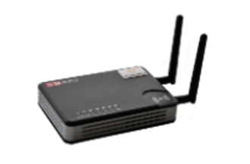


Conditions:
Promotion offer limited

KidsBlocker |
www.kidsblocker.com |
info@kidsblocker.com |

KidsBlocker is an easy solution to help manage family access to the home internet.

- Turn on/off the internet access to any or all devices in a home network, from anywhere
- Provide an access schedule for any device
- Provide internet filtering by device - to protect from
inadvertent inappropriate exposure
- Make it as easy as possible to configure and operate

KidsBlocker recently completed a technical trial with encouraging initial feedback:
“My home is calmer now”
“It’s saved my family”
“We now have the confidence to share the online world”
“I feel like a better parent”

Please visit www.kidsblocker.com for more information and the opportunity to take advantage of the current promotion.
We're sure that you'll share our vision to provide an enjoyable and safe online experience for your family.

BOUNDARIES ONLINE ARE JUST AS IMPORTANT AS IN THE REAL WORLD

