Premium Coffee Website
- Links at the header
- Home page (the logo link (same idea as mokaclube.com.br/ with bluebottle.com footer))
  - Comment: Everything below mokaclub header, with bluebottle footer (which will be the same for all pages)
  - Comment: We need icons for: 1) a coffee plant, 2) a coffee roasting machine, 3) shipping process (box, truck…) and 4) cup of coffee(looking tasty)
  - Icon references:
  - https://www.behance.net/gallery/16424857/Flat-Design
  - https://www.behance.net/gallery/15064063/Fifa-World-Cup-Brazil-2014-Flat-Design-Shields
- Brewing guides (same idea as bluebottlecoffee.com/t/categories/coffees (drawings/icons)+ brewing guide pages (like bluebottlecoffee.com/preparation-guides/drip))
- Subscriptions (see detailed explanation below)
- Merchandise (same idea as bluebottlecoffee.com/t/categories/merchandise (drawings/icons) + product pages. We also need one “Compare page” for the procucts, just like apple.com/mac/compare/notebooks.html with the “click to drag” pointer)
- Blog (same idea as bluebottlecoffee.com/press + right lateral like haveacoffee.com.br/blog/ (like us on facebook; categories; tags))
- Our Story (same idea as bluebottlecoffee.com/our-story)
- Cart (same idea as bluebottlecoffee.com/cart)

- Links at the footer
- Contact (same idea as bluebottlecoffee.com/contact)
- Special Orders (same idea as bluebottlecoffee.com/special-orders)
- Wholesale (same idea as bluebottlecoffee.com/wholesale)
- Press (same idea as bluebottlecoffee.com/press)
- FAQ (same idea as mokaclube.com.br/faq)

- Another links / pages / features
- Sign up bar (same idea as bluebottlecoffee.com)
- Checkout (same idea as meulongboard.com.br/checkout (see image 1 below or in attachment)
- Subscriptions – the buying experience is basically the same as bluebottlecoffee.com/coffee-subscriptions. However, there are a few singularities.
  - 1) We will start from a product catalog (see image 2 below or in attachment) displaying three products (diferent types of coffee) along with their a name and short description. For the first two products the customer will have two options of subscriptions to choose from (like bluebottlecoffee.com/coffee-subscriptions “ongoing subscription” and “gift subscription”). The thirsd product only takes “gift subscriptions”.
  - 2-a) If the customer choose the “ongoing subscription”, the page scrolls down just like on bluebottle, and the options as shown in image 3 appears. The person will select its preferences and click “Continue”. Then, the page will scroll down again and the customer will choose the brewing method (there won’t be the “which coffee would you like” part from bluebottle- see image 4). 2-c) Finally, the “order summary” part is just like on bluebottle.
  - 3-a) If the person (back in the product catalog) choose “gift subscription”, we there will be an extra step on the order which is to choose how long will the subscription last (like on bluebottle), and then the process continue just as the “ongoing subscription”.

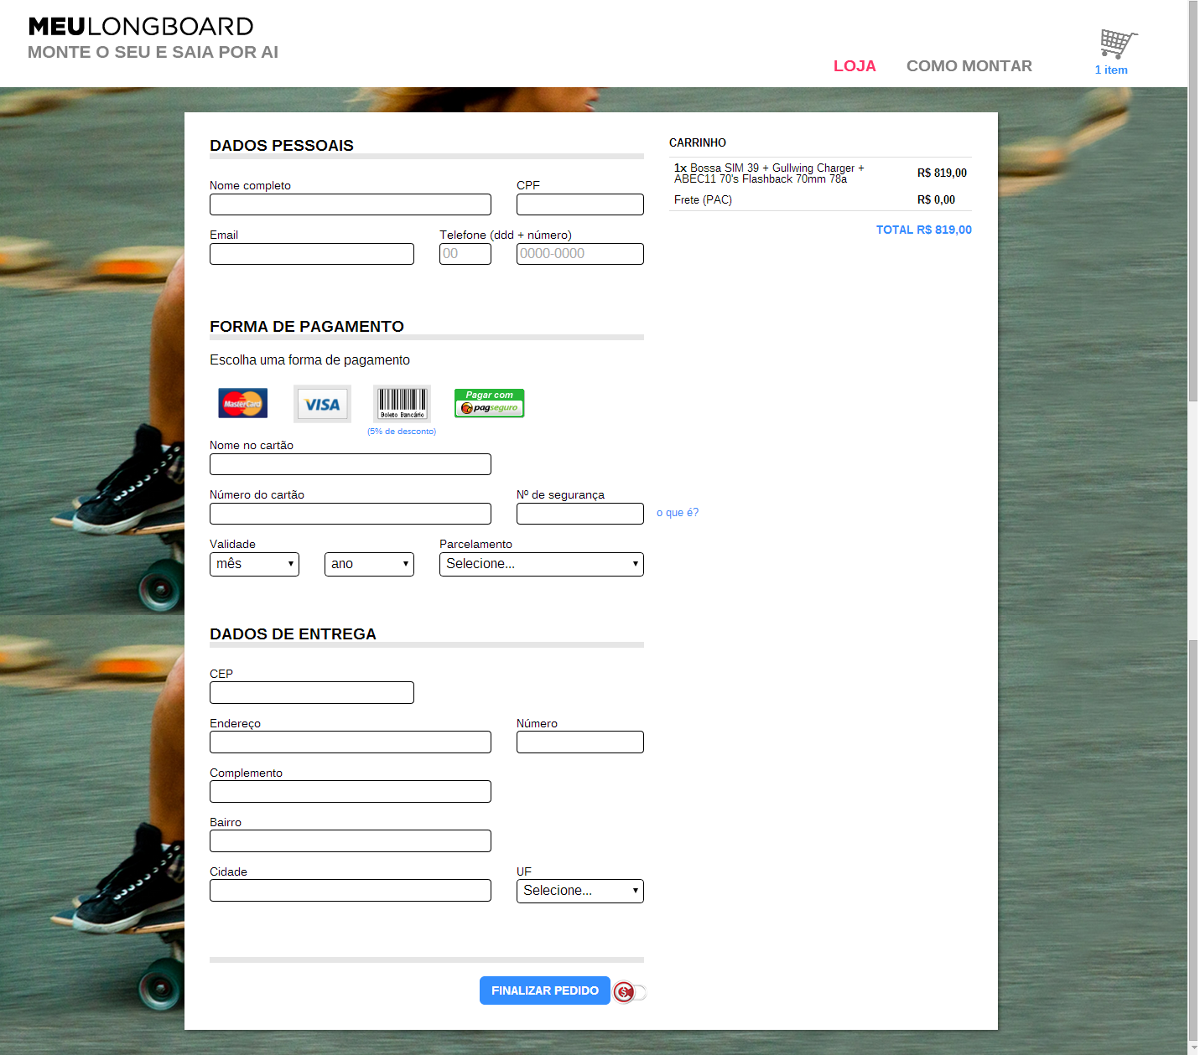
Image 1 – Checkout
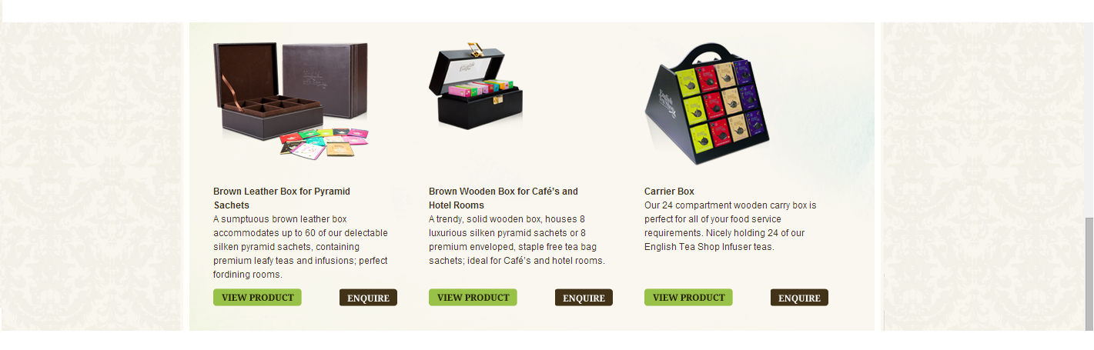
Image 2 – Subscription - Products

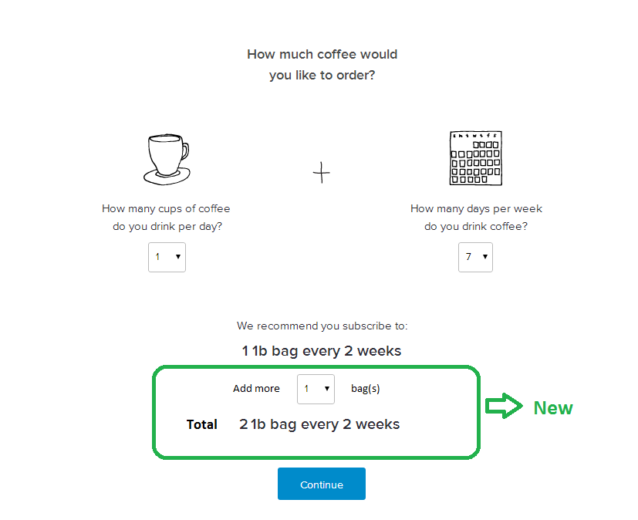
Image 3 – Subscription - Quantity Option

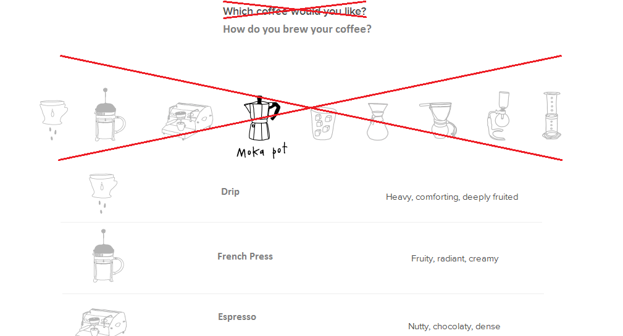
Image 4 – Subscription – Brew Method

