New Backup Assist Logo
Backup
Icon
(white

Restore
Icon
(white)
Recover
Icon
(white)
Remote
Icon
(white)_
Windows Server Backup
& Disaster Recovery
A global leader with sales in over 120 countries
BackupAssist is affordable, reliable, simple and fast
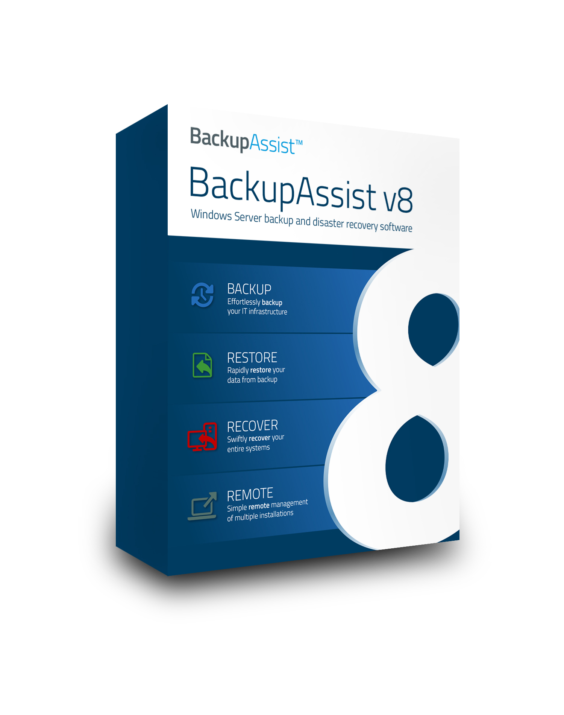 shot goes here

- Enriched scheme customization
- Enhanced Exchange granular restore
- Increased support for Server 2012 R2
- Superior Imaging Backups
- Advanced backup validation & verification
- Rapid & precise backups
- Quick Hyper-V set up
BackupAssist v8:
New features include:
Windows Server Backup and Disaster Recovery Software

Backup Icon goes here (white)
Backup
The choice of three intelligent backup
types - data replication, data compression
& data imaging
Customize a wide range of schedules,
destinations & features to plan a backup
strategy that best suits your needs

- Backup live applications like
SQL & Exchange
.
- Backup to comprehensive destinations – external & optical disks, RDX & flash drives, local directories, network locations (NAS, etc.) and iSCSI targets
.
- Customize schedules with built in media rotation schemes for your chosen destination
- Restore your Exchange databases individually or as the complete information store.
- Restore your entire SQL server or individual databases
- Fully restore Hyper-V guests and data from within your Hyper-V hosts
The flexibility of multiple backup solutions
with the simplicity of a single
Restore Console
Browse a backup or search multiple
backups at once to find the files,
folders and applications you need
Restore icon goes here (white)
Restore
Recover icon goes here (white)
Recover
- Create a customized recovery media, adding your own drivers, files and tools
.
- Choose from a selection of 13 applications, all designed to troubleshoot and assist in recovery
.
- Start a computer and perform a bare-metal recovery with RecoverAssist’s innovative recovery environment
The security of data recovery
after a critical failure occurs
Create a bootable media and launch
a complete recovery environment,
quickly returning a computer to a
previous operating state

The ease of remote management
and intelligent monitoring
Use two powerful tools to manage and monitor multiple BackupAssist
installations from a central console
- Receive one email per day for all installations on your LAN instead of one per installation with the Central Monitoring Console
- Monitor your backups and view reports anywhere you go with On-The-Go remote mobile app
Restore icon goes here (white)
Remote
Reseller stamp goes here

