ACF website – initial brief

- Objectives, target audience, key features
- Good and bad commercial finance websites
- Structure and content of ACF site.

- Objectives, target audience, promotion, key features
ACF provides "Sales Aid Finance" through ALTERNATIVE financial and contract solutions. Specialising in the Print and Technology markets, ACF offers Value Added Resellers (VARs) a range of innovative, cost effective, value added options to enhance their sales
The ACF website will evolve through a number of different phases, mirroring the different stages of the development of the business.

Phase 0 (now) (Ph0)
- Objectives: the main purpose of the website will be to become the public face of ACF, therefore reflecting what ACF stands for, providing all the relevant information about the business, its products and the management team; offering the option to download brochures mainly in PDF format (not a priority); collecting user data (e.g. email address, company details etc.), with an easy and friendly contact session (web, email, phone) for anyone aiming to get in touch with ACF. In Ph0, we don’t expect the website to become a major route to market for ACF and will rather be used as a way to impress our target audience – “they have an impressive website, therefore they must be good” – who will visit the website mainly because they will have heard of us already. Nonetheless, Search Engine Optimisation (SEO) will be already relevant in Ph1 to ensure we show up on at least the first Google page for basic searches such as “Alternative Commercial Finance”.
- Target Audience: customers (mainly copiers and IT resellers); investors (traditional funders, wholesalers, family offices); intermediaries and partners (brokers, accountants, etc.)
- Promotion: mainly from face to face contact with potential customers (e.g. copier dealers), we are not planning to promote the website in any other way in Ph0
- Key features: we are looking for a home page with another level of information underneath. The website will have to be simple, clear, easy to navigate, impactful, very professional, interesting enough without being too fancy. There will be no need to update the website regularly in Ph0, as the content will be mostly static. Key features will include:
  - a strong homepage
  - a very friendly contact us option, also allowing us to collect appropriate data (not too much, to avoid putting people off); we do not expect this feature to be used too often, as we are targeting potential customer in face to face meetings
  - enough text to be informative, without becoming boring, with a good balance of text and pictures
  - PDF brochures for download (not on day 1, just in due course)
  - option to upload a few short videos (low priority, later on)

Phase 1 (early 2015)
- Objectives: same as Phase 0
- Target Audience: same as Phase 0
- Promotion: same as Phase 0, perhaps pushing a bit more on SEO
- Key features: largely as Phase 0 although the content might become more dynamic and we will aim to upload a few videos and brochures, which will be more of an exception in Phase 0

Phase 2 (later 2015)
- Objectives: the website will still be mainly informative rather than transactional, although the content will become richer and updated more frequently, potentially to include examples of deals from the previous 6 months
- Target Audience: same as Ph1
- Promotion: potentially more based on social media, although with a selective and targeted approach
- Key features: broadly the same as Ph1, although
  - with content updated more regularly, including case studies and testimonials
  - more interactive, with brief questionnaires/tests to engage potential customers (e.g. Platform Black working capital need tests)
  - potentially with a stronger link to social media

Phase 3 (2016)
- Objectives: the website will become transactional, enabling customers to load deals directly, at least for some simple products (e.g. simple leases, ECF)
- Target Audience: same as Ph1 and 2, although it will become even more relevant for customers and intermediaries, offering them the option to transact directly through the web
- Promotion: likely to involve more traditional marketing (e.g. stand at a trade association, etc.) and PR
- Key features: significant evolution from Ph2, to include
  - customer dedicated transactional section (simple, clear, user friendly)
  - intermediaries dedicated transactional section (simple, clear, user friendly)
  - full security
  - features that will allow to request, approve, sign contractual documentation through the website

- Good and bad commercial finance websites

These are 9 examples of commercial finance websites, from very good ones to very bad ones, including major banks, innovative providers, small and larger brokers.

http://www.platformblack.com/ (very good)

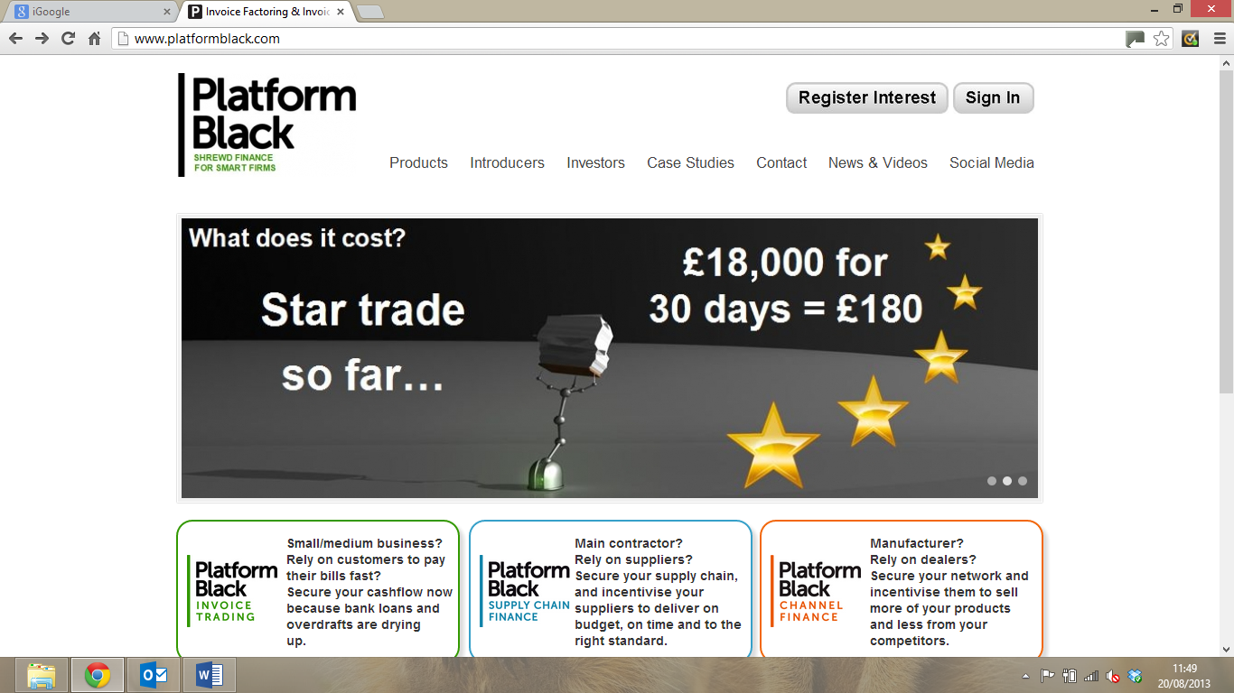

- clear and relatively engaging
- focus on three products already from the home page
- some simple diagnostic and contact us options at the bottom
- loads of case studies and very clear user guides, good and straightforward content
- overall very informative, with easy access content and not too wordy
- dedicated sessions to Introducers, Investors, Social Media
- a transactional site, therefore a good benchmark for Ph3 for us, but already relevant for all the informative content and non-transactional features

http://www.corporateadvances.co.uk (bad)

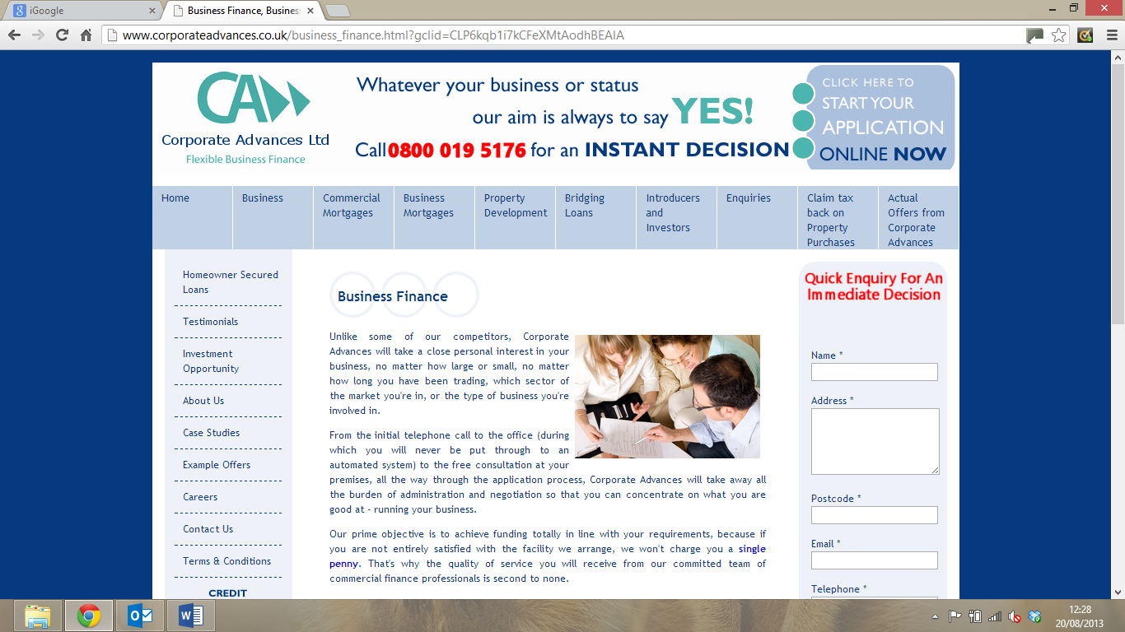

- it takes 5 mins to read all that small print, which is meant to welcome you to the website
- annoying feature asking you to register before you have even started browsing, “to win a case of wine”
- “Whatever your business or status, our aim is always to say yes” – terrible, setting the wrong expectations. Platform Black instead guides you through what makes sense for your business
- Very generic, “we can do everything for everyone”

http://www.portmanassetfinance.co.uk (good)

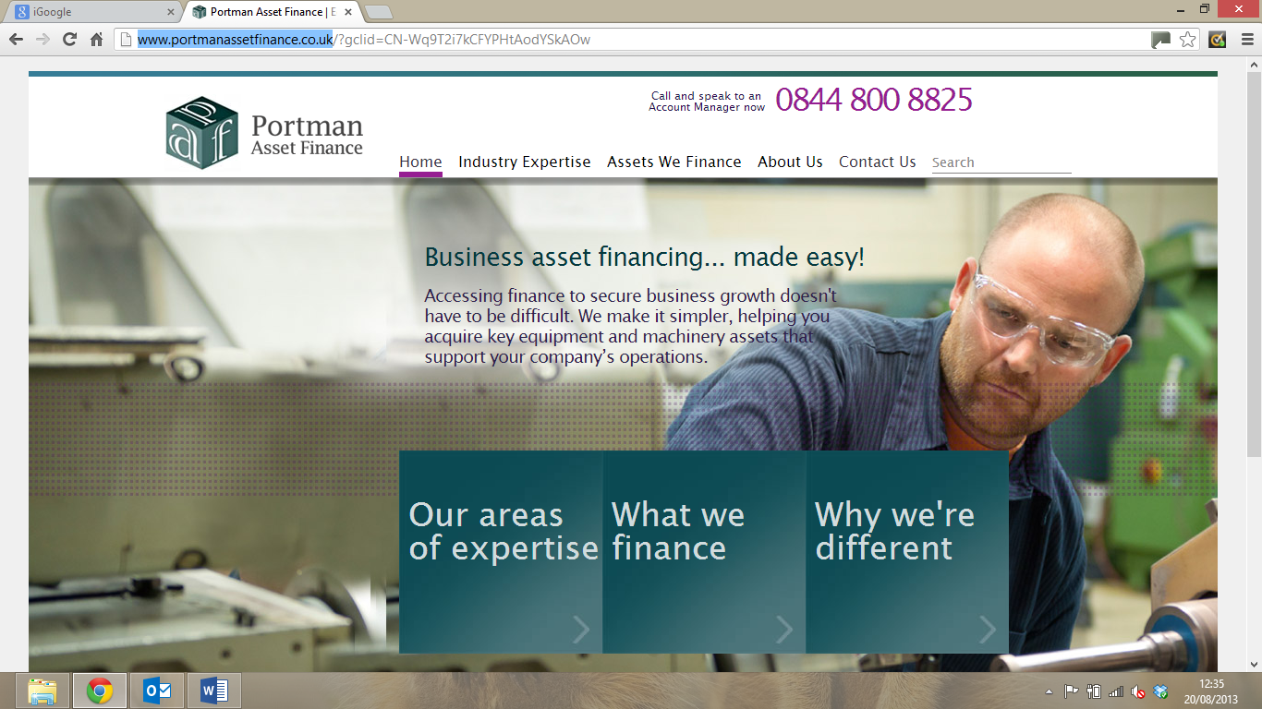

- Nice and clear front page, you understand what they are about
- One paragraph of text, explaining what they stand for
- Three boxes with exactly the right messages
- Immediately pointing at industry expertise and type of assets they finance, top and bottom of the page
- If you click on “Computer and IT Finance”, as an example, there is a simple, although not very engaging, list of benefits and type of equipment; same if you click on an industry
- Relatively clear why they are different – dedicated account manager, industry expertise, asset as the only security

www.fundingcircle.com (very good)

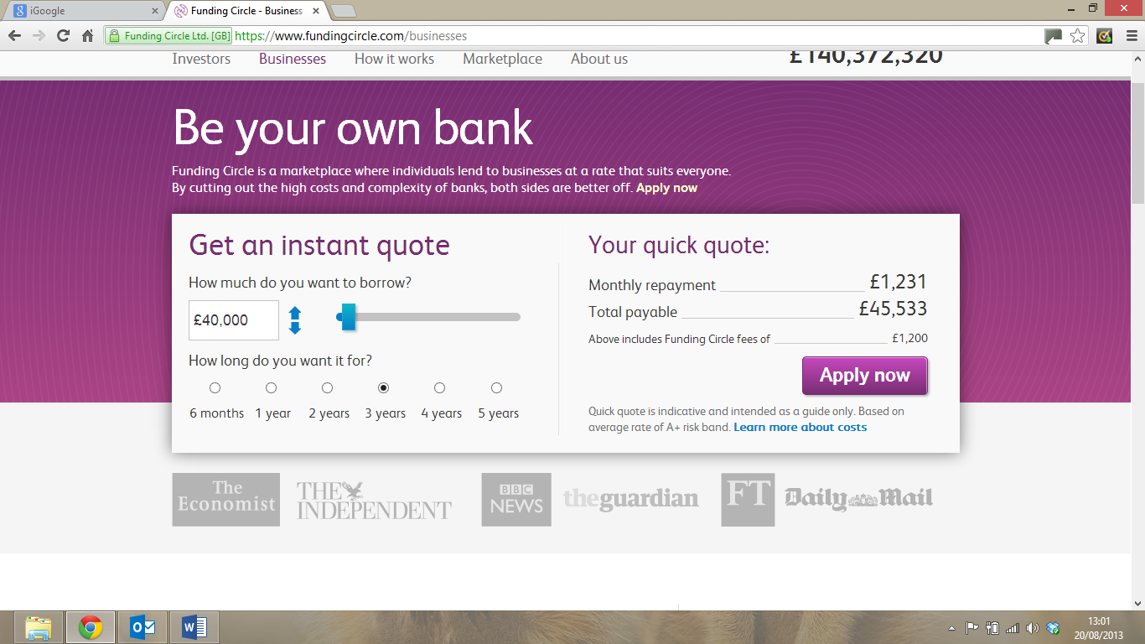

- The Businesses section couldn’t be more clear
- Under the investors section, the first thing you see is a simple video guide
- The statistics are brilliant, it couldn’t be more clear and transparent
- Obviously more relevant for Squirrl, but some principles do apply to ACF, as well
- Interesting that their projected loss rate is in the 4% range, perhaps not that low; when you add the Funding Circle fees, the actual return for the investors becomes less attractive than expected

http://www.barclayscorporate.com (average)

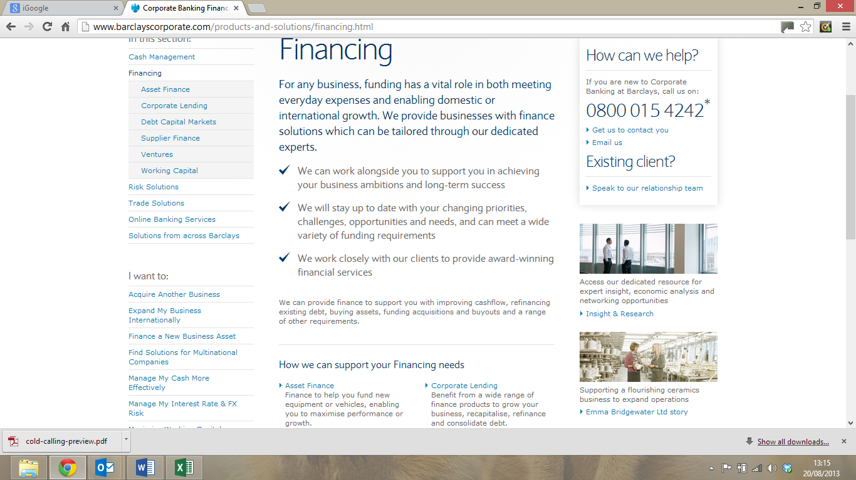

- Ok first page with Why Barclays (“Rated best bank…”)
- Then when you drill down you find loads of small print
- Nothing really distinctive, just another major bank

http://www.gecapital.co.uk (average)

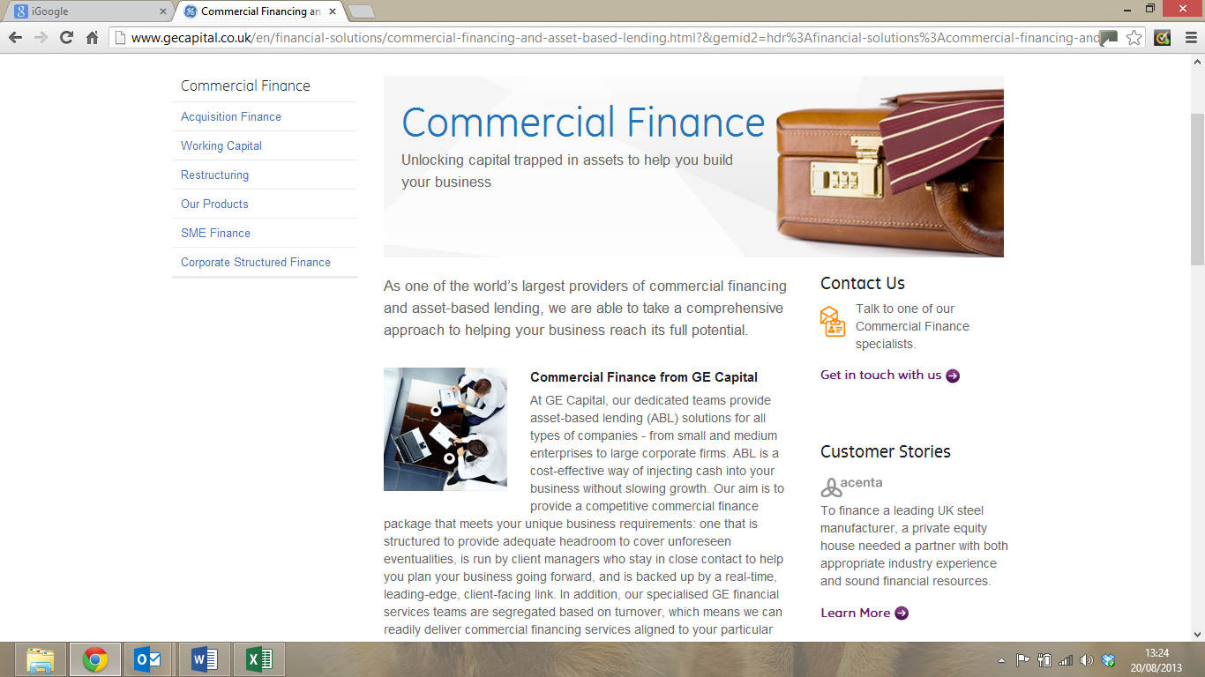

- As for Barclays, ok home page, relatively simple
- Then at the next levels, it becomes wordy and not at all distinctive
- Good contact us and customer stories on the side of the page

http://www.goodmanconsultancy.com (very bad)

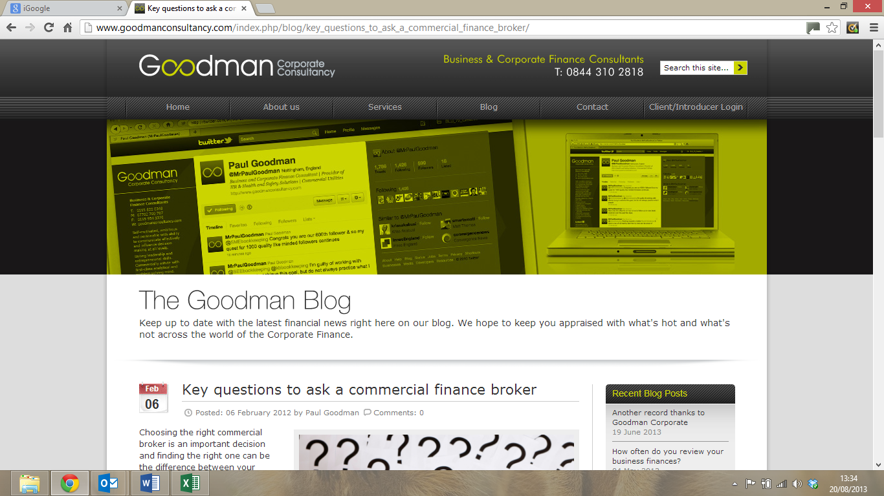

- What is good about the site is that it comes up on the first page of a Google “commercial finance” search and not even as a sponsored link – good SEO
- At a glance, the front page looks well-structured and relatively engaging
- Then you realise that are spelling mistakes
- You click on the blog and the last post is from February 2012, with no one actually replying or commenting
- Even worse, despite allegedly having a few years of history, you click on case studies and they are “coming soon”
- (yes, I don’t like Paul Goodman)

http://marketinvoice.com/ (very good)

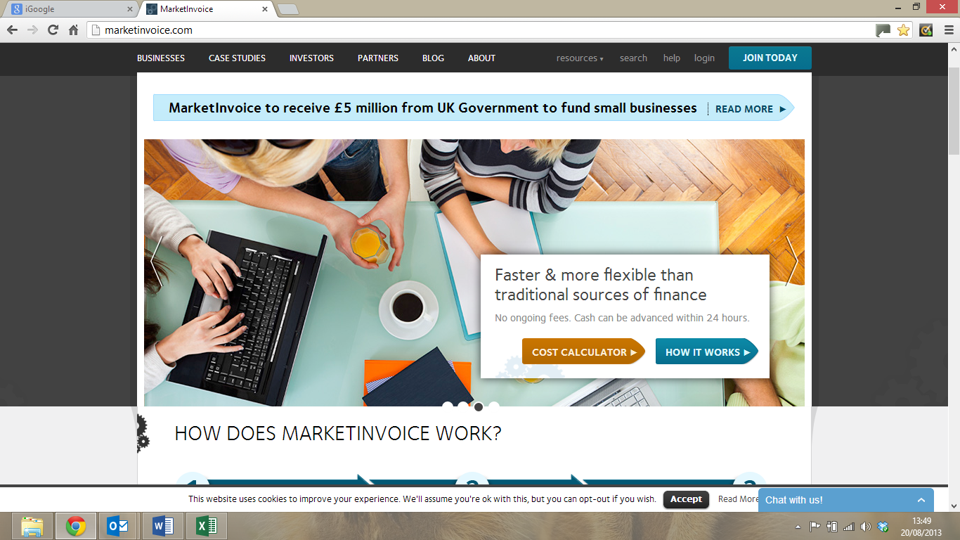

- Engaging home page, simple, with 3 simple steps
- In the business section, the calculator is very good – although the fees they are charging are really high
- In the business section, by scrolling down you have all the information you need, with no small print and quite an engaging format, including a video case study
- Interesting section for partners and introducers, with video case studies

http://www.shireleasing.co.uk (average)



- Good home page, with a few clear messages, all the four main options are engaging enough to want to click on them
- Then, when you get to the second level, it becomes boring and it is all in small print, same as the big banks although not as good
- Also, in the About Us section they claim, “Shire Leasing is the largest independent funding house in the UK for equipment finance and asset leasing” – it is either not true and therefore hidden at the back or, if it is true, why not putting it on the front page

3. Structure and content of ACF site.
The examples discussed above suggest a few simple guidelines for the ACF website:
- Engaging and simple homepage, ideally distinctive
- A few clear and relevant sections
- No more than 2 levels deep from homepage – each section can have just one more level
- Pictures and videos, although they have to be meaningful – limited use of videos, if any, in Ph0
- No small print, fewer words and clear messages
- Overall, the various Platform Black, Funding Circle, MarketInvoice etc. are far superior to the traditional banks and the smaller brokers; of the smaller providers, Portman Asset Finance is a good one
- In terms of content, things that stand out include:
  - Fee calculators (not in Ph0)
  - Stats
  - Video presentation of products (limited, if any, in Ph0)
  - Video case studies (limited, if any, in Ph0)
  - PR and awards
  - Sector expertise (relevant in Ph0)
- Things to avoid:
  - Spelling mistakes
  - Having blog-type interactive sections and not updating them
  - Small fonts and endless rants
  - Being too generic, “we can do everything for everyone”

Potential site structure – Homepage (simplified for Ph0): Please note that items in ( ) indicate information. Items outside brackets indicate headings.

(Logo - see Logo-01.jpg)
Why
Alternative ? (Box A)
Solutions (drop down menu of Managed Services, Public Sector, Education)
Contact (Box B click through)
(Rolling pictures giving the flavour of the site)
(Box C - Static with no click through)
Managed Services Solutions (Box D with click through)
Public Sector Solutions (Box E with click through)

Education Solutions (Box F with click through)

(Leave space for company details etc)

Content for Homepage:
Logo:
Content for Box C text:
We provide "Sales Aid Finance" through ALTERNATIVE financial and contract solutions. Specialising in the Print and Technology markets, we offer Value Added Resellers (VARs) a range of innovative, cost effective, value added contract and finance options to enhance their sales.
Our solutions are fully financed and we are totally independent from any VAR, technology provider or traditional finance house.

Potential site structure – Level 1 from box A "Why Alternative" (simplified for Ph0): Please note that items in ( ) indicate information. Items outside brackets indicate headings.

(Logo - see Logo-01.jpg)
Why
Alternative ?
Solutions (drop down menu of Managed Services, Public Sector, Education)
Contact (Box A click through)
(Leave space for company details etc)
Home
(Why alternative description)

Content for Why Alternative description box
In the ever changing world of print and technology projects, innovation and differentiation are key for successful VARs. ACF offers a new, fresh, ALTERNATIVE approach to the changing demands of the customer, designing specific contract and funding solutions to meet individual needs. No longer is it possible to simply "offer a one fits all solution". We are not a production line. We spend our time understanding the issues and researching the results. We work closely with our VAR's and will bespoke solutions for them given their own peculiar requirements - if there is a solution we will find it.
We boast our own suit of funding approved contracts, which enables us to work with VARs and their customers to make our solutions totally tailored to the needs of each projects.
Please check our Managed Services, Public Sector and Education solutions, to find out more.

Potential site structure – Level 1 from box B "Contact" (simplified for Ph0): Please note that items in ( ) indicate information. Items outside brackets indicate headings.

(Logo - see Logo-01.jpg)
Why
Alternative ?
Solutions (drop down menu of Managed Services, Public Sector, Education)
Contact (Box A click through)
(Leave space for company details etc)
Home
(Contact details)

Content for description of Contact box.
Simple contact us form that captures relevant information about the company and their enquiry so we can contact them with specific information to answer their questions. Content will include. Name of Organisation, Contact person, email, telephone number, Type of organisation, Reseller or User, Solution required, Any specific query. Should be able to email the contact information directly to info@alternativecf.co.uk

Potential site structure – Level 1 from box D or Solutions drop down menu Managed Services Solutions (simplified for Ph0): Please note that items in ( ) indicate information. Items outside brackets indicate headings.

(Logo - see Logo-01.jpg)
Why
Alternative ?
Solutions (drop down menu of Managed Services, Public Sector, Education)
Contact (Box A click through)
(Static picture giving the flavour of the content)
(Description of Managed Services see below)
(Leave space for company details etc)
Home
Managed Services Solutions

Content for description of Managed Services box.
Large enterprises, as well as SMEs, non-for profit and most Public Sector organisations, ask for flexibility as a key requirement for any technology implementation. They are well aware that their needs will keep evolving over the lifetime of the technology they chose to implement and therefore ask for a contractual and financing approach to meet those ever changing needs.
A typical example would be the deployment, service and overall management of a fleet of print output devices, perhaps integrated into a document management system or complete IT system.
A traditional lease, even in some of the more innovative forms, is not enough to provide the flexibility that is required to effectively manage the evolution of the solutions in dynamic organisations, because every time an asset or a service element has to be added, taken off or simply modified, the contractual complexity involved gets in the way.
ACF’s Managed Services solutions offer all the flexibility required by a technology project, within the framework of a robust, transparent, easy to manage contractual and financing structure. ACF provide support to the sales team on each managed services contract assisting with any changes the customer needs whilst ensuring the contract is fit for purpose.
Please contact us at info@alternativecf.co.uk to find out more.

Potential site structure – Level 1 from box E or Solutions drop down menu Public Sector Solutions (simplified for Ph0): Please note that items in ( ) indicate information. Items outside brackets indicate headings.

(Logo - see Logo-01.jpg)
Why
Alternative ?
Solutions (drop down menu of Managed Services, Public Sector, Education)
Contact (Box A click through)
(Static picture giving the flavour of the content)
(Description of Public Sector see below)
(Leave space for company details etc)
Home
Public Sector Solutions

Content for description of Public Sector box.
Most public sector bodies increasingly require contract flexibility. In particular, some large tender frameworks contain clauses that make funding off balance sheet extremely difficult. Two examples are the ability to assign and walk-away clauses, which require the VAR to potentially take back hardware and discontinue technology solutions in case of closure or downsizing of a department with the total loss falling on the VAR.
Such clauses made it difficult for many VARs to finance large tender frameworks, leaving only the largest VARs and some manufacturers to compete in this important market. ACF developed a solution that mitigates these risks which is incorporated into our financing tool.
Please contact us at info@alternativecf.co.uk to find out more.

Potential site structure – Level 1 from box F or Solutions drop down menu Education Solutions (simplified for Ph0): Please note that items in ( ) indicate information. Items outside brackets indicate headings.

(Logo - see Logo-01.jpg)
Why
Alternative ?
Solutions (drop down menu of Managed Services, Public Sector, Education)
Contact (Box A click through)
(Static picture giving the flavour of the content)
(Description of Education see below)
(Leave space for company details etc)
Home
Education Solutions
Content for description of Education box
Using the right type of financial product is essential for technology projects in the Education sector. We understand the legal and statutory issues and have designed a suite of contracts that provide perfect solutions.
Schools, academies and most education providers ask their technology suppliers for the flexibility to change and, under specific circumstances, terminate their contracts before the end of the original contractual terms. In addition the difference between a finance lease that is prohibited and a rental that is not prohibited - these are two of the issues we have had to deal with.
Such flexibility has discouraged some VARs from doing business in the education sector and financing these projects is becoming ever more difficult with traditional funders.

Please contact us at info@alternativecf.co.uk to find out more.

