  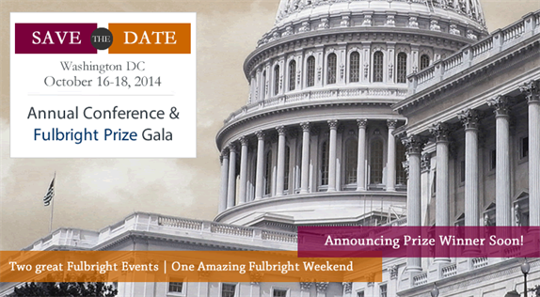
 |  |  | Connect | Support | Engage | inspire | Alumni
Save the Date: for the Fulbright Event of the Year!
Dare to Act!
October 16 - 18, 2014
Annual Conference
Hyatt Regency Hotel on Capitol Hill, Washington DC
400 New Jersey Avenue, NW
Washington, DC 20001, US
J. William Fulbright Prize for International Understanding
October 17, 2014
Ronald Reagan Building and International Trade Center
1300 Pennsylvania Ave., NW
Washington DC 20004
The Fulbright Association’s 37th Annual Conference and the 20th J. William Fulbright Prize Ceremony is the leading forum for connecting Fulbright alumni - networking opportunities and sharing of best practices. International exchange experiences and cutting edge Social Innovation globally is what Fulbright is known for.
The Annual Conference and J. William Fulbright Prize for International Understanding provides unparalleled opportunities to connect with professionals, international commissions, visiting Fulbright students and scholars, chapter leaders and the international community representing international exchange organizations in 50 states, 60 chapters and several international countries, as well as exchange and foreign policy professionals from the U.S. Department of State and the Fulbright Foreign Scholarship Board.
Early Bird Registration will open May 29th, 2014 at www.fulbright.org. Please note that there is one rate for the annual conference including the prize ceremony with an option to register separately for the prize gala.
The conference will include an opening embassy reception, prize ceremony/gala, the Selma Jeanne Cohen Lecturer award, and several other stimulating presentations.
Hyatt hotel registration is NOW open. You can also call 1-888-421-1442 referencing Fulbright Association in order to make a reservation.
If you have any questions regarding the conference or are interested in sponsorship opportunities, please email info@fulbright.org or call 1-202-775-0725.
Stay tuned for exciting speakers and session announcements, call for proposals and a full list of sponsorship opportunities!
 |  |  | Fulbright Association  1320 19 St, NW, Suite 350  Washington DC 20036 | www.fulbright.org  Stay Connected  

This email was sent to '@@email@@' from Fulbright Association. If you wish to stop receiving email from us, you can simply remove yourself by visiting: @@unsubscribe_url@@

