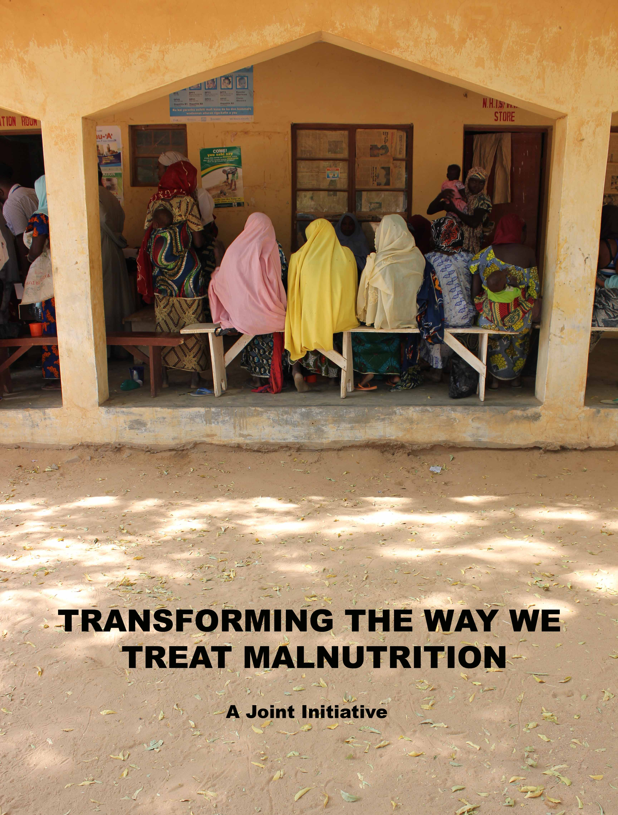
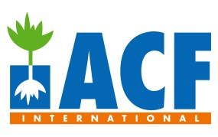


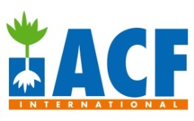
BACKGROUND

Globally, it is estimated that over 19 million children are severely acutely malnourished (SAM) at any one time. These children are more than nine times more likely to die than a well-nourished child. Whilst the number of children affected remains largely consistent year after year, the capacity to identify, rehabilitate and cure severe acutely malnourished children has undergone dramatic transformations in recent decades.

The first such transformation came with the development of tailor-made therapeutic milks in the early 1980s. These milks offered for the first time the opportunity to successfully rehabilitate severely malnourished children. As with all powder-based formulas, the provision of such milks requires access to hygienic conditions and clean water. Because such conditions are rare in contexts with high SAM prevalence, the milks could only be provided safely under in-patient care in hospitals (or Therapeutic Feeding Centres, TFCs, as they were known). This approach led to a number of challenges: first, the fixed-capacity model meant that the supply of care did not correspond to demand in the communities, but rather to the size and therefore capacity of these facilities. Second, once admitted, overcrowding increased the likelihood of cross-infection amongst children whose immune system was already compromised. The caretakers were also affected; the opportunity costs of staying in hospital for over 30 consecutive days was high, leading to many abandoning the facilities or not attending in the first place. Although there is no reliable data on the subject, it is estimated that the inpatient model of care treated only around 10% of affected cases in programme areas and only a couple of hundred thousand cases of SAM globally each year for most of the 1980s and 1990s.

These conditions gave rise to a second transformation linked to the development of Ready-to-Use Therapeutic Foods (RUTFs). RUTFs are energy-dense, micronutrient-enriched pastes that have a nutritional profile similar to the traditional therapeutic milk based diet used in inpatient therapeutic feeding programmes and are often made of peanuts, oil, sugar and milk powder. What makes RUTFs different, however, is the fact that they do not require cooking, refrigeration or the addition of water. The absence of water reduces the risk of contamination, making them ideal products for home based treatment. In the late 1990s, the advent of RUTFs gave rise to a home-based service delivery model for the treatment for severe acute malnutrition (the Community-based Therapeutic Care, or CTC, model). The CTC model was initially developed and implemented by a number of international Non-Governmental Organisations (iNGOs). The effectiveness of this model quickly became apparent: not only were recovery rates comparable to that of inpatient care, but more importantly, being a variable capacity model with low opportunity costs for caretakers, it led to unprecedented levels of coverage being achieved. Instead of 10% of SAM cases receiving treatment in programme areas, 70% of cases were being reached. The number of SAM cases treated globally in the first decade of the 2000s went from a couple of thousand to over a million.

In 2007, the combined benefits of this model were acknowledged by the World Health Organisation (WHO), the World Food Programme (WFP), UNICEF and the UN’s Standing Committee on Nutrition (SCN) and led to the integration of community-based treatment (relabelled as Community-based Management of Acute Malnutrition or CMAM) into routine services delivered by Ministries of Health (MoH) in over 60 countries around the world. These services, provided with the support of iNGOs including Action Against Hunger (ACF), today reach more than 2 million SAM children a year.

Although the transformations in the type of treatment used and the way treatment is delivered have radically increased the number of children receiving treatment, there is still the capacity to treat significantly more. In 2012, ACF launched the Coverage Monitoring Network (CMN); the first ever inter-agency initiative to assess the coverage of SAM-treatment services. There are many indicators to measure the effectiveness of CMAM services (e.g. cure rates, average length of stay, average weight gain), but coverage (the proportion of needs met by an intervention) provides arguably the most reliable measure of impact. The recent development of comprehensive and innovative coverage monitoring tools (including the SQUEAC and SLEAC methods) has provided the means by which to monitor programme coverage practically and easily. What is more, these methods provide not only an estimation of the services’ coverage in its target area but also highlight the main factors preventing beneficiaries from accessing the services (also known as ‘barriers to access’). The CMN was created as a response to a growing sense amongst iNGOs that the levels of coverage being achieved by SAM-treatment services was increasingly falling short of initial expectations, and a desire to understand what lay behind this change in performance.

By the end of 2013, the CMN project will have assessed over 100 SAM-treatment programmes in an estimated 28 countries around the world. Initial findings suggest that on average SAM-treatment services currently reach around 40% of SAM cases in their target areas. This means that the number of SAM cases treated globally could be significantly increased, perhaps doubled, by simply improving the performance and coverage of existing services. Improving coverage requires understanding of the barriers to access. Across the world, assessments are identifying a series of consistent factors that limit the capacity of caretakers to seek treatment for children suffering from SAM. The first barrier is a communication gap between the services and the intended beneficiaries. People residing in areas with services are generally unaware of these services, how they work and what they offer. Even when such awareness about service availability does exist, awareness amongst caretakers about the condition of SAM itself is often limited. Increasing public understanding has been shown to increase coverage by more than one percent a month. But increasing demand for the services has helped highlight a second challenge; the health infrastructure of most Ministries of Health is ill-prepared to cater for the high number of cases seeking treatment. The number of health facilities (e.g. health centres, health posts, clinics) in most health districts or provinces in Africa and Asia is low, meaning that many are forced to travel long distances to the nearest facility offering care. Whilst there, waiting times can exceed several hours, as few primary health care workers are tasked with delivering care. This coupled with inconsistent quality of care, insecurity and competing priorities means that as many as 2 out of 3 caretakers with children affected by SAM simply do not seek care or ‘default’ (stop attending) after only a few visits.

These challenges are not unique to the treatment of SAM; they have affected the implementation of other public health interventions including the prevention and treatment of HIV/AIDS, Tuberculosis, and Malaria. But whilst these interventions have changed their delivery approaches to deal with these barriers (implementing the rapidly growing integrated Community Case Management model of care, delivered by Community Health Workers for these diseases), relatively few attempts to introduce significant changes to the delivery model of the treatment of SAM have been made. Pilot research has shown that modifications to the service delivery model – including the delivery of SAM treatment by Community Health Workers (CHWs) at community-level - can reach over 90% of the affected cases. These examples, however, have shown the efficacy of such models (i.e. what can be achieved in controlled settings with optimal support and supervision) but not its effectiveness (i.e. what can be achieved in “normal” settings with routine support). What is missing is evidence that Ministries of Health can adapt and enhance the current service delivery model and incorporate new elements necessary to deliver higher coverage and performance. This joint initiative and the Innocent Foundation aims to contribute to filling that gap.

OBJECTIVE

Overall Objective

The overall objective of this initiative is to increase the proportion of severely malnourished children treated globally, in CMAM or similar programs, by transforming the current service delivery model and improving access to treatment services.

Specific Objectives

- To pilot alternative models that empower community health workers to play a more direct role in the provision of SAM treatment
- To build an evidence-base about the effectiveness of this approach and its comparative advantage over the existing model of service delivery
- To advocate for further implementation, adoption and scale up of this model at country and global level
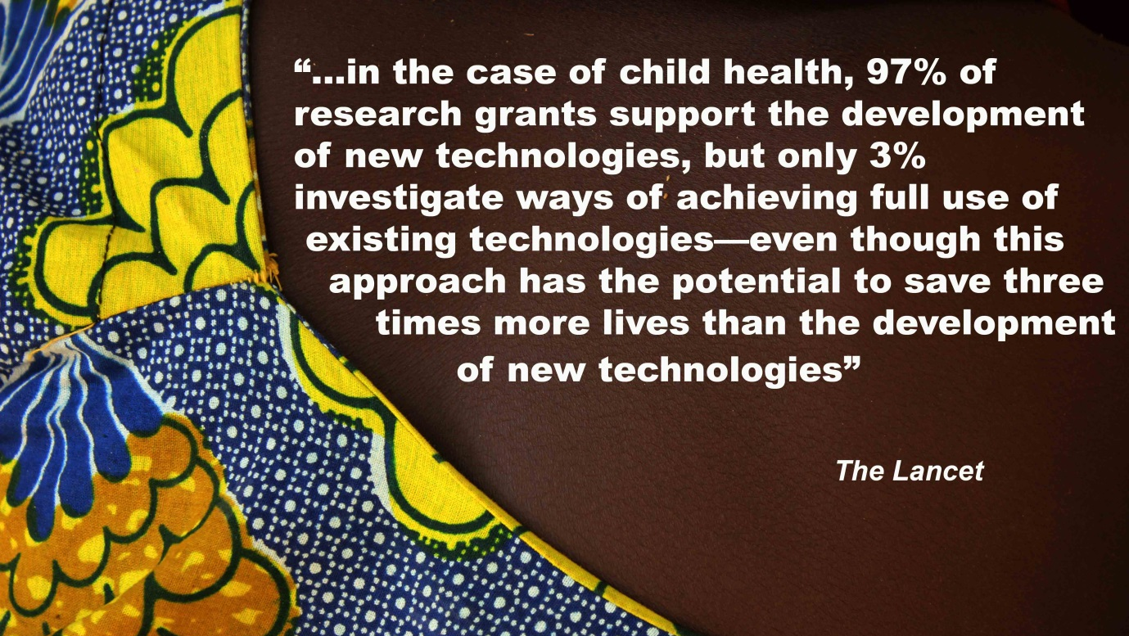
STRATEGY

The implementation strategy for the proposed initiative consists of four phases. Given the innovative nature of much of the proposed work, the details of many of the activities under these four phases will only become clearer as currently on-going work develops, and in particular, after the completion of the Inception Phase (Phase 1). The general sequence of activities and overall focus of these stages, however, is expected to remain largely unchanged.

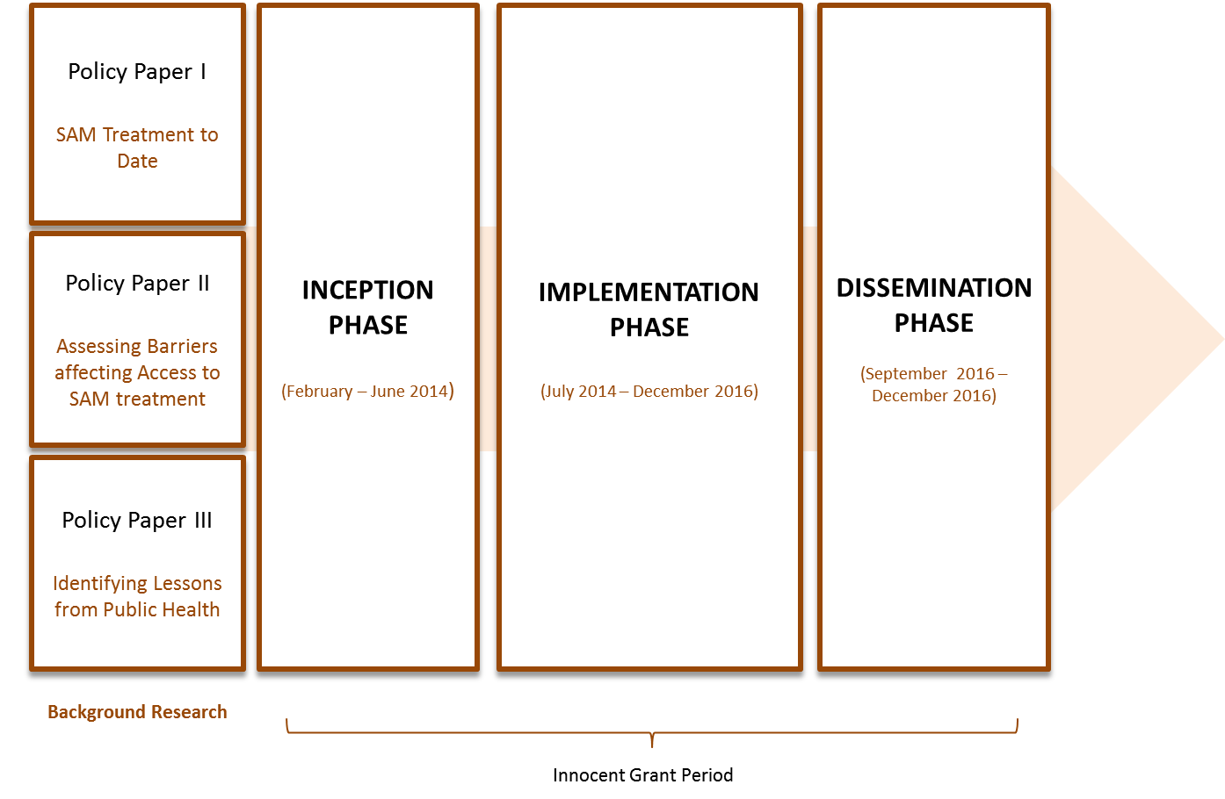

Background Research (January 2013– February 2014)

Between January 2013 and February 2014, Action Against Hunger coordinated a multi-stakeholder, multi-layered background research process. The primary aim of this phase is to produce a detailed analysis about the past, present and potential future of SAM treatment programming. This analysis, implemented by Action Against Hunger and its partners (including Save the Children, Concern Worldwide, International Medical Corps, Helen Keller International, World Vision and Valid International and a core team of external reviewers) provides the foundations for the subsequent phases of programme modelling and piloting which will be supported by the Innocent Foundation.

SAM Treatment Data
With funding from the European Commission’s Office for Humanitarian Aid & Civil Protection (ECHO), the Office of Foreign Development Assistance (OFDA) of USAID and its own funds, ACF launched a literature review of SAM Treatment in January 2013. The review provides one of the most comprehensive analysis to date of the history of SAM treatment, from the development of therapeutic milks and the in-patient model of care, to the introduction of RUTFs and the CTC/CMAM models of outpatient care. The review includes an analysis of every publicly available dataset from CTC/CMAM programmes around the world, including trends in clinical performance and coverage. The review was published under the title Access for All, Volume 1: Is community-based treatment of
severe acute malnutrition (SAM) at scale capable of meeting global needs?

Community Perspective
The literature review was then complemented with a series of field visits to high performing SAM-treatment programmes. ACF recruited an independent external consultant (May – August 2013) to build on the findings of the review and to visit three (3) high performing SAM-treatment programmes in Ethiopia, Kenya and Pakistan. The aim of the field work component was to provide a human perspective on the issue of access to SAM treatment. Building on the partnerships established as part of the on-going Coverage Monitoring Network (CMN) Project, the consultant was able to select high performing programmes from the pool of programmes currently supported by ACF and Concern Worldwide, two of the leading nutrition organisations. As part of these field visits, the consultant documented the experiences of caregivers, service providers and community members. The review was published under the title Access for All, Volume 2: What factors influence access to community-based treatment of severe acute malnutrition?

Broader Literature Review
The final step of this process was to put these perspectives on SAM treatment within the broader context of the experiences of public health interventions, including HIV/AIDS, Tuberculosis and Malaria, to ascertain how these interventions have addressed similar challenges in access and performance. This final review sets out to extract the key strategic and tactical changes made by these interventions and the lessons generated from these adaptations to service delivery. In particular, the review identifies integration into national services and further decentralisation of service delivery as key measures taken to successfully improve access and coverage. The review is expected to be published in April 2014.

The analysis carried out during the preparatory phase suggests that integration of SAM treatment into existing healthcare packages delivered by Community Health Workers (CHWs) could provide a model capable of bridging some of the most common barriers to access faced by traditional service delivery models. There is, however, limited evidence about the implications of delivering SAM treatment through CHWs, in particular as part of a national system for the development of health care packages through outreach systems. The grant from the innocent foundation would enable Action Against Hunger and its partners to build on the findings of this analysis and to put some of the potential solutions for improving access to SAM treatment to the test.

Inception Phase (February 2014 – June 2014)

A five-month inception phase will be implemented between February and June 2014. During this phase, five crucial activities will take place

- Understand the Policy Environment
During this period, Action Against Hunger will attend the first Integrated Community Case Management (iCCM) Evidence Review Symposium organised by UNICEF and the World Health Organisation (WHO) in Accra, Ghana (March 3rd – 5th, 2014). This event will enable the project to better understand current thinking on the design, implementation and evaluation of iCCM services, and to establish formal and informal linkages with other stakeholders involved in the integration of SAM treatment and iCCM.

- Formalise Field Arrangements
Action Against Hunger will also use this period to travel to selected field locations (including Mali and Pakistan) to meet with key stakeholders for the study. These visits will be essential to ensure to adequately explore the strategic and practical dimensions of the study, develop study plans and budgets and perhaps most importantly to involve key national policy makers from the Ministry of Health and the relevant UN agencies, in the project and its outcomes. In addition, this period will be used to initiate (and whenever possible complete) the process of securing Ethical Approval in both study locations.

- Develop Detailed Study Proposals
The inception phase will also be essential to enable Action Against Hunger and its partners to develop detailed study proposals. The proposal will provide a detailed study architecture for the study implementation, as well as the alignment of tools and protocols with research questions and implementation strategy.

- Finalisation of Inter-Agency Agreements
During this phase, Action Against Hunger will define and finalise any administrative and legal arrangements with its partners, outlining clear roles and responsibilities and allocation of project resources. Agreements are expected to be needed between ACF-UK, ACF-Pakistan, ACF-Mali, Aga Khan University (Pakistan) and in the form of Memorandums of Understanding (MoUs) with Ministries of Health in Pakistan and Mali.

- Convene Stategic Advisory Group (SAG)
During the inception phase, the members of the Strategic Advisory Group (SAG) governing and steering the overall project will also convene to review the study protocols, and develop a plan for regular engagement and support to each country, as well as the necessary steps for optimal project coordination.

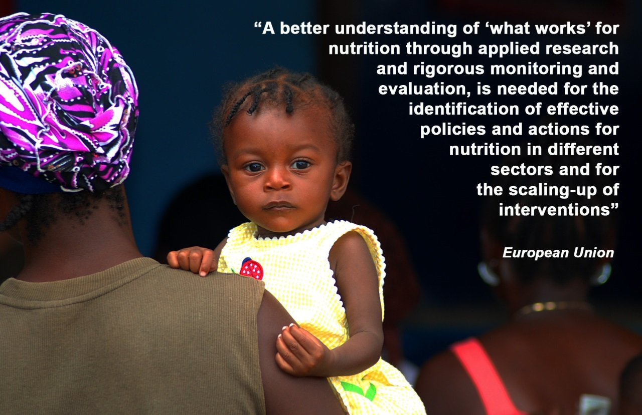

At the end of the Inception phase, Action Against Hunger will provide the innocent foundation with an inception report describing the final design, timeframe, evaluation framework and budget of the project.

Implementation Phase (July 2014 – December 2016)

The implementation phase of the project will begin in July 2014 and last until December 2016. The project will build on two distinct study arms; one study will be carried out in Pakistan and another study in Mali. Each of these studies will explore the feasibility and impact of transforming the role of Community Health Workers in the provision of SAM treatment. In each country, the specific focus of the study has been developed with the broader nutrition and health policy environment in mind, so that the findings of the study will have more significant effects on the future of SAM treatment in each context. Yet, both studies share enough common ground to enable the meta-analysis required to meet the objectives of the project.

Pakistan Study

Study Rationale
In Pakistan, an estimated one million children are affected with SAM. Recent drought, floods and conflict have increased the vulnerability of children to malnutrition. The Pakistan National Nutrition Survey of 2011 reported serious levels of global acute malnutrition (15.1%) and stunting (43%). In some of provinces, such as Sindh Province, rates are even higher; in Dadu district, where ACF currently operates, a recent anthropometric survey revealed a GAM rate of 12.6%. The current model of delivering CMAM services through parallel systems set up and supported by NGOs does not support linkages and integration with on-going child health services nor sustained early identification and treatment of acute malnutrition. This means that programs tend to focus on treating large numbers of cases of SAM each year rather than trying to prevent it through integration with the health systems. Yet, there is currently little evidence on the feasibility, cost-effective and impact (in terms of coverage and quality of care) of integrating treatment of acute malnutrition with treatment of common childhood illness.

The Pakistan study will examine the impact of integrating early identification and treatment of acute malnutrition with a basic package of child health interventions delivered by Lady Health Workers (LHWs) and Lady Health Volunteers (LHVs) on the quality and cost effectiveness of a treatment program for SAM and additional benefits of community mobilization. This study will document the effect on quality of the program and on cost effectiveness of identifying and treating acute malnutrition early in the progression of the disease. The incremental effect on these outcomes of implementing IYCF education and treatment of common childhood illness in addition to early identification and treatment of acute malnutrition will also be studied. Research activities will be designed and implemented jointly with Aga Khan University. The University accounts for 70% of all biomedical research in Pakistan, and much of its work focuses on community related health science research. Aga Khan’s support to the study will be led by the renowned Dr. Zulfiqar A. Bhutta, a key contributor to The Lancet’s series on Maternal and Child Nutrition series. Their technical expertise, robust network of researchers across Pakistan and Sindh province, and their track record in influencing Pakistan’s national health policy and practice, make them an ideal partner for this study.

Study Hypothesis
Early identification of acute malnutrition with effective identification and treatment of child illness through government employed LHVs and LHWs will both reduce incidence of MAM/SAM and also ensure SAM remains ‘uncomplicated’ and easy to treat. If SAM is detected early it can be easily treated with simple protocols by government LHVs and LHWs. Therefore by identifying more cases when they are ‘uncomplicated’ SAM treatment duration should be shorter and less costly. Detecting SAM early and bringing the service closer to people’s homes through the government employed staff will improve both uptake and compliance leading to better treatment coverage.

Study Objective
The study will have two primary objectives
- To estimate and compare the incidence of MAM and SAM among children under-five years of age in areas that provide Standard CMAM program delivered at facility and community level by government health care providers compared with the standard CMAM program delivered at facility by ACF staff.
- To compare the effectiveness (i.e. the rate of recovery and coverage) and cost effectiveness of treatment of SAM provided within Standard CMAM program delivered at facility and community level by government health care providers compared with the standard CMAM program delivered at facility by ACF staff.

Study Design
A two cell cluster randomized trial will be implemented to achieve the objectives of the project. The study will use two groups:

Group A- Government employed staff | Group B- ACF employed staff
- Intensive CMAM training | - Intensive CMAM training
- Identification of cases and referral to nearest Basic Health Unit (BHU) by the LHWs as per standard CMAM guidelines to be assessed and enrolled by Government LHV/Nurse.  - Further follow ups will be done by the LHW at the health house. | - Identification of cases and referral to nearest BHU by the ACF outreach staff as per standard CMAM guidelines to be assessed and enrolled by ACF CMAM Nurse.
- Identification of diarrhea and Pneumonia and referral to nearest health facility as per standard LHW guidelines | - Identification of diarrhea and Pneumonia and referral to nearest health facility as per standard LHW guidelines
- Counselling at facility and community level | - Counselling at facility level

Clusters will be defined as the population of children 0-59 months under a functional Lady Health Worker (LHW) and will be randomly allocated to one of the groups. A set of pre-condition for groups will be defined to safeguard the comparative value of the study. A cross sectional baseline survey will be conducted to ascertain the baseline indicators and an independent team of data collectors will be recruited and trained by the Aga Khan University will conduct the routine data collection on the nutrition indicators, compliance, recovery rates and complications.

The study will monitor a key set of indicators, including:
- Basic demographic characteristic of the household
- Household access to health services, water and sanitation
- Women and children feeding practices including IYCF
- Anthropometry (Height, weight, MUAC)
- Prevalence of MAM and SAM as well as Stunting, wasting and underweight.
- Children health status and co morbidities
- CMAM performance indicators

The team will visit each identified household in all two groups on a weekly basis. This routine data collection will provide the required process as well as outcome indicators and also will cross validate the activities being done by the LHWs. Data collection instruments will be developed to collect the data on the time of recruitment, follow ups and end of study. This will be linked to theory of change (TOC) and ensuring that the process is well documented throughout the study.

ACF will work in coordination with Agha Khan University (AKU) research team in ensuring that all modalities are operational and that technical training and follow-up is provided accordingly and with the participation and agreement of the Department of Health, Sindh. ACF will provide the implementation training to the LHWs and the LHVs/nurses while also be providing the essential supplies. ACF will provide on the job coaching for a semester to the Government staff and will shift to a technical oversight/supervision role for the rest of the period. The government staff will then be responsible for all steps involved in the community case management of SAM (i.e. screening, referral, supply chain management, information management, reporting and follow-up) until the successful discharges from the program. ACF will work closely with the AKU research teams at all steps from designing, data collection to conclusion of the study and finalizing the report and will ensure its support as and when required.

Risks & Mitigation Strategies
Access and security are of primary importance to ACF and its partners. The study will take place in a comparatively stable and secure part of the country, away from other more challenging regions (e.g. tribal and border areas). The implementation of study/programme activities by national staff will also decrease the security risks and ensure adequate access to all areas of the study location. Other risks, including supply chain breaks will also be mitigated through the purchasing and pre-positioning of buffer stocks.

Mali Study

Study Rationale
The Kayes Region in Mali consistently reports high levels of acute malnutrition. In 2013, nutrition surveys carried out in the region identified Global Acute Malnutrition (GAM) and Severe Acute Malnutrition (SAM) rates of 7.7% and 1.2% respectively. Since 2010, ACF has been supporting the Ministry of Health in the provision of SAM treatment in the region, and in Kita health district in particular. Much of the support has been provided through 42 health facilities (Cscom) in the area. In spite of the many advantages and successes of this approach, a recent coverage assessment carried out by ACF determined that facility-based treatment in Kita was estimated to be reaching around 25% of the affected population. Awareness and distance were found to be major barriers to access preventing caregivers from accessing care. Stronger links with the community were identified as key areas of improvement.

In Kita, there are two layers of the health system in the community; a cadre of unpaid community volunteers (Relais Communautaire) and a salaried network of Community Health Workers (Agent Sante Communautaire). As in many other countries, CHWs in Mali are tasked with providing integrated Community Case Management (iCCM) of malaria, diarrhoea and pneumonia as well as the screening, referral and follow up of children with malnutrition. This approach has proven instrumental in bypassing the limitations of facility-based services and boosting the coverage of these interventions. In Kita, CHWs have supported the World Food Programme (WFP) in the identification of Moderate Acute Malnutrition (MAM) but until now have played a more minor role in the identification and treatment of Severe Acute Malnutrition (SAM). The purpose of this study will be to explore the potential of integrating SAM identification and treatment as part of iCCM services delivered by CHWs. The implementation of the study will be led by ACF, but specific opportunities for collaboration with Tufts University (through the secondment of research staff) and UNICEF Mali (funding/opening additional study locations) will be explored during this inception phase.

Study Hypothesis
The integration of SAM treatment as part of the iCCM package currently delivered by CHWs in Mali will provide improve early identification of cases and better access to treatment services. In doing, clinical outcomes of SAM treatment (including cure, death and in particular defaulter rates) will improve. Other crucial measures of performance and programme effectiveness, including coverage and cost-effectiveness will also improve. Finally, the quality of care provided to SAM cases and their caregivers will not be negatively affected by further decentralisation of treatment services.

Study Objective
The study in Mali will have one primary objective
- To compare the effectiveness, coverage, quality of care and cost-effectiveness of SAM treatment services provided at facility level with treatment services provided by trained Community Health Workers (CHWs) in two areas of Kayes Region in Mali

Study Design
The study will be an observational study comparing key performance indicators in two neighbouring sectors of Kita District, Kayes Region. The study will include all children admitted into joint Ministry of Health/ACF programme in each of these two sectors (locations) over a twelve-month period. In one sector (control), SAM treatment will continue to be provided at facility level. In the other sector, SAM treatment will be delivered by trained Community Health Workers (ASC). In both locations, the study will evaluate four key sets of indicators
- Clinical Outcomes (Cure, Death and Defaulter Rates) of children enrolled in the programme
- Cost-effectiveness
- Treatment Coverage
- Quality of Care

Two sectors of Kita District will be used for this study; South Kita and Centre-North Kita.

 | South KIta | Centre-North Kita
Number of SAM Admissions, and percentage of total (2013) | 1,173 (26%) | 792 (17.6%)
Number of Community Health Workers (CHWs) | 21 | 14
Number of Existing Health Facilities providing SAM treatment | 8 | 7

Prior to the initiation of the study, baseline information will be collected for these four indicators. In addition, a national and district level meeting will be conducted with key stakeholders (including representatives of the Ministry of Health, formal and informal community leaders, etc.) to outline the objective of the study and promote greater engagement of the health authorities in both the implementation of activities and utilisation of results.

Community Health Workers (CHWs) in the study area will be identified and trained using national SAM treatment protocols. In both study locations, the study will carry out comprehensive community sensitisation activities to ensure adequate levels of awareness about the location and nature of the treatment services. During the course of the study, ACF will carry out regular supervision visits jointly with the Ministry of Health, to monitor the progress made by both arms of the study. All data generated by the study will be reported, documented and analysed in real-time. ACF will continue to support the Ministry of Health in Kita District in the distribution of RUTF across the district, and in maintaining a robust buffer stock to avoid breaks in the supply chain during the course of the study.

A second study arm in Mali may develop, following preliminary discussions with UNICEF in-country. This second arm would explore the same questions concerning the comparative performance of CHW-delivered SAM treatment but in a location with little or no external (NGO) involvement. This would further strengthen the type of data collected and the scope of the study analysis. Further discussions with UNICEF will take place during the inception phase.

Risks & Mitigation Strategies
Access and security are of primary importance to ACF and its partners. The study will take place in a comparatively stable and secure part of the country, away from other more challenging regions (e.g. tribal and border areas). The implementation of study/programme activities by national staff will also decrease the security risks and ensure adequate access to all areas of the study location. Other risks, including supply chain breaks will also be mitigated through the purchasing and pre-positioning of buffer stocks.

Dissemination Phase (September 2016 – December 2016)

The evidence generated by the studies will need to be documented and disseminated if it is to have the desired transformational effect on national and global nutrition policy and practice. Although full data analysis will not be completed until the end of the project, preliminary analysis can and will begin in September 2016. The dissemination strategy will have two basic strands; a national level influencing dimension (Advocacy) and a technical/academic dimension (Publication).

Advocacy
Building on the growing role of Action Against Hunger as a leading voice on the subject of SAM and SAM treatment, and the upcoming launch of its long-term advocacy campaign promoting universal coverage of SAM-treatment, the organisation will mobilise its resources to prepare the ground for the policy and programmatic recommendations resulting from this overall process. From the start of this project, Action Against Hunger will use its advocacy platforms to highlight the need for innovation and change, and to raise awareness about the research being conducted. First, ACF will reinforce and disseminate findings on SAM-treatment. ACF is in a unique position because of its links with regular field surveillance work, its global coverage programme work, and its partnerships with organisations which analyse and process relevant data on acute malnutrition (including FEWSNET, UNICEF and CMAM Forum). Second, ACF will maximise existing partnerships and build new ones to promote the findings (and policy implications) of this initiative. Advocacy at a national level will be of primary importance; ACF will engage with national health authorities from the start of this initiative, but as evidence emerges, it will scale up its efforts to share information with relevant health and nutrition stakeholders at a local and federal level. These activities are recognised as pivotal in boosting the contributions of this project to national and international nutrition policy and practice.

Publication
To maximise the effect of the programme, Action Against Hunger will coordinate the publication of at least four (2) articles for publication in peer-reviewed journals. Producing material of this kind will be essential to demonstrate the comparative effectiveness of integrating SAM treatment into iCCM services and promote more widespread uptake amongst Ministries of Health and other nutrition services in Pakistan, Mali and around the world. To complement this, summaries of published articles will also be produced and shared with the wider (less specialised) humanitarian and development community. This will be achieved by including them in field periodicals and by participating in public forums such as workshops and conferences.

OUTPUTS & PRODUCTS

Inception (February - June 2014)
- Global
  - Study proposal & protocols
  - Sub-grant agreement between Action Against Hunger and its partners
  - Final project budgets and timelines
- Pakistan & Mali:
  - Study design agreed by partners and approved by ethical review committees
  - Study data collection tools and data management plan developed

Implementation (June – December 2016)
- Global
  - Six Monthly Reports
- Pakistan & Mali:
  - Data collection completed
  - Final data analysis and study report for donor completed
  - Theory of Change documentation paper on research process produced

Dissemination (September 2016 – December 2016)
- Global
  - Lessons Learned Final Project Report (External)
  - Pakistan: 2 peer-reviewed journal articles drafted and submitted
  - Mali: 2 peer-reviewed journal articles drafted and submitted
  - Global: may include 1 peer-reviewed journal article with meta-analysis from Pakistan and Mali

BENEFICIARIES

The proposed project will reach a number of different people in each of its different phases

Project Phase |  | Primary Activity/Output | Estimated Direct Beneficiaries | Estimated Indirect Beneficiaries | Means of Verification
Background Research |  | Policy Papers | - | 500 | No. of downloads
Field Study | Mali | Pilot Project | 2,900 |  | Patient Records/Database
Field Study | Pakistan | Pilot Project | 950 |  | Patient Records/Database
Publications |  | Peer-Review Papers |  | 600 | No. of downloads
Total |  |  | 3,850 | 1,100

The project estimates to reach approximately 4,950 beneficiaries. Indirect beneficiaries (1,100) will include primarily academic, humanitarian and development practitioners, health staff and policy makers. All of the direct beneficiaries (3,850) will be severely malnourished children (SAM) in need of therapeutic treatment. The project expects to reach these SAM cases over a 24 month period at an estimated cost per beneficiary of around £233.

HUMAN RESOURCES

The project will be implemented by a multi-disciplinary team of technical and operational experts working at a global, regional and national level (see Annex I). A full description of the project team will be developed in conjunction with the study proposal, and will be available at the end of the inception period. The team is expected to comprise;

Profile | No. Staff | Location | Proportion of Time | No. of Months
Global Level
Strategic Advisory Group |  | Global | - | 33
Programme Management & Compliance Advisor | 1 | UK | 5% | 33
Global Technical Advisor | 1 | UK | 100% | 33
Finance Controller | 1 | UK | 5% | 36
Mali Study
Study Coordinator (ACF) | 1 | Mali | 100% | 30
Nutrition Coordinator (ACF) | 1 | Mali | 20% | 24
Field Nutrition Coordinator (ACF) | 1 | Mali | 20% | 18
Field Supervisors (ACF) | 5 | Mali | 30% | 18
Technical & Quality Advisor (ACF) | 1 | Spain | TBC | 24
Pakistan Study
Principal Investigator (Aga Khan University) | 1 | Pakistan | TBC | TBC
Co-Principal Investigator (Aga Khan University) | 2 | Pakistan | TBC | TBC
Study Coordinator (Aga Khan University) | 1 | Pakistan | 100% | TBC
Co-Investigator (ACF) | 1 | Pakistan | TBC | TBC
Technical & Quality Advisor (ACF) | 2 | US | TBC | TBC

FINANCE & REPORTING

The costs of background research activities will be covered by Action Against Hunger and the Coverage Monitoring Network (CMN) project. The costs of SAM treatment, including CHWs (Mali) and LHWs (Pakistan) are already covered in country by their respective MoH, UNICEF and other ACF donors.

A full project budget has been developed to cover the Inception and Field Study components of the project (Attached). The ACF team will maintain regular communication with counterparts at the innocent foundation, to discuss progress, emerging findings and potential opportunities and challenges in the implementation of activities and associated expenditures. ACF will formally report to the innocent foundation according to the following timetable.

Phase | Activity | Date | Amount
Grant Set Up: Jan-Mar 2014 | Finalise proposal and budget | TBC | -
Grant Set Up: Jan-Mar 2014 | Sign MOU | 28/3/14 | -
Inception Phase: Feb to June 2014 | Grant instalment paid | 1/4/14 | £129,509.76
Inception Phase: Feb to June 2014 | Report covering Feb to June 2014 + confirmed Semester 1-5 proposal, budget, logframe | 30/6/14 | -
Inception Phase: Feb to June 2014 | Report + inception documents approved | 31/7/14 | -
Semester 1: July to Dec 2014 | Grant instalment paid | 1/8/14 | £184,743.35
Semester 1: July to Dec 2014 | Report covering Jul – Dec 2014 submitted | 31/1/15 | -
Semester 1: July to Dec 2014 | Report approved | 28/2/15 | -
Semester 2: Jan -Jun 2015 | Grant instalment paid | 1/3/15 | £160,123.59
Semester 2: Jan -Jun 2015 | Report covering Jan-June 2015 submitted | 31/7/15 | -
Semester 2: Jan -Jun 2015 | Report approved | 31/8/15 | -
Semester 3: Jul - Dec 2015 | Grant instalment paid | 1/9/15 | £161,681.19
Semester 3: Jul - Dec 2015 | Report covering Jul – Dec 2015 submitted | 31/1/16 | -
Semester 3: Jul - Dec 2015 | Report approved | 28/2/16 | -
Semester 4: Jan - Jun 2016 | Grant instalment paid | 1/3/16 | £126,922.29
Semester 4: Jan - Jun 2016 | Report covering Jan-June 2016 submitted | 31/7/16 | -
Semester 4: Jan - Jun 2016 | Report approved | 31/8/16 | -
Semester 5: Jul – Dec 2016 | Grant instalment paid | 1/9/16 | £136,655.15
Semester 5: Jul – Dec 2016 | Report covering Jul – Dec 2016 submitted | 31/1/17 | -
Semester 5: Jul – Dec 2016 | Report approved | 28/2/17 | -
 |  |  | £899,635.32

In addition:
- ACF UK representative will present to the innocent foundation trustees once per year (to be agreed at mutually convenient time)
- ACF UK representative will present to innocent drinks employees once per year (to be agreed at mutually convenient time)
- ACF UK and innocent foundation to explore opportunities to launch grant publicly in H2 2014

WORKPLAN

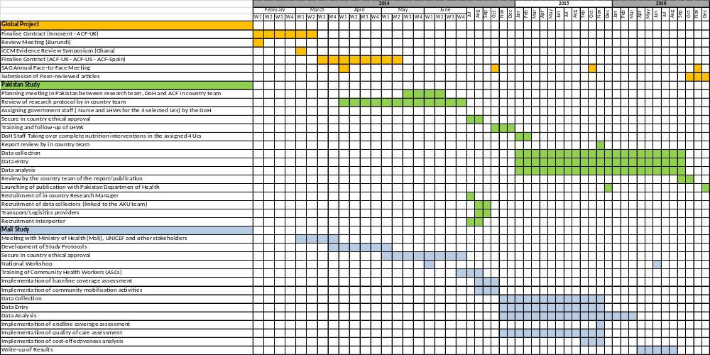
ANNEX I. RESEARCH TEAM STRUCTURE

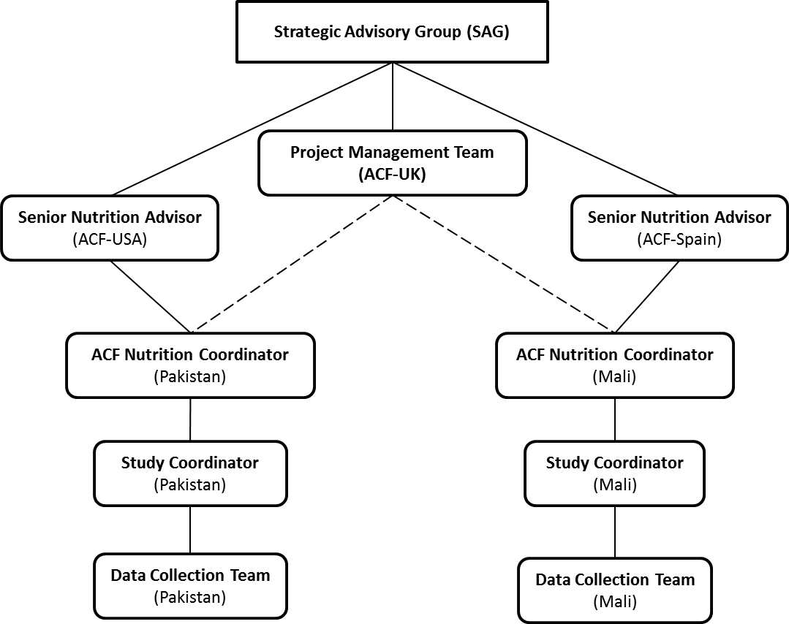

Strategic Advisory Group (SAG)
The purpose of the SAG is to provide strategic guidance and support to the research project. The SAG will be ultimately responsible for ensuring the overall relevance, appropriateness and quality of the research. The SAG is expected to meet once a year (face-to-face) and to schedule quarterly conference calls to review progress. The SAG is expected to be composed of the following members: Saul Guerrero (ACF-UK), Jose Luis Alvarez (ACF-UK), Chloe Puett (Independent) Maureen Gallagher (ACF-US) and Pilar Charle (ACF-Spain). External representatives for the SAG will be sought during the inception phase.

Project Management Team (ACF-UK)
The overall project management team will be composed a Global Technical Advisor (100%), a Global Programme Management & Compliance Focal Person (5%) and a Global Financial Controller (5%). The team will provide technical coordination and support, grant management, financial oversight, advocacy and communication support to the individual studies and the broader project. The project management team will report directly to the SAG and act as the primary interlocutor with the innocent foundation over the course of this project.

Senior Nutrition Advisors (ACF-USA & ACF-Spain)
The Senior Nutrition Advisors in ACF-USA and ACF-Spain (who provide support to Pakistan and Mali respectively) will act as the primary link between the SAG and the Project Management Team and the individual country teams. The Senior Nutrition Advisors will be expected to provide technical and quality assurance support to country teams, oversight of activity implementation and to communicate progress to the Project Management Team on a regular basis.

ACF Nutrition Coordinator (Mali & Pakistan)
The ACF Nutrition Coordinator will be responsible for ensuring the adequate implementation of the research protocol and for the quality of data collection, analysis and dissemination in each of the studies. The Nutrition Coordinators will also ensure coherence with other ACF programmes as well as the broader nutrition and health policy and practice in the country. The Nutrition Coordinator will be supported directly by the Senior Nutrition Advisors.

Study Coordinator (Mali & Pakistan)
The study coordinator will be responsible for overseeing the day-to-day implementation of research activities and managing the data collection team. The coordinator will be employed and hosted by ACF-Spain and ACF-USA in Mali and Pakistan respectively and will be line managed by the ACF Nutrition Coordinators in their respective countries. The position is expected to be filled by an experienced, national/regional researcher, recruited and selected by ACF with the support of Senior Nutrition Advisors and Project Management Team.

In Pakistan, the Aga Khan University team will play a central role in the design, implementation and analysis of study activities. Members of that the study team are expected to include:

Principal Investigator | Professor Zulfiqar A Bhutta | MBBS, FRCPCH, FAAP, PhD  Founding Director  Centre of Excellence in Women & Child Health, The Aga Khan University
Co- Principal Investigator | Dr. Sajid Bashir Soofi | MBBS, FCPS  Associate Professor, Women & Child Health, The Aga Khan University
Co- Principal Investigator | Dr. Muhammad Atif Habib | MBBS, MPH  Senior Instructor Reseasrch, Women & Child Health, The Aga Khan University
Study Coordinator: | S.Shujaat H Zaidi | MS Sociology  Senior Social Scientist, Women & Child Health, The Aga Khan University

Data Collection Team (Mali & Pakistan)
A team (TBC) of data collectors will be responsible for collecting relevant research data during the data collection period in each country. The data collectors will be line managed by the field coordinator, and will be identified and recruited by ACF with the support of the study coordinator. Data collectors will have prior experience in data collection in public health, nutrition and other elated area of work.

Scaling Up Nutrition A Framework for Action Policy Brief 2010
Lancet 2008: WHO is currently estimating the global number of severely acutely malnourished children and the global number of deaths associated with severe acute malnutrition
The most commonly used Therapeutic Milks are known as F-75 (the “starter formula”) and F-100 (the “catch-up” formula) and were technically developed by Prof. Mike Golden, commercially produced by French company Nutriset and field tested by Action Against Hunger.
See more on the issue of TFC performance here
There are currently a range of RUTFs formulas and producers around the world. The most commercialised version, Plumpynut®, has the consistency and taste of peanut butter and is also produced by the French company Nutriset who pioneered the original formula.
The CTC model was developed by Valid International and the international NGO Concern Worldwide. It was subsequently implemented by a large number of iNGOs including Action Against Hunger.
The SPHERE Minimum standards for nutrition programmes of this kind stipulate that programmes must succeed in ensuring recovery rates of over 75%, death rates of <10% and defaulting rates of <15%.
For more information please refer to UNICEF’s E-Bulletin (2012)
Read the full Joint Statement
More information on UNICEF’s Global SAM Treatment update
Visit www.coverage-monitoring.org to find out more about the CMN Project. The project is co-funded by the European Commission’s Office for Humanitarian Aid & Civil Protection (ECHO) and the Office of Foreign Development Assistance (OFDA) of USAID.
The Semi-Quantitative Evaluation of Access & Coverage (SQUEAC) and Simplified-LQAS Evaluation of Access & Coverage (SLEAC) were developed by Valid International, the Food and Nutrition Technical Assistance (FANTA) project, with the support of Brixton Health, UNICEF, Action Against Hunger, World Vision, Concern Worldwide, Save the Children and Tufts University.
An Action Against Hunger programme in Uganda provides one of the best documented examples of the effect of community engagement on programme coverage.
Read the report on this pilot project in Bangladesh
Including Steve Collins (founder of Valid International and developer of the CTC model), Andre Briend (former Head of Nutrition at WHO, and developer of the first RUTF formulation) and Mark Myatt (developer of all currently used coverage assessment methodologies).
Pakistan National Nutrition Survey (2011). Aga Khan University, Pakistan Medical Research Council & Nutrition Wing Ministry of Health Pakistan, https://pak.humanitarianresponse.info/document/national-nutrition-survey-2011-0,

