Push Ups

- Lie face down on the floor with your feet together curled slightly so you rise onto the ball of your feet. Keep your knees on the floor if you need to.
- Place your hands shoulder width apart on either side of your chest.
- Draw your abs in.
- Inhale as you raise your body up until your arms are straight.
- Keep your head and neck level with your body (don’t look up or down) and don’t allow your back to rise or fall.
- Exhale out as you lower your body back to the ground.
- Repeat.

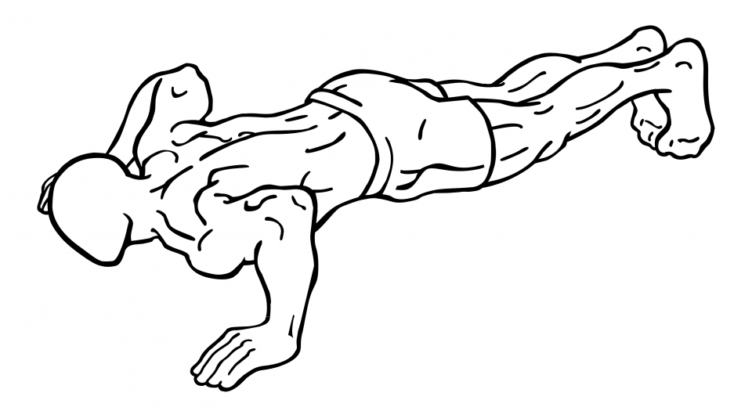

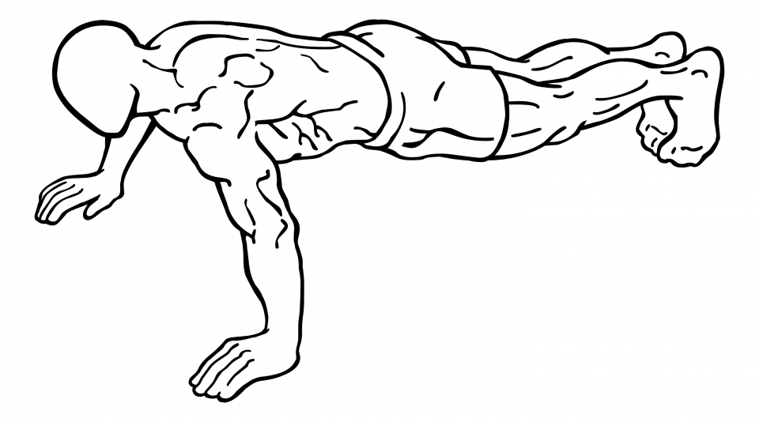

One Arm Dumbbell Shoulder Press

- Stand with your feet shoulder width apart, back straight and abs drawn in.
2. Grasp a dumbbell in your hand and lift it with a bent elbow to your shoulder height to start.
3. Lift the dumbbell straight up until your arm is fully extended overhead.
4. Lower in a controlled manner and return to starting position.
5. Repeat and then switch sides.

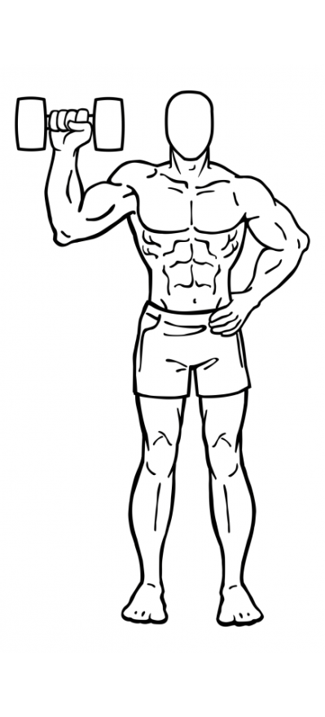

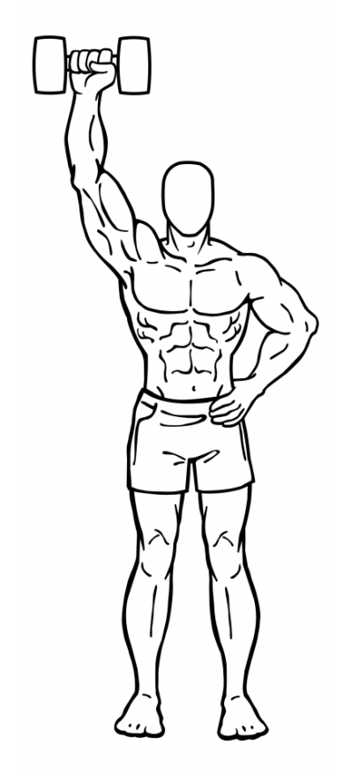

Shoulder Shrugs

- Stand with your feet shoulder width apart and a slight bend in your knees.
- Hold a dumbbell in each hand, with your arms at your sides.
- Lower your shoulders as much as possible.
- With your arms straight raise both shoulders up towards your ears.
- Hold the upright position for a moment and then lower in a controlled motion.

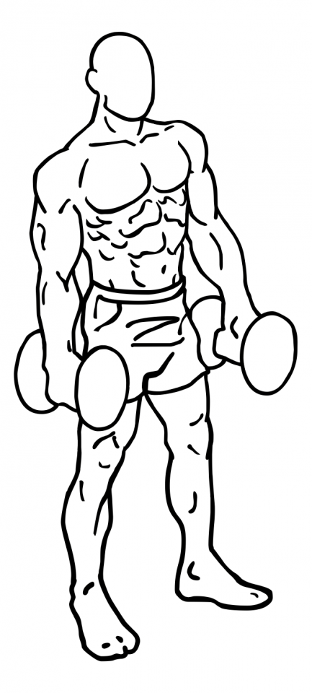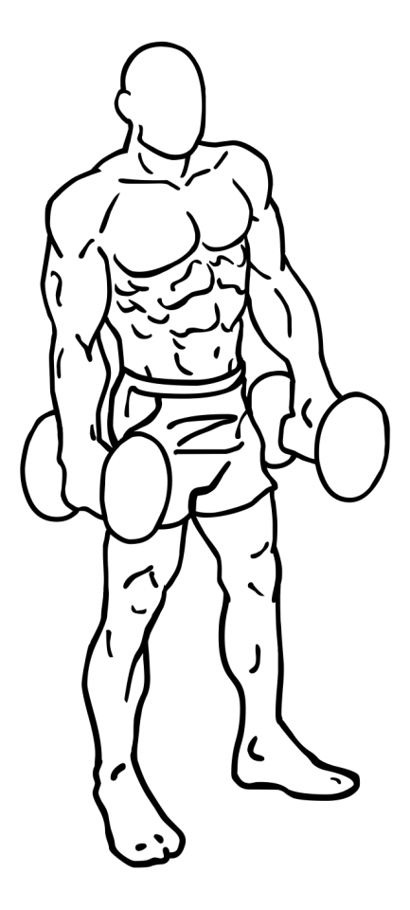

Dumbbell Raise

- Stand upright with your feet shoulder width apart and a slight bend in your knees.
- Grasp a dumbbell in each hand, in front of your thighs. This is your starting position.
- Draw your abs in.
- Raise the dumbbells up on either side of your ribs in a rowing motion by bending your elbows moving them outwards.
- Lower to starting position and repeat.

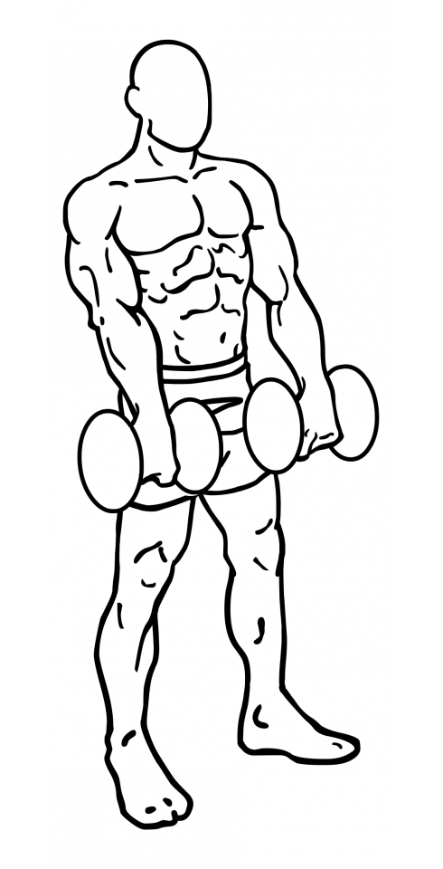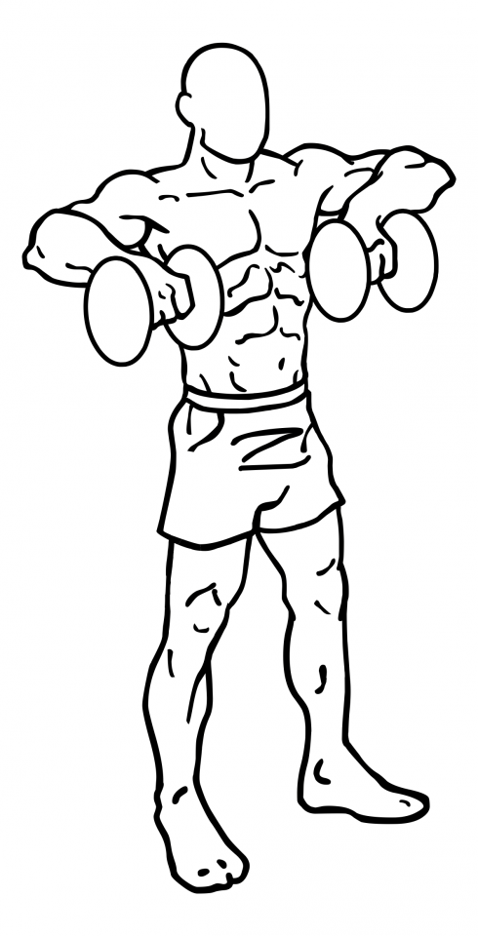

Flat Bench Leg Raises

- Lie on the floor with your hands under your hips supporting your back.
- With your feet together and your toes flexed upwards, raise your straight legs up a few inches off the floor; both of your legs should have no contact with the floor. This is your starting position.
- Keep your legs straight with a slight bend in the knees and raise your legs to just before 90 degrees with your hips.
- Pause at the top and lower your legs in slow controlled manner back to the starting position.
- Repeat.

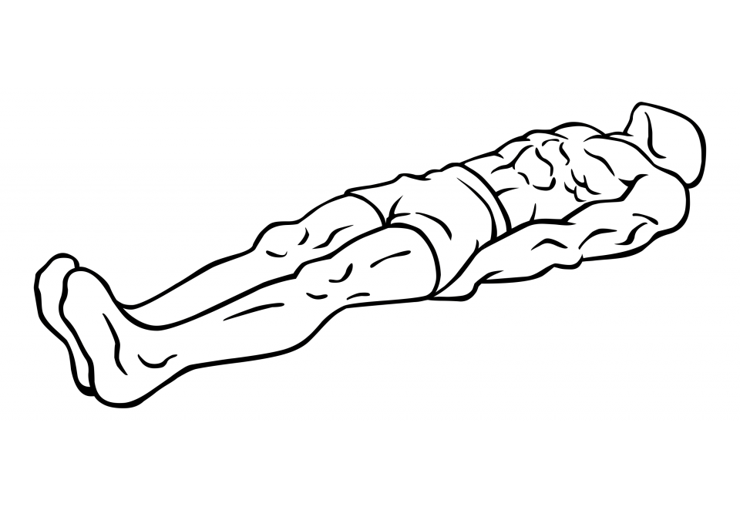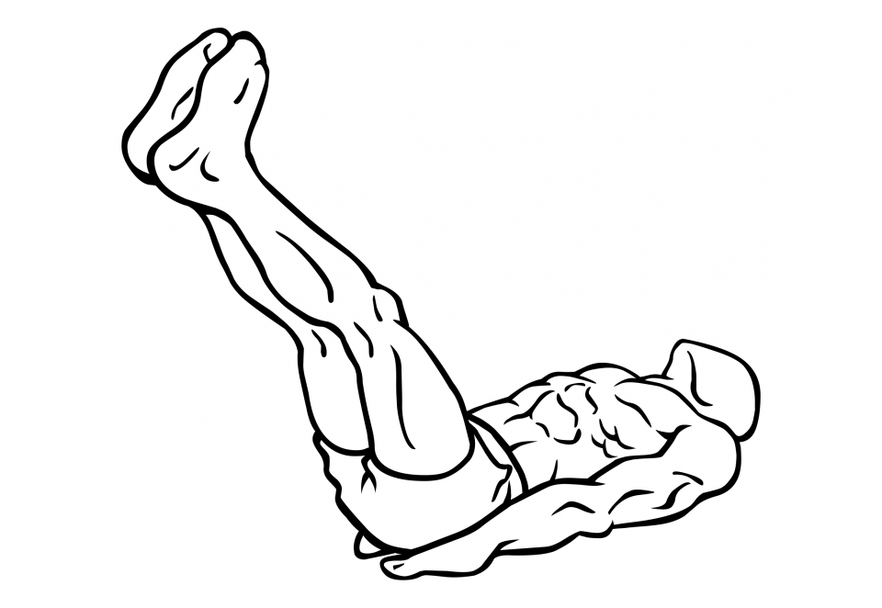
Lateral Dumbbell Raises
- Grasp a dumbbell in each hand, palms facing inward towards your body with the dumbbells at your sides.
- Standing with your feet shoulder with apart, draw your abs in and bend your knees slightly.
- While keeping your torso still, raise your arms up keeping them mostly straight with a slight bend in the elbows.
- Raise your arms up until in line with your shoulders; your palms should face the floor.
- Hold the position for a moment, and then in a controlled movement lower your arms to the starting position.
- Repeat.

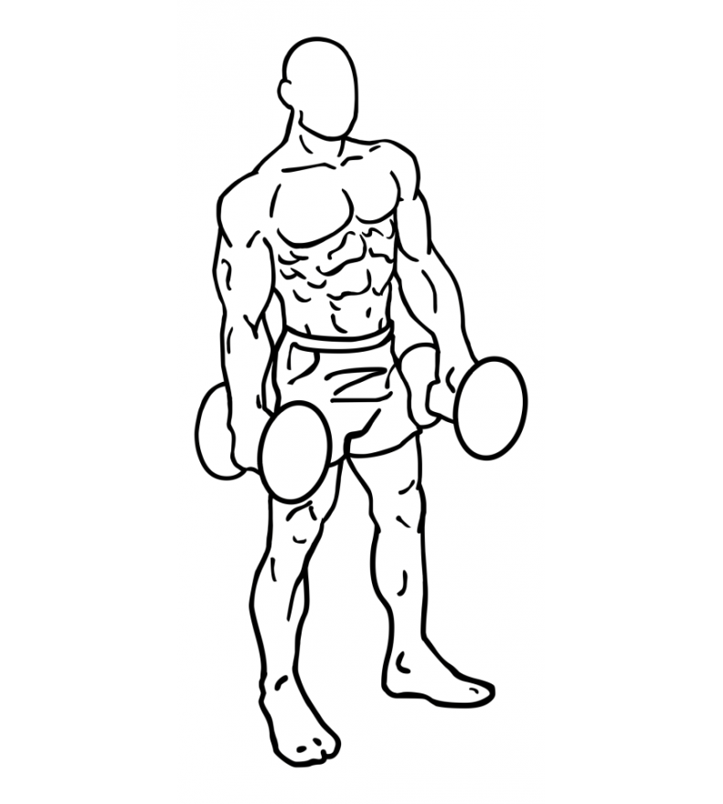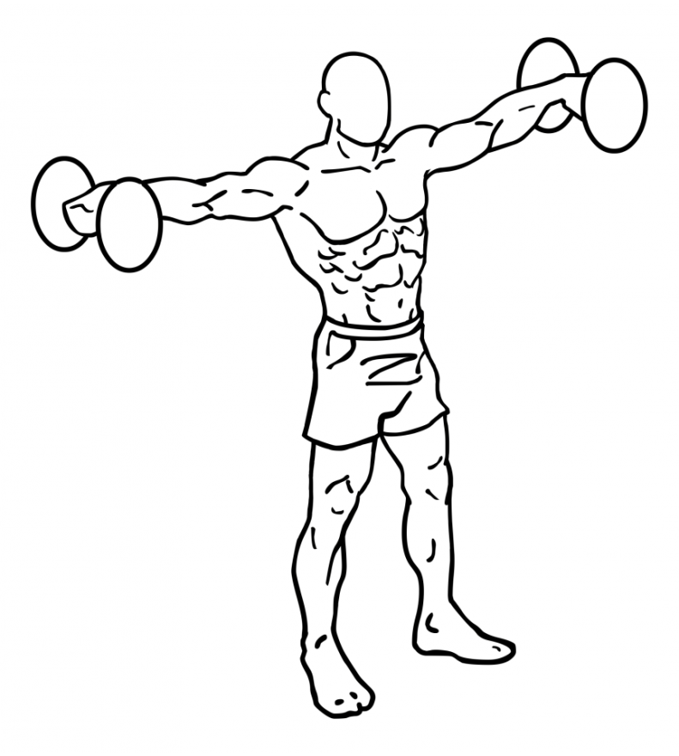
Arnold Press

- Sit on a chair or bench, feet pointed forward with your abs drawn in.
- Grasp a dumbbell in each hand with your palm facing towards your body.
- Bend your elbows to 90 degrees and raise both your arms to the starting point in line with your shoulders.
- With a steady controlled motion, raise your arms up while straightening your elbows while also rotating your forearms so that your palms now face away from your body.
- Bring the dumbbells closer together but do not fully extend your elbows.
- With a controlled motion lower the dumbbells to the starting position at your shoulders.

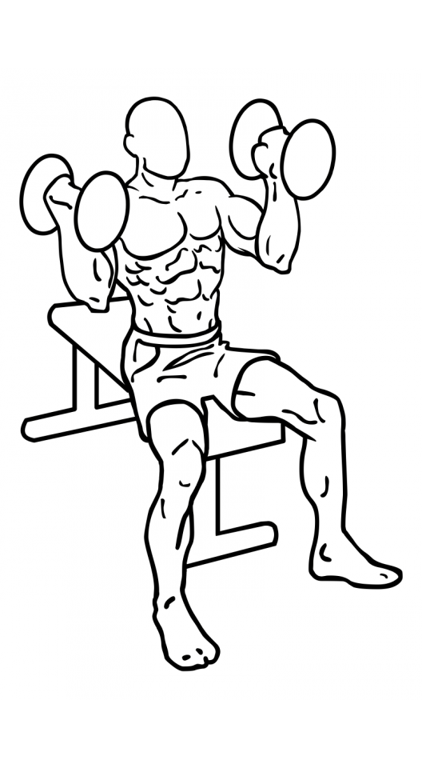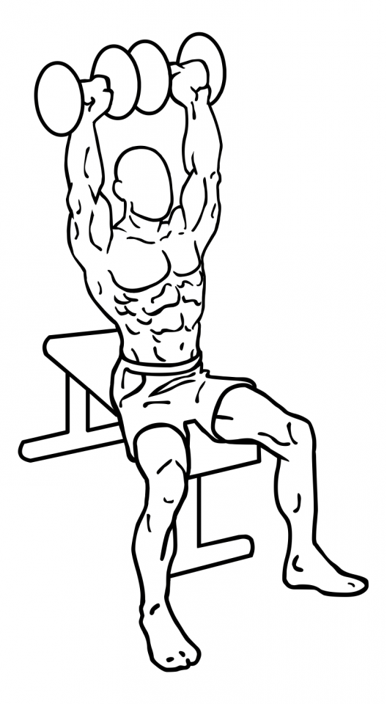

Rear Deltoid Row Dumbbell

- Place your right foot on the floor, and rest your left knee and hand on a flat bench or chair.
- Lean forward so your body’s weight is supported by your left arm and knee.
- Keeping your back flat, reach down and pick up the dumbbell with your right hand.
- Raise your right arm as close to your chest as possible, while bending and bringing your elbow back as far as you can.
- Pause at the top for a moment and then lower the dumbbell in a controlled manner to the starting position.
- Switch arms by doing the opposite positioning.
- Repeat.

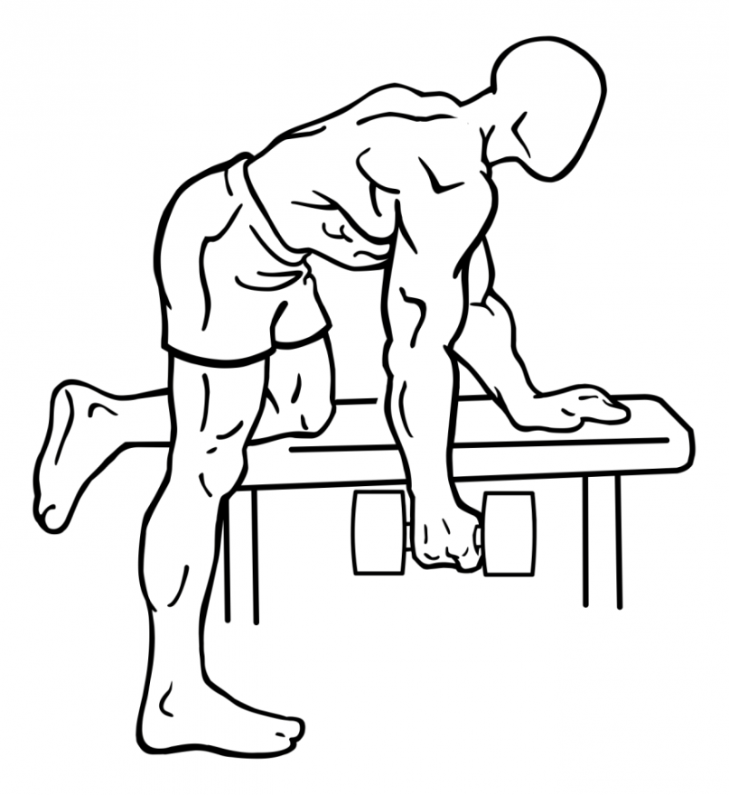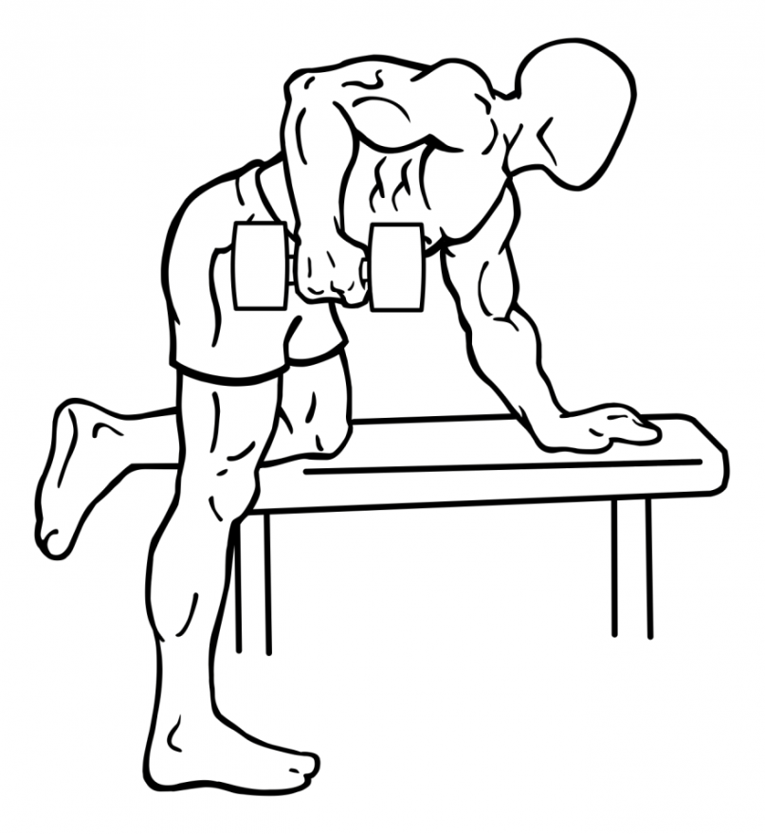
Supermans

- Lie flat on your stomach with your arms stretched out in front of you.
- Raise your arms and legs off the floor and hold this position for two seconds.
- Return to the starting position on the floor.
- Repeat.

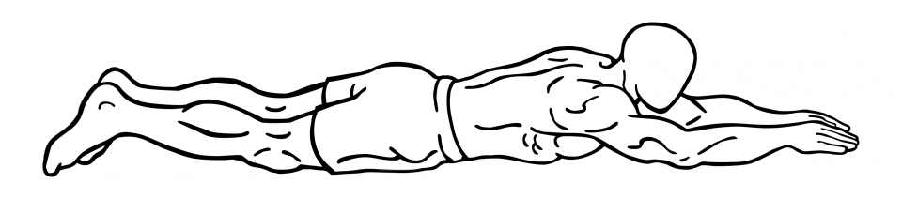

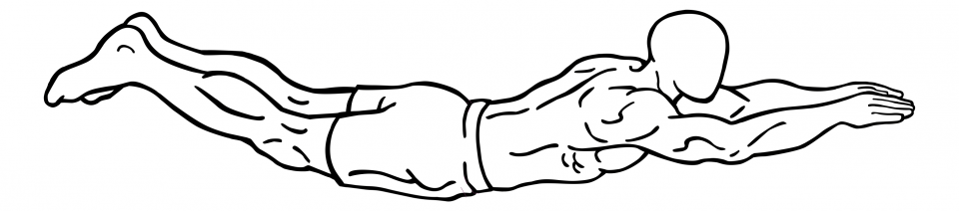
Front Raises

- Stand with your feet shoulder width apart, abs drawn in and knees slightly bent.
- Grasp a dumbbell in each hand, with your palms facing down.
- Start with the dumbbell at waist height.
- Raise your left arm, keeping your elbow slightly bent and your arm straight, in line with your shoulder.
- Pause for a moment and with a controlled motion lower your arm to back to the starting position at your waist.
- Repeat with your right arm.
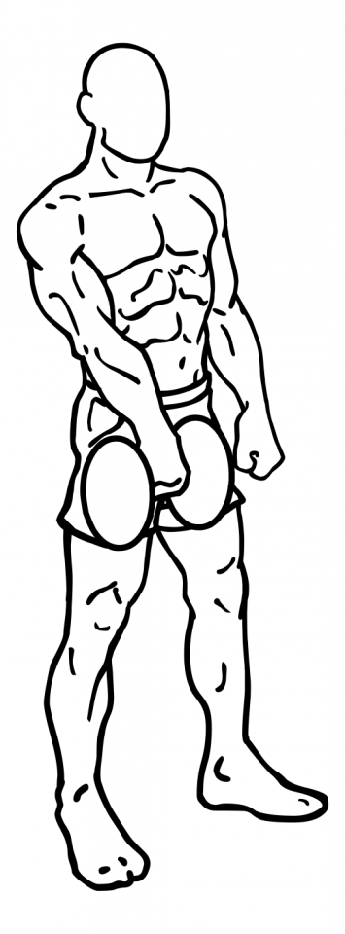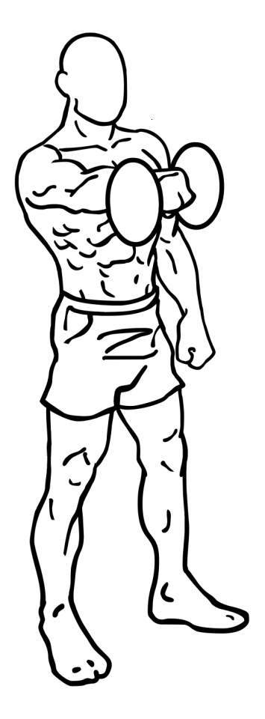

Dumbbell Upright Row

- Grasp a dumbbell in each hand with an overhand grip (palms facing downwards) and hold them in front of your thighs.
- Stand with your feet shoulder width apart, your abs drawn in and your back straight.
- Starting with the dumbbells at your thighs, slowly raise them up towards your shoulders by bending your elbows.
- Pause at the top and rotate your shoulder blades together.
- Lower the dumbbells in a controlled motion to your thighs.
- Repeat.

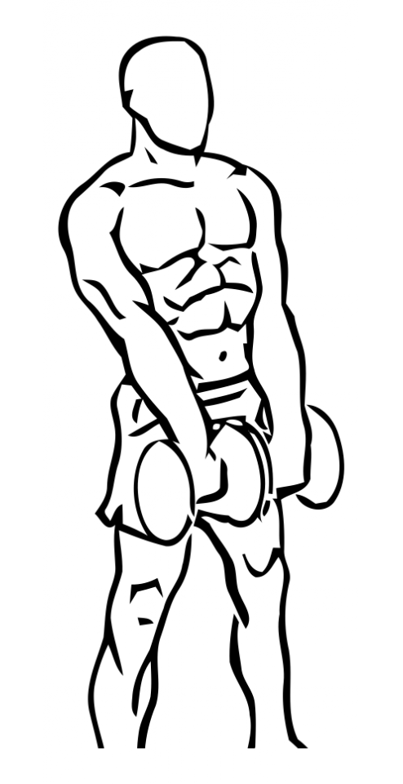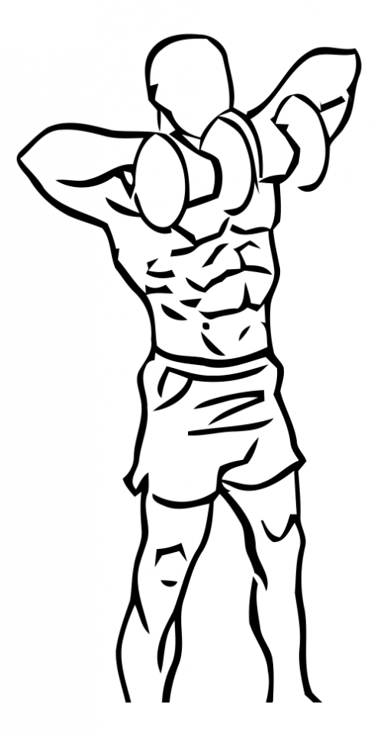

Side Plank

- Lie on one side of your body with your legs straight and your forearm perpendicular to your body in front of you.
- Drawing your abs in, slowly raise yourself up so you are balanced on your feet and your forearm.
- Hold this position for thirty seconds and slowly return back to the starting position.
- Repeat on other side.

