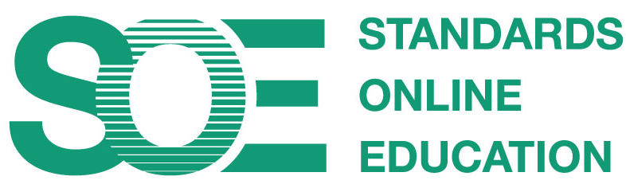

Mitch Parsell and Collaborators

One: Students

Students are supported in their online learning with a quality curriculum [1-4], opportunities for interaction with peers and staff [5&6], and appropriate support [7&8].

1. Curriculum materials are aligned, available and engaging
Threshold | The necessary materials are constructively aligned and available online
Good | The materials are provided using a variety of media to engage students and support diversity
Excellent

