Page Graphics / Icons

About 25 dance silhouette graphics. These will be used alongside page headings and sub-headings for a website that’s purpose is to help women break free from crazy-making abuse. The poses are very passionate, emotional, either speaking of desperation, crazy-making, or breaking free.

The images below are the poses I’d like. The words will not need to be part of the graphic because they will be text and not images in the pages.

All silhouettes should be women -- even if the sample pose image shows a man -- except the one: Abusive Men.

The silhouettes should be parts solid black and parts one other color, alternate between purple, green and choral… lighter shades of these colors to make a strong contrast with the black parts, but enough color to see the color.


Either make the skin and hair black, and the clothing and accessories the other color, or make the clothing and hair black, and the skin the other color. I will give you a couple examples of the silhouette coloring here.

Black skin & hair and color clothing Black clothing & hair and color skin

The women should be a variety of ages, ethnicities, wearing a variety of clothes: flowy skirts, conservative slacks and blouse, tailored skirt (maybe not possible with these dance positions), jeans, baggy hip-hop clothes, leggings/yoga pants, shorts… I’m not sure how you will show the variety of ethnicities in silhouettes… maybe different hairstyles? The main thing is to not show the same woman over and over. Different ages is probably best shown in clothing type.

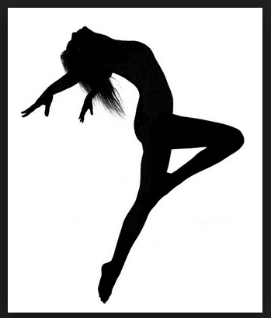Steps to Crazy-Breaking

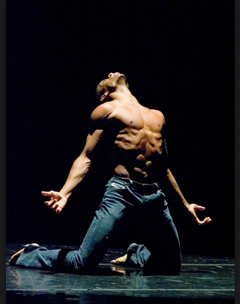Share Your Story

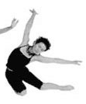Abuse 411: Learn About Abuse

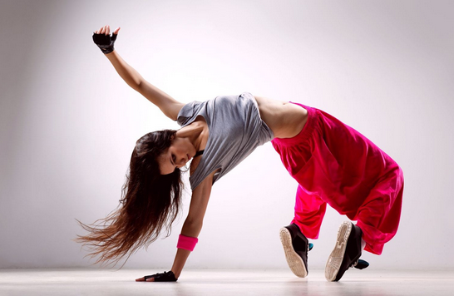smaller: Verbal and Emotional Abuse Tactics for Power and Control

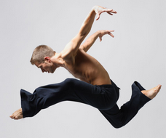smaller: Abusive Men

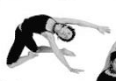smaller: Victims of Abuse

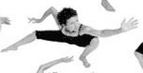smaller: Abuse & Gender

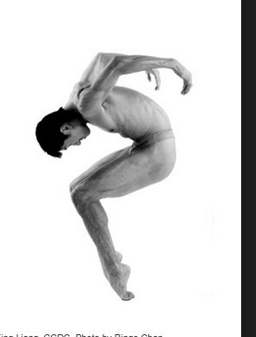smaller: Faith and The Church

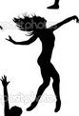Find Books, Groups or People To Help You

Events

Workshops, Training & Certifications

smaller: Workshops for Everyone

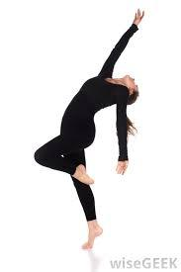smaller: For Community Leaders

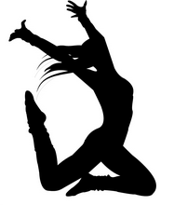smaller: For Mental Health Professionals

Mission & Vision

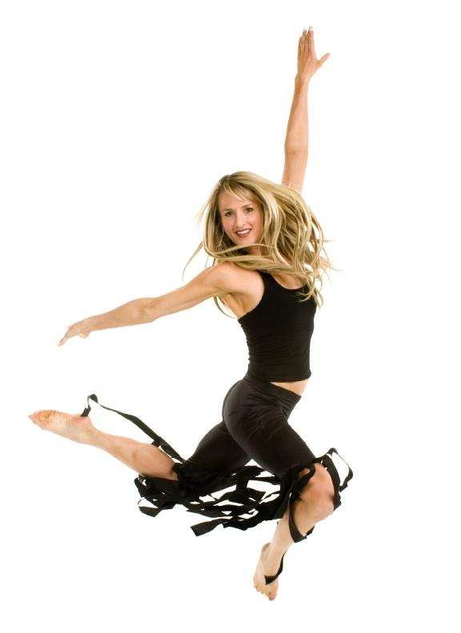smaller: Crazy-Breaking’s Vision

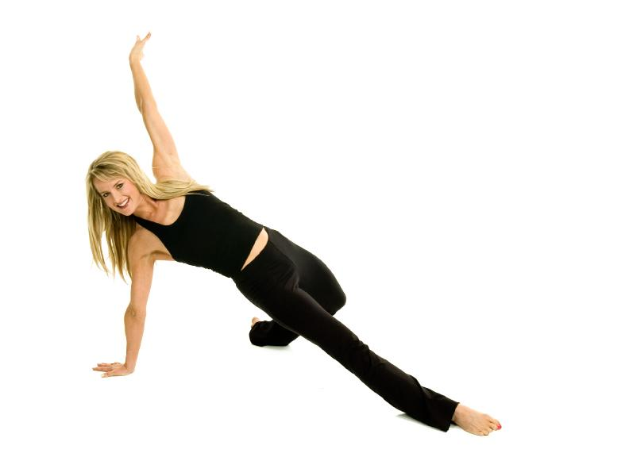smaller: About the Founder
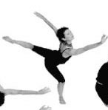Volunteer

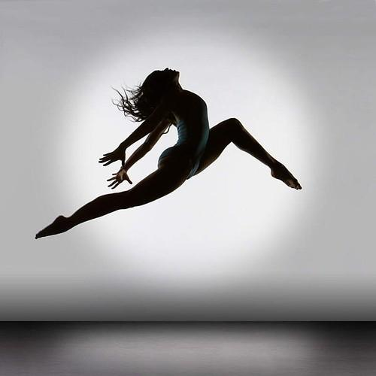Donate

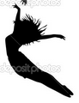Crazy-Breaking In The News

Extras/Miscellaneous

