ACCESS Design Brief logo

Austin ICU Critical Care Education and Skills series (ACCESS) is an education program run through the Intensive Care Unit at the Austin Health for junior medical staff.
The sessions are run weekly for a 6 month period. These sessions are aimed to enhance the skills of junior doctors to further themselves in critical care for the ward environment.

Style factors:
- A colour pallet that reflects the Austin health logo
A design that reflects:
- Critical care
- Education
- Features of teamwork
- Intensive Care medicine
- Collegiality
- Support
- Interactivity

Current ACCESS Logo
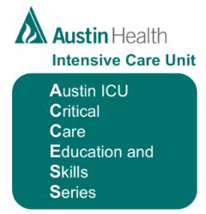

Austin Health Logo



