Logo Development – Intellectus Training www.intellectustraining.com.au – Online Training Company

ABOUT US
We are an online training company that provides short online courses for businesses and professional. We focus on Professional Development (Soft Skills); Desktop Applications and IT Technical Certification courses. Clients can purchase courses online or call our sales team for information.
Our Mission
To empower people and companies to reach their full potential.
Our Vision
Build a one stop shop for Australian companies and individuals that need access to a flexible online learning solution.
Our Values
- Quality Online Education
- Interactive Learning Environment
- Consultative Approach to Sales
- Honesty, Reliability and Respect
- Customer Centric – Building Relationships
Our Purpose
To become a reference in quality online education in Australia and NZ, delivering a modern and flexible learning solution that goes straight to the point, is mobile and easy to access. Education whenever and wherever you want.
We hope to build a strong online presence via Social Media and paid online advertisement. For this reason, a strong and remarkable image will be key to our success. We have originally chosen a head with cogs, although it was a good idea at the time, we soon noticed that many other online training companies have the same image.

LOGO BRIEF
Visual Style
We want an image that will be easily remembered by our clients and prospects. We are open when it comes to styles, however ideally we would prefer one of the following:
- Pictorial Mark: Image or shape that is easily recognizable to represent our business
- Abstract Mark: Shape or symbol used to convey the values of our business
- Character: A character or mascot to represent our business

We do not want:
- People with graduation caps and books
- Shape like people (very common in logos)
- No mouse shape logos

Font Style
- We are not happy with the current font
- We would like something modern and contemporary
- Ideally it should be well integrated into the current website format
Sample font: 
Colours
- Our website is grey and red, and we would want colours that match the current look.
- We are open to different hues of red and grey.
- Please see colour palette below for a sample of red and shades of grey.
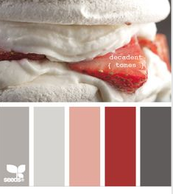

Additional Comments
- The logo can be modern and young, as long as it still appeals to the corporate market. It can also be playful, this said we don’t want a childish symbol.
- KEY WORDS: Intellectus, intelligent, technology, education, modern, mobile, elearning, wisdom, smart.
- What’s the symbol for Intellectus?
Examples of things we like
Below you will see a few examples of logos that we like. This is to give you an indication of the style we are looking for, we don’t want different interpretations of these examples. The images below or a reference only.
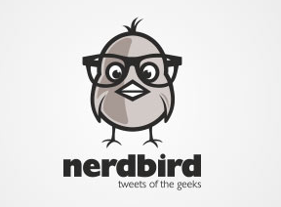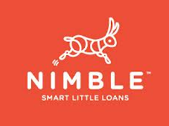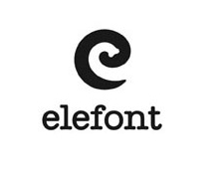
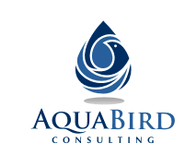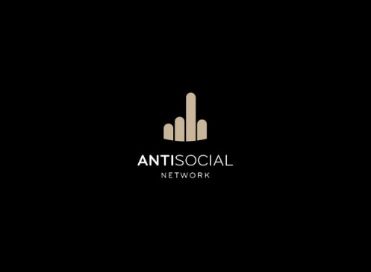
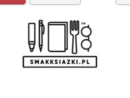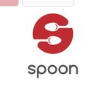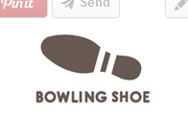


Animal images that can symbolise wisdom
Could look into images of animals that symbolise wisdom: Elephant or owl – This said an animal drawing cam come across as childish and we need to also address the corporate market. Think in the lines of a silhouette.
