NTCHISI FOREST LODGE BRIEFING

Background
Since January 2014 Ntchisi Forest Lodge in Malawi has new ownership. The former owners had taken over in 2007 and introduced a new house style (including logo, paper and website). This house style is outdated 7 years later and doesn’t totally reflect what we as new owners have in mind what the lodge should be and look like.

Information on Ntchisi Forest Lodge
Ntchisi Forest Lodge sits on the escarpment of the East African Rift Valley in some of Malawi's last remaining indigenous rainforest in an isolated spot near Lilongwe, Malawi's capital at an altitude of 1400 meters. Guests can relax whilst enjoying stunning mountain and Lake views, experience the warm-hearted hospitality of a part of rural Malawi where tourists are still a rarity, and enjoy relaxing and walking in the beautiful scenery.
The lodge is an old colonial building that was built in 1914 and accommodates 5 rooms, 2 living rooms, 1 khonde, 1 terrace and a kitchen. The rooms can be positioned in mid-range tourist destination, the forest cabin will be a bit more top end and camping is for the shoestring traveller.

The lodge is eco-friendly; we run on solar energy, are using the compost of our waste.

The activities we offer are guided hikes in the rainforest, with a traditional healer and village walks.

Ntchisi Forest Lodge runs a Community Trust; our guests can do a contribution towards community projects

Target
We want a new house style in order so potential customers are more attracted to the lodge and its stunning location and current customers recognise us better. We also want to position the location better than is being done in our current logo.

The new house style should reflect want we stand for and what we offer to guests. Their should always be a clear call to action so people can really act on what they see.

Target Audience
Our clientele can currently be divided amongst two major groups

Expats
These are people that (temporarily) work in Malawi and are always looking for interesting locations to spend their spare time. Most of the year they will spend on the lakeside, but once in a while they want something else. Weekends are mostly popular and families also spend time in their holidays. They work for NGO’s, embassies and sometimes for businesses. In the city they go to the same shopping centres, lunch places as other expats do. Most of them come from Lilongwe (a two hour drive). They want to relax, a lot of them come for the forest and they want good food. They are used that facilities are more basic in Malawi, because they have visited many places around. They mostly book by telephone or send an email.

International mid range tourists.
Most of travellers come from Europe, followed by North America and South Africa. They are either on holidays in Malawi or are passing by Malawi. They want an authentic Malawi experience, are more interested in the cultural activities and the eco aspect of our lodge. In their itinerary they include Ntchisi Forest Lodge because it’s something different than other Malawi attractions. Especially if they arrive from the airport they have no expectations and are used to good proper facilities.

Other target groups
Volunteers
Via one of our tour agents we already receive groups of volunteers. They will stay at the lodge and work in the community. They are looking for better deals and mostly want to book privately for themselves.

Businesses.
In the near future we want to offer businesses in Ntchisi and Lilongwe to make use of conference facilities in (one of) our living rooms. These will be small sized groups (maximum of 12 people) that can combine their conference with stretching their legs in the rainforest.

In generally Ntchisi Forest Lodge is visited by couples (can be honeymooners), few singles and families.

Market
Malawi is becoming more popular as a tourist destination. It has a lot of things on offer: the lake, wildparks with the Big 5 reintroduced in one park and more to come, forest reserves and the Nyiaka Plateau. It was nominated in 2013 by Lonely Planet as a top 5 destination to travel to.
There is a lot on offer for many tastes; from Backpacker destinations as Nkata Bay and Monkey Bay to very exclusively private lodges.

There are a few lodges that are in the same price range. Competitors can be divided into:
Lake lodges – first destination for many people is the lake. There is lots of accommodation in SAlima, Cape McLear and around Nkotatkota
Forest lodges – there are a few more forest lodges in other areas where people can make stunning hikes. Think of Luwawa Namizuma, Zomba Forest Lodge
City – From the airport most people decide to go to the city Lilongwe where there is plenty of accommodation. Think of Africa House, Kiboko Hotel, Madidi Lodge
Proximity – In the near proximity of NFL the nearest lodges are all at least two drive away. There are local lodges in Ntchisi but they are more of a different category and more catered for the African traveller. Think of Lifupa, Bua River Lodge, Nkotakota lodges

Ntchisi Forest Lodge is unique because it boasts one of the last remaining indigenous rainforests, it has excellent food that many people rave about and it is very peaceful.

Core values
These are our external values
Personal – we give guests a warm welcome by meeting them at the car park and waving when they leave, we know our guests name(s), we are interested in our guests, we try to meet the wishes of our guests as much as possible
Peaceful – we strive to give our guests a peaceful retreat. A guest can take his time to relax at any time and any place in and around the lodge. Undisturbed, noiseless
Homy – guests need to have the feeling that they are home away from home. They can put off their shoes and relax on the couche(s), sit in front of a logfire and we serve food that reminds people of home and family

Internally we use the 5 S model:

Super Service: We provide service to our guest at all times, we think ahead about what our guest might want/like and try to accommodate all their wishes within reason.

Strong: We show confidence in our work and approach guests in an open and confident manner, speaking clearly, looking guest in the eyes. We are proud of our work and are happy to receive compliments from guests.

Smile: When attending guests we always do this with a smile!

Spotless: at Ntchisi Forest lodge we make sure that the premises, the materials, the gardens are spotless, as well as we take care of our personal hygiene.

Security: We make sure our guests feel safe at Ntchisi Forest Lodge at all times.

Briefing House style

Look and feel
Fresh and personal, not lethargic and not too tight

Tagline
Our current tagline is ‘Life undisturbed’. This absolutely says what we stand for, but there is more to that.

In our opinion ‘The Pure Life’ is more reflecting the wider range what we stand for.
Pure = the environment | the forest | the air
Pure = people (not spoiled from main touristareas)
Pure = food (fresh herbs) and water (from the forest spring)
Pure = eco friendly
Pure = friendliness and openness
Pure = you can be who you want to be

Use of colour
Fresh colours:
Apple green: nature, freshness, growth.
White: purity, freshness , simplicity and cleanliness
Brown: earth, outdoor, strong, sustainable, intimate, helpful

What needs to be produced
- Logo with and without tagline.
Current logo (see www.ntchisi.com) is a graphic style. It is distinctive from competition but has some disadvantages:
- not easy to remember and to recognise
- the name Ntchisi is hard to read
- not very scalable
- is more targeted at birdlovers

New logo can also be an iconic logo (text and and image) but has to solve disadvantages from the old logo.

Some examples of nice logo’s

Healthy Coffe; Nice fresh colours

Barefoot Runners: nice image combined with text
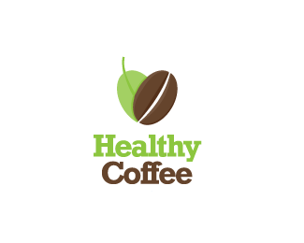

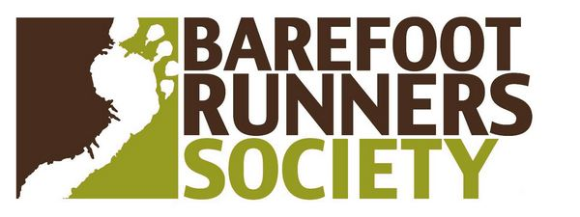

- Business cards
- Writing paper
- Format for Flyers (A5) and posters (A4)
- House style document with typography (this also has to be used on website)
- Website;
We will choose a responsive Wordpress template for hotel usage (targeted for conversion) and house style guidelines will have to be translated into design of the website

