Website Mock-up Brief

Web Site
Our website is currently active but need a revamp. The website address is www.101BusinessInsights.info. The best way to get a good feel of what we do is to register as a member (free) and experience first-hand some of the functionality.

Visual Language and Style
The Visual Language and Style for 101 Business Insights is as follows: White background, Black and Orange as theme colours with vibrant coloured cogs representing the 21 business disciplines. Herewith our primary identity, typeface, Logo colour pallet and Illustration style.
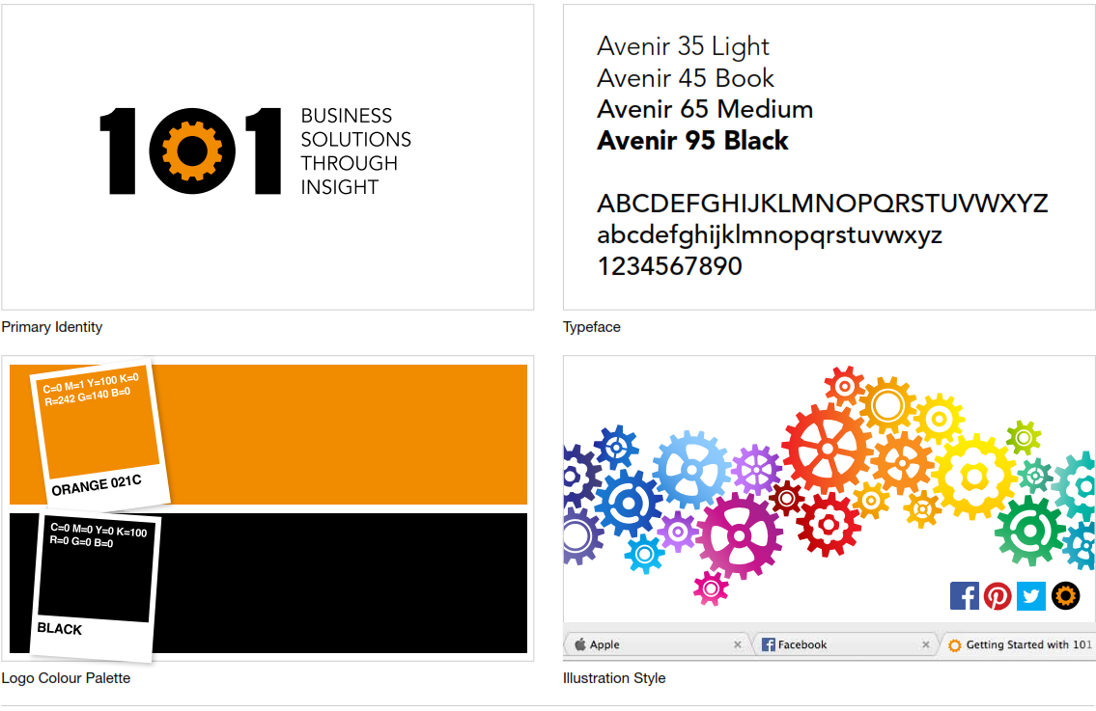

101 Business Insights Logo
The 101 Business Insights Logo must be incorporated into the site. The logo comprises both the 101 as well as the slogon, as follows:


21 Business Disciplines
101 Business Insights provides a synthesis of insights across 21 Business Disciplines. Each Business Discipline is represented by a unique cog and colour, see below.
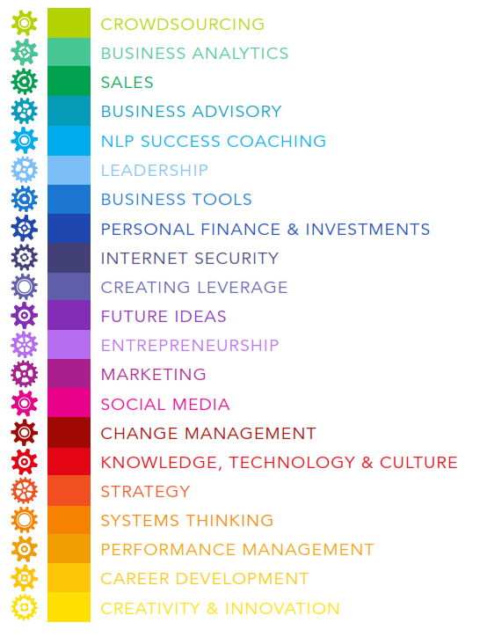

The Interaction between the 21 Business Disciplines
A core element of what we do is link business solutions together across multiple business disciplines, this is symbolized by the interlocking of the cogs, see image below.


Business Discipline Banners
Each Business discipline has its own unique rendering of the cogs together with its name. Here are a few examples.
 | 
 | 

Target Audience
Our Target audience include:
- Graduates
- MBAs
- Solution Providers, e.g. software companies, web developers, consultants etc…
- Authors of business books
- Job seekers
- Entrepreneurs
- Managers
- Specialists
- Executives
- Employees
Our Affiliate Partners include:
- Grad Schools
- Universities
- University Faculty
- Job Portals
- Companies
- Recruiters
The Welcome screen must be able to provide both our 1) Target Audience and 2) Affiliate Partners with a direct link to the value proposition that has been designed and which is unique and relevant to them. Each type of Target Audience and Affiliate Partner has a uniquely designed value proposition which is encapsulated in an infographic.

Navigation Sections
The website should have 4 Navigation menus, namely:
- Top Bar
- Logo Bar
- Main Menu
- Footer Menu

Top Bar
The Top bar must display the following information in real-time, i.e. as it changes on the site.
- iMembers: The number of members
- iPoints: The total number of Sitewide Insight Points
- iAttributes: Displays the total number of member attributes points (e.g. experience, qualifications, authorship)
- iNetworking: Displays the total number of member networking points (e.g. profile, messages, teams)
- iActivity: Displays the total number of member activity points (e.g. sharing, commenting, posts)
- iDollars: Displays the total number of member activity and networking points
- iShares: Displays the total number of member activity and networking points, rounded down to the nearest 100,000.
The numbers should all be displayed as digital numbers and create a nice visual as they increment in real-time. The updates should not be dependent on a page refresh.
The Top bar must have 4 permutations, namely:
- Everyone
- Just me
- My Friends
- My Teams
Users must be able to access each of these permutations from the top bar through some form of link, or image or whatever.
Herewith a possible implementation for the ‘Everyone’ permutation.
3,458 | 1,700,250 | 800,125 | 600,100 | 300,025 | i$900,125 | 900,000
iMembers | iPoints | iAttributes | iActivity | iNetworking | iDollars | iShares

Herewith a possible implementation for ‘Just Me’ permutation.
1 | 15,200 | 7,500 | 4,580 | 3,120 | 7,700 | 5,000
Me | My Points | My Attributes | My Activity | My Networking | My Dollars | My Shares

Etc…

Logo Bar
The Logo Bar should be positioned just below the Top Bar and should contain two elements:
- The Logo, as follows:

And the,
- Notice Board, which should be used to stream live updates and notices, such as:
  - Promotions: Who’s just been promoted to next Ranks, Stars…
  - New Affiliates: Affiliates etc…
  - Goals: Goals achieved…
  - Did you know?
  - Hot Tip: etc…
  - Competition… across areas of engagement
Etc…

Users should have the option of collapsing and expanding the Logo Bar so that once they have seen the notices they can hide them. It may also be an option to stream updates across the collapsed Logo Bar, if that is an option.

Main Menu
The main menu will comprise several permutations, similar to the Top Bar, here are a list of the various permutations:
- Insights (This will replace the core menu option and what you currently see on our home page)
- Profile (This will replace the Buddy Press menu options that are currently on the site)
- Partner1 (New menu for Affiliate Partners)
- Partner2 (New menu for Affiliate Partners)
- Partner3 (New menu for Affiliate Partners)
- Etc…

If the ‘Insights’ option is chosen, then the Main Menu displayed must be the one applicable to Insights, as indicated below.
Insights Main Menu | Sub1 | Sub2 | Sub3 | Sub4 | Sub5 | Sub6 | Sub7 | Sub8 | Sub9 | Sub10 | Sub11
Home
Disciplines | Business Advisory | Business Analytics | Business Tools | Career Development | Change Management | Creating Leverage | Creativity & Innovation | Crowdsourcing | Entrepreneurship | Future Ideas | Internet Security
 | Knowledge, Technology & Culture | Leadership | Marketing | NLP - Success Coaching | Performance Management | Personal Finance & Investments | Sales | Social Media | Strategy | Systems Thinking
Insights | Search/Feed
Library | About / Search | Archive | Books | Getting Started | Index | Infographics | Links | Slides | Tutorials | Upcoming Topics | Videos
Rewards | iPoints | iRank | iStars | iDollars | iShares
Members | About / Search | Individuals | Teams | Insight Affiliates | Affiliate Authors | Moderators | Channel Partners | Shareholders
Hire me | About / Search
About Us | Vision etc. | The Team | Contact Us | Membership | Policy | Terms & Conditions

If the Profile option is chosen, then the Main Menu displayed must be the one applicable to the user Buddy Press Profile, as per to the extract below, but most certainly nothing like this!
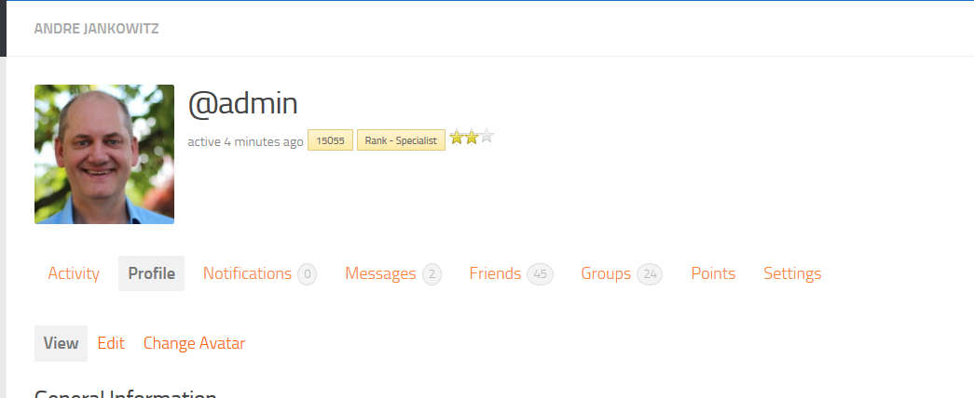

If the Partner1 option is chosen, then the Main Menu displayed must be the one applicable to our Partner. Typically what we would then want to do is display their web site within this frame.
This is just a placeholder and we do NOT need this to be incorporated at this point, just so long as provision has been made for the inclusion of Partner menus…

Once the user selects one of the Options, e.g. Insights or Profile from the list, the Main Menu must change to the appropriate sub-menus for that selection. The user must also have the option of changing their selection at any time and being able to display one of the other menus.

Memberships
The website is a MEMBERSHIP based site and our main objective is for new visitors to become members and for members to sign in, so this needs to be prominent. However, once a member has signed in Log in section should be minimized or hidden.

Deliverable
I’m looking for a graphic mock-up which encapsulates this design style and reflects all the key components of our requirements. An image file or ideally PowerPoint presentation is required as an output.

