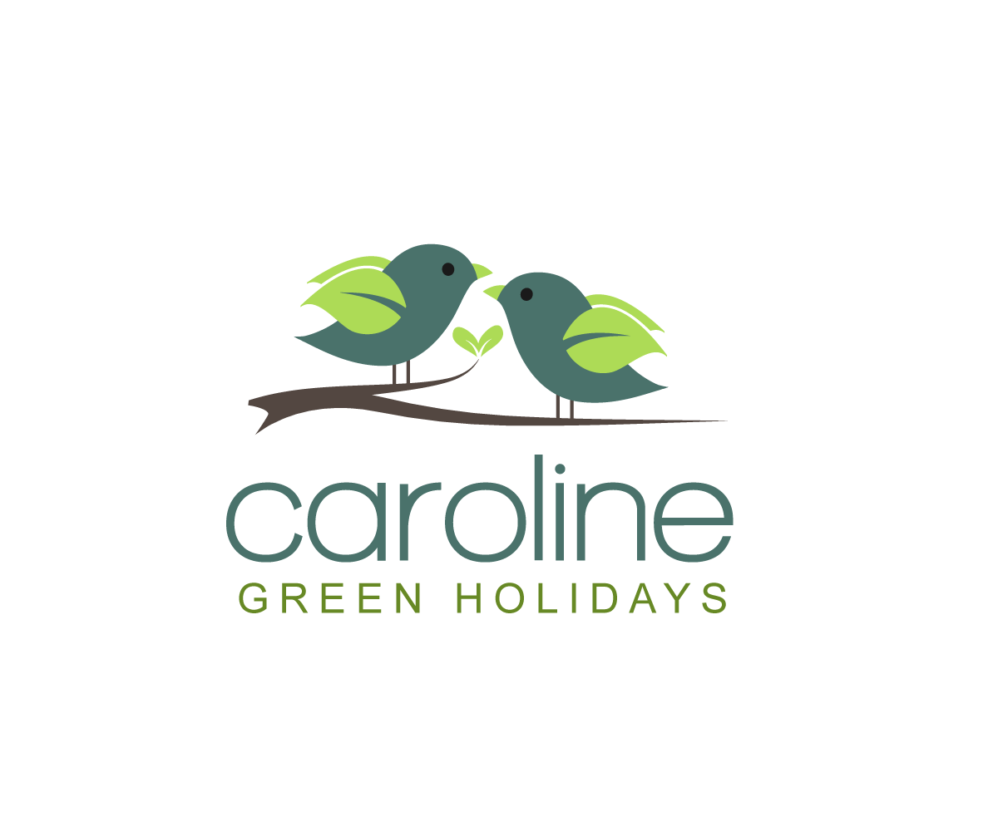

Luxury holidays at great value!

About Us

Your comfort is our goal. Let us help you with planning your fantastic escape. We seek to provide you with a restful retreat that you can think of as your home away from home. We carbon offset your travel to help the environment. Consumer protection is provided as standard to cover you in case of nasty surprises such as ash clouds. We also try to source small and local accommodation rather than the large international organisations that dominate the industry.

Our Travel
Our holidays are tailored to your needs, and our rooms feature beautiful décor and all the amenities you could need. We have made it easy and safe to reserve and pay.

Our Staff
We believe in the small is beautiful concept.
The company has two directors.
We try to help our best and brightest at university by encouraging them to set up on their own and become our main Sales Representatives.
This allows them to gain valuable experience and support whilst at university and provides us with the flexibility we need to compete against the big guns.

What makes us different?

Simple pricing
What you see is the total cost of everything, not a complex breakdown that only an industry expert can decipher

No hidden surcharges
The price we include is cleared defined and there are no credit card charges

Holidays designed around you
Tell us what you want and we'll design the holiday to your needs

Small is beautiful
We a small family run business with an emphasis on a personal touch and flexibility

Community based approach
We use small community based suppliers where possible to encourage social responsibility

Carbon off-setting
We offset the carbon from both flights and car travel to help minimise net effect on the environment

Consumer protection
Green Holidays will provide comprehensive set of insurances and bonding so you can continue your holiday or get a refund in the case of insolvency or ash clouds

Disabilities and minorities
We have a clear policy on recruiting people from minorities and those with disabilities if they meet the requirements of the job

Our Honeymoons

Let us help you with your honeymoon
Deciding where to go on your honeymoon is an important decision, one we intend to make once
Whether it’s an exotic escape to a pristine secluded beach, a luxurious safari, a cosmopolitan mecca or you have not quite decided yet contact us to discuss!
Benefit from our expertise, consumer protection and fantastic rates...



Asia

Friendly people, beautiful beaches and a rich cultural heritage awaits you in Asia. If you are willing to spend two days in transit Asia Is a great venue.
You are sure to enjoy the delights that the Orient has to offer if you like amazing beaches, exploring new cultures and getting pampered.

Key Destinations
Maldives
Thailand
Sri Lanka
Bali
Japan

Sub Saharan Africa

Africa is the ideal destination for the connoisseur with abundant wildlife, gorgeous beaches, adventure sports and renowned vineyards.
If you are looking for something extraordinary and are not worried about getting a bit dusty Africa is the destination for you.
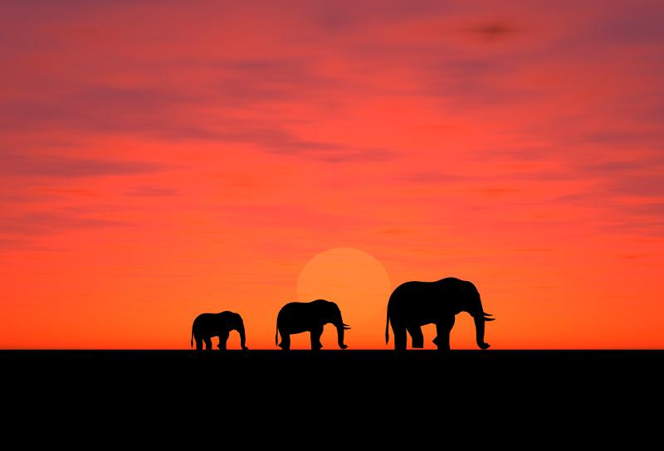
Key Destinations
Mauritius
Madagascar
Tanzania
Botswana
South Africa
Kenya
Namibia
Zambia
North Africa & The Middle East
If you are not looking to travel far and are looking for a beach based luxury holiday North Africa and The Middle East is a great choice.
Vibrant marketplaces, friendly people and pristine beaches await you.
Many people have been put off by recent instability in the region but this has not affected every destination. By working with us we can help you select the ideal holiday in peace.

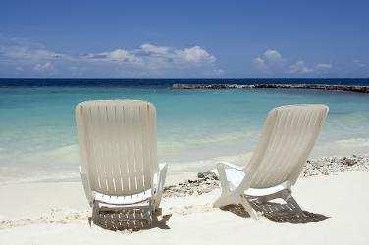
Key Destinations
Abu Dhabi
Doha
Egypt
Algeria
Morocco

Europe
If you are looking for short travel times, great architecture and delightful cuisine Europe may be the destination for you.
These locations are renowned as some of the most romantic in the world and we can help book you in to some of the most prestigious at a reduced cost.
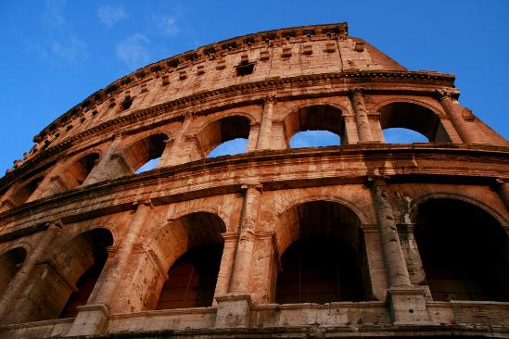
Key Destinations
Paris
Rome
The Alps
Greece
Spain
Vienna
Venice
Istanbul
Tuscany

North America
Always a favourite for those looking for the cosmopolitan experience or a great rail journey across beautiful valleys and glistening peaks, North America is a great option for those with the money.
Most people opt for a shorter honeymoon in North America to compensate for higher costs but we can ensure you get the best quality accommodation for a fair price.

Key Destinations
New York
Quebec
British Columbia
San Francisco
Cancun
Las Vegas

Central America
Central America offers tropical sun and pristine coastline to those willing to travel. Honeymoon locations are firmly established in the area although many are expensive.
Let us help you get past the costs and ensure you get the most from your once in a lifetime experience.

Key Destinations
Cancun
Bahamas
St Lucia
Belize
Costa Rica
Aruba
Dominica
Jamaica
Anguilla
Antigua

South America
South America is still developing as a honeymoon location and there is the opportunity to get a great deal for an unforgettable experience.
There is a great deal of linguistic and cultural heritage in the region for the budding adventurer to sample.
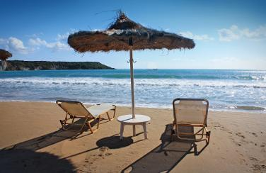
Key Destinations
Cartagena
Tayrona National Park
Machu Picchu
Easter Island
Iguassu Falls
The Amazon
The Galapagos
Rio de Janeiro
Buenos Aries

