

Join us this fall in Vietnam & Costa Rica

Compete. Create. Connect.
Travel Designed to Revive and Expand Creative Thinking

When 1,500 of the top CEO’s from around the world were interviewed, they believed that more than rigor, management, discipline, integrity or even vision, creativity ranked number one.

The Xchallenge Connection has designed a cultural playground for the mind to explore its creative pipeline, incorporating daily challenges that excite, engage, interact and educate.

=
Compete. Daily mystery challenges have each participant fully immersed and engaged in a stimulating and educational environment designed to build team skills, leadership and expand creativity while competing daily for prize rewards.
Create. Explore cuisine, language, history and communities.
Connect. Side by side, with your teammate and the XChallenge crew, you will intimately explore culture, address challenges and build strategies that you can apply to day-to-day living, while having the time of your life!
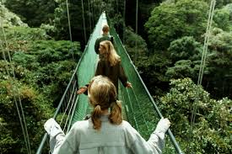

Your XChallenge team is on the ground beside you ensuring that each element of the event is managed to perfection. We promise that when the daily challenge is complete, luxurious accommodation and relaxation are waiting!
Experience a 5* - 10 day mystery challenge immersed in the vibrancy of Vietnam or Costa Rica.
Vietnam October 2014 Costa Rica November 2014
Contact us to learn more. louise@ptm.cc 1.800.872.8090 x 340 www.xchallenge.com

