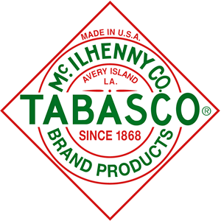

For more than 140 years, the TABASCO® trademark, bottle and white diamond label have identified the most famous pepper sauce in the world. They have become universal symbols — both individually and collectively — of the finest quality ingredients and unique aging process used in the making of TABASCO® brand Pepper Sauce. This powerful brand recognition is an asset not only to McIlhenny Company but to our customers as well.

Edmund McIlhenny was given seeds of Capsicum frutescens peppers that came from Mexico or Central America, and he first planted them on Avery Island, Louisiana, over 140 years ago. Today, just as then, when the peppers reach the perfect shade of deep red and are at their juiciest, they are carefully picked by hand.

The fresh peppers are mashed, mixed with a small amount of Avery Island salt extracted from the salt mines that lie beneath the Island, and placed in oak barrels. The wooden barrel tops are covered with more Avery Island salt to form a natural protective barrier, and the pepper mash is allowed to age for up to three years in the McIlhenny warehouse. This process creates the subtle flavor notes that are unique to our Original Red Sauce.

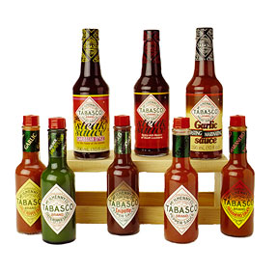 |  | 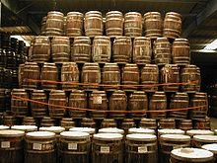

HBL Specialty Foods is an authorized dealer of TABASCO© branded products in Southern California. We distribute TABASCO© hot sauces, salsas, condiments, barbeque and steak sauces, pickled vegetables and various gift items to foodservice, convenience stores and retail food and supermarket outlets.

What differentiates our company from other food distributors is that we provide our food products on our own display. So, instead of searching throughout a store for our products, they are conveniently located in one convenient spot. Below are pictures of a few examples of our displays at other locations:

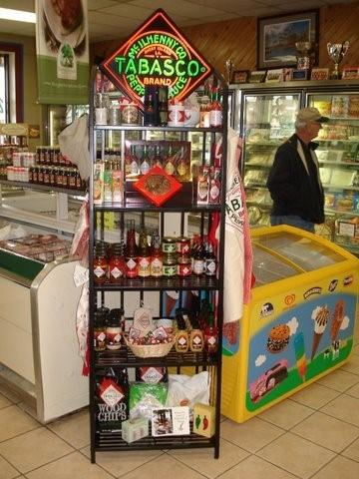 | 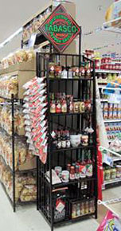 | 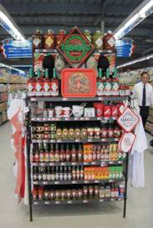

The dimensions of our displays are as follows: 24" wide, 14" deep, 72" height to top shelf, and 82" to top of the TABASCO© lighted clock sign. (TABASCO© lighted sign uses standard 120 volt wall outlet).

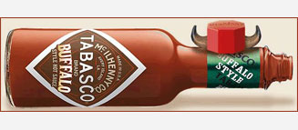

Our Products

TABASCO® Pepper Sauce
 | Since 1868, TABASCO® Sauce has been made with just three ingredients: fully aged red peppers, Avery Island salt, and distilled high-grain natural vinegar. This simple recipe - when brought together and aged with the greatest care and attention - produces the incredibly pungent, fiery pepper sauce that's beloved the world over.
  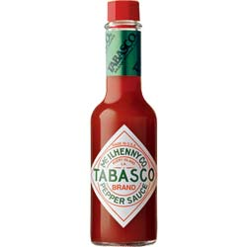
  00001 | TABASCO® Pepper Sauce 2oz
  00003 | TABASCO® Pepper Sauce 12oz
  00015 | TABASCO® Pepper Sauce 5oz
  00016 | TABASCO® Miniatures 1/8oz

TABASCO® Green Pepper Sauce
 | It's all about the flavor of jalapeño peppers, yet it's the mildest of the TABASCO® family. Rich and tangy, it has a gentler heat that won't blow you away.
  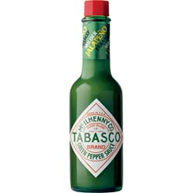
  00930 | TABASCO® Green Pepper Sauce 5oz
  00971 | TABASCO® Green Pepper Sauce 2oz
  00299 | TABASCO® Green Miniatures 1/8oz

TABASCO® Habanero Pepper Sauce
 | A Jamaican-style pepper sauce blended with mango, papayas, tamarind, banana, ginger, and ground black pepper. The result is a deceptively fruity, yet fiery HOT sauce.
  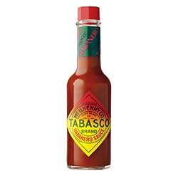
  00609 | TABASCO® Habanero Pepper Sauce 2oz
  00610 | TABASCO® Habanero Pepper Sauce 5oz

TABASCO® Sweet & Spicy Sauce
 | Say hello to the newest sauce from TABASCO® that's great for dipping. That's right, we said dipping! That's because this blend of exotic Asian flavors and a touch of TABASCO® Original Red Pepper Sauce is perfect for dipping your favorite finger foods-everything from egg rolls to chicken tenders to French fries!
  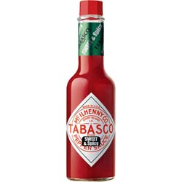
  00660 | TABASCO® Sweet & Spicy Sauce 5oz

TABASCO® Garlic Pepper Sauce
 | A milder member of the TABASCO® family, it blends the flavor of garlic with three different peppers - a smoother cayenne, a small amount of oak-aged tabasco pepper, as well as mellow red jalapeño.
  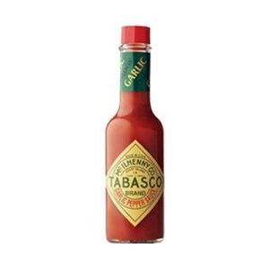
  00704 | TABASCO® Garlic Pepper Sauce 2oz
  00705 | TABASCO® Garlic Pepper Sauce 5oz

TABASCO® Chipotle Pepper Sauce
 | Pour it on! Our NEW TABASCO® Chipotle Sauce is made from select smoked red jalapeño peppers and has a smooth, rich smoky flavor. And it's our first pepper sauce that you can sprinkle on like a condiment, or really pour on like a steak sauce or marinade! Use a generous amount to marinate and grill chicken, flank steak, fajitas, hamburgers, vegetables, pork loin, and more - because it's not just about adding heat, it's about adding great smoky flavor.
  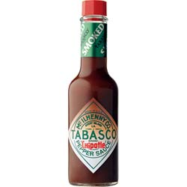
  00770 | TABASCO® Chipotle Pepper Sauce 5oz

TABASCO® Brand Buffalo Style Sauce
 | TABASCO® Buffalo Style Sauce -- Buffalo Style, Perfected......Once you try new TABASCO® Buffalo Style Sauce, you'll see that it stands head and horns above the rest. It's a thick sauce, so it sticks to food better. And it has just the right amount of heat, so it does more than make one-of-a-kind wings. It goes great on any kind of chicken, on sandwiches, burgers, and a whole lot more. It's the TABASCO® of Buffalo Style Sauces.
  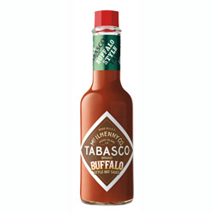
  00250 | TABASCO® Brand Buffalo Style Sauce 5oz

TABASCO® Buffaleaux Cajun Style Hot Sauce
 | In Buffalo, NY, folks spell it "buffalo sauce”, but folks from Cajun country in south Louisiana spell it "buffaleaux sauce". TABASCO® Buffaleaux style hot sauce stands head and horns above the rest. It's a thick sauce, so it sticks to things better, and it has just the right amount of heat, so it does more than make one-of-a-kind wings..
  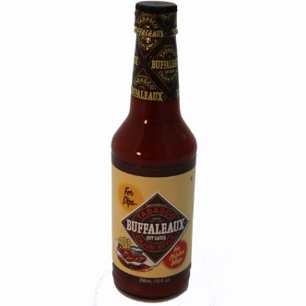
  00914 | TABASCO® Buffaleaux Cajun Style Hot Sauce 10oz

TABASCO® Raspberry Chipotle Sauce
 | TABASCO® Chipotle Sauce is blended with a vibrant raspberry puree to make a sweet, smoky, spicy sauce that goes great with beef, fish, or fowl and makes an awesome vinaigrette dressing for your favorite salad.
  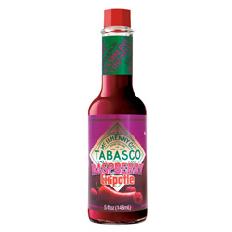
  00820 | TABASCO® Raspberry Chipotle Sauce 5oz
TABASCO ® Salsa
 | Prepared with vegetables at their peak of freshness, this premium salsa is spiced with the world's premium pepper sauce brand, TABASCO®. The flavor is so astoundingly good you'll want to enjoy it by the spoonful! Available in Medium, Chipotle or Hot!!
  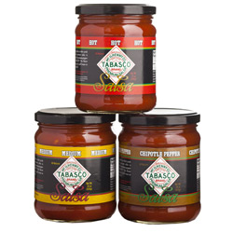
  00132 | TABASCO ® Salsa Medium 16oz jars
  00134 | TABASCO ® Salsa Hot 16 oz jars
  00136 | TABASCO ® Salsa Chipotle 16 oz jars

TABASCO® Spicy Pepper Jelly
 | Available in Spicy or Mild Jalapeño. TABASCO® Pepper Jelly can be used to add the perfect blend of spicy and sweet flavor to any meal. Serve with cream cheese and crackers or as a hors d'oeuvres, on your salads, or as a glaze on your grill.
  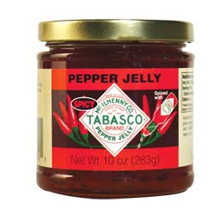
  00310 | TABASCO® Spicy Pepper Jelly 10oz

TABASCO® Jalapeno Pepper Jelly
 | Available in Spicy or Mild Jalapeño. TABASCO® Pepper Jelly can be used to add the perfect blend of spicy and sweet flavor to any meal. Serve with cream cheese and crackers or as a hors d'oeuvres, on your salads, or as a glaze on your grill.
  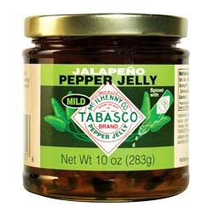
  00315 | TABASCO® Jalapeno Pepper Jelly 10oz

TABASCO® 7 Spice Chili Recipe
 | Made from 100% natural, fresh ingredients including herbs and spices this rich blend has just the right amount of TABASCO® Pepper Sauce. Just add 1lb of ground beef and your favorite beans for a quick and delicious chili that will leave you and your family calling for more. Available in Original or Spicy.
  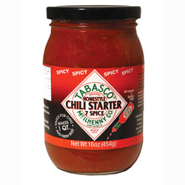
  00400 | TABASCO® 7 Spice Chili Recipe (Original) 16oz

TABASCO® 7 Spice Chili Recipe
 | Made from 100% natural, fresh ingredients including herbs and spices this rich blend has just the right amount of TABASCO® Pepper Sauce. Just add 1lb of ground beef and your favorite beans for a quick and delicious chili that will leave you and your family calling for more. Available in Original or Spicy.
  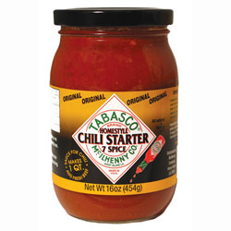
  00405 | TABASCO® 7 Spice Chili Recipe (Spicy) 16oz

TABASCO® Spicy Mayonnaise
 | Made with Blue Plate Real Mayonnaise and flavored with TABASCO® Pepper Sauce to create a mayonnaise with the zesty flavor of South Louisiana.
  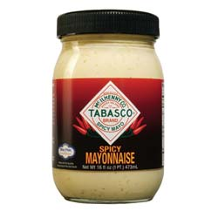
  02300 | TABASCO® Spicy Mayonnaise 16oz

TABASCO® Coarse Ground Mustard
 | Delicious and bold Creole style mustard made from a blend of mustard seed, horseradish and TABASCO® Pepper Sauce. Great as a base for grilling, an added flavor to marinades, dips and dressings, or on your favorite sandwich!
  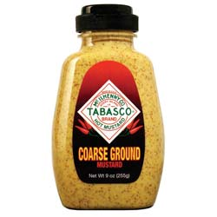
  02360 | TABASCO® Coarse Ground Mustard 9oz

TABASCO® Spicy Brown Mustard
 | A unique vibrant mustard perfect for adding a little spice and a lot of flavor to your favorite sandwich.
  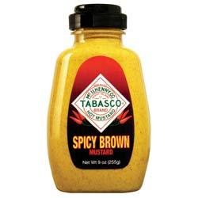
  02365 | TABASCO® Spicy Brown Mustard 9oz

TABASCO® Spicy Ketchup
 | A rich flavored ketchup perfect for fried foods and seafood cocktail sauces.
  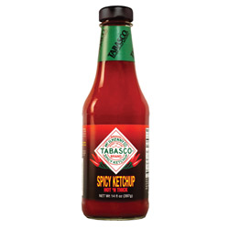
  02150 | TABASCO® Spicy Ketchup 14oz

TABASCO® Bar-B-Que
 | This is the perfect combination of flavors and spices to complement any item on your grill.
  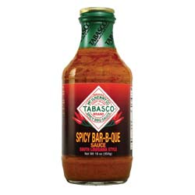
  02010 | TABASCO® Bar-B-Que Sauce 16oz

TABASCO® Brand Steak Sauce
 | It's a powerful, zesty combination that adds soul to basting sauces for grilled meats like hamburgers, hot dogs, chicken, or London broil.
  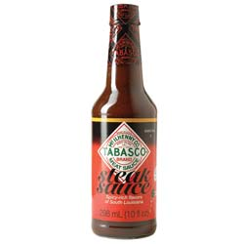
  00910 | TABASCO® Brand Steak Sauce 10oz

Caribbean Style Steak Sauce
 | It's a bold blend of exotic island spices, herbs, tomatoes, raisins, ripe mangoes, and TABASCO® Pepper Sauce that delivers the sweet-hot tropical flavor of the Caribbean islands.
  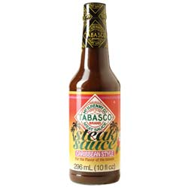
  00912 | Caribbean Style Steak Sauce 10oz

TABASCO® Garlic Basting Sauce
 | Wake up beef and other favorites with this flavorful sauce. It has a bold flavor with just the right amount of garlic, spices, and aged peppers. Use as a marinade or straight out of the bottle.
  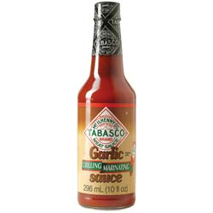
  00916 | TABASCO® Garlic Basting Sauce 10oz

TABASCO® Teriyaki Sauce
 | Add the perfect balance of sugar and spice with TABASCO® Teriyaki Sauce. A savory blend of soy sauce, sugar, wine, and a dash of TABASCO® Pepper Sauce. Enliven your favorite food!
  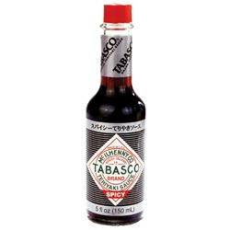
  00818 | TABASCO® Teriyaki Sauce 5oz

TABASCO® Brand Soy Sauce
 | Try TABASCO® Soy Sauce as a natural meat tenderizer or use it as a tasty marinade for beef, pork and lamb. Naturally brewed soy sauce is spiced with TABASCO® to add zing to just about everything.
  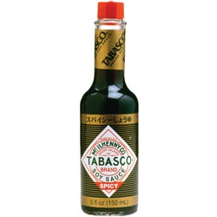
  00918 | TABASCO® Brand Soy Sauce 5oz

TABASCO® Worcestershire Sauce
 | Spicy and robust! Tamarind fruits and aged peppers mingle together in TABASCO® Worcestershire Sauce adding a spicy and robust flavor to any dish. This is great on burgers, caesar salads and, of course, Bloody Marys. For best results when preparing meats, marinate overnight in refrigerator with TABASCO® Worcestershire Sauce.
  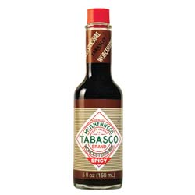
  00825 | TABASCO® Worcestershire Sauce 5oz

TABASCO® Pickled Okra
 | Eat them right from the jar, or use them to dress up a Bloody Mary or any favorite Creole recipe.
  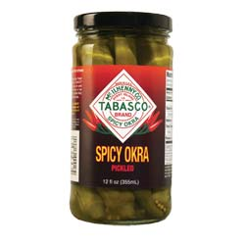
  02400 | TABASCO® Pickled Okra 12oz

TABASCO® Hot & Sweet Pickles
 | Cucumber slices pickled in TABASCO® Pepper Sauce and cane sugar.
  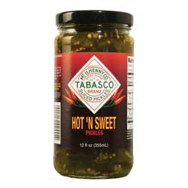
  02555 | TABASCO® Hot & Sweet Pickles 12oz

TABASCO® Dill Pickle spiced with Garlic
 | Cucumber slices pickled with a distinct flavor of TABASCO® Pepper Sauce and garlic.
  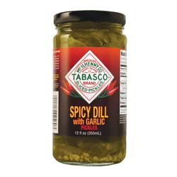
  02560 | TABASCO® Dill Pickle spiced with Garlic 12oz

TABASCO® Olives Stuffed with Pimento
 | Select Spanish olives spiced with genuine TABASCO® brand crushed red peppers.
  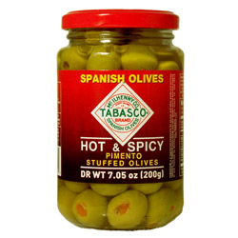
  00835 | TABASCO® Olives Stuffed with Pimento 7.5oz

TABASCO® Gift Box
 | Large box includes all five TABASCO® brand pepper sauces (classic Original Red, Green Jalapeño, Garlic Pepper, Chipotle, and Habanero) and three TABASCO® brand meat sauces (Steak, Caribbean, and Garlic Sauces.)
  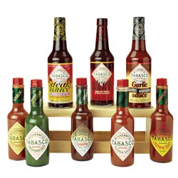
  04123 | TABASCO® Gift Box (Large)

Mini Travel Pack
 | Great to take on the road or give as gifts! 4 pack 1/8 oz. miniatures
  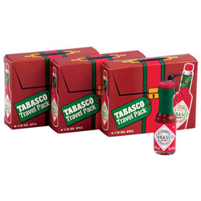
  00008 | Mini Travel Pack

TABASCO® Sauces Family of Flavors
 | A satisfying sample of seven TABASCO® Pepper Sauce flavors in a 5-oz. bottle - Original Red, Green Jalapeño, Garlic Pepper, Habanero, Chipotle, SWEET & Spicy and Buffalo Style. Great for corporate gifts. Ships packaged in an attractive foiled gift box
  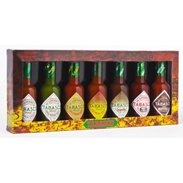
  05706 | TABASCO® Sauces Family of Flavors Gift Pack 7 – 5oz bottles

TABASCO® Spicy Gift Box
 | To bring you even more great tastes from the Cajun countryside, The McIlhenny family has brought a full line of specialty condiments to spice things up. Large condiment set includes: Bar-B-Que Sauce, Spicy Brown Mustard, Coarse Ground Mustard, Spicy Mayonnaise, Spicy Dill Pickles, Hot 'n Sweet Pickles.
  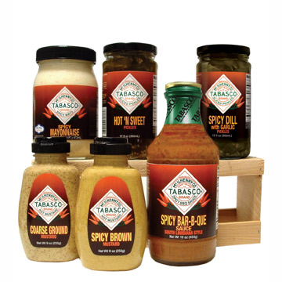
  08641 | TABASCO® Spicy Gift Box (Large)

TABASCO® Gift Box
 | Small gift box includes classic TABASCO® Original Red Sauce, milder TABASCO® Garlic Sauce, TABASCO® Green Sauce, 2 jars of TABASCO 7 Spice Homestyle Chili Starter® (spicy and mild), and a Travel Pack holding four TABASCO® Original Red miniatures
  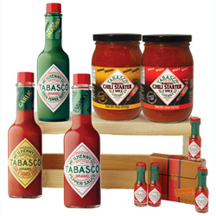
  08640 | TABASCO® Gift Box (Small)

TABASCO® Condiment Gift Box
 | To bring you even more great tastes from the Cajun countryside, the McIlhenny family has brought a full line of specialty condiments to spice things up. Small condiment set includes: Spicy Ketchup, Bar-B-Que Sauce, Spicy Mayonnaise, Spicy Brown Mustard, and Coarse Ground Mustard.
  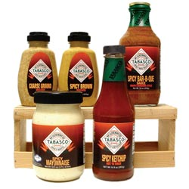
  04701 | TABASCO® Condiment Gift Box (Small)

Spicy Popcorn Recipes
 | A TABASCO® logo canvas bag filled with 1 lb. of popcorn, two tantalizing popcorn recipes and a miniature TABASCO® sauce bottle.
  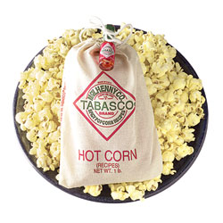
  04350 | Spicy Popcorn Recipes (1 lb. bag)

Aunt Sally’s SUGAR & SPICE PRALINES
 | Aunt Sally's Creamy Sugar & Spice Pralines spiced with TABASCO® Pepper Sauce.
  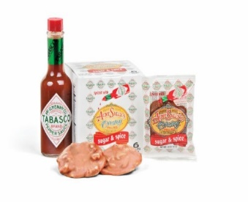
  NA | Aunt Sally’s SUGAR & SPICE PRALINES SINGLES - 12 individually wrapped 1.5oz pralines
  NA | Aunt Sally’s SUGAR & SPICE PRALINES - 6 individually wrapped 1.5oz pralines

Cinnamon Flavored Candy
 | Children and adults alike enjoy this "hot" cinnamon-flavored candy. McIlhenny Company offers this gourmet "hot" candy in a TABASCO® style bottle and handy bags. A great gift idea for anyone with a spicy, sweet tooth.
  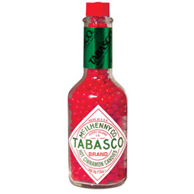
  03500 | Bag of Cinnamon Flavored Candy 1oz
  03679 | Bottle of Cinnamon Flavored Candy (Glass) 5oz
  03692 | Bag of Cinnamon Flavored Candy 4oz

Cinnamon Flavored Lollipop
 | A spicy treat for the whole family. Lollipops are sold individually.
  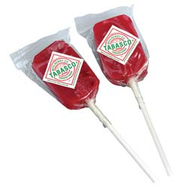
  04600 | TABASCO® Cinnamon Flavored Lollipop

Apron
 | Show you've got great taste when you cook in your very own TABASCO® apron.
  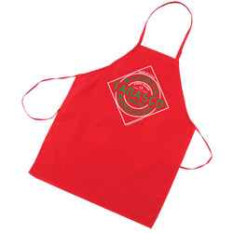
  03183 | TABASCO® Logo Red Apron

Caps
 | White Cap w/ Green & Navy Logo Cloth Strap w/ Velcro for adjustment
  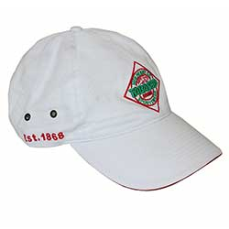
  04730 | Cap, Classic White

Mitt
 | A little Spicy "Help" is the kitchen is always welcomed!
  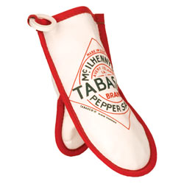
  04949 | TABASCO® Oven Mitt

Mitt
 | Cotton Linen quilted with a heat resistant backing.
  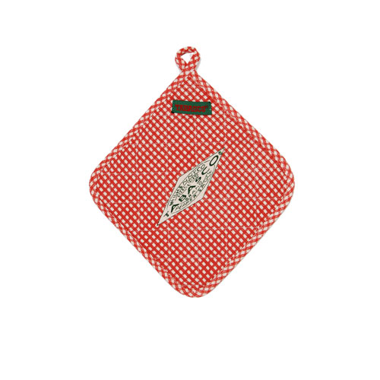
  04949 | TABASCO® Oven Mitt

Potholder
 | Cotton Linen quilted with a heat resistant backing.
  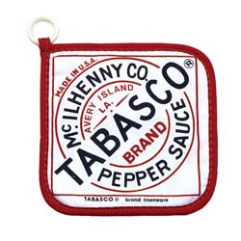
  05325 | TABASCO® Logo Potholder

Beer Mug
 | This 15 oz. glass mug with handle has TABASCO® logo etched on the front.
  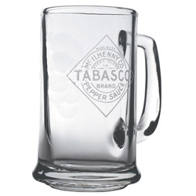
  07610 | TABASCO® Logo Beer Mug

Coffee Mug
 | All TABASCO® lovers would enjoy nothing better than to drink their favorite "hot" beverage from their own TABASCO® logo ceramic mug. 12 oz. mug
  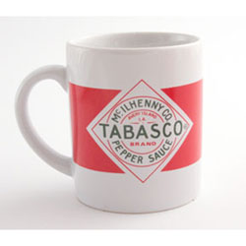
  08061 | TABASCO® Logo Coffee Mug (Red/White)

Woodchips
 | Talk about great flavor. These wood chips are made from the white oak barrels used to age TABASCO® Pepper Sauce
  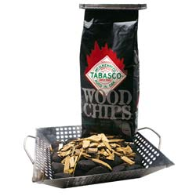
  09227 | TABASCO® Woodchips (Basket & Charcoal Not Included)

Cookbook
 | Written by Paul McILhenny
  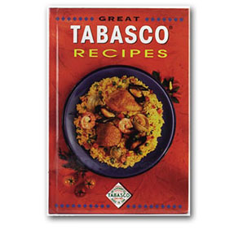
  NA | Great Tabasco Recipes Cookbook

