Task Outline
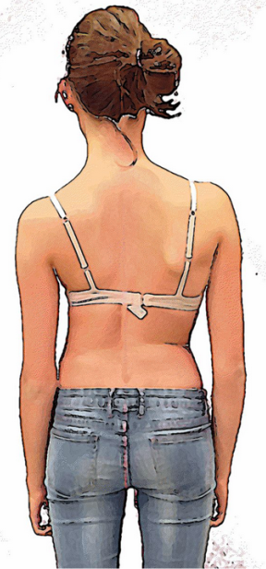
We need three digital “illustration style” graphics – with depth (similar to a photo) but with a hand drawn/cartoon style. Similar to the style of image below:

Task Description
These graphics will be used in medical/science marketing material, so need to be accurate to the photos provided. The aim of this project is to have graphics which are still like a photo but are ‘de-personalised’ and all in the same styling and colouring - please refer to the above image for styling and colour guide. However, we would like it to be cleaner and more professional than this image where possible.
Format
- In an eps or high resolution format suitable for printing and use in Indesign
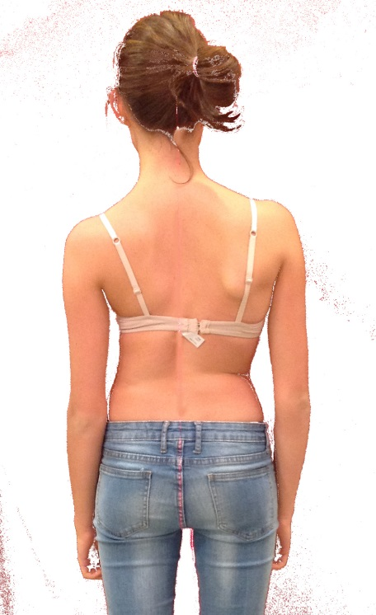
- With an opaque background
