LULUBUBS (working name)

Brand promise
Stylish, practical clothes for parents who don’t want to dress their kids in ‘cutesy’ baby wear.

Target market
- Parents & gift buyers (friends, grandparents)
- Want to dress their kids in clothing they might wear.
- Not overly price sensitive but don’t want to pay designer prices – they know that babies grow out of their clothes fast.
- Shop where ever is convenient: online, dept stores, boutiques, shopping malls

What we need
- 5 stylish, clean graphics to be used for baby clothes
- Will be printed on white cotton jersey, although white background not mandatory for the patterns
- Unique elements of the pattern must not be over a space greater than 100mm x 150mm, then repeatable over the full dimensions
- Unisex
- Not cutesy or babyish – a print an adult might also wear.
- For Pinspiration please look at:
  - Pinner Luluh77 (Lucy Hill)
  - Board name: Cool patterns & graphics
- Design concepts for each graphic outlined below.
- The 5 graphics should be quite distinct from each other however use common colours (as outlined below) and wherever else is possible/ appropriate. As we will also be producing matching single colour baby pants.

 | Name | Description | Colours
1 | Chevron | A clean chevron pattern in 5-6 colours | Primary: Red  Also incorporate: white, grey (same grey used in 4. Fine Lines), blue (same as one of the colours in 3. Waves) & 1-2 other colours
2 | Leafy | Use leaves & foliage as your inspiration – think palms & ferns rather than autumn leaves | Primary: any green  Also incorporate: white & other shades of green
3 | Waves | Use the ocean & water as your inspiration but no need to be literal. The pattern shouldn’t be too ‘uniform’ – and remain distinct from the chevron graphic | Primary: n/a  Also incorporate: sea blues & greens
4 | Fine lines | A plain white background with a funky ‘line drawing’ graphic – open to any inspiration here: nature, geometric shapes… no stripes. | Primary: White  Also incorporate: black & grey
5 | Tribal | Inspired by Navajo and Aztec prints, in particular those based on feathers. | Primary: Any colour combination can be used for this design but ensure some crossover with colours used in other designs.

Specs
- CMYK
- Samples / working files in PDF 300mm x 300mm
- Final file in Adobe Illustrator
- Final graphic dimensions 1000mm x 1000mm

Product application

Initial
- short sleeve onesie/baby grow
- Tracksuit pants/ leggings (3-5 single colours depending on common colours in graphics)
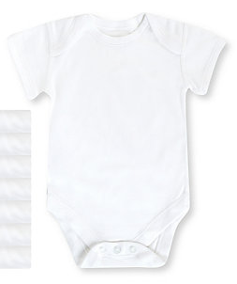

Products - future
- Long sleeve onesies
- T-shirts kids
- Large cotton muslin wraps

