
WHAT IS HOT STONE?
HOT STONE REFERS TO THE OLD TECHNIQUE OF BAKING THAT BEGAN THOUSANDS OF YEARS AGO. AT A TIME WHEN OVENS WERE MADE WITH STONES AND MEATS AND PASTRIES WERE COOKED DIRECTLY ON THE HEARTH. TODAY AT HOT STONE WE COMBINE THIS CENTURIES OLD METHOD WITH NEW AND INNOVATIVE RECIPES USING HIGH QUALITY FRESH INGRIDIENTS TO BRING YOU DELICSOUS AND FLAVOURFUL DISHES.
THE DOME AND FLOOR OF OUR OVEN IS MADE WITH A STONE MATERIAL WITH A THICKNESS OF 30CM. THIS THICK STONE MATERIAL HELPS MAINTAIN THE OVEN AT HIGH TEMPRATURE REACHING UP TO 800 DEGREES FAHRENHITE. THIS TEMPRATURE COOKS BREADS AND PIZZAS REALLY FAST AND RESULTS IN A DELICATE CRUST THAT IS CRISPY ON THE OUTSIDE AND MOIST INSIDE WITH A SPECIAL GREAT FAVLOUR.



FOR EASY RECOGNITION, IN THE FOLLOWING MENU YOU WILL SEE ALL OUR OVEN BAKED DISHES MARKED WITH THIS SYMBOL ( )
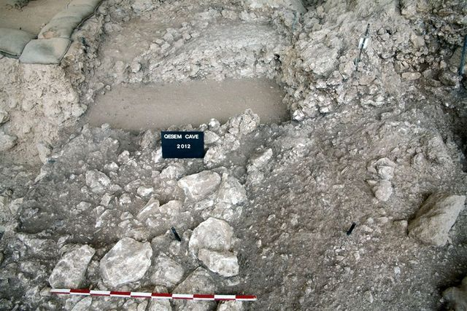
PICTURED ABOVE ARE THE REMAINS OF THE OLDEST KNOWN HEARTH USED FOR COOKING. DISCOVERED IN THE LEVANTE REGON IN THE YEAR 2000, ARCHIOLIGSITS ESTIMATE THIS OVEN TO BE 300 THOUSAND YEARS OLD. IT WAS BUILT WITH STONES AND HAS AN AREA OF APPROXIMATELY 4 SQUARE METERS. EVIDENCE SUGGESTS THIS OVEN WAS USED FOR COOKING MEATS AND IT REACHED TEMPRATURES OF UP TO 900 DEGREES FAHRENHITE.

