The Company
Noble Sovrano Ltd is a value based infrastructure development and real estate company. We are involved in planning, designing, construction and management of infrastructure development. We take on the biggest issues that affect us all, road, water, transportation, Energy and the need for places to live and work. We are proud of our ability to create and deliver good solutions to our clients whether in construction, engineering consulting and real estate.
Our company is founded on a strong belief in our core values. We have a real commitment to innovation and the support of good ideas. The firm is built upon years of experience in the Nigerian Construction, consulting and real estate environment.
Our Aim
Our mission is to develop a global infrastructure development company that will represent true industry standards and be a conspicuous player not only in Nigeria but Africa and the world over.
Excellence in service remains the major driving force of the firm in the built environment. We have core values that provide guiding principles for everyone at Noble Sovrano, these core values help us work effectively together and with others to provide a better place to work, a better service to our clients, and support to the communities in which we work.

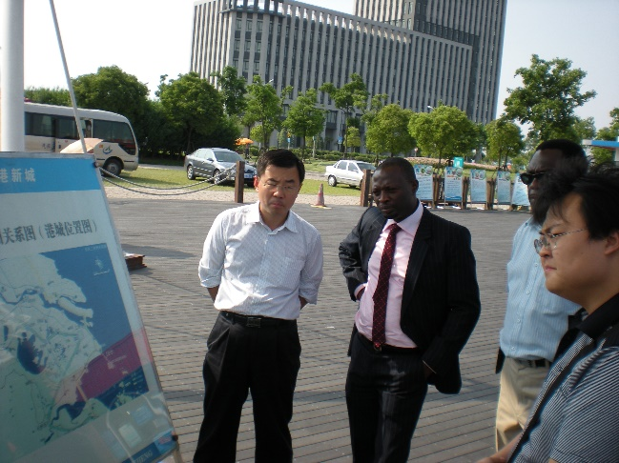

Our Services
Consulting
- Road design
- Building structural design
- Storm and waste water sewer systems
- Large expanse drainage network design
- Infrastructure planning for large area (hectarage) property developments
- Flood assessment, mitigation and river engineering hydraulic modelling
- Lidar survey, contour mapping, Terrain modelling.
- Wastewater treatment system
- Mechanical and electrical infrastructure design
- Project management
- Area terrain photography and video
Construction
- Road construction
- Commercial and residential Building Construction
- Storm water drainage construction
- Sewer networks and treatment plant construction
- Civil works construction.
- Electrification.
Real Estate
Commercial property development and lease/sale
Residential property development and lease/sale

PROJECTS

Lekki Free Trade Zone Storm Water Drainage Master Planning and Design

The trade zone is a China-Lagos state government project under development to turn it into a modern satellite city of the international metropolis of Lagos. We designed the storm drainage infrastructure for the over 30 square kilometre trade zone with focus on the Lagos lagoon and Atlantic Ocean tidal levels and a network of artificial rivers. We have carried out several such storm water drainage design and flood assessments and developing terrain models for precision engineering works.
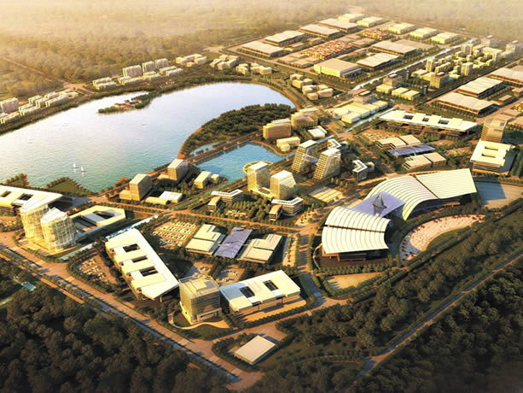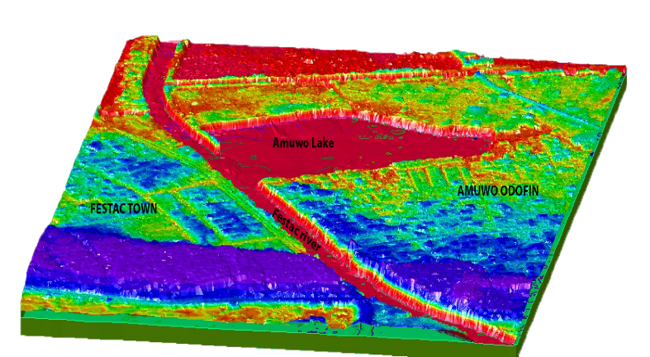

Road construction for have homes lekki
As one of our road construction projects, at alma beach lekki we constructed a networks of roads and drainage infrastructure for the haven homes estate and almond court estates. These infrastructures were also designed by our design team.
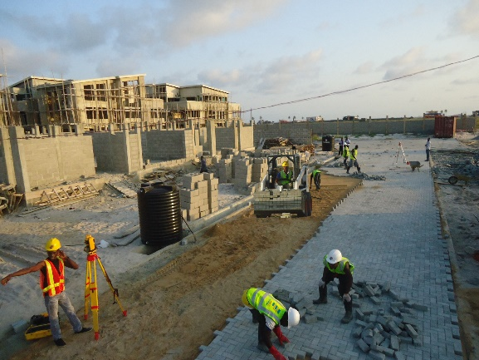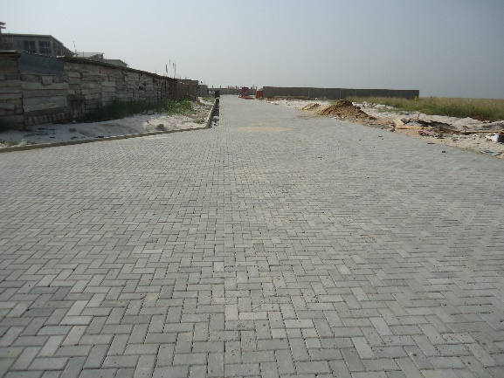

Construction of Worthe Mall Abuja
We constructed worthe mall to feature luxury shops. We developed this commercial property which is one of our real estate ventures to offer our clients a great place to showcase their business. 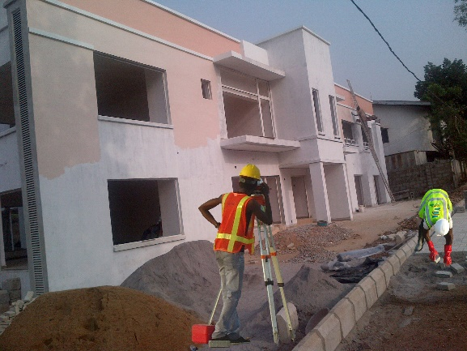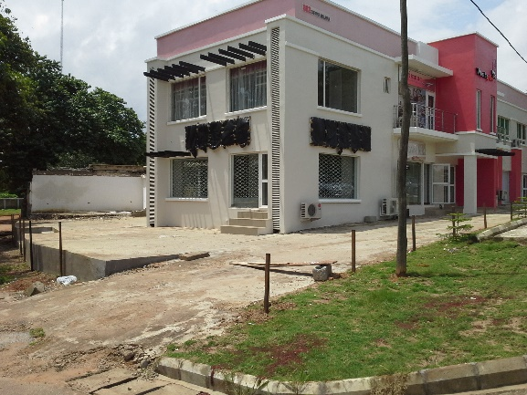

Design and construction of JCIL estate Lekki
We did detailed design of this modern estate in Lekki Lagos to have infrastructure such as roads drainages, underground electrification, waste water sewer system, water supply etc. All buildings were designed to have modern architecture and fittings. We are also involved in its construction.
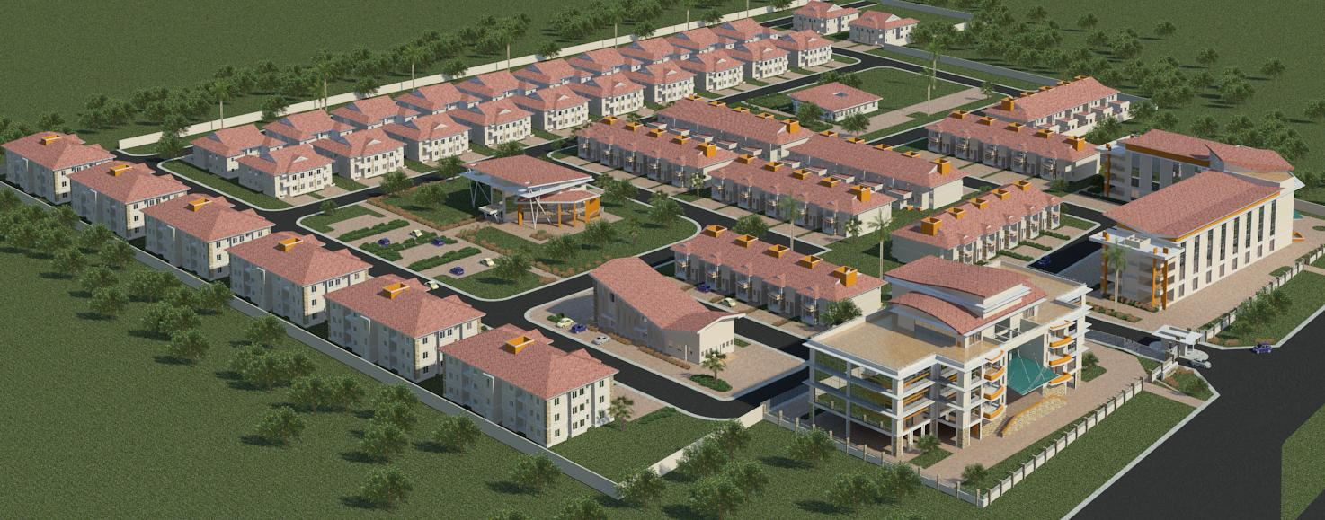

Construction of road and civil infrastructure for platinum estate
In magboro Ogun state we are constructing the network of roads, drainages and civil infrastructures for this estate which spans over 25 hectares. Construction works are in top gear to ensure a neat delivery. Our construction methods are with high precision works and our works speak for itself. Just about a km from this site, we are developing an ultra-modern market with about 4000 shops as one of our real-estate venture.
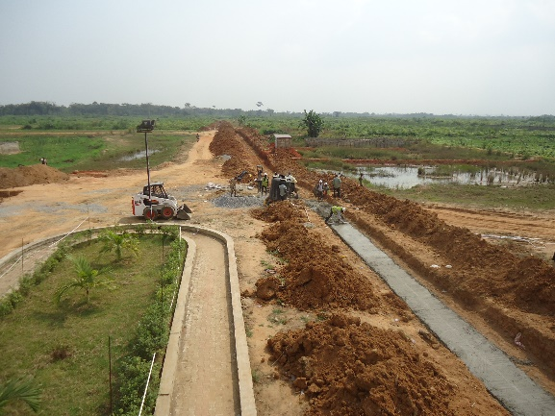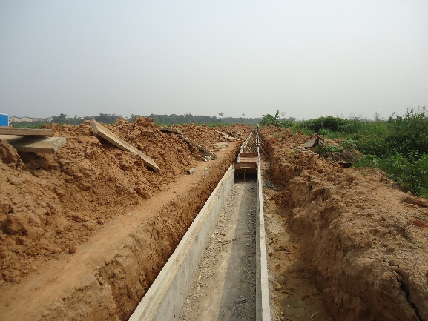

High definition Area photograph and video
We have conducted several high definition area photographs and video for massive projects or locations. It is very useful in project planning and scoping, it has helped our various client to understand the terrain of their proposed or developed project site. Below are a few such shots.
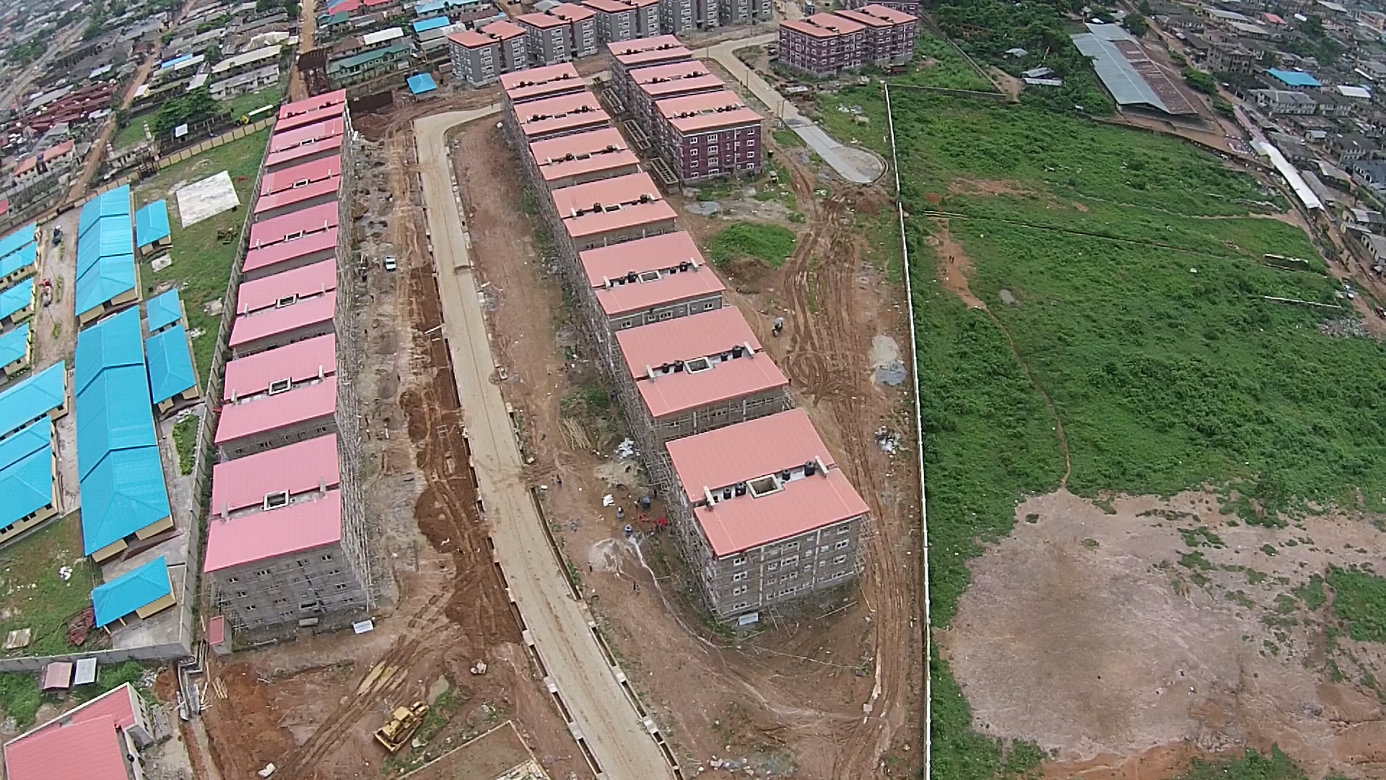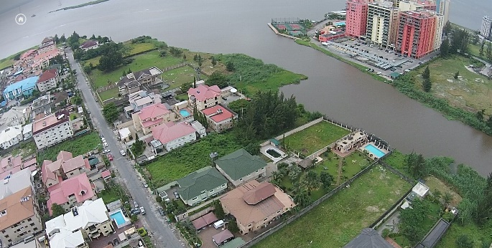

CONTACT US
5, Asenuga Street, off Opebi link Road. Ikeja Lagos. Nigeria
+234 13428006
+234 7046332023

http://www.noblesovrano.com
info@noblesovrano.com

