Following is my company logo:
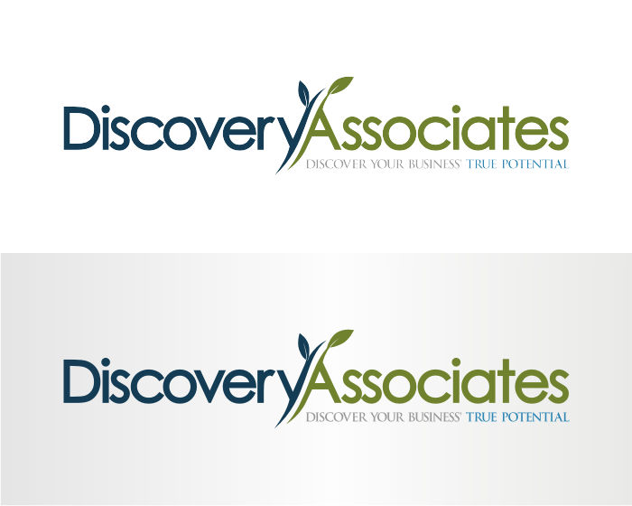

I need a version of the following logos tweaked to look professional. I created them in Powerpoint with clipart just to play around with some names and my font choice was limited to what was available in PowerPoint):


Partner™
Proposal


I will be using these service/product logos in advertising along with my company logo above. I don’t what them too matchy-matchy, but the colors have to not clash with my logo and they have to look like they have some unity, but are different services/products.
StartUP Smart: This service will be a package offered to startups that will include a logo, a business plan, and a market and competitor landscape analysis.

Proposal Partner: With this service, we will work with the client to create a proposal to be submitted for business funding opportunities. I like the idea of the handshake, but again, I just grabbed a handshake from clip art and made the color of the letters fit. You can integrate the name and handshake however you think is best. I kind of like these colors together, but I’m open to ideas. Again, I want to point out that while the brown that I used is not part of my color palette, it does go with it and therefore was just fine.
MarketSmart: Please feel free to play around with the location of the magnifying glass, the colors of the lettering (although I don’t mind these colors), and the font style. It might even be interesting to have something small show up in the magnifying glass that was part of the main color that you didn’t see before the magnifying glass was put on it (kind of like discovering hidden market information – maybe a few different colored blocks that together look red, but when magnified are there…). Or, that might look too cluttered, not sure. Just see what you think looks best. Simple is fine as well.
FYI, S.M.A.R.T stands for Systematic Market Analysis and Review of Technology. I need this printed in a complimentary color and font that I can use with either of the SMART (Startup Smart or MarketSmart) services.
My main color palette is the following, so as long as the colors that you pick don’t clash but are complimentary, I’m fine with whatever you think would look best. I liked the colors in the clip art logos, but was also limited to clip art. I don’t want it too matchy-matchy, but would likeit to look nice on a website or brochure, when all the colors are used together:
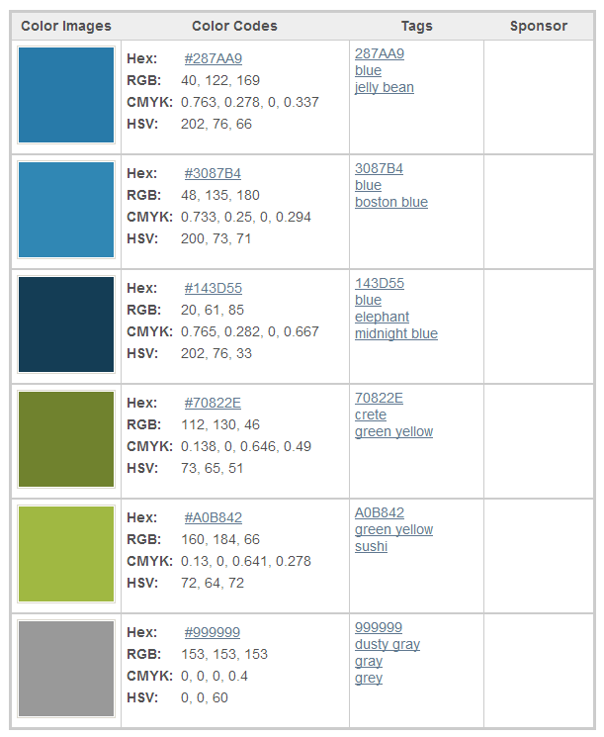
THANKS!!

