This is my heroine, 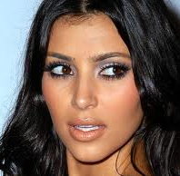 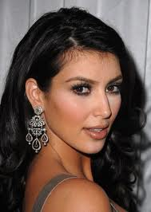
a younger, more natural looking Kim Kardashian. She’s described in the book as an exotic beauty with curly black hair, although she would wear it in waves and even straighten it at times.

The book’s hero, a guy from a documentary. My hero isn’t in the military. This captures his personality though.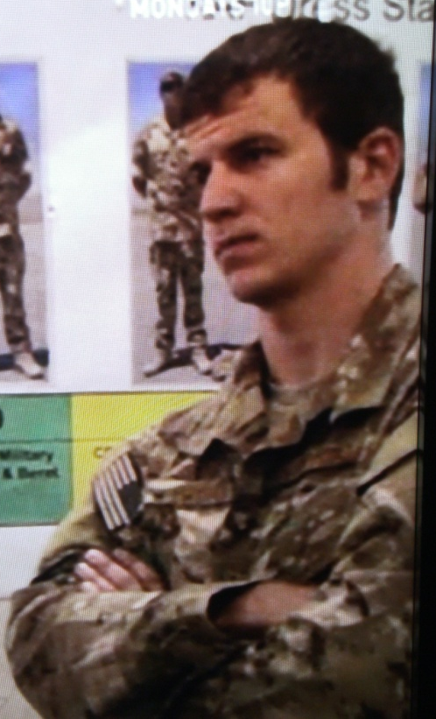

Here are some examples of pics that give an idea of what I’m looking for. In all of these, I like the hands.

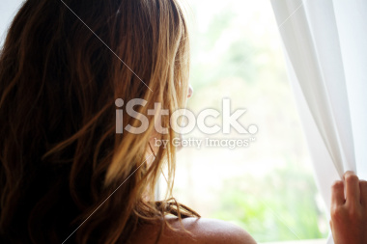
http://www.istockphoto.com/stock-photo-24533429-looking.php?st=3908b93
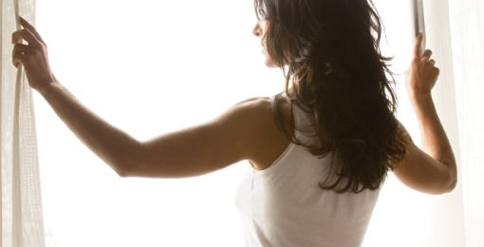
http://doktori.mk/files/upload/294/woman+looking+out+window_3.jpg
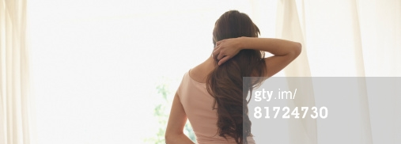
http://www.gettyimages.com/detail/photo/woman-standing-indoors-by-large-windows-royalty-free-image/81724730
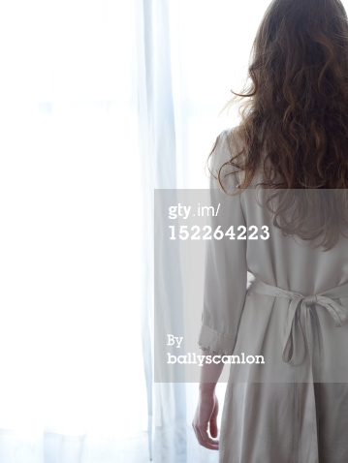 Don’t like what she’s wearing. And not wild about the hands.
http://www.gettyimages.com/detail/photo/young-red-haired-woman-looking-out-a-window-royalty-free-image/152264223
This is a view taken from the lake of Buckingham Fountain in Grant Park, the opposite side of the view I need, though. This shows the spring color scheme I’m going for with the blue of the lake added in. So you know for the angle, my characters’ building is in the very upper right of the picture, mostly out of the frame.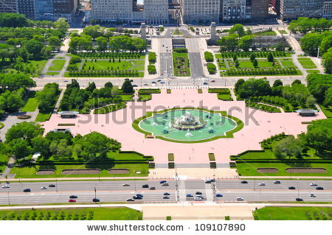
This is Metropolitan Tower, my main characters’ building: 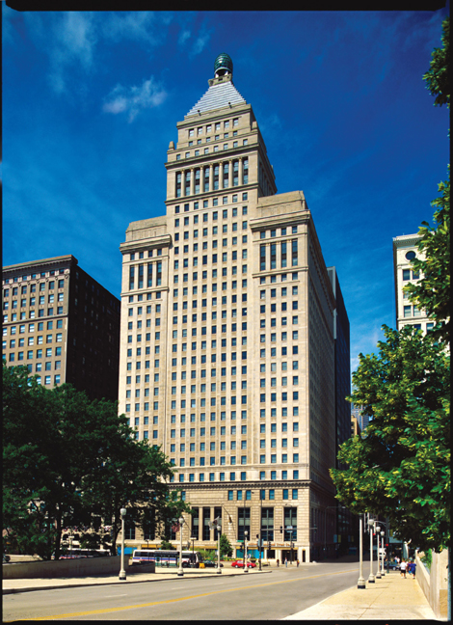

A lot of my scenes in Grant Park happen during the day—my h/h are runners—and I mention the toasted skyline. Here’s a couple pics that work for that. On the back perhaps? At this point I’m throwing out ideas. I’d be very open to something different on the back.
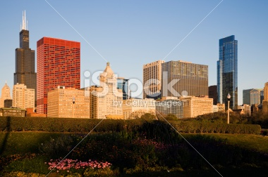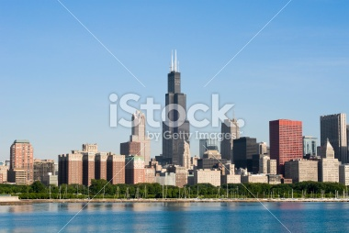 Metropolitan tower is all the way on the right here; has that pyramid on the top.
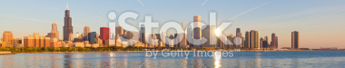
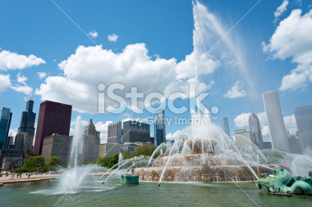Met Tower is just below and left of the i in iStock.

