An opportunity for collaboration section | Change to:
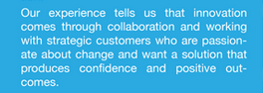 | Our experience tells us that innovation comes through collaboration. We work with strategic partners who want a solution that delivers successful change across their organization and demonstrated benefits.
 | Sorry I made an error in my request – the word “too” should be “to:”
Under the Pillars section – Identifying stakeholders interest and influence levels
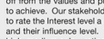 | The word influence needs to have a capital I.
Under the Pillars section – Reports and Plans
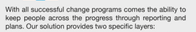 | This paragraph needs to be changed to:  With all successful change programs comes the ability to keep people informed. TPTribe provides reports and plans as core information tools for your change program.
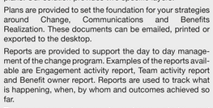 | Can the words at the beginning of both paragraphs be BOLD. Eg. Plans and Reports  Can the Plans paragraph be ‘left justified’ as the text appears justified and out of order to the rest of the text.
 | Please delete this
Under the Pillars section – Engagement
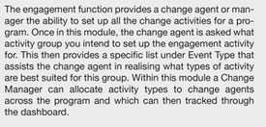 | There are minor grammar changes.  The forth line down can you replace the word “you” with “they”. Eg …they intent to set up…..  The second last line needs to have the word “be” between then and tracked. Eg. ..which can then be tracked through….
Front Page
 | Can the words Red Carpet Program be shifted down a line please.

