Where TPTribe started…
Marabou Enterprises is a small consulting company based in Australia that provides organisational change services. In 2012 we launched into the development of our flagship product TPTribe – Transforming Projects and released into the global market our Software as a Service Change Management application.
Throughout our years of professional engagements and careers we understand that there are many methodologies and frameworks that establish both good and bad change management practices. TPTribe has been created from world’s best practice and real implementations.

Change management
Change Management comes in many forms and can be driver from many sources and directions. Common drivers of change are:
- IT System replacements or upgrades
- Organisation restructures
- Office relocations
- Mergers and acquisitions
- Compliance
- Stronger drive for further improvement (BPM)
The underpinnings of Change:
There are a number of conditions that best practice has shown are necessary to apply change successfully in projects:
- A commitment to change from the very highest levels of the organisation;
- Alignment to the core strategy;
- A strong model or methodology to guide the journey; and
- The ability to effectively and efficiently communicate the strategic message of change and change culture.

What TPTribe can do for change practitioners?

TPTribe core capabilities underpin the opportunity of success in any change initiative. Within our product you will find a methodology that asks each subscribed user or team to think about a change framework via the menu choices. For the novice change agent TPTribe is there to guide and educate on the foundation elements used in best practice change management. For the experienced change practitioner it establishes a system which you can manage the fundamental activities for the change program being managed and enable dashboard views and reporting of events, activities and benefits.

How do I access the application?
TPTribe – Transforming Projects™ can be accessed as a Software as a Service offering via the cloud at www.tptribe.com

Confidence – security and privacy guaranteed
TPTribe has full SSL security via GeoTrust - Sites secured by GeoTrust SSL certificates are providing up to 256 bit encryption thereby offering the highest level of encryption and security possible. This means you can rest assured that communications between your browser and this site's web servers are private and secure.
The site has also been assessed and certified by TRUSTe - the leading global data privacy management solutions provider and offers a suite of software and services enabling companies to safely collect and use customer data to power their digital businesses around the world – enabling them to unlock the full value of their data while building trust, driving engagement, and ensuring compliance.
We have selected to host on Amazon Web Services to ensure 24/7 availability in services and protection of data management.

Subscription levels
TPTribe offers 4 tiers of subscription and depending on your team size and extent of change maturity your organisation is undertaking will determine the level of subscription you need.
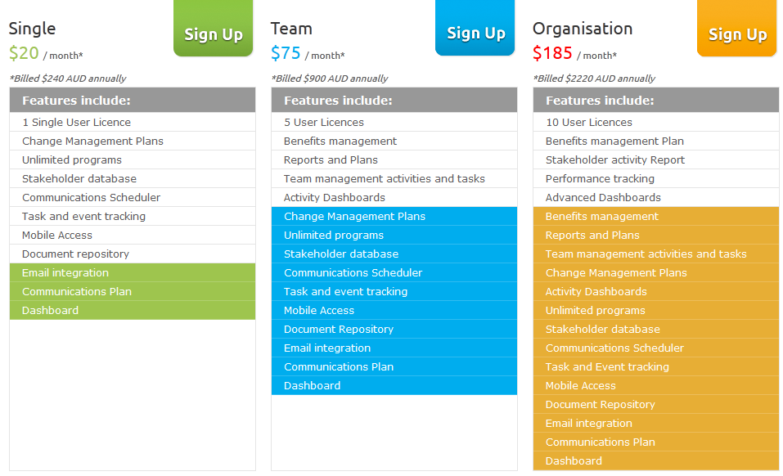Tier 4 is the Customize subscription– you gain the full suite of services under “Organisation” but it is customised in both price and number of users for your change needs. It often comes with a proof of capability program (on request) that provides for rapid uptake of the services for programs already initiated or new programs about to commence.
A packaged arrangement that can be negotiated with our Sales and Marketing Director Kaye Price (kaye.price@marabou.net.au)

Some details of TPTribe
The TPTribe change management framework is designed around key pillars of managing change programs. Within the program we have designed the application to teach the novice change practitioner foundation change principles such as:

Identifying stakeholders interest and influence levels
When running any change program one fundamental challenge is the balance of communication and engagement to everyone affected by change. Often when managed incorrectly it can lead to change burn-out and people switching off from the values and purpose the organisation is trying to achieve. Our stakeholder profile asks the change agent to rate the Interest level a person may have in the program and their influence level. These two elements are given a high, medium or low rating. This drives an engagement approach that maximises the communication approach for them as individuals by grouping them in target areas.

Engagement
The engagement function provides a change agent or manager the ability to set up all the change activities for a program. Once in this module the change agent is asked what activity group you intend to set up the engagement activity for. This then provides a specific list under Event Type that assists the change agent in realising what types of activity are best suited for this group. Within this module a Change Manager can allocate activity types to change agents across the program and which can then tracked through the dashboard.

Benefits
Our philosophy on change has always been “if you can’t align the benefits you expect to gain from a change initiative to either the corporate vision, strategies or goals then you really need to ask yourself is this the right thing to be doing”?
As change professionals’ benefits is where communication begins. TPTribe provides the change agent an ability to record all the benefits expected from a change initiative. It teaches novice practitioners the fundamental questions necessary to ask around describing benefits, outcomes, attributes and measures. Furthermore, it asks them to identify who in the business will own the outcome and where in the business the value is to be achieved.
Once the benefits are created the establishment of communication and key messages flows as a natural roadmap is clear in each benefit described.

Reports and Plans
With all successful change programs comes the ability to keep people across the progress through reporting and plans. Our solution provides two specific layers:
Plans are provided to set the foundation for your strategies around Change, Communications and Benefits Realization. These documents can be emailed, printed or exported to the desktop. They come in two formats:
- MS Word so that the change agent can edit the context to suit their methodology or approach and brand with their company formats etc.
- PDF so that it’s a controlled document that is easily read via any device.
Reports are provided to support the day to day management of the change program. Examples of the reports available are Engagement activity report, Team activity report and Benefit owner report. Reports are used to track what is happening, when, by whom and outcomes achieved so far.
These reports can be run and saved to your desktop and can then be distributed by you internal systems. They come in two formats:
- MS Excel so that the change agent can add filters and styles and possibly depth through graphs that can articulate the message.
- PDF so that it’s a controlled document that is easily read via any device.

The following pages provide some screen shots of the application.

Dashboard
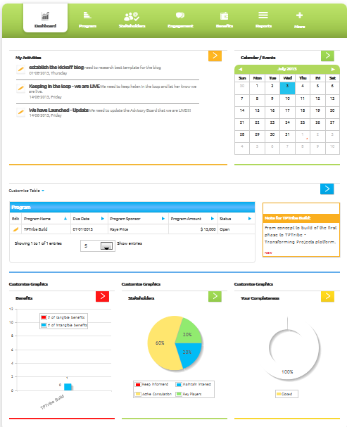

Program edit page
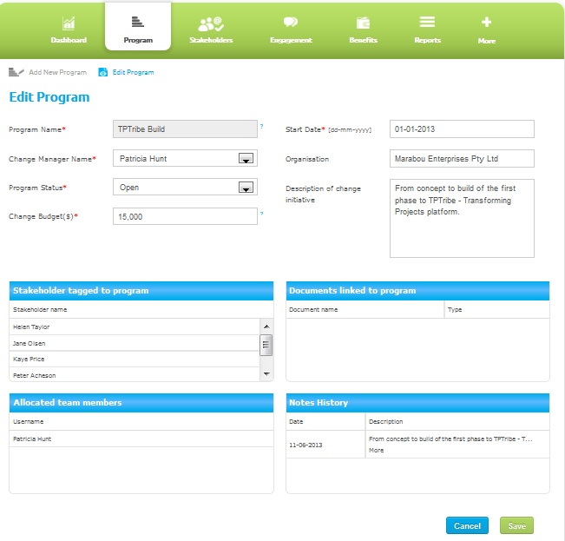

Stakeholder Edit Page
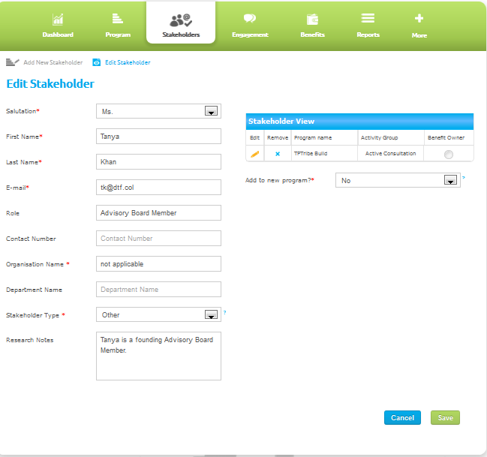

Engagement Edit Page
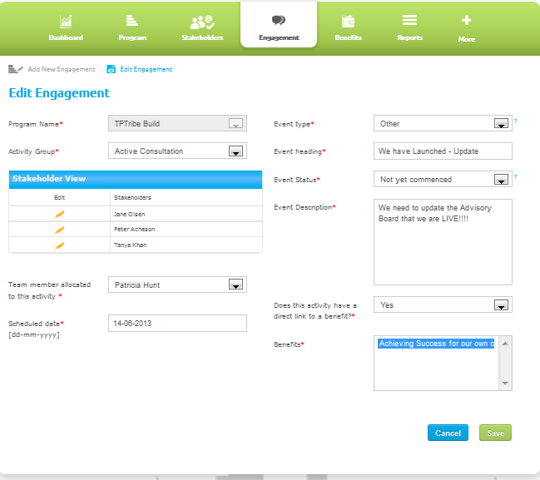

Benefit Edit Page
