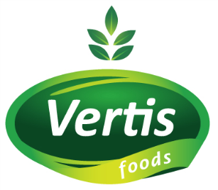

Creative Brief - Packaging

BACKGROUND
Romania
Romania is a country in SE of Europe, in the Balkan region. As a culture is a mixture of Latin roots and Balkan heritage. The country is a 25 year old democracy which had a blooming and expansive economy in the first years and is now a developed country after European standards and a 7 year old member of the European Union.
Romania is more polarized when it comes to social status rather than having a very strong and wide middle class. This is the main reason why most of the products are targeting the low mainstream segment. The mainstream products are mostly created out of a compromise between the audience’s reality (available budget) and their aspirations and wishes for belonging to a better group (their aspirational perception regarding themselves).
There are a lot of multinational companies on the Romanian FMCG market which are not adapting their products to the Romanian reality.
There are also Romanian companies who opt for one of the three solutions below:
- Copying the multinationals and not disclosing that they are Romanian (Strategy: It’s foreign, so it’s better – this goes well with the collective perception on imported products)
- Promoting romanian identity: the best natural products are made in Romania
- Finding in-house solutions for branding which are most of the time confusing and disruptive for the collective perception of the target audience

Vertis Foods
Vertis Foods is a company active on the Romanian FMCG market for almost 20 years. Until 2013 it was only dealing with coffee (importing, processing/roasting and blending) which made it become the second largest Romanian independent coffee processor. In 2013 it started expanding into new directions such as importing and distributing canned vegetables, fruits, fish and sweets.
The company’s mission is to bring quality food to target audiences of any social status (you receive a bit more than what you spend). Our core values are: reliability, loyalty and commitment to development.

Corporate Communication History
The name Vertis Foods was given in 2012 and it is practically the first corporate name which was promoted to the distributors and other business partners. We have just rebranded our logo to make it more suitable for use on our products so our strategy is: „don’t go for anonymous, chose a branded product”
Main problem: The product portfolio is quite wide and it includes a few old in-house made brands from the first years (Morena Café), a new brand (Rio Cafe) – both registered TMs of Vertis Foods, as well as some brands that don’t belong to us for the canned products. This is why we want to implemet for the canned products our brand and by using the Vertis logo to create a bit of order and memorability and, of course, to also concentrate our communication efforts as we only benefit from a small communication budget.
New positioning: the Great brand of the lower mainstream.

Vertis Foods Products
Products under Vertis registered brands
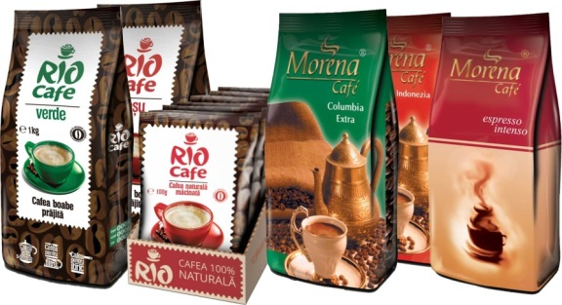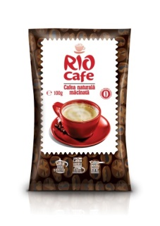

Products under foreign brands
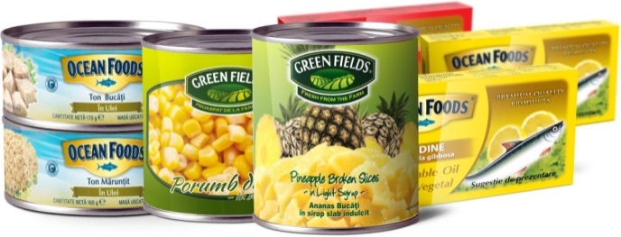

PACKAGING
We want to change the packaging for the canned pineapple slices and canned pineapple broken slices which is now under the greenfields brand (which doesn’t belong to Vertis).
Submission requirements:
- Editable file (AI) for the 2 products with 0.3 mm bleed defined.
- Mockup requested for both products, editable version.
- Fonts used.
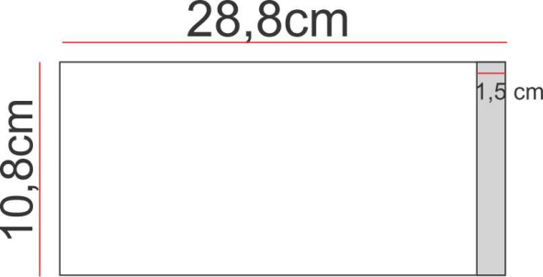
Label characteristics:
- Paper applied on round cans
- Cut Dimensions : 10,8cm(height)x27,8cm (width). Width includes 1,5cm overlap for glueing. The overlap can be on he back or on the side surface depending on the designer choice

- Label content requirements: in annex 1a and 1b.
  - The English version is only for your information, we will be using the Romanian one on the actual product labels!!
  - Numbers/Percentagesfor nutrition facts and contents may be changed during the contest period
  - Please pay atention to ROMANIAN SPECIAL CHARACTERS (found in ANSI - Central Europe fonts)

Must have
The design should take into consideration the visibility on the shelf among competitor products (annex 2) and that the product is a MAINSTREAM product.
We want a very tasty (in terms of making your mouth water) and clean design (less is more). The design should be easily modifiable for other canned fruits or vegetables.
The package must display on the front the following elements listed in the order of their should have noticeability:
- Vertis Green logo
- Pineapple picture
- Product name
Designers should take into account that the shelfs for displaying the products in the shops may have an elevation of up to 3 cm that can overlap the product label.

Guidelines
- We would like the packaging to be as simple as possible (or at least not to sabotage the Vertis name ), as our strategy depends on the agressive communication of the Vertis logo.
- We would also like to communicate through suggestive and optimal colours as to be easily spotted on the shelf.
- As we have quite a minimal communication budget we need basically for the packaging to do a lot of the communication job itself
- FMCG is a highly visual industry so we have to include pictures of the products on the packages (even more than others do, as we are focused on health and quality - we want people to have that feeling of fresh products even though we are selling canned ones)
Urgent up-coming projects
- Rebranding packaging for our other canned products.
- Packaging for other products such as sugar sticks (5 grams)
- Company Stationery
- Coffee packaging

ANNEX 1a Label content requirements PINEAPPLE SLICES
# | ROMANIAN | ENGLISH TRANSLATION | COMMENTS
F1 | Vertis greens logo 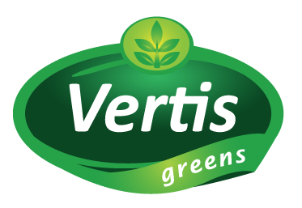 | - | Mandatory on the front  Provided in a separate file
F2 | Ananas Rondele  în sirop slab îndulcit | Pineapple Slices  In Light Syrup | Product name/ can be 2 lines with the second line smaller  Mandatory on the front
F3 | Pineapple image | - | Mandatory on the front
4 | Sugestie de prezentare | Serving suggestion | Mandatory text on the pineapple image (by law).  Small caps minimum font height: 1,2 mm
5 | Ingrediente: Ananas(60.20%), Apă(31.7%), Zahăr(8%), Acid Citric(0.10%) | Ingredients: Pineapple(60.20%), Sugar(8%), Water(31.7%), citric acid (0.10%) | Small caps minimum font height: 1,2 mm
6 | Informații nutriționale:  O porție: ½ cană (130g)  Porții/cutie – aprox. 3  Cantitate/ porție  *% din doza zilnică recomandată bazată pe 2000 kcal.  Doza dumneavoastră zilnică poate fi mai mare sau mai mică în funcție de nevoia dumneavoastră de calorii. | Nutrition Facts:  Serving Size ½ Cups (130g)  Serving per Container About 3  Amount/serving  *Percent Daily Values are based on a 2,000 calories diet.  Your daily value may be higher or lower depending on your calories needs. | Small caps minimum font height: 1,2 mm
  Calorii 68 Acizi grași 0
  Lipide  din care Lipide saturate | 0g  0g | 0%  0%
  Colesterol | 0g | 0%
  Sodiu | 10mg | 0%
  Carbohidrați  Fibre  Zaharuri | 17g  <1g  17g | 6%  0%
  Proteine | 0g
  Vitamina A 0% Vitamina C 2% Calciu 2% Fier 2%
  Calories from fat 68 Total fat 0g
  Total Fat  Saturated Fat | 0g  0g | 0%  0%
  Cholest. | 0g | 0%
  Sodium | 10mg | 0%
  Total Carbohydrates  Dietary Fiber  Sugars | 17g  1g  14g | 6%  0%
  Protein | 0g
  Vitamin A 0% Vitamin C 2% Calcium 2% Iron 2%
7 | Sugestie de servire  A se servi simplu sau împreună cu prăjituri și produse de patiserie.  Poate servi pentru marinarea cărnii.  Perfect pentru piureuri din fructe. | Serving Suggestion  Excellent with cakes and pastries.  Great marinades for meat.  Also perfect for fruit smoothies. | Small caps minimum font height: 1,2 mm
8 | Cantitate netă: 565 g.  Masă uscată: 340g.  Volum: 580 ml. | Net Weight 565 g.  Drained Weight 340 g.  Volume: 580 ml. | Small caps minimum font height: 1,2 mm
9 | IMPORTATOR:  SC VERTIS FOODS SRL  Șos. Berceni nr. 104P, sector 4, București, ROMÂNIA  Tel: +4021 368 48 48  Fax: +4021 334 91 42  E-mail: consumator@vertisfoods.ro | Import Company:  SC VERTIS FOODS SRL  Șos. Berceni nr. 104P, sector 4, București, ROMÂNIA  Tel: +4021 368 48 48  Fax: +4021 334 91 42  E-mail: consumator@vertisfoods.ro | Small caps minimum font height: 1,2 mm
10 | A SE CONSUMA ÎNAINTE DE DATA INSCRIPȚIONATĂ PE AMBALAJ | Production & Expiry date on the can lid | Small caps minimum font height: 1,2 mm
11 | Produs sterilizat | Sterilized Product | Small caps minimum font height: 1,2 mm
12 | 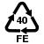 | -
13 | Produs în Tailanda | Product of Thailand | Small caps minimum font height: 1,2 mm
14 | EAN13 barcode: 642326700027 | - | To be generated by the designer  Minimal width: 3cm
15 | A se depozita la loc uscat, întunecos, ferit de razele soarelui și de îngheț, la o temperatură cuprinsă între 0-28⁰C. A se consuma imediat după deschidere. | Store in a cool dry, dark place, away from direct sun light and freezing, at a temperature between 0-28⁰C. To be consumed shortly after opening. | Small caps minimum font height: 1,2 mm

ANNEX 1b Label content requirements PINEAPPLE BROKEN SLICES

# | ROMANIAN | ENGLISH TRANSLATION | COMMENTS
F1 | Vertis greens logo | - | Mandatory on the front
F2 | Ananas Bucăți  în sirop slab îndulcit | Pineapple Broken Slices  In Light Syrup | Product name/ can be 2 lines with the second line smaller  Mandatory on the front
F3 | Pineapple image | - | Mandatory on the front
4 | Sugestie de prezentare | Serving suggestion | Mandatory text on the pineapple image (by law).  Small caps minimum font height: 1,2 mm
5 | Ingrediente: Ananas(60.20%), Apă(31.7%), Zahăr(8%), Acid Citric(0.10%) | Ingredients: Pineapple(60.20%), Sugar(8%), Water(31.7%), citric acid (0.10%) | Small caps minimum font height: 1,2 mm
6 | Informații nutriționale:  O porție: ½ cană (140g)  Porții/cutie – aprox. 4  Cantitate/ porție  *% din doza zilnică recomandată bazată pe 2000 kcal.  Doza dumneavoastră zilnică poate fi mai mare sau mai mică în funcție de nevoia dumneavoastră de calorii. | Nutrition Facts:  Serving Size ½ Cups (140g)  Serving per Container About 4  Amount/serving  *Percent Daily Values are based on a 2,000 calories diet.  Your daily value may be higher or lower depending on your calories needs. | Small caps minimum font height: 1,2 mm
  Calorii 80 Acizi grași 0
  Lipide  din care Lipide saturate | 0g  0g | 0%  0%
  Colesterol | 0g | 0%
  Sodiu | 10mg | 0%
  Carbohidrați  Fibre  Zaharuri | 20g  <1g  17g | 6%  0%
  Proteine | 0g
  Vitamina A 0% Vitamina C 2% Calciu 2% Fier 2%
  Calories from fat 80 Total fat 0g
  Total Fat  Saturated Fat | 0g  0g | 0%  0%
  Cholest. | 0g | 0%
  Sodium | 10mg | 0%
  Total Carbohydrates  Dietary Fiber  Sugars | 20g  <1g  17g | 6%  0%
  Protein | 0g
  Vitamin A 0% Vitamin C 2% Calcium 2% Iron 2%
7 | Sugestie de servire  A se servi simplu sau împreună cu prăjituri și produse de patiserie.  Poate servi pentru marinarea cărnii.  Perfect pentru piureuri din fructe. | Serving Suggestion  Excellent with cakes and pastries.  Great marinades for meat.  Also perfect for fruit smoothies. | Small caps minimum font height: 1,2 mm
8 | Cantitate netă: 565 g.  Masă uscată: 340g.  Volum: 580 ml. | Net Weight 565 g.  Drained Weight 340 g.  Volume: 580 ml. | Small caps minimum font height: 1,2 mm
9 | IMPORTATOR:  SC VERTIS FOODS SRL  Șos. Berceni nr. 104P, sector 4, București, ROMÂNIA  Tel: +4021 368 48 48  Fax: +4021 334 91 42  E-mail: consumator@vertisfoods.ro | Import Company:  SC VERTIS FOODS SRL  Șos. Berceni nr. 104P, sector 4, București, ROMÂNIA  Tel: +4021 368 48 48  Fax: +4021 334 91 42  E-mail: consumator@vertisfoods.ro | Small caps minimum font height: 1,2 mm
10 | A SE CONSUMA ÎNAINTE DE DATA INSCRIPȚIONATĂ PE AMBALAJ | Production & Expiry date on the can lid | Small caps minimum font height: 1,2 mm
11 | Produs sterilizat | Sterilized Product | Small caps minimum font height: 1,2 mm
12 |  | -
13 | Produs în Tailanda | Product of Thailand | Small caps minimum font height: 1,2 mm
14 | EAN13 barcode: 642326700021 | - | To be generated by the designer  Minimal width: 3cm
15 | A se depozita la loc uscat, întunecos, ferit de razele soarelui și de îngheț, la o temperatură cuprinsă între 0-28⁰C. A se consuma imediat după deschidere. | Store in a cool dry, dark place, away from direct sun light and freezing, at a temperature between 0-28⁰C. To be consumed shortly after opening. | Small caps minimum font height: 1,2 mm

ANNEX 2 Competitor brands
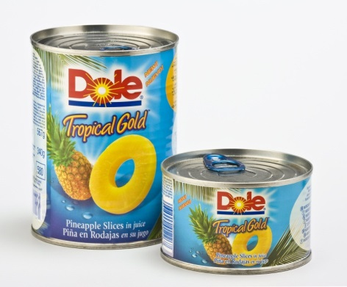 | 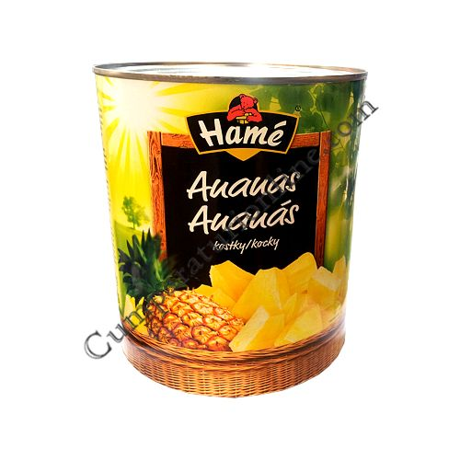 | 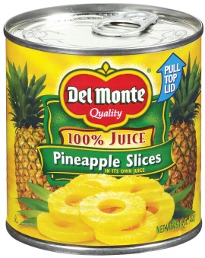
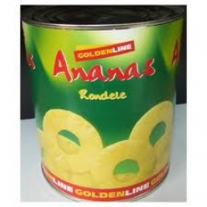 | 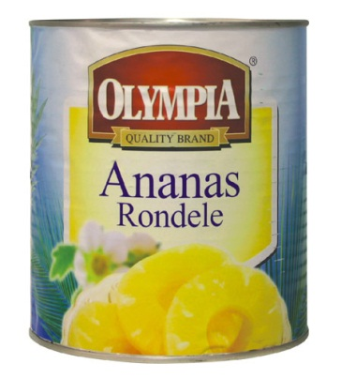 | 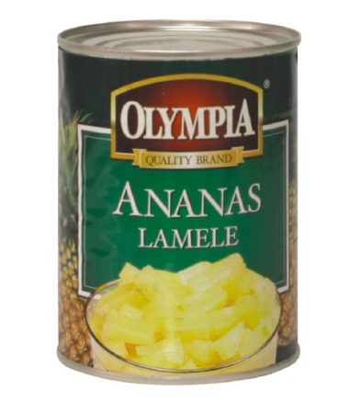
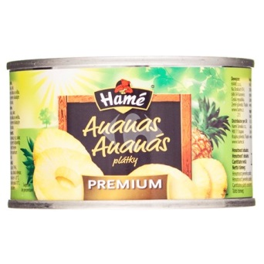 | 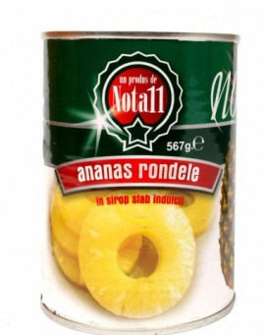 | 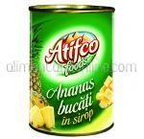
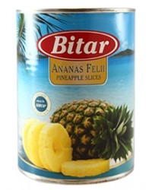 | 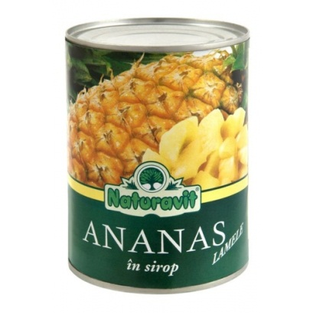 | 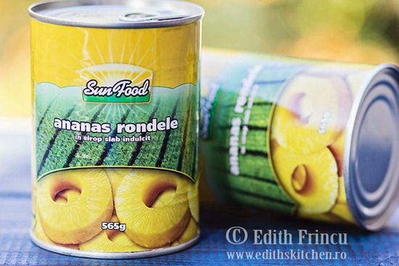
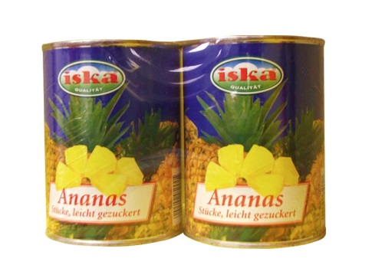 | 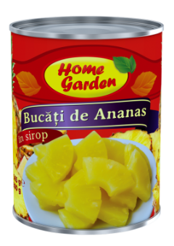 | 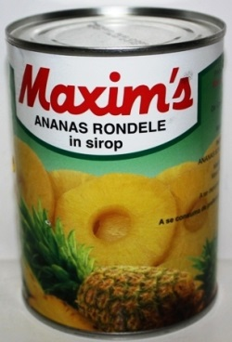
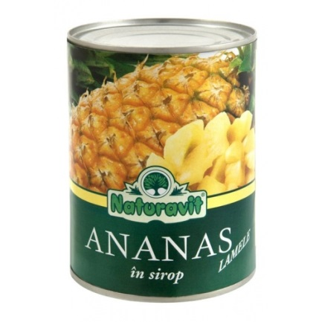 | 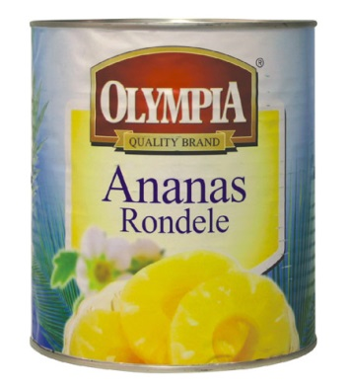
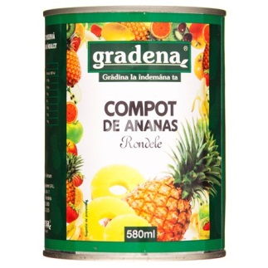 | 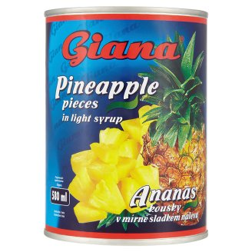 | 