Questionnaire | Notes
Do you keep track of where all your money is spent?
Do you do your own tax return?
Do you have a preferred investment type (Shares, property, other)?
Do you have multiple super funds?
Do you have a home loan?
Do you have enough savings to fund your lifestyle if you couldn’t work?
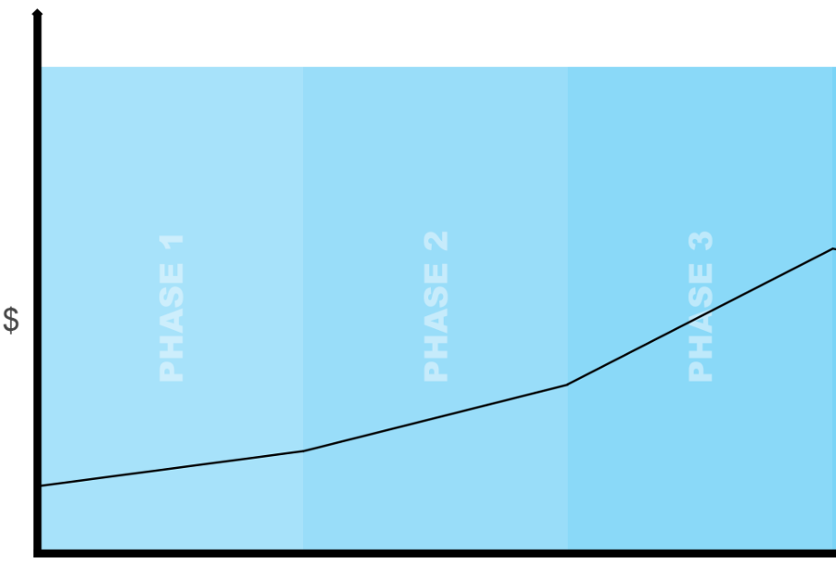
Phase 1 – Starting out | Phase 2 – Laying the foundation | Phase 3 – Break free
Your situation:  - Work full time  - Eliminate debt  - Save for first property  - Consider other investments and savings plans | Your situation:  - Purchased first home  - Start a family  - Protect assets  - Build investment portfolio  - Start planning for the future  - Implement correct tax structures | Your situation:  - Pay off your residential home  - Purchase investment properties  - Grow investment portfolio  - Plan for retirement
Professionals involved:  - Budget coach  - Financial adviser  - Accountant | Professionals involved:  - Budget coach  - Financial adviser  - Mortgage broker  - Accountant  - Conveyancer | Professionals involved:  - Budget coach  - Financial adviser  - Mortgage broker  - Accountant  - Conveyancer  - Lawyer

 | Your financial snapshot…
Your details |  |  | Partner’s details
Name: |  |  | Name:
D.O.B: |  |  | D.O.B:
Occupation: |  |  | Occupation:
Annual salary: |  | $ | Annual salary: | $
Children: |  |  | Child’s age:

Assets
Description | Date purchased | Value | Details
Residential home |  | $
Investment property |  | $
Cash |  | $
Car(s) |  | $
Superannuation |  | $
Total Assets |  | $

Liabilities
Description | Lender | Term | Amount | Details
Residential home |  |  | $
Investment property |  |  | $
Personal loan |  |  | $
Car loan |  |  | $
Credit cards |  |  | $
Total Liabilities |  |  | $

I/We consent to you using personal and credit information about me/us for the purpose of arranging or providing credit, insuring credit, and for direct marketing of products and services offered by you or any organisation you are affiliated with or represent. The personal information provided by me/us will be held by you. I/We can gain access to the information by contacting you. I/We have the right to request not to receive marketing material. You may disclose personal information about me/us as required by law, or to organisations involved in providing credit to me/us, any of your associates or contractors, (including, for example, stationary printing houses, mail houses, lawyers, accountants), or people considering acquiring or taking an interest in your business or assets. I/We hereby authorise you to receive information from any lender about our credit affairs, and to provide any relevant real estate agent, lawyer, or conveyance with details of whether finance has been approved for us, and if it has the terms of that approval, including providing a copy of any approval letter. I/we may disclose personal information to any industry body, tribunal, court or otherwise in connection with any complain regarding the approval or management of your loan - for example if a complaint is lodged about me/us or the lender.

Signature(s): _________________________________________________________________ Date: ___ /___ /___

