So the Palm Tree doesn’t appear as if it is literally in the water, can we make the wave coming in from the left be a small patch of sand, should be easy to slightly tweak with a squiggly line under to show it as an island?

Below are two image of an island in the British Virgin Islands which are the inspiration for this project. The 1st is the tree and beach. But in the 2nd image you’d see this is one of the smallest islands in the world.

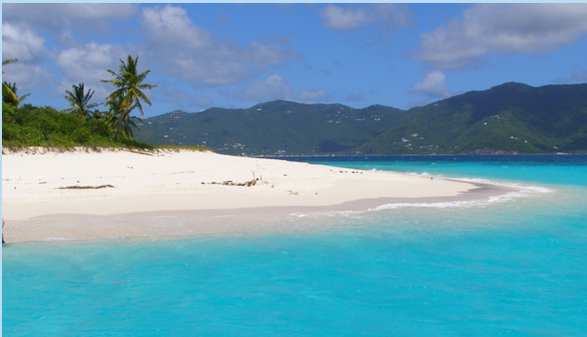

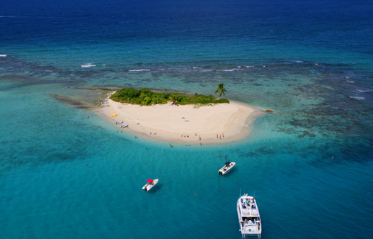

While we keep the version of the Pink/Purple sun; looking for one like this with a light pink type background; with the tree and PAE pink, with the waves Pink. This will be in preparation to support Breast Cancer Awareness month.

