Creative Brief - LOGO

BACKGROUND
Romania
Romania is a country in SE of Europe, in the Balkan region. As a culture is a mixture of Latin roots and Balkan heritage. The country is a 25 year old democracy which had a blooming and expansive economy in the first years and is now a developed country after European standards and a 7 year old member of the European Union.
Romania is more polarized when it comes to social status rather than having a very strong and wide middle class. This is the main reason why most of the products are targeting the low mainstream segment. The mainstream products are mostly created out of a compromise between the audience’s reality (available budget) and their aspirations and wishes for belonging to a better group (their aspirational perception regarding themselves).
There are a lot of multinational companies on the Romanian FMCG market which are not adapting their products to the Romanian reality.
There are also Romanian companies who opt for one of the three solutions below:
- Copying the multinationals and not disclosing that they are Romanian (Strategy: It’s foreign, so it’s better – this goes well with the collective perception on imported products)
- Promoting romanian identity: the best natural products are made in Romania
- Finding in-house solutions for branding which are most of the time confusing and disruptive for the collective perception of the target audience

Vertis Foods
Vertis Foods is a company active on the Romanian FMCG market for almost 20 years. Until 2013 it was only dealing with coffee (importing, processing/roasting and blending) which made it become the second largest Romanian independent coffee processor. In 2013 it started expanding into new directions such as importing and distributing canned vegetables, fruits, fisn and sweets.
The company’s mission is to bring quality food to target audiences of any social status (you receive a bit more than what you spend). Our core values are: reliability, loyalty and commitment to development.

Corporate Communication History
The name Vertis Foods was given in 2012 and it is practically the first corporate name which was promoted to the distributors and other business partners (the name has not yet reached the final consumer as we didn’t consider the rebranding to be complete; it was only used in business presentations).
Main problem: The product portfolio is quite wide and it includes a few old in-house made brands from the first years (Morena Café), a new brand (Rio Cafe) – both registered TMs of Vertis Foods, as well as some brands that don’t belong to us for the canned products. This is why we considered declining the corporate logo to create a bit of order and memorability and, of course, to also concentrate our communication efforts as we only benefit from a small communication budget.

Vertis Foods Products
Products under Vertis registered brands
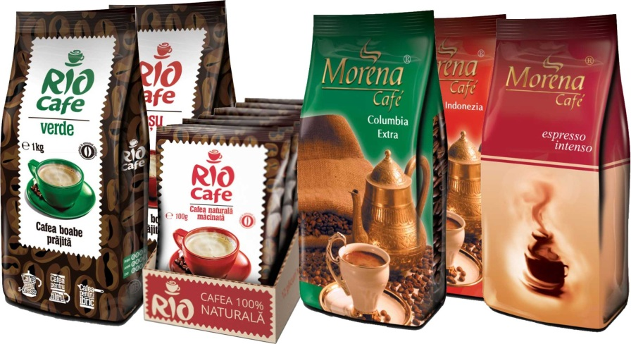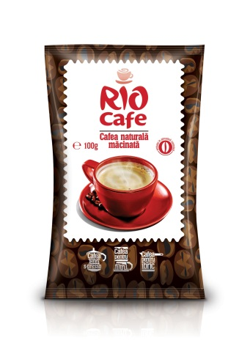

Products under foreign brands
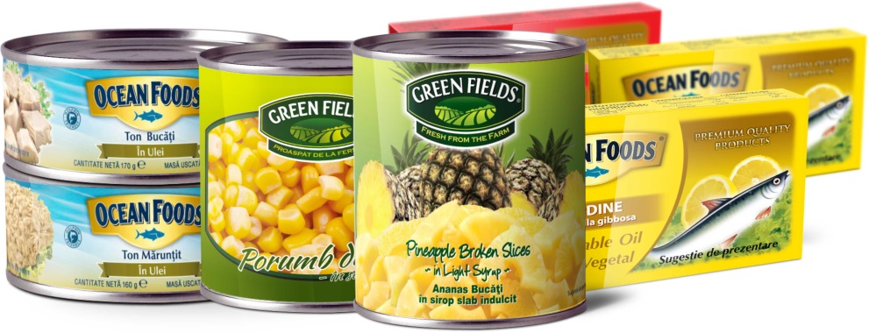

LOGO
In use corporate logos
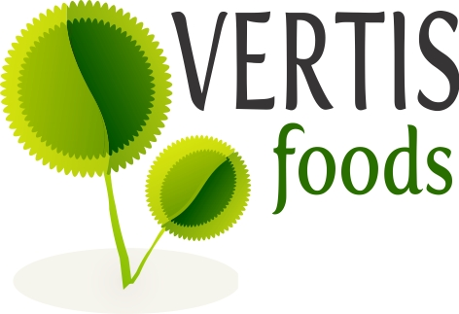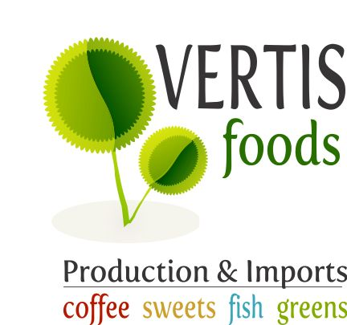

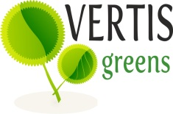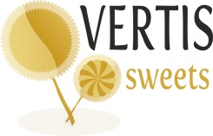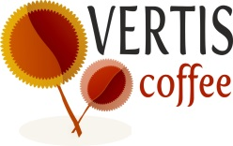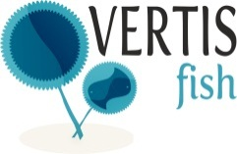
The logos are all in-house made and they were only used so far on business presentations and stationaries. They HAVE NOT yet reached the final consumer.
Limitations: our logos have been created in Corel Draw. It was not necessary a choice so please feel free to use any of the following: Corel Draw, Illustrator, Photoshop.

Objectives and expectations
- We want to have a strong and coherent corporate brand with its natural declinations: coffee, greens, fish, sweets.
- We expect the logos to be memorable, to stand out on the shelf and most importantly to communicate that we are a very SAFE company health and taste wise.
- We intend to use the declined logos in the packaging for all our products, especially as we will now be found in key accounts across the country (e.g.: Billa, Carrefour, Selgros)
We require this type of versions: color, bi-color and monocolor.
Something to be considered: The logos for the greens, fish and sweets might need to include the name of the product (sweet corn, fresh tuna, angry sardines etc. – whatever we’ll decide upon) on the packagings.

Logo-type
- We are flexible in modifying the logos to serve our corporate and communication goals.
- We also welcome just a lift of the actual logos if they are considered to be the right fit for our company.

Where the logos will be used
- The corporate logo: stationaries, powerpoints, commercial offers etc.
- The declinated logos: in powerpoints, commercial offers and on the actual products.

Guidelines
- We would like the logo to be as simple as possible (or at least not to sabotage the name), as our communication pillar is the Vertis name.
- We would also like to communicate through suggestive and optimal colours as to be easily spotted on the shelf.
- As we have quite a minimal communication budget we need the logo to really be unique and stand out of the crowd (basically to do a lot of the communication job itself – with the packaging, of course)
- Please, take into consideration the opportunities for packaging (as this will be the next upcoming project) – FMCG is a highly visual industry so we will have to include pictures with the products on the packages (even more than others as we are focused on health and quality)

Urgent up-coming projects
- Rebranding packaging for all our canned products.
- Packaging for other products such as sugar sticks (5 grams)
- Coffee packaging

.

